EFFECT OF SPECIFIED TRAINING WITH SIGN LANGUAGE AND VIBRATOR AIDS ON SELECTED PSYCHO MOTOR VARIABLES AND SKILLS IN HANDBALL AMONG DEAF AND
DUMB COLLEGE STUDENTS

Dissertation Submitted to the Tamil Nadu Physical Education and Sports University Chennai
for the fulfillment of the requirement
for the award of Degree of

DOCTOR OF PHILOSOPHY

IN

PHYSICAL EDUCATION

Submitted by

- SIGAMANI REG.NO: 287

Guided by

Dr. C. SUGUMAR

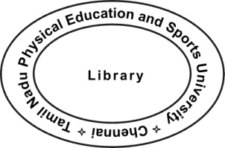

*99002150*

TAMIL NADU PHYSICAL EDUCATION AND SPORTS UNIVERSITY CHENNAI, TAMIL NADU
JULY - 2015

Dr. C. SUGUMAR, M.P.E.S., M.Phil., Ph.D.,

Deputy Director of Physical Education and Yoga Centre,
Gandhigram Rural Institute, Deemed University,
Gandhigram.
Tamil Nadu. India.

CERTIFICATE BY THE SUPERVISOR

This is to certify that the thesis entitled “EFFECT OF SPECIFIED TRAINING WITH SIGN LANGUAGE AND VIBRATOR AIDS ON SELECTED PSYCHO MOTOR VARIABLES AND SKILLS IN HANDBALL AMONG DEAF AND DUMB COLLEGE STUDENTS” is a record of research work done by R. SIGAMANI, a part time scholar of Doctor of Philosophy, in Department of Physical Education, Gandhigram Rural University, Gandhigram, Dindigul during the year 2011 – 2015.

This thesis is his original work and it has not previously formed the basis for the award to any candidate, for any degree, diploma, associateship or other similar titles. This thesis represents, entirely an independent work on the part of the candidate but for the general guidance by me.

Station: Gandhigram | (C. SUGUMAR)
Date: | Supervisor

ii

DECLARATION BY THE SCHOLAR

I, SIGAMANI, R., part time scholar of Doctor of Philosophy, in

Department of Physical Education, Gandhigram Rural University, Gandhigram,

Dindigul, hereby declare that the thesis entitled “EFFECT OF SPECIFIED TRAINING WITH SIGN LANGUAGE AND VIBRATOR AIDS ON SELECTED PSYCHO MOTOR VARIABLES AND SKILLS IN HANDBALL AMONG DEAF AND DUMB COLLEGE STUDENTS” submitted to Tamil Nadu Physical Education and Sports University for the award of Doctor of Philosophy in Physical Education is my original work and it has not previously formed the basis for the award of any degree, diploma associateship, fellowship or any other similar titles to any candidate of any University.

Station: Chennai

Date:

(R. SIGAMANI)

iii

DEDICATED TO

MY

BELOVED PARENTS

iv

ACKNOWLEDGEMENT

I find words inadequate to express my sense of gratitude to my guide Dr. C. Sugumar, Deputy Director of Physical Education and Yoga Centre, Gandhigram Rural Institute, Deemed University , Dindigul who guided this study. As an ardent lover of physical education and humanistic kind, he got himself enthusiastically involved in my research work and helped me in all the ways possible by offering valuable suggestions at every stage of my study and enabled me completing the thesis in time.

I would be failing in my duty if I do not remember the precious moments I spent in the library of Gandhigram Rural Institute, Deemed University, Dindigul and Tamil Nadu Physical Education and Sports University, Chennai for collecting the materials for this dissertation. So, I thank the respective librarians for the same.

I thank Dr. M. Mohammed Ibrahim, Former Principal, Dr. T. Brahmanandha Perumal, The Principal, Dr. P. Jothi Venkatesvaranan, Head of the Department of Computer Science, Dr. M. Kalidhas, Head of the Department of Commerce, (in-charge of Deaf and Dumb Department), Dr. R. Dhamodharan, Asst. Controller of Examination, Dr. S. Vinayagam, Deputy Warden, Colleagues in Physical Education Department, Presidency College, Chennai and my family members who involved in this dissertation execution work directly and indirectly so that I could finish my work in a successful way.

R. SIGAMANI

v

TABLE OF CONTENTS

 | Page
Certificate by the Supervisor | ii
Certificate by the Scholar | iii
Dedication | Iv
Acknowledgement | v
Table of Contents | vi
List of Tables | x
List of Illustrations | xiii
List of Appendices | xiv

CHAPTER I |  | INTRODUCTION | 1 - 23
1.1. | Overall Percentage |  | 1
1.2. | Capacity of Hearing Disabled |  | 2
1.3. | Educational Methods |  | 4
1.4. | Vibrator training |  | 5
1.6. | Sign Language |  | 11
1.7. | Training and Handball Skills |  | 13
1.8. | Highlights of Deaf and Dumb People |  | 15
1.9. | Objectives of the Study |  | 18
1.10. | Statement of the Problem |  | 18
1.11. | Hypotheses |  | 18
1.12. | Significance of the Study |  | 19
1.13. | Delimitations |  | 19
1.14. | Limitations |  | 20
1.15. | Meaning and Definition of the Operational Terms |  | 20

vi

TABLE OF CONTENTS (Contd )

Page

CHAPTER II REVIEW OF RELATED LITERATURE 24 - 64

2.1. Studies Related to Specified Training on Handball Skills and 24
Performance

2.2. Studies Related to Deaf and Dumb 48

2.3. Studies Related to Vibrator aid and Sign Language Training 51

2.4. Summary of the Literature 63

CHAPTER III METHODOLOGY 65 - 86

3.1. Selection of Subjects 65

3.2. Selection of Variables 66

3.3. Experimental Design 70

3.4. Selection of Tests 71

3.5. Pilot Study 71

3.6. Reliability of the Data 72

3.7. Instruments Reliability 73

3.8. Orientation to the Subjects 73

3.9. Training Programme 73

3.10. Test Administration 78

3.9. Collection of Data 85

3.12. Statistical Technique 85

CHAPTER IV RESULTS AND DISCUSSION 87 - 140

4.1. Overview 87

4.2. Test of Significance 88

4.2.1. Level of Significance 89

4.3. Computation of Dependent ‘t’ test, Analysis of Covariance and 89
Scheffe’s Post Hoc Test on Reaction Time

vii

TABLE OF CONTENTS (Contd )

Page

4.3.1. Results of Dependent ‘t’ Test on Reaction Time 90

4.3.2. Results of Analysis of Covariance on Reaction Time 90

4.3.3. Results of Scheffe’s Test on Reaction Time 91

4.3.4. Discussion on Findings on Reaction Time 94

4.4. Computation of Dependent ‘t’ test, Analysis of Covariance and 95
Scheffe’s Post Hoc Test on Movement Time

4.4.3. Results of Scheffe’s Test on Movement Time 97

4.4.4. Discussion on Findings on Movement Time 100

4.5. Computation of Dependent ‘t’ test, Analysis of Covariance and 101
Scheffe’s Post Hoc Test on 9M Front Throw

4.5.3. Results of Scheffe’s Test on 9M Front Throw 103

4.5.4. Discussion on Findings on 9M Front Throw 106

4.6. Computation of Dependent ‘t’ test, Analysis of Covariance and 107
Scheffe’s Post Hoc Test on Dominant Hand Speed Pass

4.6.1. Results of Dependent ‘t’ Test on Dominant Hand Speed Pass 107

4.6.3. Results of Scheffe’s Test on Dominant Hand Pass 109

4.6.4. Discussion on Findings on Dominant Hand Speed Pass 112

4.7. Computation of Dependent ‘t’ test, Analysis of Covariance and 113
Scheffe’s Post Hoc Test on Overhead Pass

4.7.1. Results of Dependent ‘t’ Test on Overhead Pass 113

4.7.3. Results of Scheffe’s Test on Overhead Pass 115

4.7.4. Discussion on Findings on Overhead Pass 118

4.8. Computation of Dependent ‘t’ test, Analysis of Covariance and 119
Scheffe’s Post Hoc Test on Accuracy Throw

4.8.1. Results of Dependent ‘t’ Test on Accuracy Throw 119

4.8.3. Results of Scheffe’s Test on Accuracy Throw 121

4.8.4. Discussion on Findings on Accuracy Throw 124

viii

 | TABLE OF CONTENTS (Contd... | )
 |  |  |  | Page
4.9. | Computation of Dependent ‘t’ test, Analysis of | Covariance | and | 125
 | Scheffe’s Post Hoc Test on Jump and Throw
4.9.1. | Results of Dependent ‘t’ Test on Jump and Throw |  |  | 125
4.9.3. | Results of Scheffe’s Test on Jump and Throw |  |  | 127
4.9.4. | Discussion on Findings on Jump and Throw |  |  | 130
4.10. | Computation of Dependent ‘t’ test, Analysis of | Covariance | and | 131
 | Scheffe’s Post Hoc Test on Dribbling
4.10.1. | Results of Dependent ‘t’ Test on Dribbling |  |  | 131
4.10.3. | Results of Scheffe’s Test on Dribbling |  |  | 133
4.11. | Summary of Findings |  |  | 137
4.12. | Discussion on Hypotheses |  |  | 139

CHAPTER V SUMMARY CONCLUSIONS AND |  | 141 - 143
 | RECOMMENDATIONS
5.1. | Summary | 141
5.2. | Conclusions | 142
5.3. | Recommendations to the Society | 143
5.4. | Recommendations to the Researchers | 143

BIBLIOGRAPHY | 144 - 153
Books | 144
Journals | 145
Proceedings | 152
Unpublished Theses | 153
Websites | 153

ix

LIST OF TABLES

Table |  | Page
I | Selection of Tests and Units of Measurement | 71
II | Intra class Co-efficient of Correlation on Selected Variables | 72
III | Training Schedule (Monday) | 75
IV | Training Schedule (Wednesday) | 76
V | Training Schedule (Friday) | 77
VI | Training Schedule (Specified Drills Practiced during the | 78
 | Training Programme)
VII | Levene’s Test of Equality of Error Variances on Selected | 86
 | Variables of VTG, VSTG Training Groups and Control Group
VIII | Summary of Mean Standard Deviation and Dependent ‘t’ Test | 89
 | for the Pre and Post Tests on Reaction time of Experimental
 | and control Groups
IX | Analysis of Covariance for the Data on reaction time among | 90
 | Experimental and Control Groups
X | Scheffe’s Test for the Differences between the Adjusted Post | 91
 | Test Paired Means of Reaction Time
XI | Summary of Mean Standard Deviation and Dependent ‘t’ Test | 95
 | for the Pre and Post Tests on Movement time of Experimental
 | and Control Groups
XII | Analysis of Covariance for the Data on Movement time among | 96
 | Experimental and Control Groups
XIII | Scheffe’s Test for the Differences between the Adjusted Post | 97
 | Test Paired Means of Movement time
XIV | Summary of Mean Standard Deviation and Dependent ‘t’ Test | 101
 | for the Pre and post Tests on 9M Front Throw of Experimental
 | and Control Groups
XV | Analysis of Covariance for the Data on 9M Front Throw among | 102
 | Experimental and Control Groups
XVI | Scheffe’s Test for the Differences between the Adjusted Post | 103
 | Test Paired Means of 9M Front Throw

x

LIST OF TABLES (Contd )

Table Page

XVII Summary of Mean Standard Deviation and Dependent ‘t’ Test 107
for the Pre and Post Tests on Dominant Hand Speed Pass of
Experimental and Control Groups

XVIII Analysis of Covariance for the Data on Dominant Hand Speed 108
Pass among Experimental and Control Groups

XIX Scheffe’s Test for the Differences between the Adjusted Post 109
Test Paired Means of Dominant Hand Speed Pass

XX Summary of Mean Standard Deviation and Dependent ‘t’ Test 113
for the Pre and Post Tests on Overhead Pass of Experimental
and Control Groups

XXI Analysis of Covariance for the Data on Overhead Pass among 114
Experimental and Control Groups

XXII Scheffe’s Test for the Differences between the Adjusted Post 115
Test Paired Means of Overhead Pass

XXIII Summary of Mean Standard Deviation and Dependent ‘t’ Test 119
for the Pre and Post Tests on Accuracy throw of Experimental
and Control Groups

XXIV Analysis of Covariance for the Data on Accuracy Throw among 120
Experimental and Control Groups

XXV Scheffe’s Test for the Differences between the Adjusted Post 121
Test Paired Means of Accuracy Throw

XXVI Summary of Mean Standard Deviation and Dependent ‘t’ Test 125
for the Pre Post and Adjusted Post Tests on Jump and Throw of
Experimental and Control Groups

XXVII Analysis of Covariance for the Data on Jump and throw among 126
Experimental and Control Groups

XXVIII Scheffe’s Test for the Differences between the Adjusted Post 127
Test Paired Means of Jump and Throw

XXIX Summary of Mean Standard Deviation and Dependent ‘t’ Test 131
for the Pre and Post Tests on Dribbling of Experimental and
Control Groups

xi

LIST OF TABLES (Contd )

Table Page

XXX Analysis of Covariance for the Data on Dribbling among 132
Experimental and Control Groups

XXXI Scheffe’s Test for the Differences between the Adjusted Post 133
Test Paired Means of Dribbling

xii

LIST OF ILLUSTRATIONS

Figure |  | Page
1 | Pre Test and Post Test Mean Values of VTG, VSTG and CG on | 92
 | Reaction Time
2 | Adjusted Post Test Mean Values of VTG, VSTG and CG on | 93
 | Reaction Time
3 | Pre Test and Post Test Mean Values of VTG, VSTG and CG on | 98
 | Movement Time
4 | Adjusted Post Test Mean Values of VTG, VSTG and CG on | 99
 | Movement Time
5 | Pre Test and Post Test Mean Values of VTG, VSTG and CG on 9M | 104
 | Front Throw
6 | Adjusted Post Test Mean Values of VTG, VSTG and CG on 9M | 105
 | Front Throw
7 | Pre Test and Post Test Mean Values of VTG, VSTG and CG on | 110
 | Dominant Hand Speed Pass

- Adjusted Post Test Mean Values of VTG, VSTG and CG on 111 Dominant Hand Speed Pass

9 | Pre Test and Post Test Mean Values of VTG, VSTG and CG on 116
 | Overhead Pass

- Adjusted Post Test Mean Values of VTG, VSTG and CG on 117 Overhead Pass

11 | Pre Test and Post Test Mean Values of VTG, VSTG and CG on 122
 | Accuracy Throw

- Adjusted Post Test Mean Values of VTG, VSTG and CG on 123 Accuracy Throw

13 | Pre Test and Post Test Mean Values of VTG, VSTG and CG on | 128
 | Jump and Throw
14 | Adjusted Post Test Mean Values of VTG, VSTG and CG on Jump | 129
 | and Throw
15 | Pre Test and Post Test Mean Values of VTG, VSTG and CG on | 134
 | Dribbling

- Adjusted Post Test Mean Values of VTG, VSTG and CG on 135 Dribbling

xiii

LIST OF APPENDICES

Appendix |  | Page
I | Raw Scores of VTG, VSTG and CG on Reaction Time | 154
II | Raw Scores of VTG, VSTG and CG on Movement Time | 155
III | Raw Scores of VTG, VSTG and CG on 9 m Front Throw | 156
IV | Raw Scores of VTG, VSTG and CG on Dominant Hand Speed | 157
 | Pass
V | Raw Scores of VTG, VSTG and CG on Overhead Pass | 158
VI | Raw Scores of VTG, VSTG and CG on Accuracy Throw | 159
VII | Raw Scores of VTG, VSTG and CG on Jump and Throw | 160
VIII | Raw Scores of VTG, VSTG and CG on Dribbling | 161
IX | Pilot Study Related Photos | 162
X | Training Period related Photos | 163
XI | Training related Sign Language Photos | 164

xiv

CHAPTER I

INTRODUCTION

Among the living organisms, human being is considered as the supreme creation in the world. It is because human being only has the potential skills such as thinking and intellectual ability. The Tamil Sangam poetess Avvaiyar speaks about the greatness of human being with her phase “born as a human being is a rarity that to getting a birth without any problems such as handicapped, blind, deaf and dumb on transgender is the rarest of the rarity. Such a rare group shines well with survival skills such as education and experience. So, getting a birth of human being and enriching with education are being considered as a boon in the world. So, most of the Government in the world spend covetable amount of money to educate the children of their country. In general, education is considered as a tool for bread and butter purpose but it provides scope for all strata of society to uplift their life style.

In the brim of 20th century, our society has been facing and reporting the issues related to the special children such as physically handicapped, visually challenged, hearing impaired, deaf and dumb, and learning difficulty such as Dyslexia. The type of education designed for these people is called ‘Special Education’. Tamil Nadu Government created a Ministry for Differently Abled people (Mattruththiranaligal in Tamil) exclusively for these children. They should try their level best to utilize these facilities to share all opportunities made available for their normal counterparts.

1.1. OVERALL PERCENTAGE

The issue of special need people has got a considerable attention in recent years, globally and locally, where Al-Rousan (2007) pointed that the

2

disability has negative repercussions on the disabled person personality and counter

effect on the community. The disabled person is considered as an economical burden

on his family and community. The duty of the society is to interact positively with

various categories of disability on solid foundations and constructive objectives and

help in the development of disabled persons and reflect his improvement in all

physical, psychological, mental and social well-being, as well as to produce a

personality capable of adapting to the surrounding community standards.

Alqoraity (2001) mentioned that the deafness disability has a particular importance because of the importance of the sense of hearing to the individuals and the problems caused by losing it. The result of losing the basic means of communication among the members of the community leads to great loss for the individuals. Rateb (2007) said that the proportion of people who suffer from weak to full hearing loss reached between 4 to 5% of individuals worldwide. This deficit does not mean that disabled hearing person has lost his ability to work and satisfy his psychological and physical needs, but by training and care, he can perform a high level of performance and achievement in various fields.

1.2. CAPACITY OF HEARING DISABLED

Alkrioti (1995) insisted that the hearing-disabled are capable of performing most if not all activities that suit other ordinary people with the same orientation and mental level. It also stresses by Canon (2002) that the hearing-disabled have super power in game, play and physical achievement of some motor skills more than their ordinary peers, as they are distinguished from all other disabilities, that their organs are sound and their senses are correct, and will enjoy high fitness with the regular training, if they were guided correctly to reach a level

3

similar to the level of ordinary peers with similar orientation and mental level. That

is why the psychological factors are considered an important element of success in

all games and sports events, where Allawi (1992) pointed that when the Supreme

sports level players are similar in physical aspects, skills, and planning, the

psychological factor is that which determines the result of competition. One of the

important psychological factors in progressing and achieving are motivation, anxiety

and tension, and thus by knowing the level of these features, one can answer some

important questions concerning the deaf exercising a certain sports activities, or their

reluctance about playing with fellow peers and their participation in their activities.

Based on the foregoing researchers who try to identify the motivations of worry and anxiety among deaf players and specifically in the skills of aiming in the game of basketball in Jordan, because of its importance at all levels. It was seen that concern and tension in the area of sports for the deaf, and their achievements and behaviors reflecting all aspects of personality, and these sports accomplishments for hearing handicapped, is not dependent only on the physical and skillful evolution but also influenced by many psychological factors such as their motivations, desires, satisfactions, cognition, psychological preparedness, thinking, fear and anxiety ...
etc, It was observed that the feel roundness and happiness of the deaf player when succeed, and his disappointment and despair when he fails, affect his performance efforts strongly.

The deaf player can be encouraged or discouraged, he could be tired on sometimes paralyzed, he might get initially fever symptoms or indifference. It is a double-edged sword to engage them in sports.

4

1.3. EDUCATIONAL METHODS

Afifi (1998) pointed that there are a lot of educational methods in the teaching of deaf players the basic skills in games, and till used as the percentage of success varied in their skill and physical performance, and in this regard Mahrous (2000) recalls that the basketball game contains basic offensive and defensive skills that makes the team win, if it is performed nicely and quickly, basic skills are necessary to raise the level of the group towards excellence, any player should master the basic skills, since there are no skill that are more important than others, as it is the movements that each player should be implemented in accordance with the conditions required by the game, in order to reach positive results and saving effort and delay case of fatigue.

Ammons (2008) deaf people, since time immemorial, have always found a way to find each other and share their commonality and, in particular, their need for visual communication through sign language. Since the first schools for the Deaf were established in Paris, 1755, deaf people began congregating in more formal situations, primarily for social and cultural reasons. Most Deaf people are (and still are) born into hearing families.

They have experienced difficulties with communication and especially the misunderstanding of how Deafness affects the ability to participate in society. This, in turn, has led to negative stereotypical attitudes towards them. A classic example is the term “Deaf and dumb” which describes Deaf people as “dumb”, “stupid” or “incompetent.” Societies everywhere have viewed Deaf people as intellectually inferior, linguistically impoverished and often have been treated as marginalized citizens.

5

The first Games, known as the International Silent Games, were held in

Paris in1924. The Silent Games were the first ever sports event for any group of people with disabilities. In deaf Olympics, athletes competed in fifteen (15) different sports competitions including swimming, athletics, tennis, ten-pin bowling, basketball, indoor volleyball, beach volleyball, table tennis, handball, wrestling, cycling, football, orienteering, shooting and badminton. Assistive visual devices were used in swimming, water polo, athletics, shooting and basketball. These devices were flashing lights that replaced the starter’s gun or referee’s whistle (Ammons, 2008).

1.4. VIBRATOR TRAINING

All information about the world is perceived by human through five senses: sight, hearing, touch, smell, and taste. Tactile perception is associated with the sense of touch. Touch is perceived through the skin which contains receptors for pressure, pain, temperature, and kinetic receptors. The band width for each sense, the rate at which the brain can process information from the sensory receptors, is largest for sight and decreases rapidly for each sense in an order of vision 106 bits/s, hearing 104 bits/s, touches 102 bits/s (Goldishand and Taylor, 1974).

Human brain receives and understands vibration stimuli. Vibrotactile sensation generally means the stimulation of skin surface at certain frequency using vibrating contactors. Pacinian Corpuscles are considered performing a major role in vibrotactile perception with maximum sensitivity at higher frequencies, i.e., 200−300 Hz. The phenomenon of vibrotactile sensation was first introduced by Geldard, 1960.

6

There are four different parameters through which vibrotactile

information coding can be studied, namely, frequency, amplitude, timing and

location. A vibrotactile stimulus is only detected when the amplitude exceeds a

certain threshold, known as detection threshold (DT). In general, DT depends on
several different parameters (Van-Doren (1990) but mainly on the frequency (∼20-

- Hz) and location (fingers are most sensitive 250-300 Hz). Vibrating stimulus up to 200 Hz results in synchronized firing of afferent nerve fibers and considered capable of great physiological information flow, i.e., due to presence of large number of mechanoreceptor esp. PC’s (Kaczmarek and Rita, 1995). By using single detectable stimulus simple messages can be encoded Rehman, et al., (2008).

Van Erp, et al., (2006) has given detailed information for the use of vibrotactile displays in human computer interaction.

While presenting tactile coding information, a designer should consider the following principals (Kaaresoja and Linjama, 2005). No more than four intensity (magnitude) levels should be used. No more than nine frequency levels should be used for coding information and the difference between adjacent levels should be at least 20%. The time interval between adjacent signals should be more than 10 milli-seconds to prevent the “saltation effect”. The vibration on the hand should be carefully dealt with and long durations might make users irritated. Vibration intensity can be used to control threshold detection and sensory irritation problem; similar to volume control in audio stimuli (Rehman, 2010).

Vibration offers many potential benefits for the use of mobile phones. A mobile phone is “synchronized” with the ball in the real field. By holding the phone, users are able to experience dynamic movements of the ball, to know attacking

7

directions and which team is leading the attack. The usability test of the system

shows that vibrotactile display is suitable for rendering live football information on

mobile phones by adopting designed coding schemes with a right training process

(Rehman, et al., 2008).

Sport technologies use embedded and wearable sensors for measuring physiological aspects and muscle movements that can help coaches understand and improve the performance of athletes. Chi, et al., (2005) described that these technologies could help to improve sports performance and learning, to encourage more exercises, and to make sports more entertaining. Besides assisting coaches, sport technologies could also support athletes with real-time instructions on how to move the body or with immediate feedback on their performance. This information could be presented as artificial tactile stimuli, as sound, or visually on a display.

For acquiring motor skills, such as in sports training, it is important that the learner frequently receives instructions on how to perform the skill and feedback on the performance. Coaches typically give instructions and feedback before and after a trial, and concurrently during the execution of the movements. Yet in many sports, the coach cannot correct the learner during an exercise. A good case in point is snowboarding. Snowboarders receive instructions before descending the slope and delayed feedback after the ride. During the ride, they are spatially separated from their coach. They have to rely on their own perception of what is right or wrong (Van, et al., 2006).

For instructing snowboarders during the ride, the coach could descend alongside the student to call out instructions. Even so, snowboarders could miss

8

these spoken messages in the noisy environment. Spoken messages could also block

environmental audio cues on which snowboarders rely on. Artificial tactile stimuli

are an alternative means to give real-time instructions or feedback without these

drawbacks. These stimuli can be generated by actuators, such as vibration motors

that are sewn into the sportswear.

Tactile stimuli have been proposed as application in sports for instructing athletes where to move to, how to move, and when to move (Van, et al., 2006). Their advantage is that they directly stimulate the body, like a coach who guides the student’s movements. When the athlete needs only a hint at how to adjust the posture, a tactile stimulus can nudge the body in the right direction. Van Erp, et al., (2006) described that tactile stimuli could signal to athletes where to move to, how to move and when to move. Van Erp, et al., (2006) also reported that the first two application scenarios where and how to move—were tested with elite athletes in soccer training, cycling, and speed skating.

Furthermore, Van Erp, et al., (2006), conducted a laboratory study where rowers received tactile instructions when to move the legs and the back while exercising with a rowing machine. The findings of their study indicated that tactile instructions can help athletes maintain a high performance level. Several studies suggest that tactile instructions can support the learner in acquiring motor skills.

Bloomfield and Badler (2008) reported that tactile stimuli at the arm help novices learn karate arm movements in a virtual reality setup. Nakamura, et al., (2005) applied tactile stimuli at the wrist to instruct dance beginners when to perform a movement. In general, the participants were able to increase the number

9

of correct movements and to perform these movements faster compared to dancing

without tactile cues. Tactile stimuli were also shown to be effective for learning to

play musical instruments. For example, Holland, et al., (2010) used tactile stimuli at

the wrists and ankles for teaching drum patterns. Huang, et al., (2010) used tactile

stimuli at the fingers for teaching piano melodies.

Besides instructing when and how to perform a movement, a tactile stimulus can also act as feedback when the movement is wrong. In general, feedback does not instruct the learner how to perform a movement but it can implicitly indicate the direction to move in order to correct the error. For example, Lieberman, et al., (2007), asked participants to mimic an arm movement that was shown on a computer display.

A motion capture system tracked and analyzed the performed movements. Real-time tactile feedback at the arm represented the deviations from the target movements. This feedback resembled a force-field around the correct movement path and indicated the intended movement direction. According to the findings of their laboratory study, Lieberman, et al., (2007) reported that the addition of tactile feedback to motor training could improve performance and could support learning.

The findings of several studies indicate that artificial tactile stimuli could be beneficial for learning motor skills, such as dancing (Nakamura, et al., 2005), rowing (Van, et al., 2006), and karate moves (Bloomfield and Badler, 2008). There is also evidence that tactile stimuli can facilitate the learning of musical instruments (Holland, et al., 2010 and Huang, et al., 2010). Even so, the work (Nakamura, et

10

al., 2005, Van, et al., 2006 and Bloomfield and Badler, 2008) did not consider

realistic training scenarios but focused on laboratory settings, nor did it focus on

sports training (Holland, et al., 2010 and Huang, et al., 2010). To better understand

the potential and pitfalls of using tactile stimuli for teaching sport skills, it is

important to consider a broad range of physical activities, user groups, learning

conditions, and real-world scenarios.

1.5. SOCCER REFEREE’S VIBRATOR EQUIPMENTS

In association football, the referee is the person responsible for enforcing the Laws of the Game during the course of a match. Referee is the final decision-making authority on all facts connected with play, and is the only official on the pitch with the authority to start and stop play and impose disciplinary action against players during a match. At most levels of play the referee is assisted by two assistant referees (formerly known as linesmen), who are empowered to advise the referee in certain situations such as the ball leaving play or infringements of the Laws of the game occurring out of the view of the referee. (https://en.wikipedia.org/wiki/ Referee_(association_football). Soccer referee’s equipments are whistle, timepiece, yellow, red card, notebook, Assistant referee’s flag, Pressure gauge, Electronic boards, vanishing spray and Transmitter. Among these instruments as far as our study is concerned transmitter is taken into account. The transmitter is a common equipment for referees in top-flight leagues and international competitions. It is a radio-like device used by the officials to communicate with each other during a game. The transmitter is typically made of a body, which is worn at the waist, and a mouthpiece and earphone (http://www.football-bible.com/soccer-info/soccer-referee-equipment.html). The assistant referee’s carried an electronic flag that was

11

connected with the vibrator which was fixed in referee’s arm. When the assistant

referee switched on the button, referee would feel vibration on his arm and assistant

referee communicated with referees in the line for the foul, offside or any other

incident (http://www.goalnepal.com/news.php?id=13876).

Harold (2005) in his invention relates to a system of devices that can be integrated into elements that are designed to assist the referee in football, such as the referee's whistle, the linesmen's flags, the playing area and the ball. The inventive system can also be used for American football and for any other ball sports. The invention makes use of a series of sensor elements, LEDs (light-emitting diodes) or indicator bulbs, vibration indicators, a control console, a laser light and radiofrequency signal transmitter/receiver mechanisms together with the respective microchips thereof, all of which are known in electronics. The aforementioned elements are adapted and used as auxiliary refereeing supports in the standard elements, i.e. the whistle, flags and rectangular playing area, and, in this way, can be used to provide instant correct solutions to playing situations that could give rise to dubious decisions and subsequent disputes.

1.6. SIGN LANGUAGE

Sign language refers to the indigenous language used by the deaf group in a country. Every country has a sign language of its own, which has developed spontaneously within the deaf group of that country. In an effort to improve deaf people’s living conditions, the removal of communication barriers is of paramount importance. A deaf person must have the right to use sign language as his natural language in any social situation. The status of sign language must be raised to that of

12

a scheduled language in India. This is the primary need of the deaf community in

India today (Indian Sign Language Dictionary).

Signs can be decomposed into a set of minimal, meaningless units, including the features of hand configuration, movement and place of articulation. Hand configuration (more commonly ‘handshape’) describes the extension or flexion of one or more fingers and the orientation of the hand relative to the body and can be described in terms of a hierarchy of complexity, where the ‘simplest’ hand shapes involve the fewest number of features (selection of fingers, contact between fingers, etc.). Although sign languages are often described as ‘manual’ languages, multiple channels are used. The hands are the major articulators and their configuration, movement, and arrangement in space provide most lexical and grammatical information. However, other articulators are also involved. Mouth actions include mouthing, which provide lexical information derived from spoken language forms, while mouth gestures are also used for adverbials and echo phonology (Woll, 2001).

In most sporting events there are always players and referee(s) who use whistle, buzzers, and bells to conduct the events or games. In deaf sporting events whistle, buzzers or bells cannot be meaningful, making it necessary for visual communication and/or alternatives to be used. For example to signal the start of a race a light might be used or a hand signal while coloured flags might signal a foul or illegal play. The signals for “ball” and “strike” were the invention of William Hoy, who played basketball for 17 years, (Deaf Sports). In Games and Sports, umpires express their decision through various standard recognizable signs to carry-out the game smoothly as per laid down rules for the respective games. Different

13

games and events require different signs and signals for official purposes and

informal practices. Coaches are known to use various signs and signals directly or

discretely which are usually kept secret and practiced only among the team

members. Coaches design new signs and signals to help their team surprise their

opponents and win matches, Hence it has to be recognized that signs usually play a

major role in coaching. In events involving players with hearing disability the role of

a coach in evolving efficient sign/signals to appraise the team workout strategies,

motivating players is important and necessary.

When players with hearing and speech disabilities are involved the importance of sign language, visual and contact signaling (vibrator) become very relevant and important. This is because common audible clues (signaling) like whistling are ineffective in players with such disability. This research work focuses on effective sign and signaling for players with hearing and speech disability. Among the various aids developed to help players with hearing disability the efficacy of the vibrator especially in games like football and handball is quite noticeable.

1.7. TRAINING AND HANDBALL SKILLS

The handball is a complete collective sporting modality, characterized by a great amount and variety in its movements, ball manipulations and interaction with other athletes. Elite male handball players, who play indoors on a small court, may be more homogeneous as a whole compared to other ‘‘big playing field’’ sports. Among them, the morphological, physiological, technical tactical, psychic and environmental variables are highlighted.

14

The evaluation of the performance implicates the recognition and

denomination of the individual level of the components of the sporting performance

or of a conditioning situation. It is essential that all the variables related to the

athletes ’performance be evaluated. Athletes in all sports use psychological

preparation as a tool to enhance their performance. Psychological preparation has

many different forms and is directly related to personal preference (Shahbazia,

et al., 2011).

Junior category and psychomotor development of physical availability is medium to be built technical training through a large number of repetitions of specific skills and game skills requiring high-level sensory system. Better results can be obtained only by the players with a perfect individual technique to cope with the increasingly complex situations encountered in the game and as required by the game, often under conditions of adversity, to limit or running out of time (Ion, et al., 2014).

In high-skilled athletes, variability increased again (a functional variability that provides flexibility to the system allowing it to cope with perturbations). Several studies have highlighted that movement variability differs depending on the skill level of the athletes and changes during the movement. To score goals in team handball, throwing players must maximize their ball release speed and their throwing accuracy; however, the ball release speed is the main performance factor determining the throwing movement (Van den Tillaar & Ettema, 2006; Wagner and Muller, 2008).

15

In sport and games, particularly ball games, game situations continually

change during the event, as well as during a particular movement. Skilled athletes are able to adapt to these changing game situations leading to differences in movement variability. Team-handball throw, (Schorer, Baker, Fath, & Jaitner, 2007) movement variability was consistent with a U-shaped curve depending on the skill level of the athlete. Schorer, et al., (2007) and Wilson, et al., (2008) found a high variability in low-skilled athletes and a decrease in variability of skilled athletes resulting in a more consistent and regulated performance.

1.8. HIGHLIGHTS OF DEAF AND DUMB PEOPLE

Recent education census report says, “Among the 9 percent of handicapped people in India, 80 to 90 percent people are studious to promote themselves in education and social environment. There is a massive enrolment of handicapped students every year and the strength is steadily increasing. For example, among 69 government colleges in Tamil Nadu, around 900 to 950 handicapped students have enrolled and 150 to 175 handicapped faculty members working for the benefit of their fraternity.

Curriculum for deaf and dumb and with other difficulties is entirely different. Because students with difficulties can speak and hear which cover 80 percent of teaching and learning process. But for deaf and dumb, sign language and inter-personal methods such as touch and display can alone be used. Higher education is a concept which shapes the overall personality of a student through extra-curricular activities. Among the extra-curricular activities there are many varieties of events to channelize their positive energy and get shaped as a social well-being. The possible college level extra-curricular activities are,

16

- Sports and games (Track events and Individual events)

- National Cadet Corps

- National Service Scheme

- Rotaract Club

- Red Ribbon Club

- Green Club for Environment cleanliness

- Youth Red Cross.

Not long ago individuals having some physical or mental defects were looked down as useless persons for the society. The term ‘Handicapped’ or ‘Disabled’ were leveled against their identity. They were not whole heartedly accepted by others in the society. With the passage of time the outlook began to change.

“Deaf and Dumb” is the term commonly used to describe persons who through being deaf are unable to hear the spoken words of others, and who, consequently, remain dumb. Being deaf is the cause, dumb the consequence. Thus the term "deaf and dumb" is a misnomer, for the deficiency is single, not two-fold, although in the result it affects the two organs of hearing and speech. Among various special populations deaf & dumb is a very common type of disability seen in our society not in a very negligible quantity. It is needed to take special care and attention of this population from their childhood to give them ample opportunity to be self sufficient in future. That is why various schools have been established for the special populations in our country starting from late seventies up to date. It is needed not only to give them education but also to build a healthy body and mind for them

17

having the prime necessity of physical education as well to make them conscious

about their physique, health and fitness (Ghosh, 2014).

Social reformers and educationists are striving heard to integrate the physically challenged person with the main stream. It is our social responsibility to see it that physically challenged people leads a self reliant independent and emotionally stable life. Educationists and school administrators are now working together to fulfill that aim. Advancement in scientific knowledge is helping them in many ways in their effort. It is not easy to integrate these people with the society. Due to physical disability, they face many challenges to perform any task as par with the normal people (Ghosh, 2014).

Youth is an integral part of democratic society and future asset of mankind. It is universally recognized that Sport is an effective way for channelizing the energies of Youth for productive and meaningful purpose. Fitness has proved as a powerful but highly undervalued and under exploited tool for promoting solidarity and in contributing to an atmosphere of tolerance and understanding to the special population as an undefined part of the society.

After having gone through the various studies, investigator planned to study the effectiveness of Deaf and Dumb students’ participation in the college sports activities. The work carried out on hearing impaired players of handball team with and without sign / vibrator shows and proves effectiveness of this type of signaling among such players.

The researcher is working in the physical education department of Presidency College in Chennai which has two departments exclusively for the

18

hearing impaired students. The interest and enthusiasm shown by these students

towards sports made the researcher select this area/topic of research, which should

benefit this section of students and coaching abilities as a whole. This is the reason

for selecting the topic and carrying out research in the area of sports.

1.9. OBJECTIVES OF THE STUDY

The following are the specific objectives of this study.

- To find out the effect of specified training with vibrator aid on selected psychomotor variables and skills in handball among deaf and dumb college students.
- To find out the effect of specified training with combination of vibrator aid & sign language instruction on selected psychomotor variables and skills in handball among deaf and dumb college students.

1.10. STATEMENT OF THE PROBLEM

The present study was to find out the effect of specified training with sign language and vibrator aid on selected psychomotor variables and skills in handball among deaf and dumb college students.

1.11. HYPOTHESES

It was hypothesized that

- There would be a significant improvement on selected psycho motor and skill related variables in handball due to the influence of specified training with vibrator aid instruction.

19

- There would be a significant improvement on selected psycho motor and skill related variables in handball due to the influence of specified training with combination of vibrator aid & sign language instruction.
- There would be a significant improvement difference between specified training with vibrator aid and combination of vibrator aid & sign language instruction on selected criterion variables among deaf and dumb students.

1.12. SIGNIFICANCE OF THE STUDY

The results of the study may be useful to the following ways.

- This work explored the use of real-time vibrator and combination of vibrator aid & sign language instructions for teaching sport skills in a realistic scenario.
- This study will provide guideline for deaf and dumb college men students to improve their psychomotor and handball skills.
- It would further add to the quantum of knowledge in the area of sign language and vibrator training.

- The result can be used by the physical education teachers for further development in playing abilities of their trainees.
- The study may help other physical educators to conduct further research in this area.

1.13. DELIMITATIONS

- To achieve the purpose of the study, forty five deaf and dumb men students were selected randomly from the Presidency College, Chennai. The subjects’ age ranged between 18 and 25 years and their hearing impaired level is 90%.

20

- Selected subjects were divided into three equal groups namely experimental group I (VTG=15) vibrator aid training group, Group II (VSTG=15) combination of vibrator aid & sign language training group and Group III served as control group (CG = 15).
- The following dependent variables were selected for this study: Psychomotor variables namely reaction time and movement time, Skills namely nine meter front throw, dominant hand speed pass, over head pass, accuracy throw, jump and throw and dribbling.
- The duration of the training period was restricted to twelve weeks and the number of sessions per week was confined to five.

- The level of significance was fixed at 0.05 level, which was considered to be appropriate.
- The data were collected prior to and also immediately after the training period.

1.14. LIMITATIONS

- Subjects’ previous training was not considered.

- Subjects included in the study could not be controlled with regard to their life style, diet and habits which might have influenced their performance.
- Subject’s body type and the socio-economic status of subjects were not taken into consideration.

1.15. MEANING AND DEFINITION OF THE OPERATIONAL TERMS

1.15.1. Deaf and Dumb

Deaf person - a person with a severe auditory impairment, dummy, silent

person - a person who does not talk.

21

1.15.2. Sign Language

Sign language refers to the indigenous language used by the deaf group in a country.

1.15.3. Vibrator Aid

Vibrator aid is an instrument that produce the vibrotactile (pulsation and touch) sensation generally means the stimulation of skin surface at certain frequency using vibrating contactors.

1.15.4. Handball

Handball is a team sport in which two teams of seven players each (nine outfield players including a goalkeeper) pass a ball using their hands with the aim of throwing it into the goal of the other team. A standard match consists of two periods of 30 minutes, and the team that scores more goals wins.

1.15.5. Specified Training

The term specified training”” means “specific to one’s sport or activity,” which means the individual should be engaged in perfect practice to improve their skills. Sport specific training is simply fitness and performance training, designed specifically for sports performance enhancement. Training programs for sports performance enhancement could include areas such as strength, speed, power, endurance, flexibility, mobility, agility, techniques and strategies.

In the current study, specified training exercises are handball related drills, stretching, cone drills, jogging, rotation exercises, sprints, single jump, burpee, sit-ups, biceps and triceps curl.

22

1.15.6. Specified Training with Vibrator Aid

In the current study, during the supervised sessions the specified training with vibrator aid group was given the specified training exercises. At the same time, the medium of instruction was given by using vibrator aid only. During the unsupervised sessions, the specified training could have been included with jogging, stretching and rotation exercises.

1.15.7. Specified Training with Combination of Vibrator aid & Sign Language

In the current study, during the supervised sessions the specified training with vibrator aid and followed by sing language group was given specified training exercises. At the same time the medium of instruction was given by using vibrator aid followed by sign language. In addition to the specified training, jogging, stretching and rotation exercises were also executed to the combination of Vibrator aid & Sign Language group.

1.15.8. Reaction Time

Reaction time is the interval time between the presentation of a stimulus and the initiation of the muscular response to that stimulus.

1.15.9. Movement time

The time elapsed between the beginning and the end of a movement.

1.15.10. Passing and Throwing

This is one of the basic, technical elements. A pass must be accurate, fast and tactically useful. A position of hands while catching a ball, decision to whom a pass should be directed depends on the player’s position in a particular situation. A pass should be directed to that player whose position may menace the opponent.

23

1.15.11. Accuracy Throw

Accuracy throw is an act of throwing a handball with the combination of both confidence and precision.

1.15.12. Jump shot

This shot is mainly used by the offence players to attack a tactile group. The performance of this shot is preceded by a cross-legged jump or a jump towards the goal. Correct performance of the shot and particularly the position of the trunk and proper co-ordination of arms and legs make the one the strongest.

1.15.14. Dribbling

A dribble is the act of running with the ball at feet while maintaining possession. It is often used to take the ball around an opposition player.

24

CHAPTER II

REVIEW OF RELATED LITERATURE

INTRODUCTION

The related literature reviewed for better understanding of the problem investigated and to interpret the results are presented in this chapter. The reviews are classified under the following headings:

- Studies related to specified training on handball skills and performance

- Studies related to deaf and dumb

- Studies related to vibrator aid and sign language training

- Summary of the literature.

2.1. STUDIES RELATED TO SPECIFIED TRAINING ON HANDBALL SKILLS AND PERFORMANCE

Eliasz (2015) studied the relationships between throwing velocity and motor ability parameters of the high-performance handball players. Statistically significant differences were found between maximal ball velocity during throws with a cross-over step, and ball velocities during other analyzed throws. The highest ball velocity was achieved during the throw with a cross-over step performed by play-makers. Among the motor ability factors, total muscle strength of the body (ISI), strength of trunk flexors (abdominal muscles) and maximal arm (shoulder joint) angular velocity (MSD) have a decisive effect on the ball velocity in analyzed throwing techniques. The maximal arm speed is the most important factor determining ball velocity during-technically the simplest - throw on the spot. Muscle strength has greater influence on ball velocity during - technically more complicated - throw with an upward jump.

25

Ion, et al., (2014) examined the learning to play handball technique is to

find and assimilate technical processes driving expression of the players optimal opportunities and increase their effectiveness as structured driving current game. This research was conducted at the level of junior handball teams during a competitive year in which research subjects were in training a large percentage of technical exercises, assessed by control samples prepared by federation of specialized or domain experts. To assess the level of technical training and progress have passed control samples at the beginning and end of the research.

Loffing and Hagemann (2014) conducted two experiments to examine experienced and novice team-handball goalkeepers’ ability to predict the type of throw in handball penalties and to identify the observers’ reliance on local versus globally distributed spatial cues. In Experiment 1, following a 2 (Skill) 5 (Temporal Occlusion Condition) factorial design participants were provided with videos of team-handball penalties where the amount of viewing time was varied. In Experiment 2, another sample of experienced and novice goalkeepers watched videos of spatially manipulated penalties where specific parts of the thrower’s body or the ball were either removed or presented in isolation (2 [Skill] 9 [Display Condition] factorial design). In Experiment 1, experienced goalkeepers outperformed novices and both groups similarly improved their performances with later occlusion conditions. In Experiment 2, experienced goalkeepers were again superior to novices, and local cues (e.g., ball and hand) were sufficient for better than chance predictions in both groups.

Moreover, experienced in contrast to novice goalkeepers (i) suffered from the removal of and (ii) benefited from the addition of distal (i.e., throwing arm

26

and ball) as well as proximal (i.e., upper body) kinematic features. This research is

in line with previous findings on perceptual-cognitive expertise in sports and

suggests that experienced team-handball goalkeepers rely on multiple, globally

distributed cues when making anticipatory judgments.

Wei and Ji (2014) randomly selected a 60 elderly with mild cognitive impairment (MCI) and they were divided into training group (n = 30) and control group (n = 30). The mini-mental state examination (MMSE) score and abilities of daily living scale (ADL) score before, after 3-month, and after 6-month handball training period was measured. The results showed that MMSE score was increased and ADL score was decreased in training group after 3-month and 6- month intervention (P < 0.05), while there were no significant changes in MMSE or ADL in control group. These preliminary results indicated that handball training can improve cognitive ability in MCI.

Singh and Ram (2013) correlated anthropometric dimensions and physical fitness components with playing ability and also to develop the regression equation for the prediction of handball players playing ability. The research was conducted on Inter-University level 200 male handball players of age range 18-25 years. Twenty seven anthropometric measurements and six physical fitness components as independent variables and cumulative score of two skill tests as dependent variable were evaluated of each subject. SPSS (11.5) computer software was used to analyze the data. The study revealed that the body weight and linear measurements, i.e., standing height, sitting height, total arm length, upper arm length, leg length, thigh length, lower leg length, hand length and hand breadth; body diameter measurements, i.e., elbow and shoulder diameters; body girth

27

measurements, i.e., shoulder, chest and abdomen girths; skin-fold measurements,

i.e., biceps, triceps and sub-scapular skin-folds; body composition variables i.e., lean

body mass and fat weight and physical fitness components i.e., speed, agility, arm

and leg strength have significant correlations with playing ability of handball

players. The multiple correlations of highly correlated nine independent variables

taken together with playing ability has been found highly significant and hence the

developed equation can be used in the prediction of playing ability.

Cetin and Ozdol (2012) determined the effects of 12-week strength training on the jumping throw performance in young handball players. 18 handball players (age:13.66±0.5 year; height:160.0±6.25 cm; weight: 49.0±8.97 kg) participated to the study. The Training Group Program: A 12 week strength training and handball technical training program were supervised 3 times a week and each session was 60 min. Control Group Program: A 12 week handball technical training program were supervised 3 times a week and each session was 60 min. Push up, vertical jump (VJ), performances and some kinematic parameters (velocity (VCG) and height (hCG) of center of gravity) were evaluated before and after training program.

For kinematics parameters, performances were recorded with a camera (50Hz) and evaluated with Video point 2.0. program. There were significant differences between before and after training program in push up and the height of center of gravity parameters(p<0.05). But there is no significant differences found that vertical jump (VJ) and velocity of center of gravity (VCG) (p>0.05).

28

Graib, et al., (2012) identified the impact of anxiety and tension on the

level of performance of basketball aiming skills for deaf players in Jordan, because its appropriateness for this study the researcher used the descriptive approach, a deliberately sample composed of 10 practitioners of the game of basketball players from the Prince Ali Deaf Club (Zarka) was chosen, a number of conclusions have been reached some of them was the high performance skills of aiming caused a low level of concern among members of the sample.

The relationship between the two variables were statistically significant but was in reverse, the researchers recommended a growing interest in developing performance skills in basketball and aiming skill in basketball and carrying out more experimental and competitive games for the purpose of eliminating the barrier of fear and tension, and granting the deaf players high confidence in his performance.

Wagner, et al., (2012) determined differences in performance and movement variability for several throwing techniques in different phases of the throwing movement, and of different skill levels. Twenty-four team-handball players of different skill levels (n = 8) performed 30 throws using various throwing techniques. Upper body kinematics was measured via an 8 camera Vision motion capture system and movement variability was calculated. Results indicated an increase in movement variability in the distal joint movements during the acceleration phase.

In addition, there was a decrease in movement variability in highly skilled and skilled players in the standing throw with run-up, which indicated an increase in the ball release speed, which was highest when using this throwing

29

technique. The researchers asserted that team-handball players had the ability to

compensate an increase in movement variability in the acceleration phase to throw

accurately, and skilled players were able to control the movement, although

movement variability decreased in the standing throw with run-up.

Debanne and Laffaye (2011) conducted a study to predict the throwing velocity of the ball in Handball with anthropometric variables and isotonic tests. The aims of this study were; to (1) investigate the influence of general anthropometric variables, Handball specific anthropometric variables, and upper-limb power and strength on ball-throwing velocity in a standing position and (2) predict this velocity using multiple regression methods. Forty- two skilled male Handball players (age 21.0 ± 3.0 years; height = 1.81 ± 0.07 m; body mass = 78.3+11.3 kg) participated in the study. Researchers measured general anthropometric variables (height, body mass, lean mass, body mass index) and Handball specific anthropometric parameters (hand size, arm span). Upper-limb dynamic strength was assessed using a medicine ball (2 kg) throwing test, and power using a one repetition maximum bench press test. All the variables studied were correlated with ball velocity. Medicine ball throwing performance was the best predictor (r = 0.80).

General anthropometric variables were better predictors (r = 0.55–0.70) than Handball specific anthropometric variables (r = 0.35–0.51). The best multiple regression model accounted for 74% of the total variance and included body mass, medicine ball throwing performance, and power output in the 20kg bench press. The equation formulated could help trainers, athletes, and professionals detect future talent and test athletes’ current fitness.

30

Shahbazia, et al., (2011) investigated physical and mental fitness of

Iranian men’s handball national players. Samples of the research were 15 of Iranian men’s handball national players. Selected physical fitness tests (such as: sit and reach, VO2max, power, strength, speed, reaction time, agility) and OMSAT3 questionnaire used for measure physical and mental fitness respectively. The results of Pearson correlation showed that there was no significant relation between the factors of physical fitness and mental preparation in athletes (p>0.05).

Physical fitness scores were lower than optimal level whereas they had a very good mental preparation. Although the research subjects had low physical fitness, they achieved considerable results in Asian games. Therefore, it seems that high psychological preparedness in athletes may be effective in earning such a great position (silver medal).

Buchheit, et al., (2010) compared the effects of speed/agility (S/A) training with sprint interval training (SIT) on acceleration and repeated sprint ability (RSA) in well-trained male handball players. In addition to their normal training program, players performed either S/A (n = 7) or SIT (n = 7) training for 4 wk. Speed/agility sessions consisted of 3 to 4 series of 4 to 6 exercises (e.g., agility drills, standing start and very short sprints, all of <5 s duration); each repetition and series was interspersed with 30 s and 3 min of passive recovery, respectively.

Sprint interval training consisted of 3 to 5 repetitions of 30-s all-out shuttle sprints over 40 m, interspersed with 2 min of passive recovery. Pre- and posttests included a countermovement jump (CMJ), 10-m sprint (10m), RSA test and a graded intermittent aerobic test (30-15 Intermittent Fitness Test, V(IFT)). In

31

well-trained handball players, 4 wk of SIT is likely to have a moderate impact on

intermittent endurance capacity only, whereas S/A training is likely to improve

acceleration and repeated sprint performance.

Chelley, Hermassi and Shephard (2010) investigated relationships between peak power (PP) as measured by upper limb (PPUL) and lower limb (PPLL) force-velocity tests, maximal upper limb force assessed by 1 repetition maximum bench press (1RMBP), and pullover (1RMPO) exercises, estimates of local muscle volume and 3-step running handball throwing velocity (T3-Steps). Fourteen male handball players volunteered for the investigation (age: 19.6±0.6 years; body mass: 86.7±12.9 kg; and height 1.87±0.07 m).

Lower and upper limb force-velocity tests were performed on appropriately modified forms of a Monark cycle ergometer, with measurement of PPUL and PPLL, and the corresponding respective maximal forces (F0UL and F0LL) and velocities (V0UL and V0LL). T3-Steps were assessed using a radar Stalker ATS system. Muscle volumes of the upper and lower limbs were estimated with a standard anthropometric kit. T3-Steps was closely related to absolute PPUL and to F0UL (r=0.69, p<0.01 for both relationships). T3-Steps was also moderately related to 1RMBP and 1RMPO (r=0.56, p<0.05; r=0.55, p<0.05 respectively), and to PPLL and F0LL (r=0.56, p<0.05; r=0.62, p<0.05, respectively). When PPLL was expressed per unit of limb muscle volume, the relationship with T3-Steps disappeared. This suggests the importance of muscle volume to performance in throwing events.

32

Force-velocity data may prove useful in regulating conditioning and

rehabilitation programs for handball players. Our results also highlight the

contribution of both the lower and the upper limbs to handball throwing velocity,

suggesting the need for coaches to include upper and lower limb strength and power

programs when improving the throwing velocity of handball players.

Garcia, et al., (2010) analyzed the differences in general and specific throwing capacity of handball players as a function of the age category. Differences between throwing velocity to goal without and with opposition have also been addressed. Ninety four handball senior and U-18 players were assessed in four different situations of throwing: 1) heavy medicine ball throw, 2) light medicine ball throw, 3) throwing velocity without opposition and 4) throwing velocity with opposition. Senior players were found to perform far better than the U-18 players in all four throwing situations (p<0.001; t1=6.958; t2=8.244; t3=8.059; t4=5.399; df=92).

Throwing velocity was higher without than with opposition for both groups; the throwing velocity of the senior group was 7.79% lower (p<0.01; t=8.317; df=47) when there was opposition, whereas U-18 players’ velocity lowered by 6.03% (p<0.01; t=4.469; df=45). The results suggest that age can be a determining factor in handball players’ throwing capacity, both general and specific. Likewise, the presence and interference of a goalkeeper appears to affect throwing velocity in a negative way, especially in senior players.

Rivilla-García (2010) analyzed the differences in distance throwing with heavy and light medicine ball and throwing velocity between handball players

33

of different competitive and professional level. Likewise, the relationship between

the three throwing test of progressive specificity was analyzed: throwing with heavy

medicinal ball (TH), throwing with light medicinal ball (TL) and throwing velocity

(TV). For this purpose, sixty-five professional (P), semi- professional (S) and non-

professional (N) players were evaluated.

In the three throwing test, the results revealed that the values were significantly better as the competitive and professional level increased (TH: F 2, 63
- 34.399; TL: F 2, 63 = 53.75; TV: F 2, 63 = 70.364). Thus, in all throwing situations, the professional group showed higher values (p<0.001) than the semi-professional and non-professional groups. In all groups, significant and positive correlation between the three throwing tests were observed (p<0.01).

The correlation value between TH-TV (P: r=0.469; S: r=0.619; N: r=0.687) was lower than the correlation value between TL-TV (P: r=0.652; S: r=0.818. N: r=0.891). Therefore, handball players’ throwing ability is a decisive factor in competitive and professional level. Moreover, the results suggest that the TL is a better predictor of throwing velocity than the TH, more so in non-professional players.

Rivilla–Garcia, et al., (2010) analyzed the differences in throwing capacity among the playing positions in elite and amateur male team handball players (n=48) in four throwing tests: throwing with a heavy (THMB) and light medicine ball (TLMB), throwing velocity without (TV) and with opposition (TVO). The backs achieved the highest scores while goalkeepers had the lowest scores in the most specific tests, TLMB (F 4, 43=2.886; p<0.05), TV (F 4,=4.857; p<0.05) and

34

TVO (F 4, 43=12.828; p<0.01). The analysis of differences revealed that TV was

higher than TVO (p<0.01) in all cases. The results suggest that the playing position

is determinant in specific throws. Furthermore the influence of opposition is

significant in throwing velocity, decreasing it in all positions.

Vuleta, at al., (2010) defined reliability and factorial validity of four field specific handball tests used for the assessment of explosive (throwing) power of elite handball players. The subjects were 18 top level Croatian national handball players. The participants were tested during the middle of the competitive season. Three throws were measured for each test (R4M, R6M, R9MRS and R9MJS). The reliability was assessed through the AVR, ICC and Cronbach’s α coefficients, and the validity through the correlations obtained by the principal components factor analysis. The R6M, R9MRS and R9MJS tests had high reliability coefficients (α = 0.93, 0.93 and 0.91).

The principal components analysis extracted one statistically significant component. The R4M test had the lowest correlation with the component (r = 0.52), and the other three tests had correlation coefficients between 0.88 and 0.93. The results of the study proved that the most reliable and appropriate tests to assess the explosive (throwing) power of handball players are the R6M and R6MRS tests.

Wagner, et al., (2010) studied that the jump throw is the most applied throwing technique in team- handball ; however, a comprehensive analysis of 3D-kinematics of the team-handball jump throw is lacking. Therefore, the purpose of our study was: 1) to measure differences in ball release speed in team-handball jump throw and anthropometric parameters between groups of different levels of

35

performance and (2) to analyze upper body 3D- kinematics (flexion/extension and

rotation) to determine significant differences between these groups.

Three-dimensional kinematic data was analyzed via the Vicon MX 13 motion capturing system (Vicon Peak, Oxford, UK) from 26 male team- handball players of different performance levels (mean age: 21.2 ± 5.0 years). The participants were instructed to throw the ball (IHF Size 3) onto a target at 8 m distance, and to hit the center of a square of 1×1 m at about eye level (1.75 m), with maxi- mum ball release speed. Significant differences between elite vs. low level players were found in the ball release speed (p<0.001), body height (p < 0.05), body weight (p < 0.05), maximal trunk internal rotation (p < 0.05), trunk flexion (p < 0.01) and forearm pronation (p < 0.05) as well as trunk flexion (p < 0.05) and shoulder internal rotation (p < 0.001) angular velocity at ball release.

Results of the study suggest that team-handball players who were taller and of greater body weight have the ability to achieve a higher ball release speed in the jump throw, and that an increase in trunk flexion and rotation angular velocity improve the performance in team-handball jump throw that should result in an increase of ball release speed.

Buchheit, et al., (2009) compared the effect of high-intensity interval training (HIT) versus specific game-based handball training (HBT) on handball performance parameters. Thirty-two highly-trained adolescents (15.5±0.9 y) were assigned to either HIT (n=17) or HBT (n=15) groups, that performed either HIT or HBT twice per week for 10 weeks. The HIT consisted of 12-24 x 15 s runs at 95% of the speed reached at the end of the 30-15 Intermittent Fitness Test (V(IFT))

36

interspersed with 15 s passive recovery, while the HBT consisted of small-sided

handball games performed over a similar time period.

Before and after training, performance was assessed with a counter movement jump (CMJ), 10 m sprint time (10 m), best (RSAbest) and mean (RSAmean) times on a repeated sprint ability (RSA) test, the V(IFT) and the intermittent endurance index (iEI). After training, RSAbest (-3.5±2.7%), RSAmean (-3.9±2.2%) and V(IFT) (+6.3±5.2%) were improved (P<0.05), but there was no difference between groups. In conclusion, both HIT and HBT were found to be effective training modes for adolescent handball players. However, HBT should be considered as the preferred training method due to its higher game-based specificity.

Buchheit, et al., (2009) determined whether a 4-a-side handball (HB) game is an appropriate aerobic stimulus to reach and potentially enhance maximal
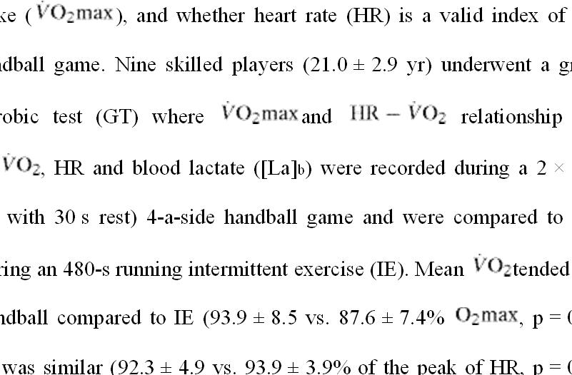
oxygen uptake ( ), and whether heart rate (HR) is a valid index of 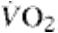

during a handball game. Nine skilled players (21.0 ± 2.9 yr) underwent a graded

maximal aerobic test (GT) where and relationship were determined. , HR and blood lactate ([La]b) were recorded during a 2 × 225 s

(interspersed with 30 s rest) 4-a-side handball game and were compared to those

measured during an 480-s running intermittent exercise (IE). Mean tended to be higher in handball compared to IE (93.9 ± 8.5 vs. 87.6 ± 7.4% , p = 0.06),

whereas HR was similar (92.3 ± 4.9 vs. 93.9 ± 3.9% of the peak of HR, p = 0.10). [La]b was lower for handball than for IE (8.9 ± 3.5 vs. 11.6 ± 2.1 mmol l−1, p = 0.04).

37

Time spent over 90% of 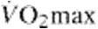was higher for handball than for IE

(336.1 ± 139.6 s vs. 216.1 ± 124.7 s; p = 0.03). The 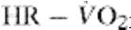relationship during

GT was high (r2 = 0.96, p < 0.001) but estimated 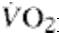from HR was lower to that measured (p = 0.03) in handball, whereas there was no difference in IE. 4-a-side handball game can be used as a specific alternative to IE for enhancing aerobic fitness in handball players. Nevertheless, the accuracy of HR measures for

estimating 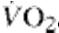during handball is poor.

Singh, et al., (2009) prepare the ‘norms profile’ of specific skills of handball players with a view to compare and evaluate further planning of handball game as it’s not being practiced in our country at present. So, an objective was set by the researchers to prepare the norms for each important specific skill of handball game at school, university and senior level of performance. Total of five hundred eighty six (N=586) players of handball were examined during School National championship (N=200), All India Inter University championship (N=195) and Senior National championship (N=191).

The tests of specific skills of Handball, standardized by Singh (2007) were used to record the specific skills of handball players. The percentile values were distributed through SPSS. These prepared norms are presented in tabular form. The research evaluation highlights that there is an increase of specific skills with participation level of handball players. Speaking specifically, the different levels’ include the level of school to university and then from university to senior level. The implicational interpretation will result in the form of an increased competitive ability of the players.

38

Ziva and Lidora (2009) studied physical characteristics, physiological

attributes, throwing velocity, accuracy and on court performances of male Handball players. For this purpose amateur player, experienced players, professional and national team players were selected. Five main findings emerged from our review:
- Elite players are heavier and have higher fat-free mass than amateur players. (2) The maximal oxygen uptake of male players was between 50 and 60 ml kg⁻¹ min⁻¹.

- Throwing velocity was higher by as much as 9% in elite male players compared with amateur male players. (4) Heart rates can rise above 160 beats min-1 in male players during a game. (5) On- court distance covered in a game averaged approximately 4 km and ranged between 2 and 5 km, depending on playing position.

The methodological concerns based on the reviewed studies are: (a) a lack of on-court physiological data; (b) a lack of experimental/manipulative studies;
- limited data on throwing accuracy; and (d) a lack of longitudinal studies. The practical implications include: (a) strength and power exercises should be emphasized in conditioning programmes, as they are associated with both sprint performance and throwing velocity; (b) speed and agility drills should also be implemented in conditioning programmes; and (c) specificity of training based upon the position of the player is of great importance when planning strength and conditioning programmes.

Marques, et al., (2007) examined the relationship between ball throwing velocity during a 3-step running throw and dynamic strength, power, and bar velocity during a concentric-only bench-press exercise in team-handball players. Fourteen elite senior male team-handball players volunteered to participate. Each volunteer had power and bar velocity measured during a concentric-only bench-

press test with 26, 36, and 46 kg, as well RMBP) strength determined. Ball-throwing 3-step running throw using a radar gun.

39

as having 1- repetition-maximum (1-

velocity was evaluated with a standard

Ball-throwing velocity was related to the absolute load lifted during the 1-RMBP (r = .637, P = .014), peak power using 36 kg (r = .586, P = .028) and 46 kg (r = .582, P = .029), and peak bar velocity using 26 kg (r = .563, P = .036) and 36 kg (r = .625, P = .017). Conclusions: The results indicate that throwing velocity of elite team-handball players is related to maximal dynamic strength, peak power, and peak bar velocity. Thus, a training regimen designed to improve ball-throwing velocity in elite male team-handball players should include exercises that are aimed at increasing both strength and power in the upper body.

Nikolaos, et al., (2007), compared a 6-month specific handball training program and a typical physical education program on various strength and jumping skills. The participants (M age = 13.7 years, SD = 1.5) were divided into the Handball Group (n = 51) and the Physical Education Group (n = 70). The Handball Group performed 3 sessions/week (60 min) including ball-handling drills, horizontal and vertical jump-shots, fast-break, and several defensive skills. The Physical Education Group performed the program provided by the Ministry of Education including track and field and other team-sport drills.

Analyses of covariance showed that the handball group displayed greater improvement in explosive strength of upper limbs, jumping performance, maximum isometric force of right grip, and 10 m running velocity. These findings showed that handball training can significantly improve preadolescent performance of upper and

40

lower limbs. The inclusion of specific handball drills into the physical education

program is recommended.

Rogulj, et al., (2007) found the influence of some motor abilities on Ball Speed during Shot in Handball. The influence of basic motor abilities on the speed of ball during the jump shot and the floor shot in Handball has been analyzed with the sample consisting of 42 students of the first year of the Faculty of kinesiology in Split. The predictory system consisted of 8 variables intended to estimate speed, agility, movement frequencies, stamina & explosive and repetitive strength whereas the ball movement speed as a criterion variable was measured by radar pistol.

The result of the regression analysis indicates that the ball movement speed was determined in a great deal by motor ability efficacy. Individually, the ball movement speed during the jump shot and the floor shot is determined, at the level of statistical importance, only by explosive strength in the form of throw. It was acceptable because this very ability from the aspects of kinesiology and anatomy requires, to the maximum extent, the kinetic efficacy of the ball throw in Handball.

Schorer, et al., (2007) examined the movement patterns of 5 left-handed handball players (ranging from beginner to national level) who threw a handball to different sections of a goal as if a goalkeeper were present. The authors used time-continuous, 3-dimensional kinematic data to assess intraindividual movement patterns and considered subjects’ intraindividual differences relative to different targets. Cluster analysis yielded the highest assignment rates for level of expertise; a mean of 92% of trials was correctly assessed.

41

The authors observed an interaction with expertise for the intraindividual

movement patterns. Variability in the novice throwers was increased, whereas (a)

advanced throwers experienced a period of stability, and (b) the expert thrower's

variability was increased. The results indicate that random variability characterizes

novice motor performance, whereas active functional variability may exemplify

expert motor performance.

Tillaar and Ettema (2007) investigated the contribution of upper extremity, trunk, and lower extremity movements in over arm throwing in team handball. In total, 11 joint movements during the throw were analyzed. The analysis consists of maximal angles, angles at ball release, and maximal angular velocities of the joint movements and their timing during the throw. Only the elbow angle (extension movement range) and the level of internal rotation velocity of the shoulder at ball release showed a significant relationship with the throwing performance. Also, a significant correlation was found for the timing of the maximal pelvis angle with ball velocity, indicating that better throwers started to rotate their pelvis forward earlier during the throw. No other significant correlations were found, indicating that the role of the trunk and lower limb are of minor importance for team handball players.

Visnapuu, et al., (2007) reported that in handball and basketball the longer the finger length the better the accuracy of the shot or throw. All shots and throws are finished with the wrist and fingers. It can be proposed that athletes with longer fingers and greater hand surface parameters also probably have greater grip strength. The aim of this study was to investigate the influence of general body and hand-specific anthropometric dimensions on handgrip strength in boys participating

42

in handball and basketball training. In total, 193 boys aged 10-17 years participated

in this study. They were divided into 6 groups: 10-, 11-, 12-, 13-, 14-15-, and 16-17-

year-olds. The body height and body mass were measured and body mass index was

calculated as general anthropometric parameters. The outlines of the hands of the

boys were drawn on paper with a thin marker. Three groups of hand anthropometric

parameters were measured: 5 finger spans, 5 finger lengths, and 5 perimeters of the

hand. Handgrip strength was measured on the dominant hand with a Lafayette

dynamometer.

As a rule, general anthropometric parameters determined the maximal handgrip strength more accurately than did specific hand anthropometric parameters. From the specific hand anthropometric parameters, finger lengths and perimeters of the hand significantly correlated with the maximal handgrip strength. In summary, fingers are the smallest, lightest parts of the motor apparatus, and, therefore, they represent the parts most easily deflected by force from the ball, but at the same time, finger control was especially important for the accuracy of different shots, both in handball and basketball. Thus, it was especially necessary to measure finger length and perimeters of the hand for practical reasons.

Marques and Gonzalez (2006) investigated the changes in physical parameters produced during an in-season resistance training (RT) and detraining (DT, or RT cessation) in 16 high level team handball players (THPs). Apart from normal practice sessions, THPs underwent 12 weeks of RT. Subjects performed 3 sets of 3-6 reps with a load of 70-85% concentric 1 repetition maximum bench press (1RMBP), 3 sets of 3-6 reps with a load of 70-95% of 4 repetition maximum parallel squats (4RMPS), plus vertical jumps and sprints. The 1RMBP, 4RMPS, speed over

43

30 m (S30), jump (countermovement jump height [CMJ]; CMJ with additional

weights [20kg and 40kg], and ball throw velocity (BTv) were tested before the

experimental period (T1), after 6 weeks (T2), and after the 12-week experimental

period (T3). Immediately after these 12 weeks, THPs started a 7-week DT period,

maintained normal practices.

The CMJ and the BTv were the only parameters evaluated during DT. The most important gains (p < 0.001) in S30 were obtained between T1-T2 and T1-T3. The BTv improved significantly (p < 0.001) only between T1-T2 and T1-T3. The most relevant increases (p < 0.001) in jumping performance took place between T1-T2 and T1-T3. The 1RMBP showed significant increases (p < 0.001) only between T1-T2 and T1-T3. The 4RMPS increased significantly between all testing trials. After the DT, THPs showed no significant losses in CMJ performance. However, they declined significantly in BTv (p = 0.023). The results suggest that elite THPs can optimize important physical parameters over 12 weeks in-season and that 7 weeks of DT, although insufficient to produce significant decreases in CMJ, are sufficient to induce significant decreases in BTv. It is concluded that after RT cessation THPs reduced BTv performance.

Souza, et al., (2006) analyzed the changes in metabolic and motor performance variables in handball players during a training program following a model proposed by Verkhoshanski and adapted by Oliveira. Eleven handball players, from 20 to 32 years old, body weight 89.5 ± 10.4 kg (70.2 and 105.1 kg), height of 184.4 ± 6.7 cm (171.8 and 198 cm) participated in this study. All participants were members of “UniFil/Londrina” Handball Team of Londrina, Paraná. The subjects were tested and retested after developing a 16-week training program, prior to the

44

start of the National League Championship. Data were analyzed using t-test for

repeated measures (p < 0.05).

The results showed very important adaptations with an increase in velocity strength (7.8%, p < 0.05), explosive strength (8.1%, p < 0.05) and agility (6.4%, p < 0.05). Moreover, the training program allowed for some metabolic adaptations, such as anaerobic power (30.5 and 37.5%, p < 0.05), and the total time the players could stand at the Yo-yo test, respectively. Aerobic power, measured by VO2max, also increased (8.1%, p < 0.05). The results suggest that the program proposed was able to create positive motor capacities responses that were observed in the lasting training posterior effect.

Gorostiaga, et al., (2005) compared physical characteristics (body height, body mass [BM], body fat [BF], and free fatty mass [FFM]), one repetition maximum bench-press (1RM (BP)), jumping explosive strength (VJ), handball throwing velocity, power-load relationship of the leg and arm extensor muscles, 5-and 15-m sprint running time, and running endurance in two handball male teams: elite team, one of the world's leading teams (EM, n = 15) and amateur team, playing in the Spanish National Second Division (AM, n = 15). EM had similar values in body height, BF, VJ, 5- and 15-m sprint running time and running endurance than AM.

However, the EM group gave higher values in BM (95.2 ± 13 kg vs. 82.4

- 10 kg, p < 0.05), FFM (81.7 ± 9 kg vs. 72.4 ± 7 kg, p < 0.05), 1RM (BP) (107 ± 12 kg vs. 83 ± 10 kg, p < 0.001), muscle power during bench-press (18 - 21 %, p < 0.05) and half squat (13 - 17 %), and throwing velocities at standing (23.8 ± 1.9 m .

45

s (-1) vs. 21.8 ± 1.6 m . s (-1), p < 0.05) and 3-step running (25.3 ± 2.2 m . s (-1) vs.

22.9 ± 1.4 m . s (-1), p < 0.05) actions than the AM group. Significant correlations (r

- 0.67 - 0.71, p < 0.05 - 0.01) were observed in EM and AM between individual values of velocity at 30 % of 1RM (BP) and individual values of ball velocity during a standing throw. Significant correlations were observed in EM, but not in AM, between the individual values of velocity during 3-step running throw and the individual values of velocity at 30 % of 1RM (BP) (r = 0.72, p < 0.05), as well as the individual values of power at 100% of body mass during half-squat actions (r = 0.62, p < 0.05).

The present results suggest that more muscular and powerful players are at an advantage in handball. The differences observed in free fatty mass could partly explain the differences observed between groups in absolute maximal strength and muscle power. In EM, higher efficiency in handball throwing velocity may be associated with both upper and lower extremity power output capabilities, whereas in AM this relationship may be different. Endurance capacity does not seem to represent a limitation for elite performance in handball.

Pori, Bon and Sibila (2005) studied the jump shot is one of the most important elements of specific handball motor behaviour. The researchers wanted to assess it with the method of expert modelling. The sample of subjects consisted of ten male elite handball players, members of the national Slovenian teams that play in the first national handball division (average height - 191.1 4.48 cm; average body mass - 90.0 ± 4.40 kg, average age - 23.4 4.2 years; average training experience in senior teams - 5.3 2.1 years).

46

The investigators analysed six backcourt players, two wing players and

two pivots. Each of the subjects executed, after a 20-minute warm-up, three jump shots. Data processing was performed by APAS (Ariel Dynamics, California, USA). Expert modelling was performed with the SPEX expert system. The researchers formed a success tree containing 17 variables, representing all five phases of the jump shot. In order to assess the validity of this kinematic model, three independent referees also assessed the quality of the jump shot. The ranks obtained from their marks were then compared with the ranks obtained with the SPEX expert model.

On the basis of the obtained results the researchers then constructed an expert mark for each analysed player. The level of concordance of the referees was high (W = 0.875), the coefficient of correlation between the actual ranks and the referee ranks was statistically significant (0.912). The final finding was that a kinematic model of the jump shot constructed in this way can also be a good criterion for assessing the quality of the basic technique of the jump shot for seniors.

Rogulj, et al., (2005) identified the differences in motor and psychological variables according to playing positions from a sample of 53 elite female junior and senior national Handball players, Motor status included 8 variables for assessment of explosive strength of landing and throwing, agility, speed strength, movement frequency, and flexibility. Psychological status was analyzed through 4 dimensions according to Eysenck: extroversion, psychotic behaviour, neurotic behaviour, and lie.

The anthropologic features analyzed showed statistically significant differences. Considering motor abilities, differences were recorded in the variables

47

for assessment of speed strength, agility and leg movement frequency, where wings

predominated, whereas goalkeepers showed predominance in flexibility. In

psychological status, differences were present in the variable for assessment of

extroversion which was most pronounced in wings, whereas psychotic behaviour

was more expressed in those at pivot position.

The differences were primarily consequential to the selection of players of a specific anthropologic profile for particular playing positions. The hypothesis of the impact of kinesiologic specificities of a particular playing position on the formation of the players' anthropologic profile should be scientifically tested. Study results might found application in training and contest practice, especially in forming anthropologic models for particular positions during the process of player selection.

Skoufas, et al., (2002) studied the throwing velocity is an important task that affects substantially the performance of a handball player. Several training methods have been suggested in order to improve this ability. The purpose of this study was to investigate the effect of training with light balls to the throwing velocity of male novice athletes and the effect of a following detraining. The subjects performed 20 weeks of handball training and were divided in two groups: one was using normal handball balls for training and the other 20% lighter ones. The first ten weeks were used for handball players to be familiar with throwing technique.

The evaluation tests performed before, in the middle and the end of the specific training period and then after 4 weeks of detraining. The estimation of the throwing velocity was taken out of the mean velocity of 7 shots against a fixed

48

target, placed 6 meters away from the subjects. A radar gun was used for measuring

the ball release velocity. The results showed that training with lighter balls could

improve the performance of throwing more than using normal balls. Additionally,

the benefit of training was maintained 4 weeks after detraining only for the group

that used the lighter ball for training.

These findings are in agreement with previous studies that involve similar movements of other sports and suggest that the decreased resistance during training that involves ballistic movements can be advantageous for the player’s performance, and therefore, trainers are encouraged to apply this method of training as a tool for improving the efficiency of shooting of novice handball players.

2.2. STUDIES RELATED TO DEAF AND DUMB

Ghosh (2014) compared the selected physical fitness components between the Deaf & Dumb and Normal school boys of west Bengal. For the purpose of the study forty two (N=42)) subjects were randomly chosen of which twenty two were deaf and dumb boys (n=22) and twenty were normal school boys (n2=20). The age of the children ranged from 12 to 20 years. They were selected from three separate districts of West Bengal Kolkata, Burdwan and Hooghly. The five different physical fitness components i.e. Speed, Agility, Muscular endurance, Flexibility and Explosive leg strength were considered as variables for the present study. The data were collected by using standard tools and techniques. Mean, standard deviation (SD) and independent t-test were the statistics used in this study for data interpretation. Level of significant difference between two groups was set at p<0.05.

For statistical calculations Excel Spread Sheet of windows version 7 was used. Result of present study revealed that in Speed, Agility and Muscular

49

Endurance no significant difference existed between the Normal and Deaf & Dumb

Boys. But in Flexibility & Explosive leg strength significant difference existed

between the Normal and Deaf & Dumb Boys. It can be concluded from the results of

the study that in flexibility the normal boys were better than the deaf and dumb boys

but the Explosive leg strength of the Deaf & Dumb Boys were better than the normal

boys.

Khidr (2010) designed to know the effect of using a computer as a new way to learn some judo skills to the players with hearing difficulty who suffer from loneliness. This research had been applied on young students, aged 13-15 years from the deaf and dump school in Zagzig city. The Researcher adapted the experimental method for two groups which had been divided into a study group and a control group using previously and later measurements for both groups. The researcher used Bortious intelligent measure that has a scale to estimate loneliness. The educational computer program was found to have a positive effect on learning judo skills to the players with hearing difficulty who suffer from loneliness.

Singleton and Morgan (2005) had stated that bilingual deaf education is all about providing a child with the acquisition of both languages so that he was able to successfully negotiate his way in both worlds (i.e., hearing and deaf). A child with bilingual skills should possess linguistic and cognitive competence as well as a clear understanding of his identity so that he can choose to participate in either linguistic and cultural group, depending on the situation. In addition, it was important to remember that deaf educational placement is not about tracking a deaf child into either world, but rather, allowing access to both.

50

Ibrahim (2004) studied the motives associated with football practice

with deaf and dumb Egyptian Union registered disabled sports, aimed at designing a scale to measure motivation of deaf and dumb to exercise football and identify the motivations of deaf to exercise football, and ranking the motivation of deaf and dumb to practice football, and the study also aimed to identify differences in motivations between deaf footballers, the researcher used descriptive approach for the study sample of (48) deaf player, and in the light of the particular sample study the motivations for practicing football for the deaf was the rewards the physical fitness and health, the challenge of disability, social relations and fame.

Abdullah and Yakoot Zidane (2000) conducted a study aimed to put a proposal training program for developing capacity linked to mobility performance skill for some volleyball skills of deaf and dumb, and it also aimed to know the impact of special mobility abilities on the level of skills for some volleyball skills related to sending from top and passing by hands from top and defensive of sending and passing by hands from down “crushing blows’ for deaf and dumb, the researcher used several researcher methods in this study, experimental and scanning approach, experimental design approach and semi experimental approach, the study sample consisted of (30) deaf student, the results helped in achieving the expected objectives of the study with the superiority of experimental group to control group .

Ali, Radwan and Zakaria Mohammed (2000) conducted a study to note the impact of a proposal program on some variables of cognitive dynamic sense, functional varieties and physical variables of the deaf and dumb, the researchers use experimental approach to a sample of (18) students, divided into two groups experimental (9) and control (9), the main results was that the proposed

51

program had led to improved capacity of cognitive dynamic sense under study and

physical and functional variables.

According to Zozo and Hassan (1999) the effectiveness of using preliminary games to learn basic skills proposal to teach basic skills and improving some mobility capabilities in handball for deaf and dumb. The researcher used experimental approach on a sample of 60 pupils from the sixth and seventh graders from hearing-impaired, they were divided into two groups, experimental (30) students and controller (30) students, the most important results were that the preliminary games led to learn games and improve the basic skills of handball in the deaf and dumb and improving the motor capacity associated with these skills.

Almuhandis (1990) conducted a study to see the impact of kinetic education program proposed on kinetic consent and some components of the motor performances to the pupils with impaired hearing (9-12) years, the researcher used the experimental approach on a sample of (55) pupils of hearing-impaired aged (9 –

- divided into two experimental number (28) and control (27) and the most significant results of the program had a positive impact on components of motor performance and on the degree of motor satisfaction.

2.3. STUDIES RELATED TO VIBRATOR AID AND SIGN LANGUAGE TRAINING

Spelmezan, et al., (2012) demonstrated the potential for teaching sport skills with realtime tactile instructions. Ten amateurs learned a riding technique with a wearable system that automatically provided tactile instructions during descents. These instructions were in sync with the movements of the snowboard and signaled how to move the body. Author found that tactile instructions could help

52

snowboarders to improve their skills. This report gave insights into the

snowboarders’ opinion and gave recommendations for teaching sport skills with

tactile instructions. The findings helped identify the conditions under which tactile

instructions can support athletes in sports training.

Warnock, McGee-Lennon and Brewster (2012) carried out an empirical user study with aged participants which evaluated the performance, disruptiveness and subjective workload of visual, audio, tactile and olfactory notifications and then compared the results with earlier findings in younger participants. It was found that disruption and subjective workload were not affected by modality, although some modalities were more effective at delivering information accurately. It was concluded that although further studies need to be carried out in a real-world settings, the findings support the argument for multiple modalities in assisted living technology.

Auvray, et al., (2011) conducted a study to investigate the extent to which tactile information that was unavailable for full conscious report can be accessed using partial-report procedures. In Experiment 1, participants reported the total number of tactile stimuli (up to six) presented simultaneously to their fingertips (numerosity judgment task). In another condition, after being presented with the tactile display, they had to detect whether or not the position indicated by a (visual or tactile) probe had previously contained a tactile stimulus (partial-report task). Participants correctly reported up to three stimuli in the numerosity judgment task, but their performance was far better in the partial-report task: Up to six stimuli were perceived at the shortest target-probe intervals.

53

A similar pattern of results was observed when the participants

performed a concurrent articulatory suppression task (Exp. 2). The results of a final experiment revealed that performance in the partial-report task was overall better for stimuli presented on the fingertips than for stimuli presented across the rest of the body surface. These results demonstrated that tactile information that was unavailable for report in a numerosity task can nevertheless sometimes still be accessed when a partial-report procedure was used instead.

Alathari (2009) conducted a study on the impact of instructional method of sign language and lip reading in teaching some basic skills in volleyball game for the deaf and mute, and aimed to identify the impact of the practical approach of the method of sign language and lip reading to learn some basic skills in volleyball game for deaf and mute, it also aimed to identify the best method in teaching some basic skills in volleyball game for the deaf and mute. The sample of the study consisted of 20 players of Hope Institute for deaf in Baghdad Governorate, experimental approach has been used in this study, and the results showed that both methods of sign language and lip reading had a positive impact on learning and mastery of skills. The results showed that sign language was more effective than lip-reading in learning the skills of throwing the ball from the bottom ,and throwing it front bottom to front and didn’t show any difference in the skill of throwing form the top between lip reading and sign language.

Eccarius and Brentari (2007) analyzed the phonological and prosodic properties of two-handed classifiers in three sign languages—American Sign Language, Hong Kong Sign Language, and Swiss German Sign Language. Their analysis was two-fold—first they examined the restrictions the forms placed on

54

handshape choice, and then they looked at their prosodic and morpho-syntactic

structures by examining the interaction between the temporal relations of the two

hands and other prosodic cues, such as eye blinks.

From the point of view of well-formedness at the word level, their work showed that: (i) in the majority of cases, two-handed classifiers obeyed the Dominance Condition of Battison (1978) while all other forms limited their complexity in a similar way at the featural level; (ii) different classified types exhibited systematic behavior with regard to their internal handshape complexity, in particular with regard to a difference between whole entity and handling classifiers, and (iii) in the majority of cases, two-handed classifiers have the same timing properties as prosodic words.

With regard to larger prosodic units, they have found evidence of the prosodic–syntactic interface at work in classifier constructions in a number of systematic ways involving national phrases. Two-handed classifiers can be divided into four major groups with regard to their prosodic structure, one of which was found only in Hong Kong Sign Language, while the other three exhibited a general pattern that applied to all three of the sign languages in their study. The findings revealed that the phonological structures and principles that hold true in non-classifier forms were also obeyed by classifiers to a large extent.

Gallace, et al., (2007) studied only under conditions of unimodal stimulus presentation. It was therefore unclear whether the same limitations on correctly reporting the number of unimodal visual or tactile stimuli presented in a display might be expected under conditions in which participants had to count

55

stimuli presented simultaneously in two or more different sensory modalities. In

Experiment 1, they investigated numerosity judgments using both unimodal and

bimodal displays consisting of one to six vibrotactile stimuli (presented over the

body surface) and one to six visual stimuli (seen on the body via mirror reflection).

Participants had to count the number of stimuli regardless of their modality of

presentation.

Bimodal numerosity judgments were significantly less accurate than predicted on the basis of an independent modality-specific resources account, thus showing that numerosity judgments might rely on a unitary amodal system instead. The results of a second experiment demonstrated that divided attention costs could not account for the poor performance in the bimodal conditions of Experiment 1. they discussed these results in relation to current theories of cross-modal integration and to the cognitive resources and/or common higher order spatial representations possibly accessed by both visual and tactile stimuli.

Morgan and Woll (2007) gave a brief overview of the description of the constructions in sign language known as classifiers. Authors focused on the need to carryout theoretically driven linguistic analyses of their use in order to understand the structure and function of these pervasive devices within the grammars of different sign languages. Research on classifiers at the level of phonology, morphology, syntax, semantics and discourse structure as well as in different populations of signers (native, non-native, child and atypical signers) will assist us in the understanding of these complex structures within the context of current research on sign language linguistics.

56

Tait, Nikolopoulos and Lutman (2007) assessed the effect of age at

implantation on the development of vocal and auditory preverbal skills in implanted

children. The study assessed 99 children, 33 in each of three groups (those implanted

between 1 and 2 years; 2 and 3 years; and 3 and 4 years). Preverbal skills were

measured in three areas: turn taking, autonomy and auditory awareness of spoken

language, using the Tait video analysis method.

The youngest implanted group made an exceptional progress outperforming in all measures than the other two groups (p < 0.01), 6 and 12 months post-implantation, whereas there was no such difference before implantation. In the youngest group, there was also significantly greater use of an auditory/oral style of communication: 85% of the group by 12 months post-implantation compared with 30% and 18% of the two older groups. Vocal and auditory preverbal skills developed much more rapidly in children implanted between 1 and 2 years in comparison with older implanted children and reached a significantly higher level by 6 and 12 months post-implantation.

In addition, younger implanted children were significantly more likely by 12 months post-implantation to adopt an auditory/oral mode of communication. These findings favoured cochlear implantation as early as between 1 and 2 years, provided that correct diagnosis and adequate hearing-aid trial had been achieved.

Gallace, et al., (2006) made a research work to support the claim that two different and dissociable processes were involved in making numerosity judgments regarding visual stimuli: substituting (fast and nearly errorless) for up to 4 stimuli, and counting (slow and error-prone) when more than 4 stimuli were

57

presented. The researchers studied tactile numerosity judgments for combinations of

1-7 vibrotactile stimuli presented simultaneously over the body surface. In

experiment 1, the stimuli were presented once, while in experiment 2 conditions of

single presentation and repeated presentation of the stimulus were compared.

Neither experiment provided any evidence for a discontinuity in the slope of either the RT or error data suggesting that subitisation does not occur for tactile stimuli. By systematically varying the intensity of the vibrotactile stimuli in experiment 3, the researchers demonstrated that the participants were not simply using the 'global intensity' of the whole tactile display to make their tactile numerosity judgments, instead of using information concerning the number of tactors activated. The results of the three experiments reported here were discussed in relation to current theories of counting and subitising, and potential implications for the design of tactile user interfaces were highlighted.

Summers, et al., (2005) compared two experiments on the discrimination of time-varying tactile stimuli, with stimulus delivery to the distal pad of the right index finger and to the right wrist (palmar surface). Subjects were required to perceive differences in short sequences of computer-generated stimulus elements (experiment 1) or differences in short tactile stimuli derived from a speech signal (experiment 2). The pulse-train stimuli were distinguished by differences in frequency (i.e., pulse repetition rate) and amplitude, and by the presence/absence of gaps (approximately 100-ms duration). Stimulation levels were 10 dB higher at the wrist than at the fingertip, to compensate for the lower vibration sensitivity at the wrist.

58

Results indicate similar gap detection at wrist and fingertip and similar

perception of frequency differences. However, perception of amplitude differences

was found to be better at the wrist than at the fingertip. Maximum information

transfer rates for the stimuli in experiment 1 were estimated at 7 bits s(-1) at the

wrist and 5 bits s(-1) at the fingertip.

Finney and Dobkins (2001) measured contrast sensitivity in deaf and hearing subjects to moving stimuli over a range of speeds (0.125–64°/s). It was hypothesized that if ASL use drives differences between hearing and deaf subjects, such differences may occur over a restricted range of speeds most commonly found in ASL. In addition, the researchers tested a third group, hearing native signers who learned ASL early from their deaf parents, to further assess whether potential differences between groups results from ASL use.

These experiments reveal no overall differences in contrast sensitivity, nor differences in visual field asymmetries, across subject groups at any speed tested. Thus, differences previously observed between deaf and hearing subjects for discriminating the direction of moving stimuli did not generalize to contrast sensitivity for moving stimuli, a result that has implications for the neural level at which plastic changes occurred in the visual system of deaf subjects.

Summers, et al., (1997) carried out experiments to investigate the information transfer available via a single vibrator on the fingertip. In a first experiment, for stimuli with durations 80 to 320 ms, discrimination of a one-octave step change in frequency at the halfway point was investigated. Results were similar for three stimulus types--sinewave, monophasic pulse and tetraphasic pulse--

59

suggesting temporal cues were more important than spectral cues in this task. In a

second experiment, subjects were required to perceive changes in a sequence of

stimulus elements.

A presentation rate of 6.25 elements s-1 was found to give better results than a rate of 12.5 elements s-1. In the former case, the potential information transfer per element was estimated to be approximately 1.0 bits, corresponding to an information transfer rate of around 6 bits s-1. Implications for the design of a tactile aid to lip reading were discussed.

Phillips, et al., (1994) conducted a study of clinical experience and research findings gathered from using vibrotactile aids over 7 years. This interest grew from a research project to evaluate four wrist-worn vibrotactile aids for the rehabilitation of the profoundly deaf. To facilitate this, a training programme was developed to help patients get the most from the aid. Having found that the RNID/Summit Tam vibrotactile aid was the most appropriate, this has been fitted to over 50 patients. The results of the comparative trial, an evaluation of our methods and a discussion of our clinical experience using vibrotactile aids with profoundly deafened patients are presented.

Summers, et al., (1994) established the best strategy for transmitting speech-derived information via a single tactile channel, measurements were made on the perception of frequency- and/or amplitude-modulated pulse-train stimuli, with a comparison of the electrotactile and vibrotactile modalities. In one experiment, vibrotactile perception of 2-oct step changes in stimulus frequency was found to be significantly better than electrotactile on a time-scale appropriate for the

60

transmission of speech features (e.g., with practiced subjects, information transfer of

69% with 200-ms vibrotactile stimuli, 32% with 200-ms electrotactile stimuli).

Perception of step changes in stimulus amplitude was similar in the two modalities

when changes in amplitude were tailored to match the different dynamic ranges

available.

In a second experiment, vibrotactile-perception of voice fundamental frequency with various codings was investigated. Both experiments showed information transfer for vibrotactile stimuli to be greater when frequency and amplitude modulation were used together rather than with one or the other in isolation (sentence-stress identification scores: 66% for FM stimuli, 69% for AM stimuli, 80% for FM/AM stimuli). It could be concluded that frequency- and amplitude-modulated vibratory stimulation was a good choice in a practical device for the profoundly hearing impaired.

Galvin, et al., (1993) conducted a study to maximize the benefits available through a tactile device, it must be accompanied by an effective and adaptive training program. There are a number of factors to be considered in the design of such a training program, including the type of tasks and response formats to include, the amount of training, subject motivation and device use, the characteristics of the potential user population, the specific device to be used and the type of information it provided, and the evaluation procedures to be followed.

The type and saliency of the information provided by a particular tactile device were highlighted as the most important yet neglected consideration in designing a training program. The training program used with the University of

61

Melbourne's multiple-channel electrotactile device was presented to show how these

important factors might be addressed, to indicate the flexibility required in a training

program, and to provide a general framework on which researchers may base the

development of programs for other tactile devices.

Morley and Rowe (1990), in their study the effect of changes in amplitude on the perceived pitch of cutaneous vibratory stimuli was studied in psychophysical experiments designed to test whether the coding of information about the frequency of the vibration might be based on the ratio of recruitment of the PC (Pacinian corpuscle-associated) and RA (rapidly adapting) classes of tactile sensory fibres. The study was based on the previous data which showed that at certain vibration frequencies (e.g. 150 Hz) the ratio of recruitment of the PC and RA classes should vary as a function of vibration amplitude.

Sinusoidal vibration at either 30 Hz or 150 Hz, and at an amplitude 10 dB above subjective detection thresholds was delivered in a 1 s train to the distal phalangeal pad of the index finger in eight human subjects. This standard vibration was followed after 0.5 s by a 1 s comparison train of vibration which (unknown to the subject) was at the same frequency as the standard but at a range of amplitudes from 2 to 50 dB above the detection threshold. A two-alternative forced-choice procedure was used in which the subject had to indicate whether the comparison stimulus was higher or lower in pitch (frequency) than the standard.

Marked differences were seen from subject to subject in the effect of amplitude on perceived pitch at both 30 Hz and 150 Hz. At 150 Hz, five out of the eight subjects reported an increase in pitch as the amplitude of the comparison

62

vibration increased, one experienced no change, and only two experienced the fall in

perceived pitch that was predicted if the proposed ratio code contributed to

vibrotactile pitch judgements. At 30 Hz similar intersubject variability was seen in

the pitch-amplitude functions. The results did not support the hypothesis that a ratio

code contributes to vibrotactile pitch perception. This study concluded that temporal

patterning of impulse activity remains the major candidate code for pitch perception,

at least over a substantial part of the vibrotactile frequency bandwidth.

Weisenberger (1989) evaluated the Siemens Hearing Instruments Minifonator, a single-channel, wrist-worn vibrotactile aid in a laboratory setting with hearing-impaired adults. Eight subjects, with hearing loss greater than 70 dB in the better ear, were administered a test battery including sound-field detection, speech awareness threshold, environmental sound identification, syllable rhythm and stress categorization, and sentence identification subtests.

Performance on each subtest was compared for hearing-aided and tactile-aided conditions. Mean performance levels for the two conditions were comparable for all but one subtest. However, closer inspection revealed that the data for the hearing-aided condition were bimodal: some subjects proved to be good hearing aid users and other performed at chance levels with their hearing aids.

Performance in the tactile-aided conditions did not show such variability and mean levels fell between the hearing-aided levels for "good" and "poor" hearing aid users. The effects of training with the device were assessed for two normal-hearing subjects, who were trained in 1-hour daily sessions over a several week

63

period on the environmental sounds and syllable rhythm and stress subtests. Results

indicated substantial improvements in performance over the course of training.

Weisenberger and Russell (1989) compared two commercially available single-channel vibrotactile aids, designed to transmit information about acoustic stimuli to persons who cannot perceive such stimuli through conventional amplification, in a number of tasks with the same subjects. Both devices employed a vibratory transducer worn on the wrist. One device represented characteristics of the envelope of the waveform by using it to modulate the amplitude of a 250-Hz carrier vibration (an amplitude-modulated, or AM, signal). The other device presented and amplitude-modulated a broad-band signal whose spectral characteristics preserved information about the signal. Subjects performed several tasks.

On some tasks (sound detection, environmental sound identification, syllable rhythm and stress categorization) information about the envelope of the stimulus was expected to be sufficient for good performance. On others (speech sound recognition) additional information about the spectral fine structure of the signal spectrum was anticipated to be required for good performance. Results indicated that the subjects performed comparably with both devices on all tasks, suggesting that they did not make use of the spectral information available in the more complex signal.

2.4. SUMMARY OF THE LITERATURE

The reviews are presented under the three sections namely studies related to specified training on handball skills and performance (n=34), studies related to deaf and dumb (n=10), and studies related to vibrator aid and sign language training (n=18). All the research studies that are presented in this section

64

prove that specified training with vibrator aid instruction, specified training with

combination of vibrator aid and sign language methods contribute significantly for

better improvement in psychomotor and Handball skill performance. From the

previous presentation of studies (Abdullah, 2000), (Ali, et al., 2000), (Button, et

al., 2003), (Chelley, et al., 2010), ((Eliasz, 2015), (Ellis and Stewart, 1997),

Etnyre, 1998), (Gallace, et al., 2015), (Gorostiaga, et al., 2005), (Graib, et al.,

2012), (Ibrahim, 2004), (Ion, et al., 2014), (Khidr, 2010), (Morley and Rowe,

1990), (Muller and Loosch, 1999), (Singh, et al., 2009), (Summers, et al., 2005), (Vulet, et al., 2006), (Wagner, et al., 2010), (Weisenberger and Russel, 1989), (Woll, 2001) and (Zozo and Hassan, 1999), were carried out in the area of sports for disabled, including deaf and hearing difficulties. Hence, in the present investigation, the researcher aimed to notice the importance of sporting activities to contribute to solving the problems of people with special needs and adapting to society.

65

CHAPTER III

METHODOLOGY

Research methodology involves a systematic procedure by which the researcher starts from the initial identification of the problem to its final conclusion. The role of methodology is to carryout the research work in a scientific and valid manner. The purpose of the study was to find out the effect of specified training with sign language and vibrator aid on selected psychomotor variables and skills in handball among deaf and dumb college students. In this chapter, selection of subjects, selection of variables, experimental design, selection of tests, pilot study, reliability of data, instruments reliability, orientation to the subjects, training programme, test administration collection of data and statistical technique adapted to analyse the data are presented.

3.1. SELECTION OF SUBJECTS

The purpose of the study was to investigate the effect of specified training using sign language and vibrator aid on selected psychomotor variables namely, reaction time and movement time and skills in handball namely, 9 meter front throw, dominant hand speed pass, overhead pass, accuracy throw, jump and throw, and dribbling among deaf and dumb college students.

For the present study, forty five deaf and dumb men students were selected randomly from Presidency College, Chennai. The age of the subjects ranged between 18 and 25 years and their hearing impaired level is 90%. Selected subjects divided into three equal groups namely Group I (VTG) vibrator aid training group (n=15), Group II (VSTG) combination of vibrator aid & sign language training group and Group III (CG) served as control group (n=15).

66

All subjects were informed about the nature of the study and their

consent was obtained to co-operate till the end of the experiment. For the pilot study and final study experimental groups (namely VTG and SVTG) were trained-up for 12 weeks using selected vibrator training and combined (sign and vibrating) training were given independently. The subjects were free to withdraw their consent, in case they felt any discomfort during the period of their participation but there were no dropouts. A qualified physician examined the subjects medically and declared them fit for the study.

3.2. SELECTION OF VARIABLES

3.2.1. Dependent Variables

Technique is the basis of any team sport. The technique is a skill which is necessary to play a game. The technique is conditioned by motor abilities of players and the frequency of exercise repetitions. The exercise repetitions provide fast and spontaneously in performing the activities. If the players have good technique, they will pay more attention to team work and properly perform tactical tasks during the game. A player is considered to be capable of playing handball if he can run fast and on purpose, change his direction of movement, catch and pass a ball in any direction regardless of the speed, shoot from any situation, free himself from an opponent, move on the court with a ball and co-operate with other players (Czerwinski and Taborsky, 1997).

Considering the activities which are performed on the court, handball technique consists of many. They are catching the ball, passing, shooting, dribbling, feinting, offensive and defensive movements, and goalkeeper’s technique. This is one of the basic technical elements. A pass must be accurate, fast and tactically

67

useful. It should be accurate so that a player has no problem when catching the ball.

Position of hands while catching a ball, decision to whom a pass should depend on

the player’s position in a particular situation. A pass should be directed to the player,

whose position may menace the opponent. Both right and left hand catching and

passing must be practiced (Czerwinski and Taborsky, 1997).

Shots are one of the most important elements of handball. They are vital elements that decide the scores. While shooting, the muscles of the lower and upper limbs, pelvic region and trunk are extremely engaged. One can assume that shooting is performed similarly to passing but with a stronger action of the trunk and upper limbs. The shot power is conditioned by the distance and hand action time on a ball. The greater the distance that the hand on the ball covers in the time unit, the stronger the shot will be performed. After receiving the ball and before dribbling, a player holds the ball with both hands. The ball is being dribbled sideways at hip level. Bouncing on the ground is performed by the combined action of the elbow and wrist joints. The angle of the bounced ball depends on the speed that the player is moving with. The faster the run, the more the angle becomes obtuse (Czerwinski and Taborsky, 1997).

Measuring throwing accuracy indicated that the percentage of missed throws did not differ between skill levels and throwing techniques. Low-skilled, as well as skilled and high-skilled level players, were able to strike the target frequently, utilizing all throwing techniques. The mean percentage of missed throws ranged from 15% to 26%. These results are in agreement with recent studies in team-handball (Bayios & Boudolos, 1998; van den Tillaar & Ettema, 2003b; Wagner et al., 2010a) that found no speed-accuracy trade-off in team-handball

68

throwing. Both high-skilled and low-skilled players were able to throw accurately,

but with different ball release speed that increased with skill level. In the context of

this study, it must be mentioned that testing conducted during this study did not

reflect numerous situations that are invoked on players during actual team handball

competition. To score a goal in competition, team-handball players throw the ball at

the side or above the defensive block player to an area of the goal where the

goalkeeper is not able to defend the goal area. These playing situations are quite

different from the ones that were conducted in this study, where a performer was

asked to throw at a target as required by the testing protocol. It is possible that

throwing accuracy that is similar between the different skill levels and throwing

techniques during testing may be quite different in team-handball competition. This

is a limitation of our study that is similar to recent studies reported on team-handball

throwing (Van den Tillaar & Ettema, 2003a, 2003b, 2006; Wagner et al., 2010).

However, author wish to convey that ball release speed in the testing situation is

similar to ball release speed in competition. The absence of the speed-accuracy

trade-off in the present study that is typical for team-handball throws necessitated

another interpretation of movement variability as in goal-orientated throwing tasks

like basketball (Button, et al., 2003) or dart throwing (Etnyre, 1998; Gross & Gill,

1982; Müller & Loosch, 1999). It was not the question of how the differences in

movement variability explain the differences in the throwing accuracy. It was the

question of how the differences in movement variability explain the ability to throw

just as accurately when the ball release speed significantly increases.

Skill-related differences were found in various sporting domains including tennis (Goulet, Bard, & Fleury, 1989), badminton (Abernethy &

69

Russell, 1987; Abernethy & Zawi, 2007), volleyball (Loffing, Schorer, Hagemann, & Baker, 2012), soccer (Williams & Burwitz, 1993), cricket (Muller, Abernethy, & Farrow, 2006) and handball (Canal-Bruland and Williams, 2010). In team-handball, besides predicting ball flight direction (Schorer, Loffing, Hagemann, & Baker, 2012) or detecting whether a shooter is about to make a shot or not (Cañal-Bruland & Schmidt, 2009; Cañal-Bruland and Williams, 2010), goalkeepers are also required to identify the type of throw. Based on the above facts the researcher selected the following variables as dependent variables for this study.

- Reaction time

- Movement time

- 9 meters front throw

- Dominant Hand Speed Pass

- Overhead Pass

- Accuracy Throw

- Jump & Throw, and

- Dribbling

3.2.2. Independent Variables

Top performance under situation-related conditions demands optimal relationships and development of all functional (cardio-respiratory and energy capacities), motor abilities, technical, tactical skills and knowledge of handballers in the function of their moving with and without the ball both in the actions on defence and attack (Vulet, et al., 2006).

70

Although technical skills, anthropometric characteristics and muscle

strength and power are the most important factors for successful participation in elite levels of handball (HB) leagues, (Gorostiaga, et al., 2005 and Rannou, et al., 2001) the importance of aerobic capacity should not be underestimated.

Ion, et al., (2014) stated in his study specific driving skill training is important in handball game. Automation of techniques and the correct techniques in the training process must ensure an appropriate workload, resulted in a large number of repetitions for each subject by using the global method of learning, as well as the analytical. Throwing is one of the most important skills in team handball (Eliasz et a1., 1990; Muijen et al., 1991; Marczinka 1993). Two basic factors are of importance with regard to the efficiency of shots: accuracy and throwing velocity. Naturally, the faster the ball is thrown at the goal, the less time defenders and goalkeeper have to save the shot.

To achieve the purpose of the present investigation, the following variables were selected as independent variables.

- Specified training with vibrator aid

- Specified training with combination of vibrator aid & sign language method.

3.3. EXPERIMENTAL DESIGN

The experimental design used for this study was similar to a random group design involving forty five subjects, who were divided at random into three groups of fifteen each. This study consisted of two experimental groups: Group I - vibrator training (VTG) and Group II – combination of sign language vibrator training (VSTG) and a control group (CG). All the subjects were tested prior to and

71

after the experimentation on selected dependent variables such as reaction time,

movement time, 9 meter front throw, dominant hand speed pass, overhead pass,

accuracy throw, jump and throw, and dribbling.

3.4. SELECTION OF TESTS

The following standardized tests were used to collect the relevant data on selected dependent variables and they are presented in Table I.

TABLE I

SELECTION OF TESTS AND UNITS OF MEASUREMENT

Variables | Tests | Units of
Variables | Tests | Measurement
Reaction Time | Nelson Reaction Time Test | In Seconds
Movement Time | Nelson Movement Time Test | In Seconds
9 Meter Front Throw | Zinn Team Handball Skills Battery | In Points
Dominant Hand Speed Pass | Zinn Team Handball Skills Battery | In Seconds
Overhead Pass | Zinn Team Handball Skills Battery | In Points
Accuracy Throw | Bergemann Test | In Points
Jump and Throw | Bergemann Test | In Point
Dribbling | Knox Speed Dribble Test | In Seconds

3.5. PILOT STUDY

A pilot study was conducted to assess the 1 RM and initial capacity of all the subjects in order to fix the load. For this, 10 deaf and dumb college men students were selected at random and divided into two groups of five each, in which group I underwent specified training with vibrator aid, group II performed specified training with combination of vibrator aid & sign language under the supervision of the researcher. However, the individual differences were considered. While constructing

72

the training programmes, the basic principles of sports training namely progression,

over load and specificity were followed.

3.6. RELIABILITY OF THE DATA

Three months before the commencement of the pilot study, the reliability of the data was established by using 10 subjects at random. To ensure reliability, test and re-test method was executed. In between the test and retest one-day rest was given to all the subjects. The researcher using the same equipments under identical conditions tested for all the selected variables twice on the same subjects. The intra class co-efficient of correlation was used to find out the reliability of the data and the results are given in table II.

TABLE II

INTRA CLASS CO-EFFICIENT OF CORRELATION ON SELECTED

VARIABLES

S.No. | Variables | ‘R’ value
1 | Reaction Time | 0.81*
2 | Movement Time | 0.80*
3 | 9 Meter Front Throw | 0.84*
4 | Dominant Hand Speed Pass | 0.85*
5 | Overhead Pass | 0.86*
6 | Accuracy Throw | 0.84*
7 | Jump and Throw | 0.83*
8 | Dribbling | 0.82*

*Significant at 0.01 level.

(Table value required for significance at 0.01 level of confidence is 0.77)

Since the obtained 'R' values are much higher than the required value, the data are accepted as reliable in terms of instrument, tester and the subjects.

73

3.7. INSTRUMENTS RELIABILITY

Instruments like measuring tape, marking tape, stopwatches, and vibrator aid available in the laboratory of Department of Physical Education, Presidency College, Chennai were all reliable and manufactured by standard companies. Instrument reliability was also established by test-retest method.

3.8. ORIENTATION TO THE SUBJECTS

The investigator explained the purpose of the training programme and also the involvement of the subjects. Before the commencement of the training programme, the vibrator aid training procedure and techniques were taught to group I (VTG) and the combination of vibrator aid and sign language training programme were taught to group II (SVTG). Three one-hour sessions were spent on alternate days (Mondays, Wednesdays and Fridays) to practice the specified training exercises. Two one-hour sessions were spent on alternate days (Tuesdays and Thursdays) to practice handball drill training. This helped them to perform the training exercises and understand the vibrator aid and sign language instructions perfectly. The sign language was taught by Mr. S. Vinoth and Mr. M. Bala, Asst. Professors, Dept. of computer Sci.,(Deaf and dumb), experts in the field of sign language. The used sign language are presented in Appendix K.

3.9. TRAINING PROGRAMME

The subjects underwent their respective training programme under strict supervision. The group I (VTG) underwent specified training with vibrator aid, group II (VSTG) underwent specified training with the combination of vibrator aid and sign language but group III (CG) did not participate any training programme during the training period. They treated as control group. The duration of training

74

period was restricted to 12 weeks and the number of sessions per week was confined

to five. Prior to the training period, at the end of the fifth week the subjects’ load

(1 RM and 100%) was assessed. Each Individual’s training load and intensity were

fixed according to the training principles. Prior to every training session, subjects

underwent 5-10 minutes of warm-up exercise, which included stretching, jogging,

striding, parallel squats, and jump and toe touch. All the subjects involved in training

programme were questioned about their stature throughout the training period. None

of them reported any injuries. However, muscle soreness was reported in the early

weeks, but it subsided later.

Specified training with vibrator aid group (VTG) was instructed to “start and stop” for one stimulus, “change of exercise” for two stimuli and “correction/error” for three stimuli. Based on the response of the subjects in the pilot study, the training schedules were constructed and presented in the following tables.

75

TABLE III

TRAINING SCHEDULE (MONDAY)

Specified Training |  | Intensity |  |  | Sets |  |  | Rest
Exercises on | I Phase | II Phase | III Phase | I Phase | II Phase | III Phase | Between
Monday | 1-4 weeks | 5-8 weeks | 9-12 weeks | 1-4 weeks | 5-8 weeks | 9-12 weeks |  | sets
4 Cone drill | 60% | 65% | 70% | 1 | 2 | 3 | 7 | -9 min
Single leg jump | 60% | 65% | 70% | 1 | 2 | 3 | 7 | -9 min
Sit-ups | 60% | 65% | 70% | 1 | 2 | 3 | 7 | -9 min
Straddle press | 60% of 1 RM | 65% of 1 RM | 70% of 1 RM | 1 | 2 | 3 | 7 | -9 min
Straddle press | 8-12 Reps | 8-12 Reps | 8-12 Reps
Burpee | 60% | 65% | 70% | 1 | 2 | 3 | 7 | -9 min
Duration of | 6sec | 6sec | 4sec | -- | -- | -- |  | --
Vibration |  |  |  |  |  |  |  | --

76

TABLE IV

TRAINING SCHEDULE (WEDNESDAY)

Specified Training |  | Intensity |  |  | Sets |  |  | Rest
Exercises on | I Phase | II Phase | III Phase | I Phase | II Phase | III Phase | Between
Wednesday | 1-4 weeks | 5-8 weeks | 9-12 weeks | 1-4 weeks | 5-8 weeks | 9-12 weeks |  | sets
4 Cone drill | 60% | 65% | 70% | 1 | 2 | 3 | 7 | -9 min
Sprints | 60% | 65% | 70% | 1 | 2 | 3 | 7 | -9 min
Sit-ups | 60% | 65% | 70% | 1 | 2 | 3 | 7 | -9 min
Biceps Curl | 60% of 1 RM | 65% of 1 RM | 70% of 1 RM | 1 | 2 | 3 | 7 | -9 min
Biceps Curl | 8-12 Reps | 8-12 Reps | 8-12 Reps
Burpee | 60% | 65% | 70% | 1 | 2 | 3 | 7 | -9 min
Duration of | 6sec | 6sec | 4sec | -- | -- | -- |  | --
Vibration |  |  |  |  |  |  |  | --

77

TABLE V

TRAINING SCHEDULE (FRIDAY)

Specified Training |  | Intensity |  |  | Sets |  |  | Rest
Exercises on | I Phase | II Phase | III Phase | I Phase | II Phase | III Phase | Between
Friday | 1-4 weeks | 5-8 weeks | 9-12 weeks | 1-4 weeks | 5-8 weeks | 9-12 weeks |  | sets
4 Cone drill | 60% | 65% | 70% | 1 | 2 | 3 | 7 | -9 min
Sit-ups | 60% | 65% | 70% | 1 | 2 | 3 | 7 | -9 min
Toe Jump | 60% | 65% | 70% | 1 | 2 | 3 | 7 | -9 min
Triceps Curl | 60% of 1 RM | 65% of 1 RM | 70% of 1 RM | 1 | 2 | 3 | 7 | -9 min
Triceps Curl | 8-12 Reps | 8-12 Reps | 8-12 Reps
Burpee | 60% | 65% | 70% | 1 | 2 | 3 | 7 | -9 min
Duration of | 6sec | 6sec | 4sec | -- | -- | -- |  | --
Vibration |  |  |  |  |  |  |  | --

78

TABLE VI

TRAINING SCHEDULE

(SPECIFIED DRILLS PRACTICED DURING THE TRAINING

PROGRAMME)

Drills |  |  | Repetition |  |  |  |  | Sets
practiced |  |  |  |  |  |  |  |  |  | Rest
on |  |  |  |  |  |  |  |  |  | Rest
on | Distance | 1-4 |  | 5-8 |  | 9-12 | 1-4 | 5-8 | 9-12 | between
Tuesday | Distance | 1-4 |  | 5-8
Tuesday |  | 1-4 |  | 5-8 |  |  |  |  |  | sets
& |  | weeks |  | weeks |  | weeks | weeks | weeks | weeks | sets
Thursday
Zig-zag | 40 m X | 2 |  | 4 |  | 6 | 1 | 2 | 3 | 4 -7 min
dribbling | 20m | 2 |  | 4
Two men | 40 m X | 2 |  | 6 |  | 8 | 1 | 2 | 3 | 4 -7 min
pass | 20m | 2 |  | 6
Three | 40 m X | 2 |  | 6 |  | 8 | 1 | 2 | 3 | 4 -7 min
men pass | 20m | 2 |  | 6

3.10. TEST ADMINISTRATION

3.10.1. Ruler Drop Test

Objective

To assess the student's reaction time.

Equipment

Metre ruler.

Direction

The ruler is held by the assistant between the outstretched index finger and thumb of the subject's dominant hand, so that the top of the subject's thumb is level with the zero centimetre line on the ruler. The assistant instructs the subject to catch the ruler as soon as possible after it has been released. The assistant releases the ruler and the subject catches the ruler between the index finger and thumb as quickly as possible. The assistant is to record distance between the bottom of the

79

ruler and the top of the subject's thumb where the ruler has been caught. The test is

repeated two more times and the average value was recorded as score. (Nelson,

1981).

Scoring

The algorithm to calculate the reaction speed is d = vt + ½at² where

d = distance in metres

v = initial velocity = 0

a = acceleration due to gravity = 9.81m/s²

t = time in seconds
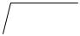

As v = 0, then vt = 0 therefore the algorithm is t = 2d / a .

3.10.2. Ruler Drop Test

Objective

To assess the subject's movement time.

Equipment

Metre ruler.

Direction

The ruler is held by the assistant between the outstretched palms of the subject's right and left hand, so that the top of the subject's thumb is level with the zero centimetre line on the ruler. The assistant instructs the subject to catch the ruler as soon as possible after it has been released. The assistant releases the ruler and the subject catches the ruler between their palms as quickly as possible. The assistant is to record distance between the bottom of the ruler and the top of the subject's palm where the ruler has been caught. The test is repeated 2 more times and the average value is used in the assessment. (Nelson, 1981).

80

Scoring

The algorithm to calculate the reaction speed is d = vt + ½at² where

d = distance in metres

v = initial velocity = 0

a = acceleration due to gravity = 9.81m/s²

t = time in seconds

As v = 0, then vt = 0 therefore the algorithm is t = 2d / a .

3.10.3. 9 meter front throw

Objective

To evaluate throwing ability of the subjects.

Equipments

Handballs, rope, a measuring tape.

Markings

 |  |  |  | 50 cm |  | 50 cm
 |  |  |  |  | 2 pt
 | 40 cm |  |  | 4 pt | 2 pt |  | 4 pt
 | 110 cm |  |  | 2 pt | 1 pt |  | 2 pt |  |  | Goal Post
 | 50 cm |  |  | 3 pt
 | 50 cm |  |  | 3 pt |  |  | 3 pt
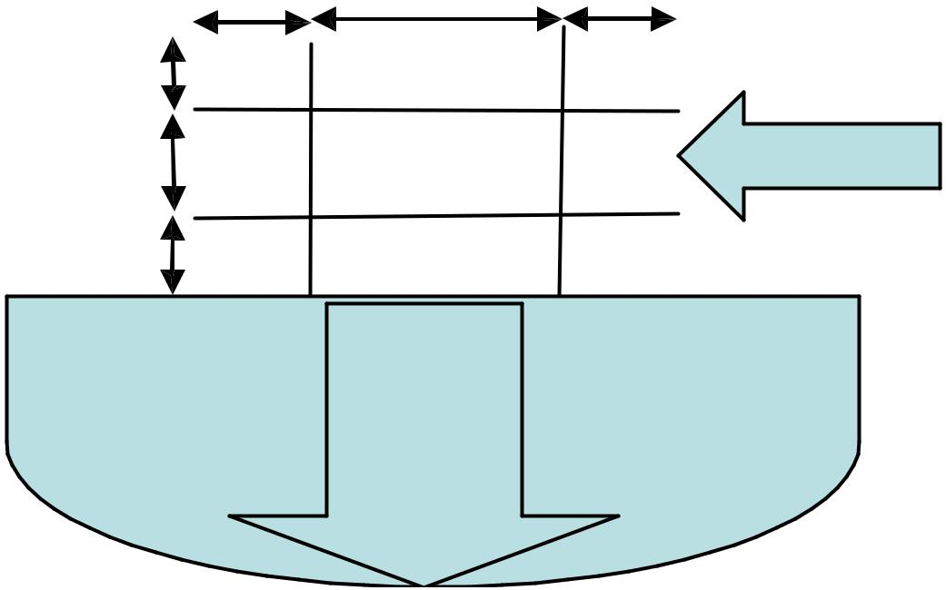

9 m Line / Free

Throw Line

81

Direction

The subject gets 10 throws, 5 when executing a jump throw and 5 when executing a set throw. The subject can take three steps before releasing a ball but the last step must be executed outside the free throw line (9 meter line). If a ball hits the court surface before it reaches the goal, no point is scored. (Zinn, 1981).

Scoring

The score for 10 trials is the sum of points awarded on each attempt.

3.10.4. Dominant Hand Speed Pass

Objective

To evaluate passing ability of the subjects.

Equipments

Handballs, rope, a measuring tape.

Direction

The subject stands behind the restraining line. Upon the signal ‘begin’, the subject uses the dominant hand to bounce a ball against the wall as rapidly as possible. He catches the return bounce and repeats until 10 bounces hit the wall. All bounces must come from behind the restraining line and the subject must catch all passes with both hands. A stop watch is started as soon as the ball first contacts the wall and is stopped when the ball hits the wall on the 10th bounce. Two trails are given. (Zinn, 1981).

Scoring

Time for the better of two timed trials is the final score. Time is recorded to the nearest 1/10th of a second.

82

3.10.5. Overhead Pass

Objective

To evaluate passing ability of the subjects.

Equipments

Handballs, rope, a measuring tape.

Markings
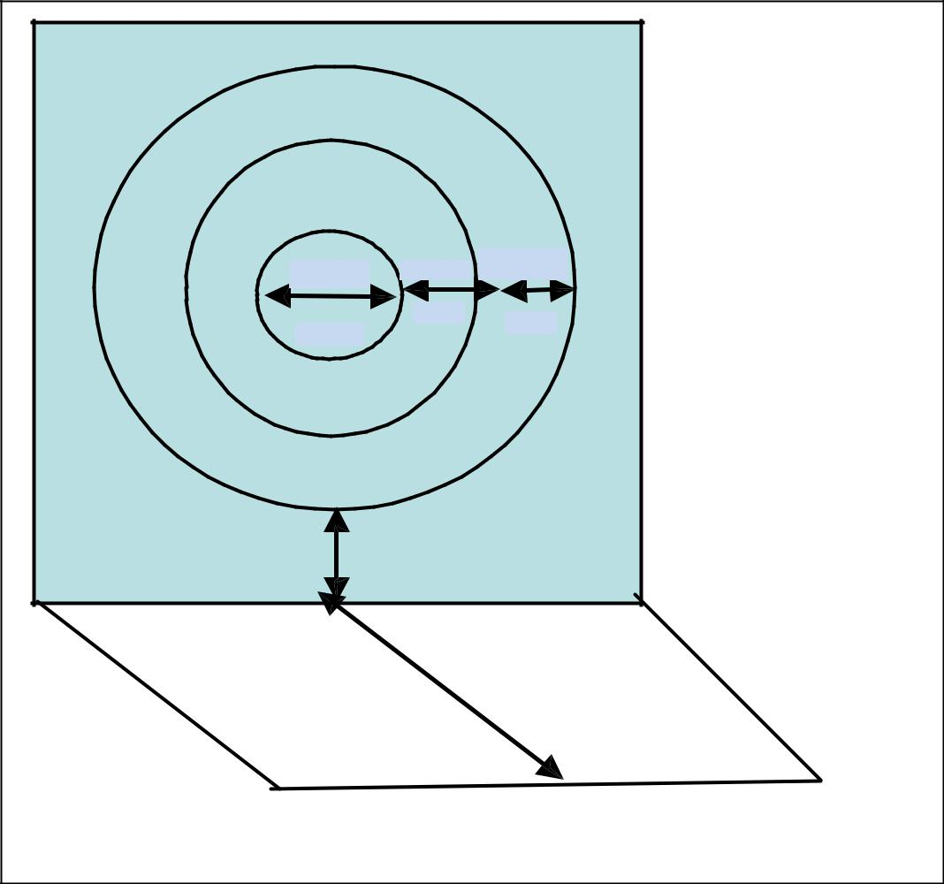

45 cm 95 cm ^{150 cm}

3 pt | 2 pt | 1 pt

Wall | 100 cm

Floor

15 m

Restraining Line

Direction

Subjects are positioned behind the restraining line. Using a one-armed throw, they throw a ball at the target. Ten passes are made and all must be executed from behind the restraining line. Points are awarded for the passes. (Zinn, 1981).

Scoring

The score is the total for 10 throws.

83

3.10.6. Accuracy Throw

Objective

To assess throwing accuracy of the subjects.

Equipments

Automobile tyre, Iorn rope and handball.

Target Marking

A automobile tyre hanging vertically from the regular handball goal

post.

Direction

Subjects are advised to use any one method of throw. The subjects stand behind the 7 meter throw line. When the vibrator is stimulated, they throw the handball towards the hanging automobile tyre. If the thrown ball passes through the hanging automobile tyre, 2 points are awarded to the subjects. If the ball touches the hanging automobile tyre, 1 point is awarded to the subjects. (Bergemann, 2004).

Scoring

The total of ten trials is the test score.

3.10.7. Jump and Throw

Objective

To assess the subject’s jump and throw ability.

Equipments

Volleyball net, Automobile tyre, Iorn rope and handball.

Target Marking

Regular volleyball net is placed on the 7 meter line from the regular handball goal post with the height of 2.44 meter. An automobile tyre hanging vertically from the regular handball post, the bottom of the tyre rested on the floor.

84

Direction

Subjects are advised to use jump shot method of throw. The subjects stand behind the 7 meter throw line and the volleyball net. When the vibrator is stimulated, they jump and shot the handball (over the net at a height of 2.43 meters) towards the hanging automobile tyre. 10 throws are given to the subjects. Two points are awarded for hitting the tyre or passing throw the center and 1 point is awarded for passing through the goal mouth. (Bergemann, 2004).

Scoring

The total of ten trials is the test score.

3.10.8. Dribbling

Objective

To assess the subject’s dribbling ability.

Equipments

Cone, stop watch and handball.

Target Marking
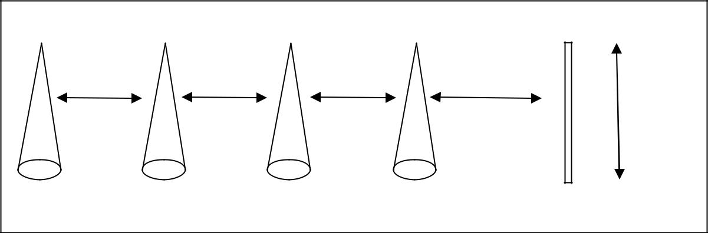

4 6 2 8 10

15’ |  | 15’ | 15’ | 20’ | 6 feet
5 | 3 | 7 |  | 1 | 9

Direction

The subject places the ball on the starting line and then stands back of it, with hands on knees. When the vibrator is stimulated, they pick up the ball and dribble in a zig-zag manner up and down.

85

Scoring

Timing is taken from when the vibrator is stimulated to when the subjects returns to the starting line. The score is the time in seconds (Knox, 1947).

3.9. COLLECTION OF DATA

The data on selected dependent variables for pre and post tests were collected three days before and after the training programme respectively. Reaction time, movement time and dribbling were tested on the first day. On the second day, 9 meter front throw, dominant hand speed pass and overhead pass were tested, and accuracy throw and jump and throw were tested on the third day.

3.12. STATISTICAL TECHNIQUE

The data was collected from the three groups before and after the experimental period. The collected data were statistically examined for significant different by dependent 't' test. No attempt was made to equate the groups in any manner. Hence, to make adjustments for difference in the initial means and test the adjusted posttest means for significant differences, the analysis of covariance (ANCOVA) was used. Whenever the 'F' ratio was found to be significant, Scheffe’s test was used as post-hoc test to determine which of the paired means differed significantly. In all cases, the criterion for statistical significance was set at 0.05 level of confidence (P<0.05).

3.12.1. Assumptions for ANCOVA

A preliminary analysis was conducted to determine whether the prerequisite assumptions of one-way univariate ANCOVA were met before preceding the univariate analysis. Thus, the assumption of equality of variance (homogeneity), was examined and presented below.

86

Levene’s Test of equality of error variances on selected variables were

calculated and presented in table VII.

TABLE VII

LEVENE’S TEST OF EQUALITY OF ERROR VARIANCES ON SELECTED

VARIABLES OF VTG, VSTG TRAINING GROUPS AND CONTROL GROUP

Variables | F Ratio | df1 | df2
Reaction Time | 2.550 | 2 | 42
Movement Time | 0.827 | 2 | 42
9 Meter Front Throw | 2.112 | 2 | 42
Dominant Hand Speed Pass | 1.825 | 2 | 42
Overhead Pass | 1.395 | 2 | 42
Accuracy Throw | 1.092 | 2 | 42
Jump and Throw | 0.718 | 2 | 42
Dribbling | 0.511 | 2 | 42

* significant at 0.05 level

(The table value required for 0.05 level of significance with df 2, 42 is 3.22)

The results from the Levene’s Test for homogeneity of variance of comparing the three groups regardless of the ability level for each of the dependent variables indicates that homogeneity of variance has been met for all the eight dependent variables. The ‘F’ ratio values for all dependent variables are less than the table value of 3.22 against with df 2 and 42 at 0.05 level of confidence. Hence, it is concluded that the assumption of homogeneity of variance has been met.

87

CHAPTER IV

RESULTS AND DISCUSSION

4.1. OVERVIEW

The analysis of the data collected is presented in this chapter. The purpose of the investigation was to find out the effect of specified training with sign language and vibrator aid on selected psycho motor variables and skills in handball among deaf and dumb college students. To achieve this purpose, 45 deaf and dumb male students those who were selected from Presidency College, Chennai, Tamil Nadu, India. The age of the subjects ranged between 18 and 25 years.

The study was formulated as a true random group design, consisting of pretest and post test. The selected subjects were divided into two experimental groups namely vibrator aid training group and combination of vibrator aid and sign language training group and control group on the basis of their level of challenge with fifteen subjects (n=15) in each. The effect of the two independent variables namely VTG and VSTG on reaction time and movement time as psycho motor variables and 9 M front throw, dominant hand speed pass, over head pass, accuracy throw, jump & throw and dribbling as skills in handball were investigated. The duration of the training period was twelve weeks and the number of sessions per week was confined to five. However, control group was not exposed to any specific training but they participated in the regular scheduled work.

All the subjects were tested on selected dependent variables prior to and after the treatment. The data pertaining to the variables in this study were examined by using dependent t-test to find out significant changes and analysis of covariance (ANCOVA) for each variable separately in order to determine the differences if any

88

among the adjusted post test means. Whenever ‘F’ ratio for the adjusted post-test

was found to be significant, the Scheffe’s test was used as post-hoc test to determine

the three paired mean differences. The level of significance was fixed at 0.05 level

of confidence in all the cases.

4.2. TEST OF SIGNIFICANCE

Clarke and Clarke (1972) said “These data must be analyzed in an appropriate manner to the research design. Such analysis can only be appropriate to the research design. Such analysis can only be accomplished through the application of pertinent statistics”.

This is the vital portion of the thesis for achieving the conclusion by examining the hypothesis. The procedure of testing the hypothesis was either by accepting the hypothesis or rejecting the same in accordance with the results obtained in relation to the level of confidence.

The test was usually called the test of significance since one can test whether the difference between the three groups or within many groups the scores were significant or not. In this study, however, the obtained F value was greater than the table value, the hypothesis was accepted to the effect that there existed significant difference among the means of the groups compared and if obtained F-value was lesser than the table value, then the hypothesis was rejected to the effect that there existed no significant difference among the means of the groups under study.

89

4.2.1. LEVEL OF SIGNIFICANCE

The purpose of this study was to find out the effect of specified training with sign language and vibrator aid on selected psycho motor variables and skills in handball among the deaf and dumb college students. The collected data were analyzed by using the analysis of covariance (ANCOVA) to find out the significant differences if any between the groups on selected criterion variables separately. In all the cases, 0.05 level of confidence was fixed to test of significance which was considered as appropriate for this study.

4.3. COMPUTATION OF DEPENDENT ‘t’ TEST, ANALYSIS OF COVARIANCE AND SCHEFFE’S POST HOC TEST ON REACTION TIME

The analysis of dependent ‘t’ test on the data obtained for reaction time of the pre-test and post-test means of VTG, VSTG and CG were analysed and presented in Table VIII.

TABLE VIII

SUMMARY OF MEAN STANDARD DEVIATION AND DEPENDENT ‘t’ TEST FOR THE PRE AND POST TESTS ON REACTION TIME OF EXPERIMENTAL AND CONTROL GROUPS

(Reaction time scores are expressed in seconds)

 |  | VTG | VSTG | CG
Pre test | Mean | 0.213 | 0.213 | 0.212
Pre test | SD | 0.010 | 0.012 | 0.009
Post test | Mean | 0.196 | 0.182 | 0.210
Post test | SD | 0.015 | 0.016 | 0.013
‘t’ test |  | 6.961* | 7.368* | 0.764

*Significant at .05 level. The table value required for .05 level of significance with df 14 is 1.761.

90

4.3.1. Results of Dependent ‘t’ Test on Reaction Time

Table VIII shows that the pre-test mean values of VTG, VSTG and CG on reaction time are 0.213, 0.213 and 0.212 respectively and the post-test mean values on reaction time are 0.196, 0.182 and 0.210 respectively. The obtained dependent t-ratio values between the pre and post test means of VTG, VSTG and CG on reaction time are 6.961, 7.368 and 0.764 respectively. The table value required for significant difference with df 14 at .05 level is 1.761. Since, the obtained ‘t’ ratio values of experimental groups are greater than the table value, it is understood that specified training with vibrator aid and specified training with combination of vibrator aid & sign language groups had significantly improved in the performance of reaction time. However, the control group had not significantly improved in the performance of reaction time. The obtained ‘t’ value for the control group is less than the table value as they were not subjected to any specific training.

The analysis of covariance on reaction time of VTG, VSTG and CG were analysed and presented in Table IX.

TABLE IX

ANALYSIS OF COVARIANCE FOR THE DATA ON REACTION TIME

AMONG EXPERIMENTAL AND CONTROL GROUPS

Adjusted Post Test Means |  |  |  | Sources of | Sum of | df | Mean | F-Ratio
VTG | VSTG |  | CG | Variance | Squares | df | Squares | F-Ratio
0.196 | 0.182 |  | 0.210 | Between | 0.00607 | 2 | 0.00303 | 18.938*
0.196 | 0.182 |  | 0.210 | Within | 0.00651 | 41 | 0.00016

* Significant at 0.05 level of confidence.

The table value for significance at 0.05 with df 2 and 41 is 3.23.

4.3.2. Results of Analysis of Covariance on Reaction Time

Table IX shows that the adjusted post-test means of VTG, VSTG and

CG on reaction time are 0.196, 0.182 and 0.210 respectively. The obtained F-ratio

91

value is 18.938, which is higher than the table value 3.23 with df 2 and 41 required

for significance at .05 level. Since the value of F-ratio is higher than the table value,

it indicates that there exist significant differences among the adjusted post-test

means of VTG, VSTG and CG. To find out which of the paired means had a

significant difference on reaction time, the Scheffe’s post-hoc test was applied and

the results are presented in Table X.

TABLE X

SCHEFFE’S TEST FOR THE DIFFERENCES BETWEEN THE ADJUSTED

POST TEST PAIRED MEANS OF REACTION TIME

VTG | VSTG | CG | Mean | Confidential
VTG | VSTG | CG | Difference | Interval
0.196 | 0.182 |  | 0.014* | 0.012
0.196 |  | 0.210 | 0.015* | 0.012
 | 0.182 | 0.210 | 0.028* | 0.012

*Significant at .05 level.

4.3.3. Results of Scheffe’s Test on Reaction Time

The table X shows that the adjusted post test mean difference on reaction time between VTG and VSTG, VTG and CG and between VSTG and CG are 0.014, 0.015 and 0.028 respectively which are higher than the confidence interval value of 0.002 at .05 level of confidence.

The pre and post test mean values of VTG, VSTG and CG on reaction time are graphically represented in figure 1.

The adjusted post test mean values of VTG, VSTG and CG on reaction time are graphically represented in figure 2.

92

FIGURE 1

PRE TEST AND POST TEST MEAN VALUES OF VTG, VSTG

AND CG ON REACTION TIME

Mean Values (in seconds)

0.22

0.21

0.21

0.20

0.20

0.19

0.19

0.18

0.18

0.17

0.17

2130. | 2130. | 2120. | 2100.
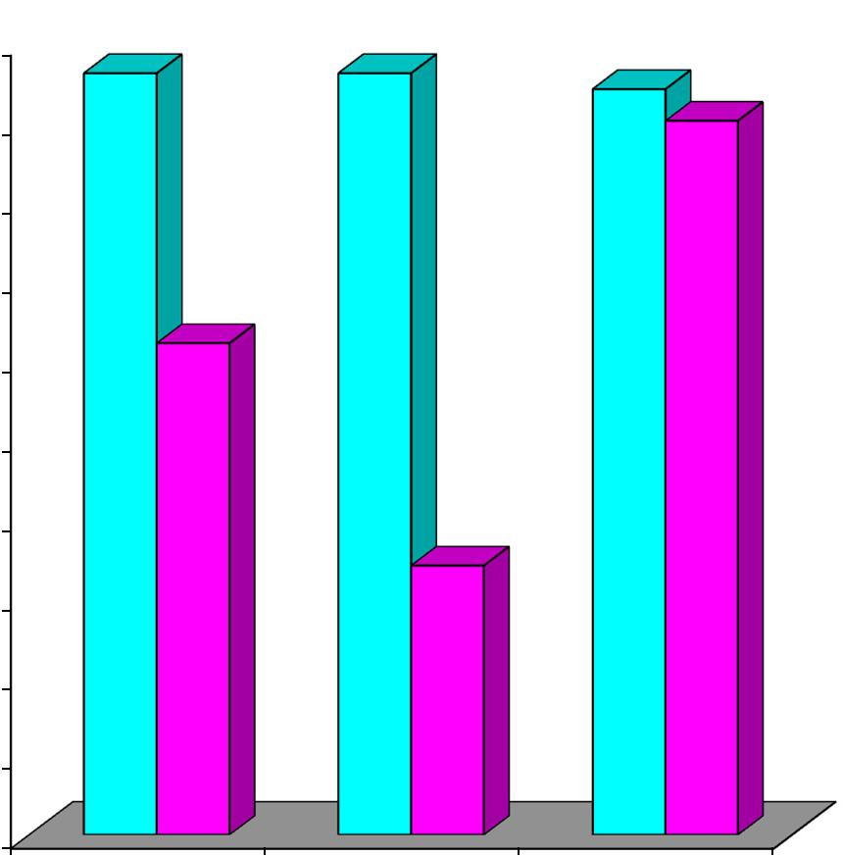

1960.

1820.

VTG VSTG CG

Pre Test Post Test

93

FIGURE 2

ADJUSTED POST TEST MEAN VALUES OF VTG, VSTG AND

CG ON REACTION TIME

Mean Values (in seconds)

0.21

0.21

0.20

0.20

0.19

0.19

0.18

0.18

0.17

0.17

2100.
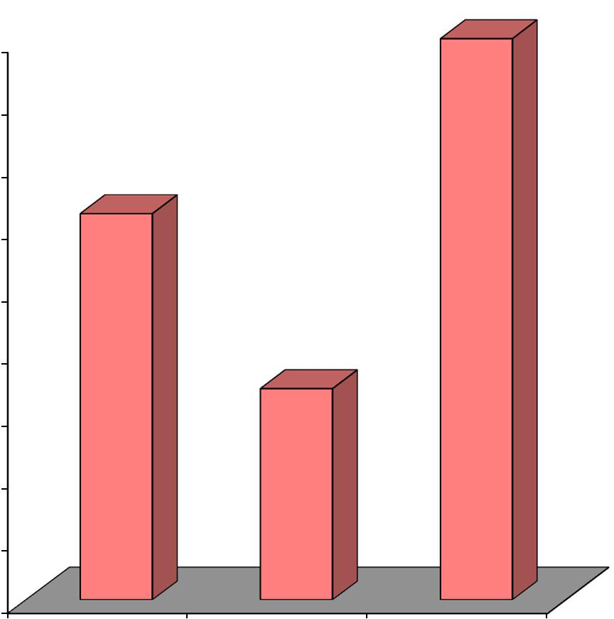

0.196

1820.

VTG VSTG CG

Adjusted Post Test Mean

94

4.3.4. Discussion on Findings on Reaction Time

The result of the study indicates that both the experimental groups significantly differed when compared to the control group on reaction time. However, it is further revealed that the experimental group namely VTG and VSTG had reduced reaction time better than the control group (CG) but VSTG had reduced reaction time better than the other two groups.

Sreejit (1988) concluded that basketball and volleyball players had a marked difference in their hand reaction times. Sharma, Khan and Butchiramaiah (1986) found out that the competitive volleyball players respond more quickly to the visual and auditory stimuli when compared to the recreational volleyball players. The present study also revealed that 12 weeks of specified training with vibrator aid and specified training with combination of vibrator aid and sign language reduced the reaction time. The present findings also very well sustained by the researchers Shahbazia (2011), Reddy (1993) and Wei and Ji (2014).

95

4.4. COMPUTATION OF DEPENDENT ‘t’ TEST, ANALYSIS OF COVARIANCE AND SCHEFFE’S POST HOC TEST ON MOVEMENT TIME

The analysis of dependent ‘t’ test on the data obtained for movement time of the pre-test and post-test means of VTG, VSTG and CG were analysed and presented in Table XI.

TABLE XI

SUMMARY OF MEAN STANDARD DEVIATION AND DEPENDENT ‘t’ TEST FOR THE PRE AND POST TESTS ON MOVEMENT TIME OF EXPERIMENTAL AND CONTROL GROUPS

(Movement time scores are expressed in seconds)

 |  | VTG | VSTG | CG
Pre test | Mean | 0.285 | 0.290 | 0.286
Pre test | SD | 0.008 | 0.007 | 0.009
Post test | Mean | 0.271 | 0.262 | 0.281
Post test | SD | 0.010 | 0.009 | 0.009
‘t’ test |  | 9.065* | 11.045* | 1.365

*Significant at .05 level. The table value required for .05 level of significance with df 14 is 1.761.

4.4.1. Results of Dependent ‘t’ Test on Movement Time

Table XI shows that the pre-test mean values of VTG, VSTG and CG on movement time are 0.285, 0.290 and 0.286 respectively and the post-test mean values on movement time are 0.271, 0.262 and 0.281 respectively. The obtained dependent t-ratio values between the pre and post test means of VTG, VSTG and CG on movement time are 9.065, 11.045 and 1.365 respectively. The table value required for significant difference with df 14 at .05 level is 1.761. Since, the obtained ‘t’ ratio values of experimental groups are greater than the table value, it is understood that specified training with vibrator aid and specified training with combination of vibrator aid & sign language groups had significantly improved in

96

the performance of movement time. However, the control group had not

significantly improved in the performance of movement time. The obtained ‘t’

value for the control group is less than the table value as they were not subjected to

any specific training.

The analysis of covariance on movement time of VTG, VSTG and CG were analysed and presented in Table XII.

TABLE XII

ANALYSIS OF COVARIANCE FOR THE DATA ON MOVEMENT TIME

AMONG EXPERIMENTAL AND CONTROL GROUPS

Adjusted Post Test Means |  |  |  | Sources of | Sum of | df | Mean | F-Ratio
VTG | VSTG |  | CG | Variance | Squares | df | Squares | F-Ratio
0.273 | 0.260 |  | 0.282 | Between | 0.00347 | 2 | 0.00174 | 29.000*
0.273 | 0.260 |  | 0.282 | Within | 0.00242 | 41 | 0.00006

* Significant at 0.05 level of confidence.

The table value for significance at 0.05 with df 2 and 41 is 3.23.

4.4.2. Results of Analysis of Covariance on Movement Time

Table XII shows that the adjusted post-test means of VTG, VSTG and CG on movement time are 0.273, 0.260 and 0.282 respectively. The obtained F-ratio value is 29.000, which is higher than the table value 3.23 with df 2 and 41 required for significance at .05 level. Since the value of F-ratio is higher than the table value, it indicates that there exist significant differences among the adjusted post-test means of VTG, VSTG and CG. To find out which of the paired means had a significant difference on movement time, the Scheffe’s post-hoc test was applied and the results are presented in Table XIII.

97

TABLE XIII

SCHEFFE’S TEST FOR THE DIFFERENCES BETWEEN THE ADJUSTED

POST TEST PAIRED MEANS OF MOVEMENT TIME

VTG | VSTG | CG | Mean | Confidential
VTG | VSTG | CG | Difference | Interval
0.273 | 0.260 |  | 0.013* | 0.007
0.273 |  | 0.282 | 0.009* | 0.007
 | 0.260 | 0.282 | 0.022* | 0.007

*Significant at .05 level.

4.4.3. Results of Scheffe’s Test on Movement Time

Table XIII shows that the adjusted post test mean difference on movement time between VTG and VSTG, VTG and CG and between VSTG and CG are 0.013, 0.009 and 0.022 respectively which are higher than the confidence interval value of 0.007 at .05 level of confidence.

The pre and post test mean values of VTG, VSTG and CG on movement time are graphically represented in figure 3.

The adjusted post test mean values of VTG, VSTG and CG on movement time are graphically represented in figure 4.

98

FIGURE 3

PRE TEST AND POST TEST MEAN VALUES OF VTG, VSTG

AND CG ON MOVEMENT TIME

Mean Values (in seconds)

0.29

0.29

0.28

0.28

0.27

0.27

0.26

0.26

0.25

0.25

 | 2900.
2850. | 2860.
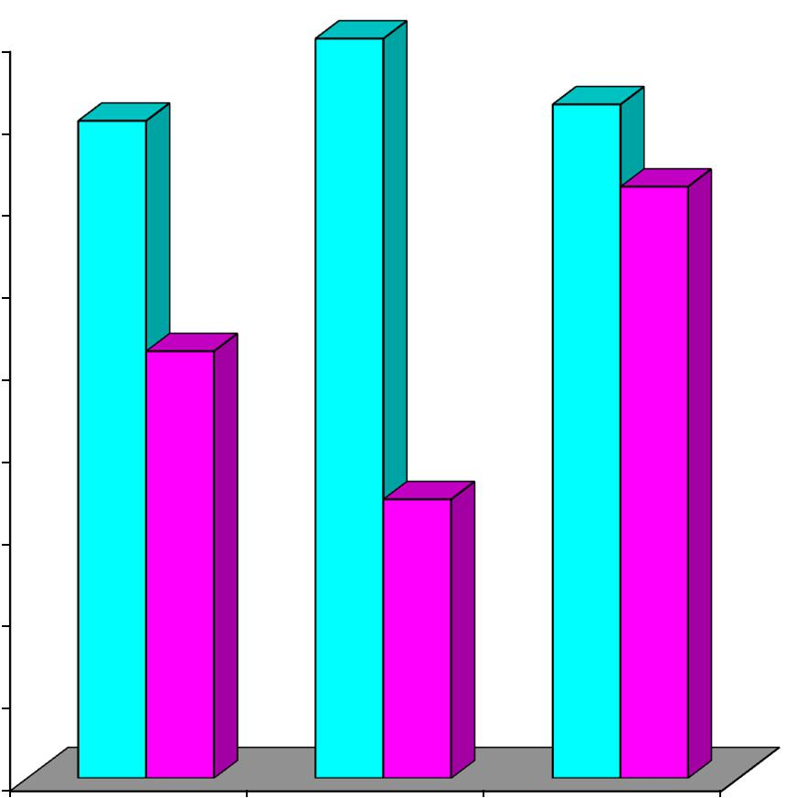

2810.

2710.

2620.

VTG VSTG CG

Pre Test Post Test

99

FIGURE 4

ADJUSTED POST TEST MEAN VALUES OF VTG, VSTG AND

CG ON MOVEMENT TIME

Mean Values (in seconds)

0.29

0.28

0.28

0.27

0.27

0.26

0.26

0.25

0.25

2820.
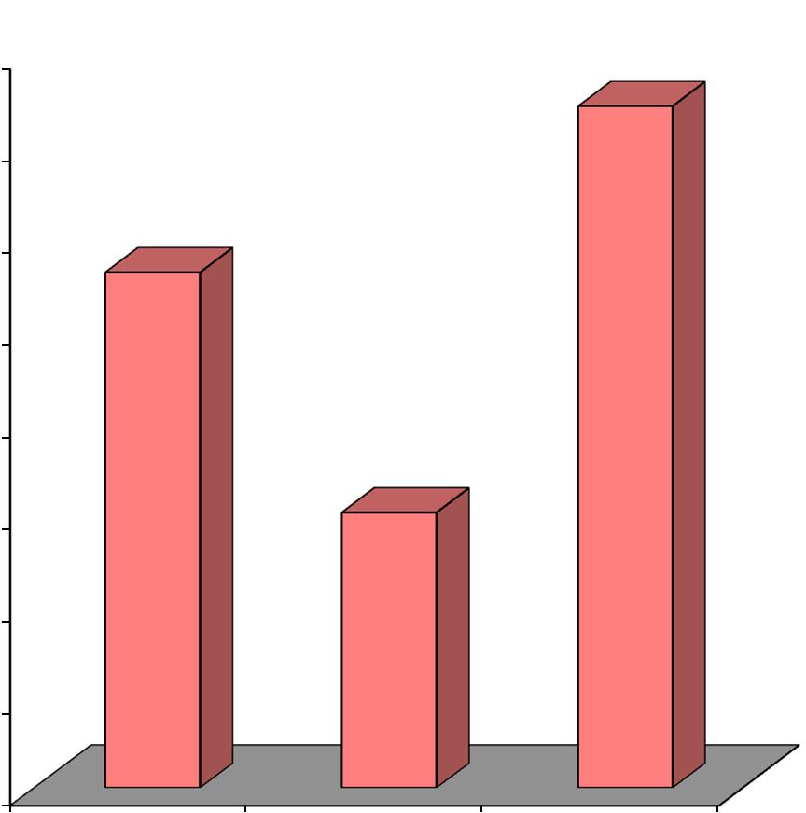

0.273

2600.

VTG VSTG CG

Adjusted Post Test Mean

100

4.4.4. Discussion on Findings on Movement Time

The result of the study indicates that both the experimental groups were significantly differed when compared to control group on movement time. However, it is further revealed that the experimental group namely VTG and VSTG had improved in the performance of movement time better than the control group (CG) but VSTG had improved in the performance of movement time better than the other two groups.

Wei and Ji (2014) concluded that due to training effect the cognitive abilities improved movement time had a close relation with the cognitive abilities. Sharma, Khan and Butchiramaiah (1986) also stated that national level Volleyball players are superior to the state level players in visual and auditory reaction time and concentration. The present study also revealed that 12 weeks of specified training with vibrator aid and specified training with combination of vibrator aid and sign language improved the movement time.

101

4.5. COMPUTATION OF DEPENDENT ‘t’ TEST, ANALYSIS OF COVARIANCE AND SCHEFFE’S POST HOC TEST ON 9M FRONT THROW

The analysis of dependent ‘t’ test on the data obtained for 9M front throw of the pre-test and post-test means of VTG, VSTG and CG were analysed and presented in Table XIV.

TABLE XIV

SUMMARY OF MEAN STANDARD DEVIATION AND DEPENDENT ‘t’ TEST FOR THE PRE AND POST TESTS ON 9M FRONT THROW OF EXPERIMENTAL AND CONTROL GROUPS

(9M Front Throw scores are expressed in points)

 |  | VTG | VSTG | CG
Pre test | Mean | 10.867 | 11.267 | 11.400
Pre test | SD | 1.642 | 1.486 | 0.737
Post test | Mean | 15.000 | 17.200 | 11.933
Post test | SD | 2.236 | 2.484 | 1.033
‘t’ test |  | 7.923* | 12.191* | 1.069

*Significant at .05 level. The table value required for .05 level of significance with df 14 is 1.761.

4.5.1. Results of Dependent ‘t’ Test on 9M Front Throw

Table XIV shows that the pre-test mean values of VTG, VSTG and CG on 9M front throw are 10.867, 11.267 and 11.400 respectively and the post-test mean values on 9M front throw are 15.000, 17.200 and 11.933 respectively. The obtained dependent t-ratio values between the pre and post test means of VTG, VSTG and CG on 9M front throw are 7.923, 12.191 and 1.069 respectively. The table value required for significant difference with df 14 at .05 level is 1.761. Since, the obtained ‘t’ ratio values of experimental groups are greater than the table value, it is understood that specified training with vibrator aid and specified training with combination of vibrator aid & sign language groups had significantly improved in

102

the performance of 9M front throw. However, the control group had not

significantly improved in the performance of 9m front throw. The obtained ‘t’

value for the control group is less than the table value as they were not subjected to

any specific training.

The analysis of covariance on 9M front throw of VTG, VSTG and CG were analysed and presented in Table XV.

TABLE XV

ANALYSIS OF COVARIANCE FOR THE DATA ON 9M FRONT THROW

AMONG EXPERIMENTAL AND CONTROL GROUPS

Adjusted Post Test Means |  |  |  | Sources of | Sum of | df | Mean | F-Ratio
VTG | VSTG |  | CG | Variance | Squares | df | Squares | F-Ratio
15.264 | 17.125 |  | 11.745 | Between | 222.829 | 2 | 111.414 | 39.171*
15.264 | 17.125 |  | 11.745 | Within | 116.615 | 41 | 2.844

* Significant at 0.05 level of confidence.

The table value for significance at 0.05 with df 2 and 41 is 3.23.

4.5.2. Results of Analysis of Covariance on 9M Front Throw

Table XV shows that the adjusted post-test means of VTG, VSTG and CG on 9M front throw are 15.264, 17.125 and 11.745 respectively. The obtained F-ratio value is 39.171, which is higher than the table value 3.23 with df 2 and 41 required for significance at .05 level. Since the value of F-ratio is higher than the table value, it indicates that there exist significant differences among the adjusted post-test means of VTG, VSTG and CG. To find out which of the paired means had a significant difference on 9M front throw, the Scheffe’s post-hoc test was applied and the results are presented in Table XVI.

103

TABLE XVI

SCHEFFE’S TEST FOR THE DIFFERENCES BETWEEN THE ADJUSTED

POST TEST PAIRED MEANS OF 9M FRONT THROW

VTG | VSTG | CG | Mean | Confidential
VTG | VSTG | CG | Difference | Interval
15.264 | 17.125 |  | 1.861* | 1.564
15.264 |  | 11.745 | 3.518* | 1.564
 | 17.125 | 11.745 | 5.380* | 1.564

*Significant at .05 level.

4.5.3. Results of Scheffe’s Test on 9M Front Throw

Table XVI shows that the adjusted post test mean difference on 9M front throw between VTG and VSTG, VTG and CG and between VSTG and CG are 1.861, 3.518 and 5.380 respectively which are higher than the confidence interval value of 1.564 at .05 level of confidence.

The pre and post test mean values of VTG, VSTG and CG on 9M front throw are graphically represented in figure 5.

The adjusted post test mean values of VTG, VSTG and CG on 9M front throw are graphically represented in figure 6.

104

FIGURE 5

PRE TEST AND POST TEST MEAN VALUES OF VTG, VSTG

AND CG ON 9M FRONT THROW

Mean Values (in points)

18

16

14

12

10

8

6

4

2

0

17.200

15.000
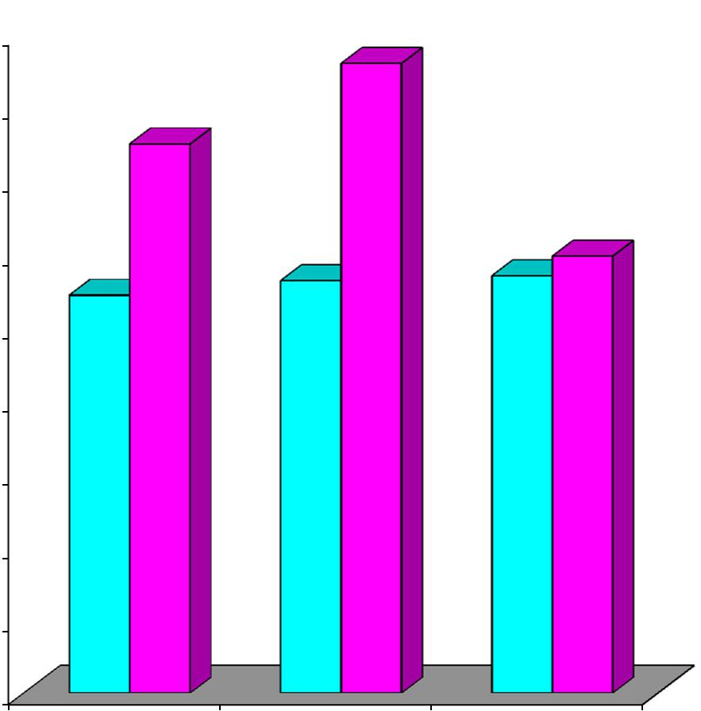

86710. | 26711. | 40011. | 93311.

VTG VSTG CG

Pre Test Post Test

105

FIGURE 6

ADJUSTED POST TEST MEAN VALUES OF VTG, VSTG AND

CG ON 9M FRONT THROW

Mean Values (in points)

18

16

14

12

10

8

6

4

2

0

12517.

15.264
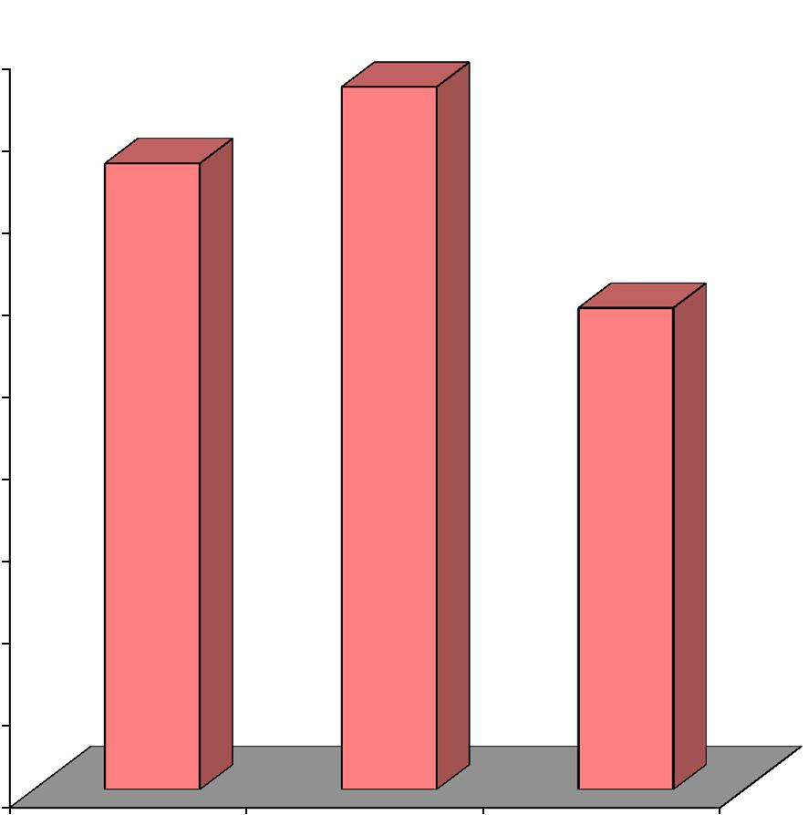

11.745

VTG VSTG CG

Adjusted Post Test Mean

106

4.5.4. Discussion on Findings on 9M Front Throw

The result of the study indicates that both the experimental groups were significantly differed when compared to control group on 9M front throwing ability. However, it is further revealed that the experimental group namely VTG and VSTG had improved the 9M front throwing ability better than the control group (CG) but VSTG had improved the 9M front throwing ability better than the VTG and CG.

Wagner and Muller (2008) suggested that team-handball players who were taller and of greater body weight have the ability to achieve a higher ball release speed in the jump throw and Wagner, et al., (2012) concluded that team-handball players had the ability to compensate an increase in movement variability in the acceleration phase to throw accurately, and skilled players were able to control the movement, although movement variability decreased in the standing throw with run-up. Rivilla-García (2010) suggested that handball players’ throwing ability was a decisive factor in competitive and professional level. The present study also revealed that 12 weeks of specified training with vibrator aid and specified training with combination of vibrator aid and sign language improved the 9M front throwing ability. The result of the present investigation is also incorporated with the findings of Cetin and Ozdol (2012), Eliasz, (Apr, 2015), Marques, et al., (2007), Skoufas, et al., (2002), Rogulj, et al., (2007), Ziva and Lidora (2009) and Pori, Bon, and Sibila, (2005).

107

4.6. COMPUTATION OF DEPENDENT ‘t’ TEST, ANALYSIS OF COVARIANCE AND SCHEFFE’S POST HOC TEST ON DOMINANT HAND SPEED PASS

The analysis of dependent ‘t’ test on the data obtained for dominant hand speed pass of the pre-test and post-test means of VTG, VSTG and CG were analysed and presented in Table XVII.

TABLE XVII

SUMMARY OF MEAN STANDARD DEVIATION AND DEPENDENT ‘t’

TEST FOR THE PRE AND POST TESTS ON DOMINANT HAND SPEED PASS OF EXPERIMENTAL AND CONTROL GROUPS

(Dominant hand speed pass scores are expressed in seconds)

 |  | VTG | VSTG | CG
Pre test | Mean | 46.733 | 46.400 | 45.933
Pre test | SD | 1.668 | 2.261 | 2.314
Post test | Mean | 44.667 | 42.467 | 45.067
Post test | SD | 2.193 | 2.031 | 2.404
‘t’ test |  | 11.973* | 21.438* | 1.179

*Significant at .05 level. The table value required for .05 level of significance with df 14 is 1.761.

4.6.1. Results of Dependent ‘t’ Test on Dominant Hand Speed Pass

Table XVII shows that the pre-test mean values of VTG, VSTG and CG on dominant hand speed pass are 46.733, 46.400 and 45.933 respectively and the post-test mean values on dominant hand speed pass are 44.667, 42.467 and 45.067 respectively. The obtained dependent t-ratio values between the pre and post test means of VTG, VSTG and CG on dominant hand speed pass are 11.973, 21.438 and 1.179 respectively. The table value required for significant difference with df 14 at .05 level is 1.761. Since, the obtained ‘t’ ratio values of experimental groups are greater than the table value, it is understood that specified training with vibrator aid and specified training with combination of vibrator aid & sign language groups had

108

significantly improved in the performance of dominant hand speed pass. However,

the control group had not significantly improved in the performance of dominant

hand speed pass. The obtained ‘t’ value for the control group is less than the table

value as they were not subjected to any specific training.

The analysis of covariance on dominant hand speed pass of VTG, VSTG and CG were analysed and presented in Table XVIII.

TABLE XVIII

ANALYSIS OF COVARIANCE FOR THE DATA ON DOMINANT HAND SPEED PASS AMONG EXPERIMENTAL AND CONTROL GROUPS
Adjusted Post Test Means |  |  |  | Sources of | Sum of | df | Mean | F-Ratio
VTG | VSTG |  | CG | Variance | Squares | df | Squares | F-Ratio
44.318 | 42.426 |  | 45.456 | Between | 69.912 | 2 | 34.956 | 29.574*
44.318 | 42.426 |  | 45.456 | Within | 48.461 | 41 | 1.182

* Significant at 0.05 level of confidence.

The table value for significance at 0.05 with df 2 and 41 is 3.23.

4.6.2. Results of Analysis of Covariance on Dominant Hand Speed Pass

Table XVIII shows that the adjusted post-test means of VTG, VSTG and CG on dominant hand speed pass are 44.318, 42.426 and 45.456 respectively. The obtained F-ratio value is 29.574, which is higher than the table value 3.23 with df 2 and 41 required for significance at .05 level. Since the value of F-ratio is higher than the table value, it indicates that there exist significant differences among the adjusted post-test means of VTG, VSTG and CG. To find out which of the paired means had a significant difference on dominant hand speed pass, the Scheffe’s post-hoc test was applied and the results are presented in Table XIX.

109

TABLE XIX

SCHEFFE’S TEST FOR THE DIFFERENCES BETWEEN THE ADJUSTED

POST TEST PAIRED MEANS OF DOMINANT HAND SPEED PASS

VTG | VSTG | CG | Mean | Confidential
VTG | VSTG | CG | Difference | Interval
44.318 | 42.426 |  | 1.893* | 1.008
44.318 |  | 45.456 | 1.137* | 1.008
 | 42.426 | 45.456 | 3.030* | 1.008

*Significant at .05 level.

4.6.3. Results of Scheffe’s Test on Dominant Hand Pass

The table XIX shows that the adjusted post test mean difference on dominant hand speed pass between VTG and VSTG, VTG and CG and between VSTG and CG are 1.893, 1.137 and 3.030 respectively which are higher than the confidence interval value of 1.008 at .05 level of confidence.

The pre and post test mean values of VTG, VSTG and CG on dominant hand speed pass are graphically represented in figure 7.

The adjusted post test mean values of VTG, VSTG and CG on dominant hand speed pass are graphically represented in figure 8.

110

FIGURE 7

PRE TEST AND POST TEST MEAN VALUES OF VTG, VSTG

AND CG ON DOMINANT HAND SPEED PASS

Mean Values (in seconds)

47.00

46.00

45.00

44.00

43.00

42.00

73346. | 40046. | 93345.
 | 66744. | 06745.
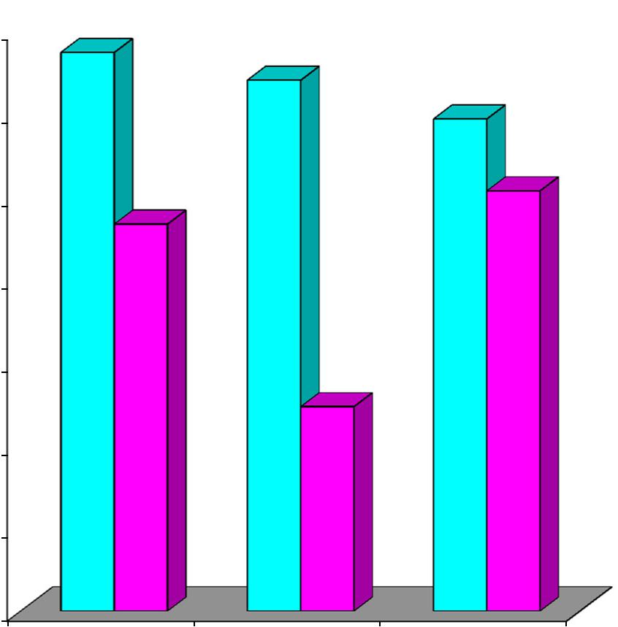

46742.

41.00

40.00
VTG VSTG CG

Pre Test Post Test

111

FIGURE 8

ADJUSTED POST TEST MEAN VALUES OF VTG, VSTG AND

CG ON DOMINANT HAND SPEED PASS

Mean Values (in seconds)

45.50 | 31844.

45.00

44.50

44.00

43.50

43.00

42.50

42.00

41.50

41.00

40.50

VTG

45645.
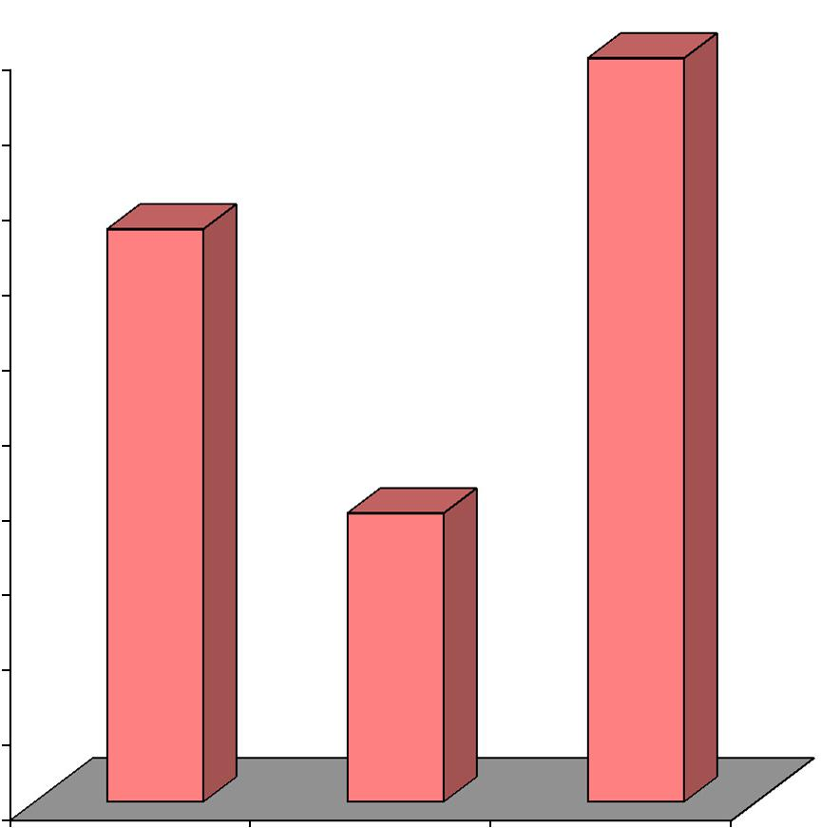

42642.

VSTG CG

Adjusted Post Test Mean

112

4.6.4. Discussion on Findings on Dominant Hand Speed Pass

The result of the study indicates that both the experimental groups significantly differed when compared to the control group on dominant hand speed pass. However, it is further revealed that the experimental group namely VTG and VSTG had improved in the performance of dominant hand speed pass better than the control group (CG) but VSTG had improved in the performance of dominant hand speed pass better than the other two groups.

The present study also revealed that 12 weeks of specified training with vibrator aid and specified training with combination of vibrator aid and sign language improved dominant hand speed pass.

113

4.7. COMPUTATION OF DEPENDENT ‘t’ TEST, ANALYSIS OF COVARIANCE AND SCHEFFE’S POST HOC TEST ON OVERHEAD PASS

The analysis of dependent ‘t’ test on the data obtained for overhead pass of the pre-test and post-test means of VTG, VSTG and CG were analysed and presented in Table XX.

TABLE XX

SUMMARY OF MEAN STANDARD DEVIATION AND DEPENDENT ‘t’ TEST FOR THE PRE AND POST TESTS ON OVERHEAD PASS OF EXPERIMENTAL AND CONTROL GROUPS

(Overhead pass scores are expressed in points)

 |  | VTG | VSTG | CG
Pre test | Mean | 6.400 | 7.000 | 6.667
Pre test | SD | 1.056 | 1.558 | 1.291
Post test | Mean | 8.200 | 10.133 | 7.133
Post test | SD | 1.146 | 1.187 | 1.685
‘t’ test |  | 7.585* | 11.225* | 0.201

*Significant at .05 level. The table value required for .05 level of significance with df 14 is 1.761.

4.7.1. Results of Dependent ‘t’ Test on Overhead Pass

Table XX shows that the pre-test mean values of VTG, VSTG and CG on overhead pass are 6.400, 7.000 and 6.667 respectively and the post-test mean values on overhead pass are 8.200, 10.133 and 7.133 respectively. The obtained dependent t-ratio values between the pre and post test means of VTG, VSTG and CG on overhead pass are 7.585, 11.225 and 0.201 respectively. The table value required for significant difference with df 14 at .05 level is 1.761. Since, the obtained ‘t’ ratio values of experimental groups are greater than the table value, it is understood that specified training with vibrator aid and specified training with combination of vibrator aid & sign language groups had significantly improved in

114

the performance of overhead pass. However, the control group had not significantly

improved in the performance of overhead pass. The obtained ‘t’ value for the

control group is less than the table value as they were not subjected to any specific

training.

The analysis of covariance on overhead pass of VTG, VSTG and CG were analysed and presented in Table XXI.

TABLE XXI

ANALYSIS OF COVARIANCE FOR THE DATA ON OVERHEAD PASS

AMONG EXPERIMENTAL AND CONTROL GROUPS

Adjusted Post Test Means |  |  |  | Sources of | Sum of | df | Mean | F-Ratio
VTG | VSTG |  | CG | Variance | Squares | df | Squares | F-Ratio
8.344 | 9.978 |  | 7.144 | Between | 59.827 | 2 | 29.914 | 20.574*
8.344 | 9.978 |  | 7.144 | Within | 59.633 | 41 | 1.454

* Significant at 0.05 level of confidence.

The table value for significance at 0.05 with df 2 and 41 is 3.23.

4.7.2. Results of Analysis of Covariance on Overhead Pass

Table XXI shows that the adjusted post-test means of VTG, VSTG and CG on overhead pass are 8.344, 9.978 and 7.144 respectively. The obtained F-ratio value is 20.574, which is higher than the table value 3.23 with df 2 and 41 required for significance at .05 level. Since the value of F-ratio is higher than the table value, it indicates that there exist significant differences among the adjusted post-test means of VTG, VSTG and CG. To find out which of the paired means had a significant difference on overhead pass, the Scheffe’s post-hoc test was applied and the results are presented in Table XXII.

115

TABLE XXII

SCHEFFE’S TEST FOR THE DIFFERENCES BETWEEN THE ADJUSTED

POST TEST PAIRED MEANS OF OVERHEAD PASS

VTG | VSTG | CG | Mean | Confidential
VTG | VSTG | CG | Difference | Interval
8.344 | 9.978 |  | 1.633* | 1.118
8.344 |  | 7.144 | 1.200* | 1.118
 | 9.978 | 7.144 | 2.833* | 1.118

*Significant at .05 level.

4.7.3. Results of Scheffe’s Test on Overhead Pass

The table XXII shows that the adjusted post test mean difference on overhead pass between VTG and VSTG, VTG and CG and between VSTG and CG are 1.633, 1.200 and 2.833 respectively which are higher than the confidence interval value of 1.118 at .05 level of confidence.

The pre and post test mean values of VTG, VSTG and CG on overhead pass are graphically represented in figure 9.

The adjusted post test mean values of VTG, VSTG and CG on overhead pass are graphically represented in figure 10.

116

FIGURE 9

PRE TEST AND POST TEST MEAN VALUES OF VTG, VSTG

AND CG ON OVERHEAD PASS
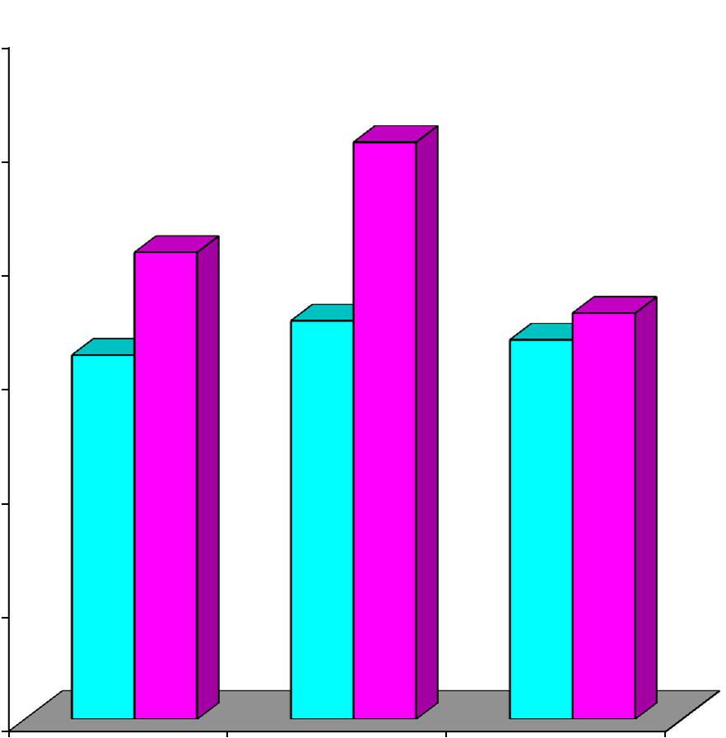

Mean Values (in points)

12

10

8

6

4

 |  | 13310.
 | 2008.
4006. | 0007. | 6676. | 1337.

2

0
VTG VSTG CG

Pre Test Post Test

117

FIGURE 10

ADJUSTED POST TEST MEAN VALUES OF VTG, VSTG AND

CG ON OVERHEAD PASS

Mean Values (in points)

10

9

8

7

6

5

4

3

2

1

0

9789.
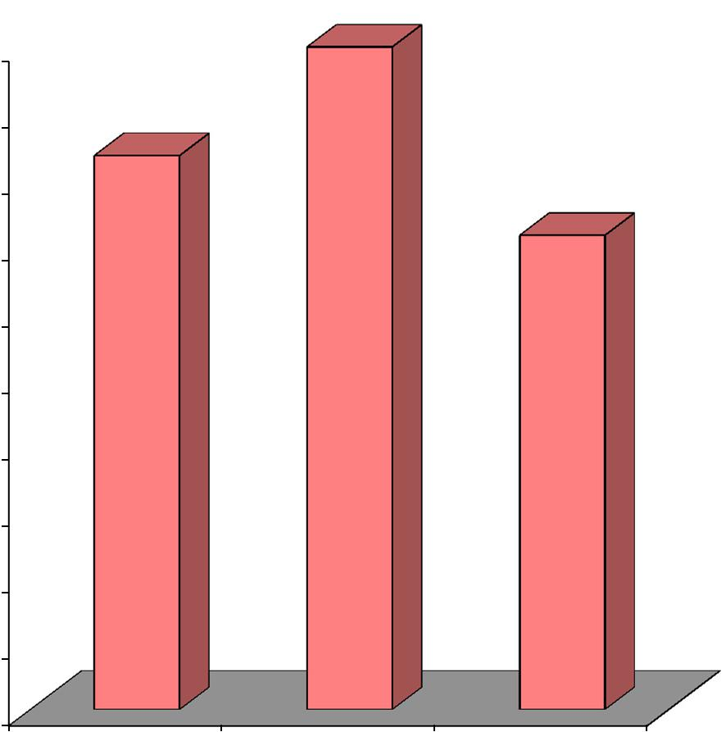

8.344

7.144

VTG VSTG CG

Adjusted Post Test Mean

118

4.7.4. Discussion on Findings on Overhead Pass

The result of the study indicates that both the experimental groups were significantly differed when compared to the control group on overhead passing ability. However, it is further revealed that the experimental group namely VTG and VSTG had improved in the performance of overhead passing ability better than the control group (CG) and sign and vibrator training group (SVTG) had improved in the performance of overhead passing ability better than the other two groups.

Reddy (1993) in his study concluded that the accuracy improved due to regular involvement in physical activity and on the whole results showed that the students improved significantly in coordinative abilities after their active involvement in physical activity which comprised of gymnastics, athletics and yoga. The present study also revealed that 12 weeks of specified training with vibrator aid and specified training with combination of vibrator aid and sign language improved the overhead passing ability of the deaf and dumb students.

119

4.8. COMPUTATION OF DEPENDENT ‘t’ TEST, ANALYSIS OF COVARIANCE AND SCHEFFE’S POST HOC TEST ON ACCURACY THROW

The analysis of dependent ‘t’ test on the data obtained for accuracy throw of the pre-test and post-test means of VTG, VSTG and CG were analysed and presented in Table XXIII.

TABLE XXIII

SUMMARY OF MEAN STANDARD DEVIATION AND DEPENDENT ‘t’ TEST FOR THE PRE AND POST TESTS ON ACCURACY THROW OF EXPERIMENTAL AND CONTROL GROUPS

(Accuracy throw scores are expressed in points)

 |  | VTG | VSTG | CG
Pre test | Mean | 4.733 | 4.867 | 4.667
Pre test | SD | 0.594 | 0.743 | 0.724
Post test | Mean | 5.600 | 6.533 | 4.867
Post test | SD | 0.632 | 0.743 | 1.125
‘t’ test |  | 8.641* | 12.574* | 1.497

*Significant at .05 level. The table value required for .05 level of significance with df 14 is 1.761.

4.8.1. Results of Dependent ‘t’ Test on Accuracy throw

Table XXIII shows that the pre-test mean values of VTG, VSTG and CG on accuracy throw are 4.733, 4.867 and 4.667 respectively and the post-test mean values on accuracy throw are 5.600, 6.533 and 4.867 respectively. The obtained dependent t-ratio values between the pre and post test means of VTG, VSTG and CG on accuracy throw are 8.641, 12.574 and 1.497 respectively. The table value required for significant difference with df 14 at .05 level is 1.761. Since, the obtained ‘t’ ratio values of experimental groups are greater than the table value, it is understood that specified training with vibrator aid and specified training with combination of vibrator aid & sign language groups had significantly improved in

120

the performance of accuracy throw. However, the control group had not

significantly improved in the performance of accuracy throw. The obtained ‘t’

value for the control group is less than the table value as they were not subjected to

any specific training.

The analysis of covariance on accuracy throw of VTG, VSTG and CG were analysed and presented in Table XXIV.

TABLE XXIV

ANALYSIS OF COVARIANCE FOR THE DATA ON ACCURACY THROW

AMONG EXPERIMENTAL AND CONTROL GROUPS

Adjusted Post Test Means |  |  |  | Sources of | Sum of | df | Mean | F-Ratio
VTG | VSTG |  | CG | Variance | Squares | df | Squares | F-Ratio
5.618 | 6.446 |  | 4.937 | Between | 16.867 | 2 | 8.434 | 18.618*
5.618 | 6.446 |  | 4.937 | Within | 18.585 | 41 | 0.453

* Significant at 0.05 level of confidence.

The table value for significance at 0.05 with df 2 and 41 is 3.23.

4.8.2. Results of Analysis of Covariance on Accuracy throw

Table XXIV shows that the adjusted post-test means of VTG, VSTG and CG on accuracy throw are 5.618, 6.446 and 4.937 respectively. The obtained F-ratio value is 18.618, which is higher than the table value 3.23 with df 2 and 41 required for significance at .05 level. Since the value of F-ratio is higher than the table value, it indicates that there exist significant differences among the adjusted post-test means of VTG, VSTG and CG. To find out which of the paired means had a significant difference on accuracy throw, the Scheffe’s post-hoc test was applied and the results are presented in Table XXV.

121

TABLE XXV

SCHEFFE’S TEST FOR THE DIFFERENCES BETWEEN THE ADJUSTED

POST TEST PAIRED MEANS OF ACCURACY THROW

VTG | VSTG | CG | Mean | Confidential
VTG | VSTG | CG | Difference | Interval
5.618 | 6.446 |  | 0.828* | 0.624
5.618 |  | 4.937 | 0.681* | 0.624
 | 6.446 | 4.937 | 1.509* | 0.624

*Significant at .05 level.

4.8.3. Results of Scheffe’s Test on Accuracy Throw

The table XXV shows that the adjusted post test mean difference on accuracy throw between VTG and VSTG, VTG and CG and between VSTG and CG are 0.828, 0.681 and 1.509 respectively which are higher than the confidence interval value of 0.624 at .05 level of confidence.

The pre and post test mean values of VTG, VSTG and CG on accuracy throw are graphically represented in figure 11.

The adjusted post test mean values of VTG, VSTG and CG on accuracy throw are graphically represented in figure 12.

122

FIGURE 11

PRE TEST AND POST TEST MEAN VALUES OF VTG, VSTG

AND CG ON ACCURACY THROW

Mean Values (in points)

7

6

5

4

3

2

 |  | 5336.
 | 6005.
7334. | 8674. | 6674. | 4.867
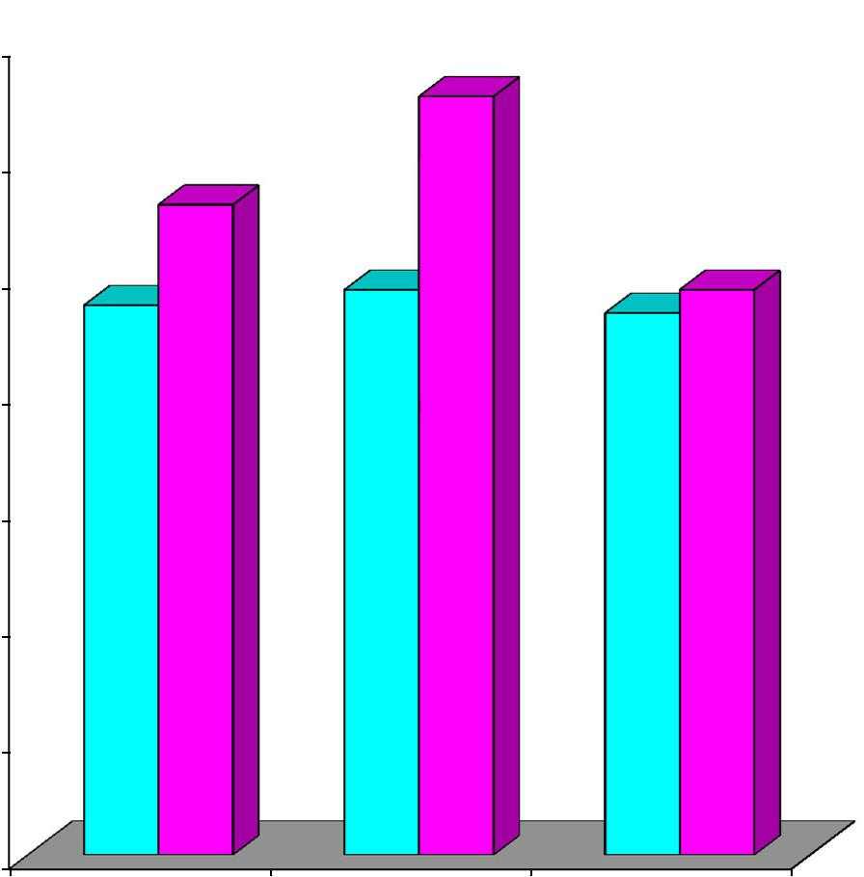

1

0
VTG VSTG CG

Pre Test Post Test

123

FIGURE 12

ADJUSTED POST TEST MEAN VALUES OF VTG, VSTG AND

CG ON ACCURACY THROW

Mean Values (in points)

7

6

5

4

3

2

6.446
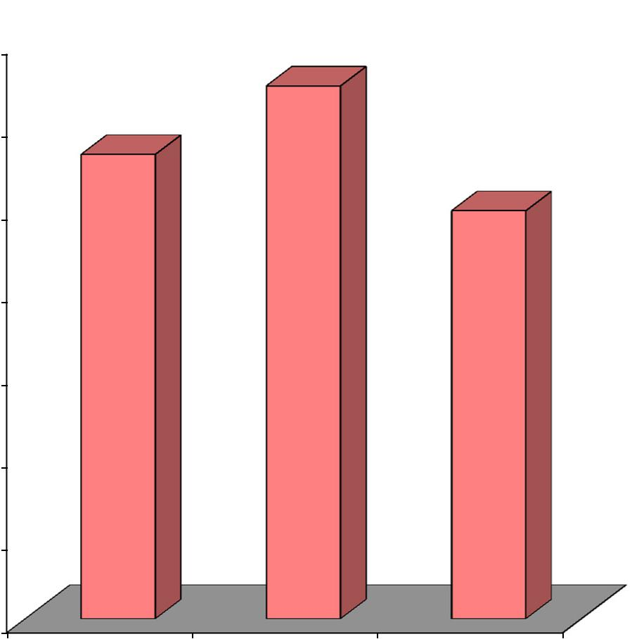

5.618

4.937

1

0
VTG VSTG CG

Adjusted Post Test Mean

124

4.8.4. Discussion on Findings on Accuracy Throw

The result of the study indicates that both the experimental groups were significantly differed when compared to the control group on accuracy throw. However, it is further revealed that the experimental group namely VTG and VSTG had improved in the performance of accuracy throw better than the control group (CG) but VSTG had improved in the performance of accuracy throw better than the other two groups.

Ziva and Lidora (2009) concluded that throwing velocity is higher by as much as 9% in elite male players compared with amateur male players and suggested that strength and power exercises should be emphasized in conditioning programmes, as they are associated with both sprint performance and throwing velocity. Rogulj, et al., (2007) found that the ball movement speed during the jump shot and the floor shot was determined, at the level of statistical importance, only by explosive strength in the form of throw. It is acceptable because this very ability from the aspects of kinesiology and anatomy requires, to the maximum extent, the kinetic efficacy of the ball throw in Handball. Visnapuu, et al., (2007) stated that finger control is especially important for the accuracy of different shots, both in handball and basketball. The present investigation also exposed that specified training with vibrator aid and specified training with combination of vibrator aid and sign language improved the accuracy throw. The findings of the present study also supported with the findings of Reddy (1993) and Marques and Gonzalez (2006).

125

4.9. COMPUTATION OF DEPENDENT ‘t’ TEST, ANALYSIS OF COVARIANCE AND SCHEFFE’S POST HOC TEST ON JUMP AND THROW

The analysis of dependent ‘t’ test on the data obtained for jump and throw of the pre-test and post-test means of VTG, VSTG and CG were analysed and presented in Table XXVI.

TABLE XXVI

SUMMARY OF MEAN STANDARD DEVIATION AND DEPENDENT ‘t’ TEST FOR THE PRE POST AND ADJUSTED POST TESTS ON JUMP AND THROW OF EXPERIMENTAL AND CONTROL GROUPS

(Jump and throw scores are expressed in points)

 |  | VTG | VSTG | CG
Pre test | Mean | 3.667 | 3.533 | 3.600
Pre test | SD | 0.900 | 0.516 | 1.056
Post test | Mean | 4.800 | 5.733 | 3.733
Post test | SD | 1.265 | 0.961 | 0.961
‘t’ test |  | 7.221* | 9.646* | 0.423

*Significant at .05 level. The table value required for .05 level of significance with df 14 is 1.761.

4.9.1. Results of Dependent ‘t’ Test on Jump and Throw

Table XXVI shows that the pre-test mean values of VTG, VSTG and CG on jump and throw are 3.667, 3.533 and 3.600 respectively and the post-test mean values on jump and throw are 4.800, 5.733 and 3.733 respectively. The obtained dependent t-ratio values between the pre and post test means of VTG, VSTG and CG on jump and throw are 7.221, 9.646 and 0.423 respectively. The table value required for significant difference with df 14 at .05 level is 1.761. Since, the obtained ‘t’ ratio values of experimental groups are greater than the table value, it is understood that specified training with vibrator aid and specified training with combination of vibrator aid & sign language groups had significantly improved in

126

the performance of jump and throw. However, the control group had not

significantly improved in the performance of jump and throw. The obtained ‘t’

value for the control group is less than the table value as they were not subjected to

any specific training.

The analysis of covariance on jump and throw of VTG, VSTG and CG were analysed and presented in Table XXVII.

TABLE XXVII

ANALYSIS OF COVARIANCE FOR THE DATA ON JUMP AND THROW

AMONG EXPERIMENTAL AND CONTROL GROUPS

Adjusted Post Test Means |  |  |  | Sources of | Sum of | df | Mean | F-Ratio
VTG | VSTG |  | CG | Variance | Squares | df | Squares | F-Ratio
4.747 | 5.787 |  | 3.733 | Between | 31.588 | 2 | 15.794 | 22.595*
4.747 | 5.787 |  | 3.733 | Within | 28.640 | 41 | 0.699

* Significant at 0.05 level of confidence.

The table value for significance at 0.05 with df 2 and 41 is 3.23.

4.9.2. Results of Analysis of Covariance on Jump and Throw

Table XXVII shows that the adjusted post-test means of VTG, VSTG and CG on jump and throw are 4.747, 5.787 and 3.733 respectively. The obtained F-ratio value is 22.595, which is higher than the table value 3.23 with df 2 and 41 required for significance at .05 level. Since the value of F-ratio is higher than the table value, it indicates that there exist significant differences among the adjusted post-test means of VTG, VSTG and CG. To find out which of the paired means had a significant difference on jump and throw, the Scheffe’s post-hoc test was applied and the results are presented in Table XXVIII.

127

TABLE XXVIII

SCHEFFE’S TEST FOR THE DIFFERENCES BETWEEN THE ADJUSTED

POST TEST PAIRED MEANS OF JUMP AND THROW

VTG | VSTG | CG | Mean | Confidential
VTG | VSTG | CG | Difference | Interval
4.747 | 5.787 |  | 1.040* | 0.775
4.747 |  | 3.733 | 1.013* | 0.775
 | 5.787 | 3.733 | 2.053* | 0.775

*Significant at .05 level.

4.9.3. Results of Scheffe’s Test on Jump and Throw

The table XXVIII shows that the adjusted post test mean difference on jump and throw between VTG and VSTG, VTG and CG and between VSTG and CG are 1.040, 1.013 and 2.053 respectively which are higher than the confidence interval value of 0.775 at .05 level of confidence.

The pre and post test mean values of VTG, VSTG and CG on jump and throw are graphically represented in figure 13.

The adjusted post test mean values of VTG, VSTG and CG on jump and throw are graphically represented in figure 14.

128

FIGURE 13

PRE TEST AND POST TEST MEAN VALUES OF VTG, VSTG

AND CG ON JUMP AND THROW

Mean Values (in points)

5.733
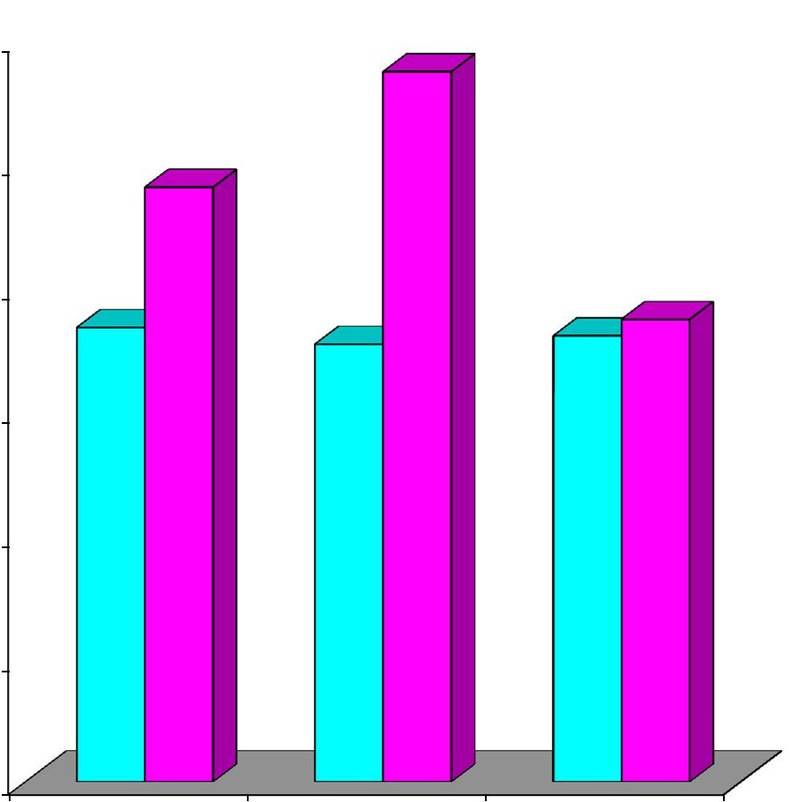

6 | 8004.

5

6673. | 5333. | 6003. | 3.733

4

3

2

1

0
VTG VSTG CG

Pre Test Post Test

129

FIGURE 14

ADJUSTED POST TEST MEAN VALUES OF VTG, VSTG AND

CG ON JUMP AND THROW

5.787
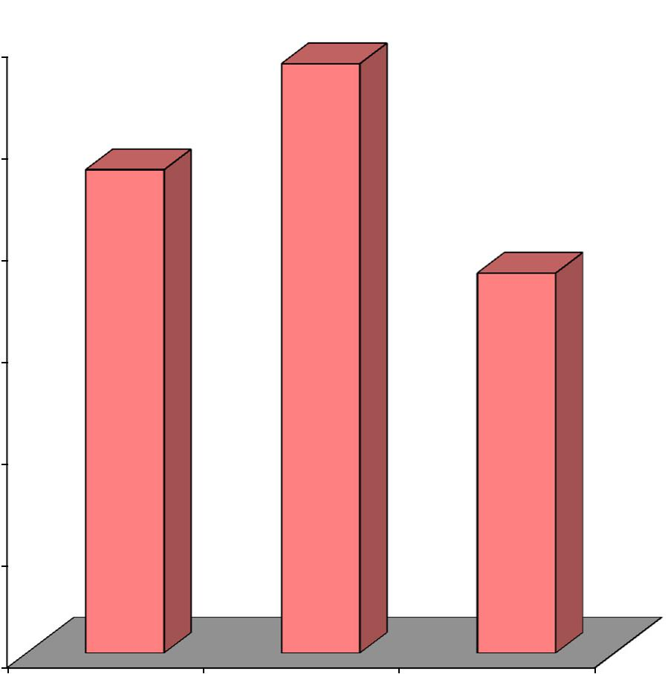

Mean Values (in points)

6

5

4

3

2

4.747

3.733

1

0
VTG VSTG CG

Adjusted Post Test Mean

130

4.9.4. Discussion on Findings on Jump and Throw

The result of the study indicates that both the experimental groups significantly differed when compared to the control group on jump and throw. However, it is further revealed that the experimental group namely VTG and VSTG had improved in the performance of jump and throw better than the control group (CG) but VSTG had improved in the performance of jump and throw better than the other two groups.

Cetin and Ozdol (2012) concluded that there were significant differences between before and after training program in push up and the height of center of gravity parameters and but there is no significant differences found that vertical jump (VJ) and velocity of center of gravity (VCG). Wagner and Muller (2008) suggest that team-handball players who were taller and of greater body weight have the ability to achieve a higher ball release speed in the jump throw. The present study also concealed that the 12 weeks of specified training with vibrator aid and specified training with combination of vibrator aid and sign language improved the jump and throw. The result of the present investigation is also incorporated with the findings of Rogulj, et al., (2007) Ziva and Lidora (2009) and Pori, Bon, and Sibila (2005).

131

4.10. COMPUTATION OF DEPENDENT ‘t’ TEST, ANALYSIS OF COVARIANCE AND SCHEFFE’S POST HOC TEST ON DRIBBLING

The analysis of dependent ‘t’ test on the data obtained for dribbling of the pre-test and post-test means of VTG, VSTG and CG were analysed and presented in Table XXIX.

TABLE XXIX

SUMMARY OF MEAN STANDARD DEVIATION AND DEPENDENT ‘t’

TEST FOR THE PRE AND POST TESTS ON DRIBBLING OF
EXPERIMENTAL AND CONTROL GROUPS

(Dribbling scores are expressed in seconds)

 |  | VTG | VSTG | CG
Pre test | Mean | 39.333 | 38.933 | 38.400
Pre test | SD | 2.610 | 2.219 | 2.414
Post test | Mean | 36.267 | 33.733 | 37.333
Post test | SD | 2.890 | 2.017 | 3.331
‘t’ test |  | 7.668* | 12.373* | 0.948

*Significant at .05 level. The table value required for .05 level of significance with df 14 is 1.761.

4.10.1. Results of Dependent ‘t’ Test on Dribbling

Table XXIX shows that the pre-test mean values of VTG, VSTG and CG on dribbling are 39.333, 38.933 and 38.400 respectively and the post-test mean values on dribbling are 36.267, 33.733 and 37.333 respectively. The obtained dependent t-ratio values between the pre and post test means of VTG, VSTG and CG on dribbling are 7.668, 12.373 and 0.948 respectively. The table value required for significant difference with df 14 at .05 level is 1.761. Since, the obtained ‘t’ ratio values of experimental groups are greater than the table value, it is understood that specified training with vibrator aid and specified training with combination of vibrator aid & sign language groups had significantly improved in the performance

132

of dribbling. However, the control group had not significantly improved in the

performance of dribbling. The obtained ‘t’ value for the control group is less than

the table value as they were not subjected to any specific training.

The analysis of covariance on dribbling of VTG, VSTG and CG were analysed and presented in Table XXX.

TABLE XXX

ANALYSIS OF COVARIANCE FOR THE DATA ON DRIBBLING AMONG

EXPERIMENTAL AND CONTROL GROUPS

Adjusted Post Test Means |  |  |  | Sources of | Sum of |  | Mean
 |  |  |  | Sources of | Sum of | df | Mean | F-Ratio
VTG | VSTG |  | CG | Variance | Squares | df | Squares | F-Ratio
35.894 | 33.696 |  | 37.744 | Between | 122.287 | 2 | 61.143 | 16.078*
35.894 | 33.696 |  | 37.744 | Within | 155.931 | 41 | 3.803

* Significant at 0.05 level of confidence.

The table value for significance at 0.05 with df 2 and 41 is 3.23.

4.10.2. Results of Analysis of Covariance on Dribbling

Table XXX shows that the adjusted post-test means of VTG, VSTG and CG on dribbling are 35.894, 33.696 and 37.744 respectively. The obtained F-ratio value is 16.078, which is higher than the table value 3.23 with df 2 and 41 required for significance at .05 level. Since the value of F-ratio is higher than the table value, it indicates that there exist significant differences among the adjusted post-test means of VTG, VSTG and CG. To find out which of the paired means had a significant difference on dribbling, the Scheffe’s post-hoc test was applied and the results are presented in Table XXXI.

133

TABLE XXXI

SCHEFFE’S TEST FOR THE DIFFERENCES BETWEEN THE ADJUSTED

POST TEST PAIRED MEANS OF DRIBBLING

VTG | VSTG | CG | Mean | Confidential
VTG | VSTG | CG | Difference | Interval
35.894 | 33.696 |  | 2.198* | 1.809
35.894 |  | 37.744 | 1.850* | 1.809
 | 33.696 | 37.744 | 4.048* | 1.809

*Significant at .05 level.

4.10.3. Results of Scheffe’s Test on Dribbling

The table XXXI shows that the adjusted post test mean difference on dribbling between VTG and VSTG, VTG and CG and between VSTG and CG are 2.198, 1.850 and 4.048 respectively which are higher than the confidence interval value of 1.809 at .05 level of confidence.

The pre and post test mean values of VTG, VSTG and CG on dribbling are graphically represented in figure 15.

The adjusted post test mean values of VTG, VSTG and CG on dribbling are graphically represented in figure 16.

134

FIGURE 15

PRE TEST AND POST TEST MEAN VALUES OF VTG, VSTG

AND CG ON DRIBBLING

Mean Values (in seconds)

40.00

39.00

38.00

37.00

36.00

35.00

34.00

33.00

32.00

31.00

30.00

33339. | 93338. | 40038.
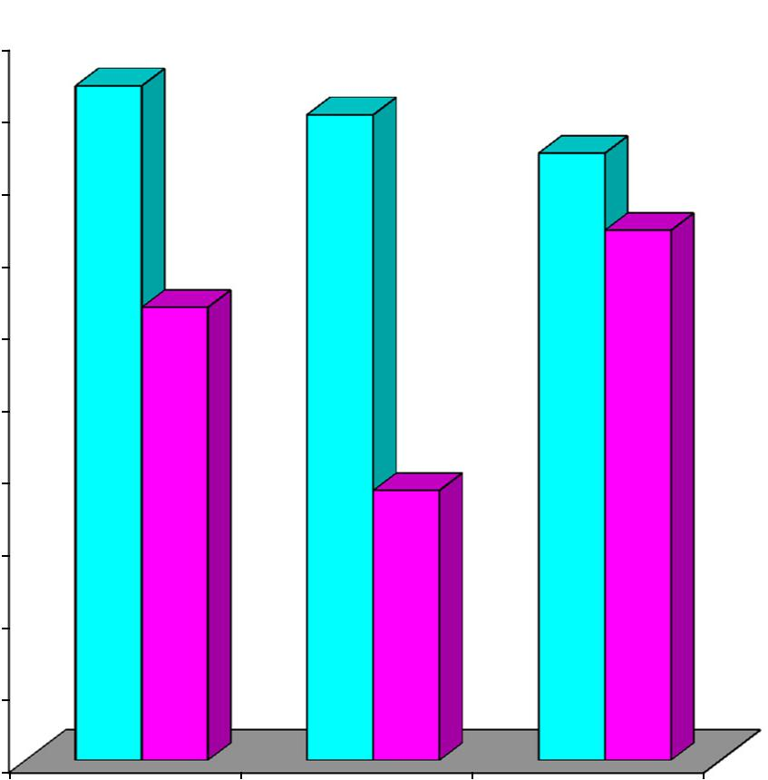

33337.

26736.

73333.

VTG VSTG CG

Pre Test Post Test

135

FIGURE 16

ADJUSTED POST TEST MEAN VALUES OF VTG, VSTG AND

CG ON DRIBBLING

37.744
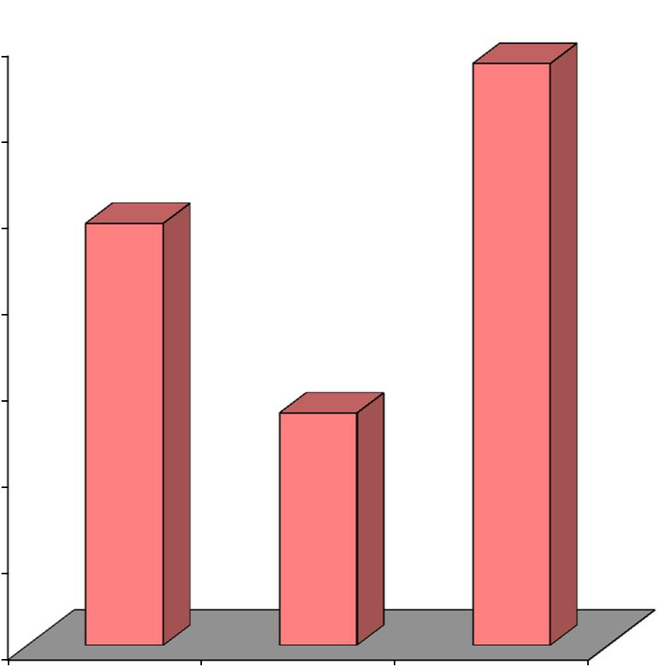

Mean Values (in seconds)

38.00

37.00 | 35.894

36.00

35.00

33.696

34.00

33.00

32.00

31.00
VTG VSTG CG

Adjusted Post Test Mean

136

4.10.4. Discussion on Findings on Dribbling

The result of the study indicates that both the experimental groups significantly differed when compared to the control group on dribbling. However, it is further revealed that the experimental group namely VTG and VSTG had improved in the performance of dribbling better than the control group (CG) but VSTG had improved in the performance of dribbling better than the other two groups.

Zozo and Hassan (1999), in their study concluded that the preliminary games led to learn games and improve the basic skills of handball in the deaf and dumb and improving the motor capacity associated with these skills.

Alathari (2009), also concluded that sign language was more effective than lip-reading in learning the skills of throwing the ball from the bottom ,and throwing it front bottom to front, and didn’t show any difference in the skill of throwing form the top between lip reading and sign language.

Mihaila Ion, (2014), examined the learning to play handball technique is to find and assimilate technical processes driving expression of the players optimal opportunities and increase their effectiveness as structured driving current game. This research was conducted at the level of junior handball teams during a competitive year in which research subjects were in training a large percentage of technical exercises, assessed by control samples prepared by federation of specialized or domain experts. To assess the level of technical training and progress have passed control samples at the beginning and end of the research. The present investigation also revealed that the 12 weeks of specified training with vibrator aid

137

and specified training with combination of vibrator aid and sign language improved

the dribbling.

4.11. SUMMARY OF FINDINGS

The results of the study indicate that significant difference exists among the pre, post and adjusted post test means of experimental and control groups on selected dependent variables among deaf-and-dumb subjects.

Successful performance in handball is determined by the specific technical-tactical skills (or knowledge of the elements) and by the quality level of basic physical condition or fitness. Successful performance of handball technical-tactical elements depend primarily on the level of the coordination-related abilities and on the strength/power fitness. Previous Croatian studies on situation-related motor abilities (Vuleta, Simenc, & Ticic, 1990), make it possible to presume that there are five latent situation-related motor dimensions accuracy, ball handling, motion speed without the ball, motion speed with the ball and ball throwing power. Abdullah and Yakoot Zidane (2001), recommend that special training programme improved the Volleyball skill among the deaf-and-dumb students. Zozo and Hassan (1999), stated that preliminary games led to learn games and improve the basic skills of handball among the deaf-and-dumb students and improving the motor capacity associated with these skills.

Previous research conducted by Spelmezan,, et al., (2012), focused on designing tactile stimuli that could intuitively represent body movements. Accuracy of throwing at the goal is an ability to realize cumulative attacking engagement of the whole team in score-open situations which is the last controlled action on the attack. For acquiring motor skills, such as in sports training, it is important that the

138

learner frequently receives instructions on how to perform the skill and feedback on

the performance. Coaches typically give instructions and feedback before and after a

trial, and concurrently during the execution of the movements. Yet in many sports

the coach cannot correct the learner during an exercise. A good case in point is

snowboarding. Snowboarders receive instructions before descending the slope and

delayed feedback after the ride. During the ride, they are spatially separated from

their coach. They have to rely on their own perception of what is right or wrong

(Van, et al., 2006). Vulet, et al., (2006), stated that teaching and training

programmes should simultaneously develop all motor abilities and continuously

apply operators (training contents) in which aiming and hitting of targets of various

sizes and forms is performed both from standing positions and while moving.

Present research also reported that deaf-and-dumb subjects were able to recognize

and to identify vibration-aid and sign language instructions during the training

period. In the present investigation the result showed that, the use of a vibrator aid

instruction based specified training and combination of vibrator-aid and sign

language instruction based specified training improve dribbling, accuracy throw,

jump and throw performance in handball.

Galvin, et al., (1993), studied the training program used with the University of Melbourne's multiple-channel electrotactile device is presented to show how these important factors may be addressed, to indicate the flexibility required in a training program and to provide a general framework on which researchers may base the development of programs for other tactile devices. Spelmezan, (2012), identified the conditions under which tactile instructions can support athletes in sports training. Alathari and Manatee (2009), study showed that

139

sign language was more effective than lip-reading in learning the skills of throwing

the ball from the bottom and throwing it front bottom to front among deaf and mute.

Gallace, et al., (2007), concluded that in relation to current theories of cross-modal

integration and to the cognitive resources and/or common higher order spatial

representations possibly accessed by both visual and tactile stimuli. The present

study also used the tactile instructions and sign language method during the

specified training sessions. In the analysis of the data indicating that specific training

with vibrator aid and specific training with combination of vibrator aid & sign

language method improves the psycho-motor variables and skills in handball among

deaf and dumb college students.

4.12. DISCUSSION ON HYPOTHESES

- It was mentioned in the first hypothesis that there would be a significant improvement on selected psycho motor and skill related variables in handball due to the influence of specified training with vibrator aid instruction. The result of the present study showed that significant improvement on selected criterion variables such as reaction time, movement time, 9 meter front throw, dominant hand speed pass, overhead pass, accuracy throw, jump and throw, and dribbling among deaf and dumb college students. Hence, the first hypothesis was accepted at 0.05 level of confidence.

- It was mentioned in the second hypothesis that there would be a significant improvement on selected psycho motor and skill related variables in handball due to the influence of specified training with combination of vibrator aid & sign language instruction. The analysis of the data revealed that due to the influence of specified training with vibrator aid and sign language significantly

140

improved on selected criterion variables among deaf and dumb college

students. Hence, the second hypothesis was also accepted at 0.05 level of

confidence.

- In the third hypothesis, it was mentioned that there would be a significant improvement difference between specified training with vibrator aid and specified training with combination of vibrator aid and sign language instruction on selected criterion variables among deaf and dumb students. The result of the present investigation also showed that the deaf and dumb college students who underwent specified training with combination of vibrator aid and sign language instruction improved significantly on selected criterion variables than that of who underwent specified training with vibrator aid instruction. Hence, the third hypothesis was accepted at 0.05 level of confidence.

141

CHAPTER V

SUMMARY CONCLUSIONS AND RECOMMENDATIONS

5.1. SUMMARY

The purpose of the study was to investigate the effect of specified training with sign language and vibrator aid on selected psychomotor variables namely, reaction time and movement time and skills in handball namely 9 meter front throw, dominant hand speed pass, overhead pass, accuracy throw, jump and throw and dribbling among deaf and dumb college students.

For the present study, forty five deaf and dumb men students were selected randomly from Presidency College, Chennai. The age of the subjects ranged between 18 and 25 years and their hearing impairment level is 90%. Selected subjects were divided into three equal groups namely experimental group I (VTG) underwent specified training with vibrator aid (n=15), Group II (SVTG) underwent specified training with combination of vibrator aid & sign language and Group III (CG) served as control group (n=15). The selected criterion variables psychomotor and handball skills were assessed prior to and immediately after the 12 weeks of training period by using the standardized tests. The experimental design used in this study was pre and post test random group design involving 45 subjects. The collected data were analyzed by using Analysis of Covariance (ANCOVA). Whenever the 'F' ratio was found to be significant, Scheffe’s test was used as post-hoc test to determine which of the paired means differed significantly. In all cases the criterion for statistical significance was set at 0.05 level of confidence (P<0.05).

142

5.2. CONCLUSIONS

The current study focuses on specified training with vibrator aid and sign language on selected psychomotor variables and skills in handball among deaf-and-dumb college students. The researchers investigated only male handball players, and training was designed only for them.

- Twelve weeks of specified training with vibrator aid and combination of vibrator aid & sign language instruction based training reduced the reaction and movement time.
- The present research concluded that specified training with vibrator aid and combination of vibrator aid & sign language improved the passing and throwing skills in handball.
- Our findings indicate that specified training with vibration aid and combination of vibration aid & sign language could support deaf-and-dumb students in improving dribbling and accuracy performance.

- At the same time enhancing the performance of all the dependent variables, specified training with combination of vibrator aid & sign language was better than the specified training with vibrator aid.
- Based on the findings, the researcher concluded that specified training with vibration aid and specified training with combination of vibration aid & sign language are practical approaches for learners in enhancing handball skills if these instructions are adapted to meet up the learners’ needs during training.

143

5.3. RECOMMENDATIONS TO THE SOCIETY

- Since the specified training with combination of vibration aid & sign language is identified as the decisive training, it is recommended to the coaches and physical education teachers to include them in their regular schedule of coaching and training programme.
- It is proposed vibration aid and sign language instructions will be gradually introduced during the training sessions and correct the errors committed by the players to enhance the performance of the players.
- Intend to conduct a long-term study where vibration aid and sign language instructions are gradually introduced during training.

5.4. RECOMMENDATIONS TO THE RESEARCHERS

The results of the study brought out the following recommendations for further studies in this area.

- Substantiate the findings in other training settings and for other physical activities/sports and games.
- The intensity of the training and number of training sessions can be fixed according to the age and gender level of the subjects.
- The present study thus needs to be strengthened or supported by more relevant research studies.

144

BIBLIOGRAPHY

BOOKS

Afifi, Mohammed Kamel (1998), Physical Education for the Disabled between Theory and Practice, Cairo : Hira House.

Alkrioti, Joseph and Alsrtaoi, Abdelaziz (1995), Introduction to Special Education, U.A.E.: Dar AlQalam.

Allawi, Mohammed Hassan, (1992), The Psychology of Training and Competitions, 7edition, Egypt : Dar Alma’ref knowledge.

Alqoraity, Abdul Muttalib, (2001), Psychology with Special Educational Needs and Upbringing, (2 edition), Cairo, Egypt : House of Arab Thought.

Al-rousan, Farooq (2007), The psychology of extraordinary children : Introduction

to Special Education, (Seventh edition), Oman : Dar Alfiker.

Ammons, D.K. (2008), Deaf Sports & Deaflympics, The International Olympic Committee of Sports for the Deaf.

Bergemann, B.W. (2004), Biomechanics: Problems and Tutorial Manual, Campbell University.

Clarke, H. Harrison, and Clarke, H. David, (1972), Advanced Statistics with Application to Physical Education, New Jersey: Englewood Cliffs, Prentice Hall, Inc.

Czerwinski and Taborsky, (1997), Basic Handball, Austria : Gutheil-Schoder-Gasse, P.9.

Johnson L. Berry and Nelson Jack. (1981), Practical Measurement for Evaluation in Physical Education, UK: Thomas Johnson and Sons, P.248.

Kaczmarek, K. and Rita, P.B. (1995), Virtual Environments and Advanced Interface Techniques, Oxford University Press.

Marczinka, Z. (1993), Playing Handball, I.H.F.:Trio Budapest Publishing Company.

Rateb, Osama Kamel (2007), Psychological Skills Training, Cairo : Dar al Arab thought, I 1.

Singleton, J. and Morgan, D. (2005), “Natural signed language acquisition within the social context of the classroom”. In M. Marschark, B. Schick, & P.E. Spencer (Eds.), Advances in sign language development by deaf children, New York: Oxford University Press, pp. 344-375.

145

JOURNALS

Abernethy, B. and Russell, D.G. (1987), “Expert-novice differences in an applied selective attention task”, Journal of Sport Psychology, 9, PP.326-345.

Abernethy, B. and Zawi, K. (2007), “Pickup of essential kinematics underpins expert perception of movement patterns”, Journal of Motor Behavior, 39, PP.353-367.

Ali, Rizwan Mohammed Radwan and Zakaria (2000), “Impact of proposed exercises program on some variables of cognition and dynamic, functional sense and physical variables of the deaf and dumb”, The Scientific Journal of Physical Education and Sports, Faculty of Physical Education for Girls, eighteenth edition, January, Cairo University, Egypt.

Auvray, M., Gallace, A. and Spence, C. (2011), “Tactile short -term memory for stimuli presented on the fingertips and across the rest of the body surface”, Attention, Perception and Psychophysics. 73(4), PP.1227-41.

Bloomfield, A. and Badler, N.I. (2008), “Virtual Training via Vibrotactile Arrays. Presence”, Tele Operators and Virtual Environments, 17(2), PP.103– 120.

Buchheit, M., Laursen, P.B., Kuhnle, J., Ruch, D., Renaud, C. and Ahmaidi, S., (2009), “Game-Based Training in Young Elite Handball Players”, International Journal of Sports Medicine, 30(4), PP.251-8.

Buchheit M., et al., (2010), “Improving Acceleration and Repeated Sprint Ability in Well-Trained Adolescent Handball Players: Speed Versus Sprint Interval Training”, International Journal of Sports Physiology and Performance, 5(2), PP.152-64.

Buchheit M., Lepretreb, P.M., Behaegelc, A.L., Milletd, G.P. and Ahmaidi, S., (2009), “Cardio-respiratory Responses During Running And Sport-Specific Exercises in Handball Players”, Journal of Science and Medicine in Sport, 12(3), PP.399-405.

Button, C., MacLeod, M., Sanders, R. and Coleman, S. (2003), “Examining movement variability in the basketball free-throw action at different skill levels”, Research Quarterly for Exercise and Sport, 74, PP.257–269.

Canal-Bruland, R., and Schmidt, M. (2009), “Response bias in Judging Deceptive movements”, Acta Psychologica, 130, PP.235-240.

Canal-Bruland, R. and Williams, A.M. (2010), “Recognizing and Predicting Movement Effects: Identifying Critical Movement Features”, Experimental Psychology, 57, PP.320-326.

Chelley, M.S., Hermassi, S. and Shephard, R.J. (2010), “Relationships Between Power and Strength of the Upper and Lower Limb Muscles and

146

Throwing Velocity in Male Handball Players”, Journal of strength and Conditioning Research, 24(6), PP.1480-7.

Chi, E.H., Borriello, G., Hunt, G. and Davies, N. Guest. (2005), “Introduction: Pervasive Computing in Sports Technologies”, IEEE Pervasive Computing, 4(3), PP.22–25.

Debanne, T. and Laffaye, G. (2011), “Predicting the Throwing Velocity of the Ball in Handball with Anthropometric Variables and Isotonic Tests”, Journal of Sports Sciences, 29(7), PP.705-713.

Eccarius, Petra and Brentari, Diane. (2007), “Symmetry and dominance: A Cross-Linguistic Study of Signs and Classifier Constructions”, Lingua, 117, PP.1169–1201.

Eliasz, J., Janiak, J., Wit, A. (1990), “Ball Flight Velocity during Throws in Handball”, Sport Wyczynowy 9-10, PP.17-23.

Ellis, M. and Stewart, D.A. (1997), “Revisiting the Effects of Balance and Motor Skill Development in Deaf Children”, CAEDHH. Journal Revue, ACESM, 23(2).

Finney Eva, M. and Dobkins Karen, R. (2001), “Visual Contrast Sensitivity in Deaf Versus Hearing Populations: Exploring the Perceptual Consequences of Auditory Deprivation and Experience with a Visual Language”, Cognitive Brain Research, 11(1), PP.171-183.

Etnyre, B.R. (1998), “Accuracy Characteristics of Throwing as a Result of Maximum Force Effort”, Perceptual and Motor Skills, 86, PP.1211– 1217.

Gallace, A., Tan, H.Z. and Spence, C. (2007), “Multisensory Numerosity Judgments for Visual and Tactile Stimuli”, Perception and Psychophysics, 69(4), PP.487-501.

Gallace, A., Tan, H.Z. and Spence, C. (2006), “Numerosity Judgments for Tactile Stimuli Distributed over the Body Surface”, Perception, 35(2), PP.247-66.

Galvin, K.L., Cowan, R.S., Sarant, J.Z., Blamey, P.J. and Clark, G.M. (1993), “Factors in the Development of a Training Program for Use with Tactile Devices”, Ear and Hearing, 14(2), PP.118-27.

Garcia Jesus Rivilla, Navarro Fernando, Grande Ignacio, Ignatova Anelia S. and Sampedro Javier, (2010), “Differences in Throwing Capacity between Senior and U- 18 Men Handball Players”, Serbian Journal of Sports Sciences, 4(4), PP.145-151.

Geldard, F. (1960), “Some Neglected Possibilities of Communication”, Science, 131, PP.1583-1588.

Ghosh, S.S. (2014), “A Comparative Study on Selected Physical Fitness Components between Deaf & Dumb and Normal School Boys of West

147

Bengal”, International Journal of Physical Education, Fitness and

Sports, 3(2), PP.52-59.

Goldishand, L. and Taylor, H. (1974), “The Optacon: A Valuable Device for Blind Persons”, New Outlook for the Blind published by the American Foundation for the Blind, PP. 49–56.

Gorostiaga, E.M., Granados, C., Ibanez, J. and Izquierdo, M. (2005), “Differences in Physical Fitness and Throwing Velocity Among Elite And Amateur Male Handball Players”, International Journal of Sports Medicine, 26(3), PP.225-32.

Goulet, C., Bard, C., and Fleury, M. (1989), “Expertise Differences in Preparing to Return a Tennis Serve: A Visual Information Processing Approach”, Journal of Sport and Exercise Psychology, 11, PP.382-398.

Graib, A.A., Qablan, S.A. and Aldmour, H.A. (2012), “Effect of Some Personal Attributes- Anxiety and Tension on the Level of Performance of Basketball Aiming Skills for Deaf Players in Jordan”, European Scientific Journal, 8(6), P.101.

Gross, J.B. and Gill, D. (1982), “Competition and Instructional Set Effects on the Speed and Accuracy of a Throwing Task”, Research Quarterly for Exercise and Sport, 53, PP.125–132.

Ibrahim (2004), as cited in Graib, A.A., Qablan, S.A. and Aldmour, H.A., (2012), “Effect of Some Personal Attributes-Anxiety and Tension on the Level of Performance of Basketball Aiming Skills for Deaf Players in Jordan”, European Scientific Journal, 8(6), P.101.

Ion, Mihaila., (2014), “Technical Training Methods for Increasing the Junior Handball Teams”, Procedia - Social and Behavioral Sciences, 116, PP.2004-2009.

Kaaresoja, T. and Linjama, J. (2005), “Perception of Short Tactile Pulses Generated by a Vibration Motor in a Mobile Phone”, in Proceedings of World Haptics, PP. 471–472.

Kaczmarek, K., Webster, J., Bach, P., Rita, U. and Tompkins, W. (1991), “Electrotactile and Vibrotactile Displays for Sensory Substitution Systems”, IEEE Transactions on Biomedical Engineering, 38, PP.1– 16.

Khidr, F.A.M. (2010), “Effect of Using Modern Soft Program for Learning Some Judo Skills and Lonely Feeling to the Hearing Impaired People”, Procedia - Social and Behavioral Sciences, 5, PP. 2058-2062.

Knox, R.D., (1947), “Basketball Ability Test”, Scholastic Coach, 17(3), P.45.

Lieberman, J., Breazeal, C. TIKL (2007), “Development of a Wearable Vibrotactile Feedback Suit for Improved Human Motor Learning”, IEEE Transactions on Robotics, PP.919-926.

148

Loffing, F., Schorer, J., Hagemann, N. and Baker, J. (2012), “On the Advantage of Being Left-Handed in Volleyball: Further Evidence of the Specificity of Skilled Visual Perception”, Attention, Perception & Psychophysics, 74, PP.446-453.

Loffing, Florian and Hagemann, Norbert (2014), “Skill Differences in Visual Anticipation of Type of Throw in Team-Handball Penalties”, Psychology of Sports and Exercise, 15(3), PP.260-267.

Marques, M.C. and González-Badillo, J.J. (2006), “In-season resistance training and detraining in professional team handball players”, Journal of Strength and Conditioning Research, 20(3), PP.563-71.

Marques , M.C., Roland van den Tilaar, Jason, D. Vescovi, and Juan Jose Gonzalez-Badillo, (2007), “Relationship Between Throwing Velocity, Muscle Power, and Bar Velocity During Bench Press in Elite Handball Players”, International Journal of Sports Physiology and Performance, 2(4), PP.414-422.

Morgan Gary and Woll Bencie, (2007), Understanding Sign Language Classifiers through a Polycomponential Approach”, Lingua, 117, PP.1159-1168.

Morley, J.W. and Rowe, M.J. (1990), “Perceived Pitch of Vibrotactile Stimuli: Effects of Vibration Amplitude and Implications for Vibration Frequency Coding”, Journal of Physiology, 431, PP.403-16.

Muijen Van A.E., Jris H., Kemper H.C.G., and lngen Schenau Van G.J. (1991), “Throwing Practice with Different Ball Weights: Effects on Throwing Velocity and Muscle Strength in Female Handball Players”, Sports Training, Medicine and Rehabilitation, 2, PP.103-113.

Müller, H. and Loosch, E. (1999), “Functional Variability and an Equifinal Path of Movement during Targeted Throwing”, Journal of Human Movement Studies, 36, PP.103–126.

Müller, S., Abernethy, B. and Farrow, D. (2006). “How do World-Class Cricket Batsmen Anticipate a Bowler’s Intention?”, The Quarterly Journal of Experimental Psychology, 59, PP.2162-2186.

Nikolaos Oxyzoglou, Aggelos Kanioglou, Stelios Rizos, George Mavridis and Christos Kabitsis, (2007), “Muscular Strength and Jumping Performance after Handball Training Versus Physical Education Program for Pre-Adolescent Children”, Perceptual and Motor Skills, 104, pp.1282-1288.

Phillips, A.J.1., Thornton, A.R., Worsfold, S., Downie, A. and Milligan, J. (1994), “Experience of Using Vibrotactile Aids with the Profoundly Deafened”, European Journal of Disorders and Communication, 29(1), PP.17-26.

Pori, P., Bon, M. and Sibila, M. (2005), “Jump Shot Performance in Team Handball
– A Kinematic Model Evaluated on the Basis of Expert Modelling”, Kinesiology, 37(1), PP.40-49.

149

Rannou, F., Prioux, J., Zouhal, H., Gratas-Delamarche, A., Delamarche, P., (2001), “Physiological profile of handball players”, Journal of Sports Medicine and Physical Fitness, 41(3), PP.349–53.

Rehman, S.U., Sun, J., Liu, L. and License, H. (2008), “Turn Your Mobile into the Football: Rendering Live Football Game by Vibration”, IEEE Transactions on Multimedia, 10(6), PP.1022-1033.

Rivilla–Garcia, J., Navarro Valdivielso, F., Grande Rodrigue, I., and Sampedro Molinuevo, J. (2010), “Handball Throwing Capacity According to Specific Playing Position”, International Journal of Medicine and Science of Physical Activity and Sports, 12(48), PP.699-714,

Rogulj, N., Srhoj, V., Nazor, M., Srhoj, L. and Cavala, M. (2005), “Some anthropologic characteristics of elite female handball players at different playing positions”, Collegium Antropologicum, 29(2), PP.705-709.

Rogulj, N., Foretic, N., Srhoj, V., Cavala, M. and Papic, V. (2007), “Influence of Some Motor Abilities on Ball Speed during Shot in Handball”, Acta Kinesiologica, 1(2), PP.71-75.

Schorer, J., Baker, J., Fath, F. and Jaitner, T. (2007), “Identification of Interindividual and Intraindividual movement pattern in handball players of varying expertise levels”, Journal of Motor Behavior, 39, PP.409– 421.

Shahbazia Mehdi, Rahimizadeha Meysam, Rajabia M R, Abdolmalekia H., (2011), “Mental and Physical characteristics in Iranian Men’s Handball National Team, Winner of Silver Medal in Asian Games-2010”, Procedia - Social and Behavioral Sciences, 30, PP.2268–2271,

Sharma Vidyasagar, Khan H.A. and Butchiramaiah, C. (1986), "A Comparative Study of Reaction Time and Concentration Among Recreational and Competitive Volleyball Players", SNIPES Journal, 9, P. 40.

Singh, K. and Ram Mange, (2013), “Prediction of Handball Players Playing Ability on the basis of their Anthropometric Measurements and Physical Fitness Components”, International Journal of Innovative Research, 2(7), P.151.

Singh, J., Kumar, R., and Singh, K. (2009), “Construction and Standardization of Specific Skill Test Battery for Male Handball Players”, Journal of Sports and Sports Sciences, NSNIS, Patiala, 32(1).

Skoufas, D., Stefanidis, P., Michailidis, C. and Hatzikotoulas, K. and Kotzamanidou, M., (2002), “The Effect of Handball Training with Underweighted Balls on the Throwing Velocity of Novice Handball Players”, Journal of Human Movement Studies, Department of Physical Education and Sport Science,Aristotle University of Thessaloniki, Greece, P.1

Souza, Juvenilson de, Antonio Carlos Gomes, Lucas Leme and Sergio Gregorio da Silva, (2006), “Changes in Metabolic and Motor Performance Variables

150

Induced by Training in Handball Players”, Revista Brasileira de Medicina do Esporte, 12(3), PP.118.

Summers, I.R., Cooper, P.G., Wright, P., Gratton, D.A., Milnes, P. and Brown, B.H. (1997), “Information from Time-Varying Vibrotactile Stimuli”, The Journal of Acoustical Society of America, 102(6), PP.3686-96.

Summers, I.R., Dixon, P.R., Cooper, P.G., Gratton, D.A., Brown, B.H. and Stevens, J.C.(1994), “Vibrotactile and Electrotactile Perception of Time-Varying Pulse Trains”, The Journal of Acoustical Society of America, 95(3), PP.1548-58.

Summers, l.R., Whybrow, J.J., Gratton, D.A., Milnes, P., Brown, B.H., and Stevens, J.C. (2005), “Tactile Information Transfer: A Comparison of Two Stimulation Sites”, The Journal of Acoustical Society of America,, 118(4), PP.2527-34.

Tait, M.E., Nikolopoulos T.P. and Lutman M.E. (2007), “Age at Implantation and Development of Vocal and Auditory Preverbal Skills in Implanted Deaf Children”, International Journal of Pediatric Otorhinolaryngology, 71(4), PP.603-610.

Tillaar, Roland van den and Ettema, Gertjan (2007), “A Three-Dimensional Analysis of Overarm Throwing in Experienced Handball Players”, Journal of Applied Biomechanics, 23, PP.12-19.

Van den Tillaar, R. and Ettema, G. (2003a), “Influence of Instruction on Velocity and Accuracy of Overarm Throwing”, Perceptual and Motor Skills, 96, PP.423–434.

Van den Tillaar, R. and Ettema, G. (2003b), “Instructions Emphasizing Velocity, Accuracy, or Both in Performance and Kinematics of Overarm Throwing by Experienced Team-Handball Players”, Perceptual and Motor Skills, 97, PP.731–742.

Van den, Tillaar, R. and Ettema, G. (2006), “Comparison between Novices and Experts of the Velocity Accuracy Trade off in Overarm Throwing”, Perceptual and Motor Skills, 103, PP.503–514.

Van-Doren C. (1990), “The Effects of a Surround on Vibrotactile Thresholds: Evidence for Spatial and Temporal Independence in the non-Pacinian I Channel”, Journal of Acoustical Society of America, PP.2655–2661.

Visnapuu, M. and Jurimae, T., (2007), “Handgrip strength and hand dimensions in young handball and basketball players”, Journal of strength and conditioning research/National Strength and Conditioning Association, 21(3), PP.923-9.

Vulet Dinko, Dragan Milano vic, Igor Grult; Igor Jukic and Zoran Pasic (2006), “Relations Between Indicators of Basic Motor Abilities and Results of Goal Throwing Accuracy Tests in Handball”, Faculty of Kinesiology University of Zagreb, Croatia, 7, (2), P.93.

151

Vuleta jr. Dinko, Goran Sporiš, Munir Talović and Eldin Jelešković (2010), “Reliability and Factorial Validity of Power Tests for Handball Players”, Sport Science, 3(1), PP.42‐46.

Wagner, H., Buchecker, M., von Duvillard, S., and Müller, E. (2010), “Kinematic Description of Elite vs. Low Level Players in Team Handball Jump Throw”, Journal of Sports Science and Medicine, 9, PP.15–23.

Wagner Herbert, Jürgen Pfusterschmied, Miriam Klous von Duvillard Serge P. and Erich Müller (2012), "Movement variability and skill level of various throwing techniques”, Human Movement Science, 31, PP.78–90.

Warnock, D.1., McGee-Lennon, M, Brewster, S. (2012), “Older users, multimodal reminders and assisted living technology”, Health Informatics Journal, 18(3), PP.181-90.

Wei Xiu-hong and Ji Li-Hi (2014), “Effective Handball Training on Cognitive Ability in Elderly with Mild Cognitive Impairment”, Neuroscience Letters, 566, PP.96-101.

Weisenberger, J.M. and Russell, A.F. (1989), “Comparison of Two Single-Channel Vibrotactile Aids for the Hearing-Impaired”, Journal of Speech and Hearing Research, 32(1), PP.83-92.

Weisenberger, J.M. (1989), “Evaluation of the Siemens Minifonator Vibrotactile aid”, Journal of Speech and Hearing Research, 32(1), PP.24-32.

Williams, A. M., & Burwitz, L. (1993), “Advance cue utilization in soccer”. In T.
Reilly, J. Clarys, & A. Stibbe (Eds.), Science and Football, PP. 239-243.

Wilson, C., Simpson, S.E., van Emmerik, R.E. A., and Hamill, J. (2008), “Coordination Variability and Skill Development in Expert Triple Jumpers”, Sports Biomechanics, 7, PP.2–9.

Woll, B., (2001), “The sign that dares to speak its name: echo phonology in British Sign Language”. In: Boyes Braem, P., Sutton-Spence, R. (Eds.), “The Hands are the Head of the Mouth: the Mouth as Articulator in Sign Language”, International Studies on Sign Language and Communication of the Deaf, 39, PP. 87–98.

Ziva, Gal and Lidora, Ronnie (2009), “Physical Characteristics, Physiological Attributes, and On-Court Performances Of Handball Players: A Review”, European Journal of Sport Science, 9(6), PP.375-386.

Zozo, Mohamed and Hassan Hamid, (1999), “Effective Use of Preliminary Games Programme Proposal to Learn Basic Skills and Improve Some Kinetic Capacities in the Deaf and Dumb Handball, Theories and Applications”, Journal, Faculty of physical education for men, Alexandria University.

152

PROCEEDINGS

Al mazroue, Muthanna Kalaf, Jassem and Abdel Moneim, (2010), “The Limits of Legal knowledge of Volleyball Disabled Seating, and Activists - Test Building Legal Knowledge of Volleyball Disabled Activist-Seating”, Physical education, Conference University of Tikrit, 31/3-1/4/2010, Iraq.

Almuhandis and Suheir Mostafa, (1990), “The Impact of Dynamic Farming Programme on Psychological Satisfaction and Some Components of Performance of Pupils with Impaired Hearing”, The First Scientific Conference, Vol. II, Faculty of Physical Education for Girls, Zagazig, Egypt.

Bayios, I., & Boudolos, K. (1998), “Accuracy and Throwing Velocity in Handball”, Proceedings of the XVI ISBS Symposium, 55, P.58.

Canon, Atiz (2002), “Battery Building of Miario Test for Emerging Basketball County in Menoufiya”, m.a., Faculty of physical education in the city of Sadat, Monufia Governorate.

Cetin E. and Ozdol Y. (2012), “Jump Shot Performance and Strength Training in Young Team Handball Players”, Procedia - Social and Behavioral Sciences, 46, PP.3187-3190,

Holland, S., Bouwer, A. J., Dalgelish, M., Hurtig, T. M. (2010), “Feeling the Beat Where it Counts: Fostering Multi-Limb Rhythm Skills with the Haptic Drum Kit”, Proceedings of TEI, ACM Press, PP.21–28.

Huang, K., Starner, T., Do, E., Weiberg, G., Kohlsdorf, D., Ahlrichs, C. and Leibrandt, R.(2010), “Mobile Music Touch: Mobile Tactile Stimulation for Passive Learning”, Proceedings of International ACM Computer Human Interaction Conference (CHI 10), ACM Press, Atlanta, GA PP.791–800.

Nakamura, A., Tabata, S., Ueda, T., Kiyofuji, S. and Kuno, Y. (2005), “Multimodal Presentation Method for a Dance Training System”, Proceedings of
International ACM Computer Human Interaction Conference Extended Abstracts, ACM Press, PP.1685-1688.

Spelmezan, D. (2012), “An Investigation into the Use of Tactile Instructions in Snowboarding”. Mobile HCI Proceedings of the 14th international conference on Human- computer interaction with mobile devices and services, 2, PP.417-426.

Van Erp. J.B.F., Saturday, I. and Jansen, C. (2006), “Application of Tactile Displays in Sports: Where to, How and When to Move”, Proceedings of EuroHaptics, PP. 105-109.

153

UNPUBLISHED THESES

Abdullah, Yakoot Zidane (2000), “Impact of Special Motor Capacity on Level of Perform for Some Basic Skills in Volleyball for the Deaf and Dumb”, Unpublished Dissertation, Faculty of Physical Education, University of Tanta, Egypt.

Alathari, shreen lo, ebee Manatee, (2009), “Study of the Impact of Sign and Lip Reading Language Curriculum Methods in Learning Some Basic Skills for Deaf Volleyball Game”, Unpublished MPhil, Baghdad University, Iraq.

Mahrous, Lamia Fawzy, (2000), “The Impact of the Use of Certain Methods of Teaching on the Standard Performance Level and Motivation of Some Games in Basketball, Studies College of Education Sports”, Dissertation, Unpublished, Faculty of physical education, University of Tanta.

Reddy Anita (1993), “Effect of Physical Education Programme on Motor Behaviour and Selected Coordinative Abilities of Deaf and Dumb Students”, Unpublished Thesis, Jiwaji University.

Rehman, S.U. (2010), “Expressing Emotions through Vibration for Perception and Control”, Doctoral Thesis, Department of Applied Physics and Electronics, Umea University, Sweden.

Sreejit, K.P. (1988), "Selected Psychomotor Performance Variation Among Players of Different Sports", Unpublished Master's Thesis, Jiwaji University, Gwalior.

Zinn, J.L., (1981), “Construction of a Battery of Team Handball Skills Test”, Unpublished Master’s Thesis, University of Iowa, Iowa City.

WEBSITES

Eliasz, J. (2015), “The Relationships between Throwing Velocity and Motor Ability Parameters of the High-Performance Handball Players”,
http://www1.arielnet.com/main/adw-22.html

Harold Gonzalez, (2005), “System of electronic devices that is designed to assist a football referee”, http://www.google.com/patents/US20050162257

https://en.wikipedia.org/wiki/ Referee_(association_football)

http://www.football-bible.com/soccer-info/soccer-referee-equipment.html http://www.goalnepal.com/news.php?id=13876

154

APPENDIX A

RAW SCORES OF VTG, VSTG AND CG ON REACTION TIME

S.No. |  | VTG |  | VSTG |  |  | CG
S.No. | Pre Test |  | Post Test | Pre Test | Post Test | Pre Test |  | Post Test
1 | 0.20 |  | 0.17 | 0.21 | 0.20 | 0.22 |  | 0.23
2 | 0.20 |  | 0.18 | 0.21 | 0.20 | 0.21 |  | 0.20
3 | 0.21 |  | 0.19 | 0.20 | 0.19 | 0.22 |  | 0.21
4 | 0.23 |  | 0.21 | 0.21 | 0.17 | 0.21 |  | 0.21
5 | 0.21 |  | 0.19 | 0.21 | 0.19 | 0.23 |  | 0.23
6 | 0.22 |  | 0.20 | 0.19 | 0.16 | 0.20 |  | 0.19
7 | 0.21 |  | 0.20 | 0.19 | 0.17 | 0.21 |  | 0.22
8 | 0.21 |  | 0.19 | 0.22 | 0.17 | 0.21 |  | 0.20
9 | 0.21 |  | 0.19 | 0.21 | 0.18 | 0.20 |  | 0.21
10 | 0.21 |  | 0.20 | 0.23 | 0.16 | 0.21 |  | 0.22
11 | 0.22 |  | 0.21 | 0.22 | 0.16 | 0.20 |  | 0.19
12 | 0.21 |  | 0.20 | 0.22 | 0.20 | 0.21 |  | 0.22
13 | 0.20 |  | 0.18 | 0.22 | 0.20 | 0.22 |  | 0.21
14 | 0.23 |  | 0.20 | 0.23 | 0.19 | 0.22 |  | 0.20
15 | 0.23 |  | 0.23 | 0.22 | 0.19 | 0.21 |  | 0.21

155

APPENDIX B

RAW SCORES OF VTG, VSTG AND CG ON MOVEMENT TIME

S.No. |  | VTG |  | VSTG |  |  | CG
S.No. | Pre Test |  | Post Test | Pre Test | Post Test | Pre Test |  | Post Test
1 | 0.29 |  | 0.28 | 0.29 | 0.26 | 0.29 |  | 0.29
2 | 0.29 |  | 0.28 | 0.28 | 0.26 | 0.29 |  | 0.28
3 | 0.28 |  | 0.27 | 0.29 | 0.25 | 0.29 |  | 0.28
4 | 0.29 |  | 0.28 | 0.29 | 0.26 | 0.28 |  | 0.27
5 | 0.27 |  | 0.26 | 0.28 | 0.25 | 0.30 |  | 0.29
6 | 0.29 |  | 0.26 | 0.29 | 0.26 | 0.28 |  | 0.28
7 | 0.29 |  | 0.28 | 0.29 | 0.27 | 0.29 |  | 0.30
8 | 0.28 |  | 0.27 | 0.30 | 0.27 | 0.29 |  | 0.27
9 | 0.29 |  | 0.28 | 0.29 | 0.27 | 0.29 |  | 0.29
10 | 0.29 |  | 0.27 | 0.29 | 0.25 | 0.27 |  | 0.27
11 | 0.29 |  | 0.28 | 0.30 | 0.26 | 0.28 |  | 0.27
12 | 0.29 |  | 0.28 | 0.29 | 0.27 | 0.27 |  | 0.28
13 | 0.27 |  | 0.26 | 0.30 | 0.26 | 0.30 |  | 0.29
14 | 0.29 |  | 0.27 | 0.29 | 0.28 | 0.28 |  | 0.28
15 | 0.27 |  | 0.25 | 0.28 | 0.26 | 0.29 |  | 0.28

156

APPENDIX C

RAW SCORES OF VTG, VSTG AND CG ON 9 M FRONT THROW

S.No. |  | VTG |  | VSTG |  |  | CG
S.No. | Pre Test |  | Post Test | Pre Test | Post Test | Pre Test |  | Post Test
1 | 9 |  | 14 | 12 | 20 | 11 |  | 12
2 | 11 |  | 14 | 12 | 18 | 10 |  | 11
3 | 8 |  | 12 | 11 | 18 | 10 |  | 11
4 | 14 |  | 16 | 13 | 20 | 11 |  | 12
5 | 10 |  | 13 | 11 | 18 | 11 |  | 12
6 | 11 |  | 15 | 14 | 20 | 12 |  | 13
7 | 12 |  | 14 | 11 | 18 | 12 |  | 13
8 | 11 |  | 16 | 12 | 18 | 12 |  | 9
9 | 11 |  | 13 | 12 | 19 | 11 |  | 12
10 | 9 |  | 17 | 11 | 14 | 12 |  | 13
11 | 9 |  | 13 | 10 | 13 | 12 |  | 13
12 | 12 |  | 21 | 11 | 14 | 12 |  | 12
13 | 11 |  | 17 | 12 | 19 | 12 |  | 12
14 | 12 |  | 15 | 9 | 15 | 12 |  | 12
15 | 13 |  | 15 | 8 | 14 | 11 |  | 12

157

APPENDIX D

RAW SCORES OF VTG, VSTG AND CG ON DOMINANT HAND

SPEED PASS

S.No. |  | VTG |  | VSTG |  |  | CG
S.No. | Pre Test |  | Post Test | Pre Test | Post Test | Pre Test |  | Post Test
1 | 43 |  | 40 | 48 | 44 | 44 |  | 43
2 | 49 |  | 48 | 46 | 42 | 49 |  | 48
3 | 46 |  | 45 | 48 | 44 | 48 |  | 47
4 | 48 |  | 46 | 44 | 41 | 49 |  | 47
5 | 48 |  | 47 | 46 | 41 | 44 |  | 41
6 | 47 |  | 45 | 40 | 37 | 48 |  | 47
7 | 47 |  | 45 | 46 | 43 | 46 |  | 48
8 | 46 |  | 43 | 48 | 44 | 44 |  | 45
9 | 46 |  | 43 | 46 | 43 | 47 |  | 45
10 | 44 |  | 41 | 45 | 41 | 47 |  | 43
11 | 47 |  | 45 | 48 | 44 | 43 |  | 42
12 | 47 |  | 45 | 48 | 43 | 49 |  | 48
13 | 48 |  | 46 | 49 | 45 | 43 |  | 42
14 | 46 |  | 44 | 46 | 41 | 44 |  | 45
15 | 49 |  | 47 | 48 | 44 | 44 |  | 45

158

APPENDIX E

RAW SCORES OF VTG, VSTG AND CG ON OVERHEAD PASS

S.No. |  | VTG |  | VSTG |  |  | CG
S.No. | Pre Test |  | Post Test | Pre Test | Post Test | Pre Test |  | Post Test
1 | 6 |  | 8 | 5 | 8 | 8 |  | 9
2 | 6 |  | 9 | 5 | 9 | 6 |  | 7
3 | 6 |  | 8 | 6 | 9 | 6 |  | 7
4 | 6 |  | 7 | 9 | 11 | 7 |  | 9
5 | 6 |  | 8 | 10 | 12 | 5 |  | 6
6 | 5 |  | 7 | 9 | 11 | 8 |  | 9
7 | 7 |  | 8 | 7 | 10 | 8 |  | 9
8 | 6 |  | 8 | 7 | 12 | 8 |  | 9
9 | 5 |  | 7 | 9 | 10 | 5 |  | 8
10 | 6 |  | 8 | 6 | 10 | 5 |  | 7
11 | 6 |  | 7 | 7 | 11 | 5 |  | 7
12 | 7 |  | 8 | 7 | 10 | 8 |  | 4
13 | 8 |  | 9 | 6 | 9 | 8 |  | 6
14 | 9 |  | 10 | 6 | 11 | 7 |  | 5
15 | 7 |  | 11 | 6 | 9 | 6 |  | 5

159

APPENDIX F

RAW SCORES OF VTG, VSTG AND CG ON ACCURACY THROW

S.No. |  | VTG |  | VSTG |  |  | CG
S.No. | Pre Test |  | Post Test | Pre Test | Post Test | Pre Test |  | Post Test
1 | 5 |  | 6 | 5 | 7 | 5 |  | 6
2 | 4 |  | 5 | 5 | 7 | 5 |  | 4
3 | 5 |  | 6 | 4 | 5 | 5 |  | 4
4 | 6 |  | 7 | 4 | 6 | 5 |  | 6
5 | 5 |  | 6 | 4 | 6 | 5 |  | 4
6 | 5 |  | 6 | 5 | 7 | 4 |  | 5
7 | 5 |  | 5 | 4 | 6 | 5 |  | 6
8 | 4 |  | 5 | 5 | 6 | 4 |  | 5
9 | 5 |  | 6 | 5 | 6 | 5 |  | 4
10 | 4 |  | 5 | 6 | 7 | 4 |  | 3
11 | 5 |  | 6 | 5 | 7 | 6 |  | 7
12 | 4 |  | 5 | 5 | 7 | 5 |  | 6
13 | 5 |  | 5 | 6 | 8 | 5 |  | 4
14 | 4 |  | 5 | 6 | 7 | 4 |  | 5
15 | 5 |  | 6 | 4 | 6 | 3 |  | 4

160

APPENDIX G

RAW SCORES OF VTG, VSTG AND CG ON JUMP AND THROW

S.No. |  | VTG |  | VSTG |  |  | CG
S.No. | Pre Test |  | Post Test | Pre Test | Post Test | Pre Test |  | Post Test
1 | 4 |  | 5 | 3 | 4 | 3 |  | 4
2 | 3 |  | 4 | 3 | 5 | 4 |  | 3
3 | 4 |  | 5 | 4 | 5 | 3 |  | 4
4 | 3 |  | 4 | 3 | 5 | 1 |  | 2
5 | 3 |  | 4 | 3 | 6 | 3 |  | 2
6 | 3 |  | 4 | 4 | 7 | 4 |  | 5
7 | 3 |  | 4 | 4 | 6 | 4 |  | 4
8 | 3 |  | 4 | 3 | 6 | 4 |  | 3
9 | 4 |  | 5 | 3 | 6 | 3 |  | 3
10 | 3 |  | 4 | 4 | 6 | 5 |  | 4
11 | 4 |  | 5 | 4 | 8 | 5 |  | 4
12 | 4 |  | 5 | 4 | 6 | 5 |  | 5
13 | 5 |  | 5 | 4 | 5 | 3 |  | 4
14 | 6 |  | 9 | 3 | 6 | 4 |  | 5
15 | 3 |  | 5 | 4 | 5 | 3 |  | 4

 |  |  |  |  |  |  |  | 161
 |  |  |  | APPENDIX H
 | RAW SCORES OF VTG, VSTG AND CG ON DRIBBLING
S.No. |  | VTG |  | VSTG |  | CG
S.No. | Pre Test |  | Post Test | Pre Test | Post Test | Pre Test |  | Post Test
1 | 40 |  | 36 | 36 | 31 | 38 |  | 34
2 | 36 |  | 38 | 37 | 34 | 39 |  | 37
3 | 40 |  | 38 | 39 | 36 | 38 |  | 36
4 | 36 |  | 33 | 38 | 34 | 36 |  | 35
5 | 42 |  | 38 | 38 | 34 | 39 |  | 38
6 | 34 |  | 29 | 40 | 32 | 41 |  | 40
7 | 38 |  | 34 | 39 | 36 | 45 |  | 44
8 | 38 |  | 36 | 39 | 34 | 39 |  | 38
9 | 40 |  | 35 | 42 | 36 | 38 |  | 36
10 | 40 |  | 37 | 39 | 33 | 35 |  | 36
11 | 38 |  | 34 | 40 | 32 | 36 |  | 35
12 | 42 |  | 40 | 43 | 36 | 39 |  | 45
13 | 42 |  | 39 | 42 | 36 | 36 |  | 35
14 | 41 |  | 38 | 36 | 32 | 39 |  | 34
15 | 43 |  | 39 | 36 | 30 | 38 |  | 37

162

APPENDIX I

PILOT STUDY RELATED PHOTOS
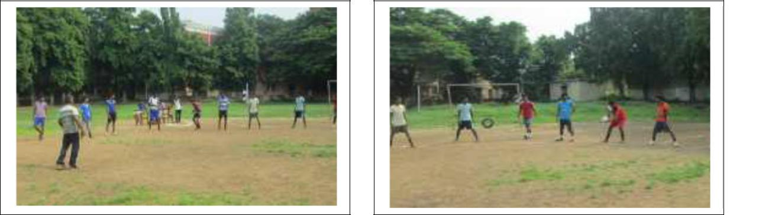
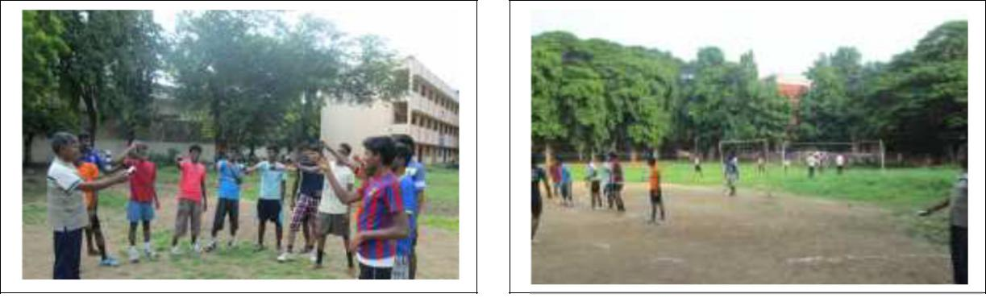
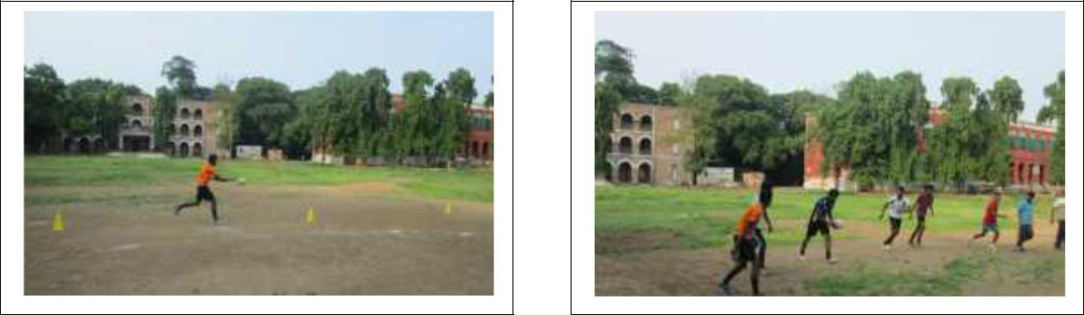

163

APPENDIX J

TRAINING PERIOD RELATED PHOTOS
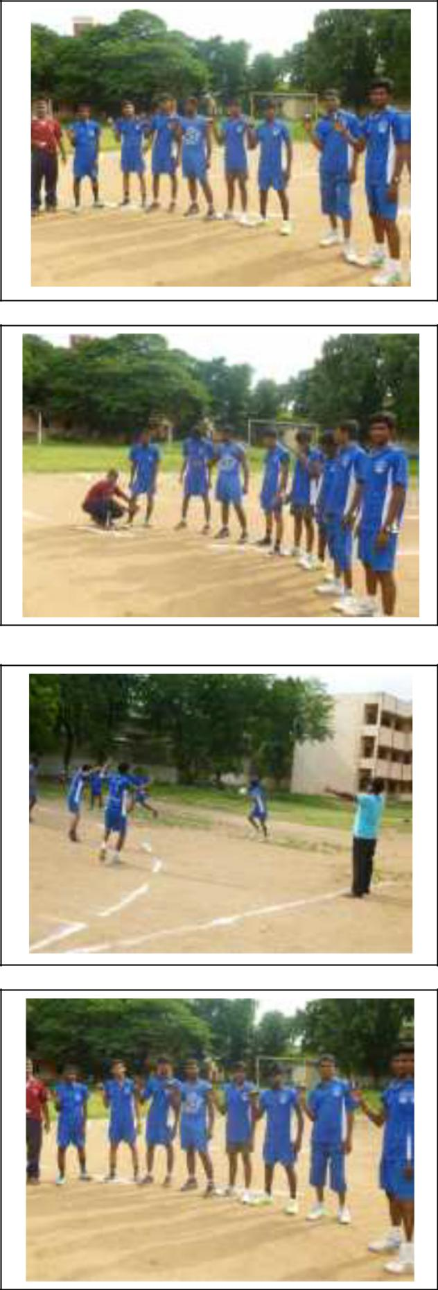

164

APPENDIX K

TRAINING RELATED SIGN LANGUAGE PHOTOS
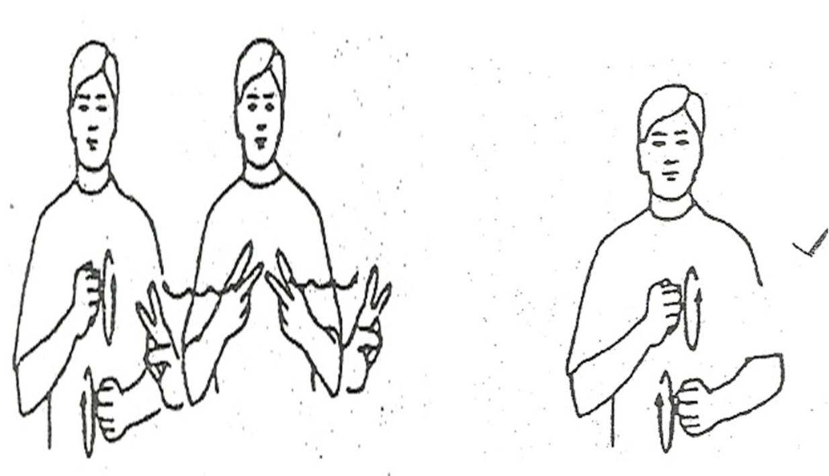

GAMES SPORTS
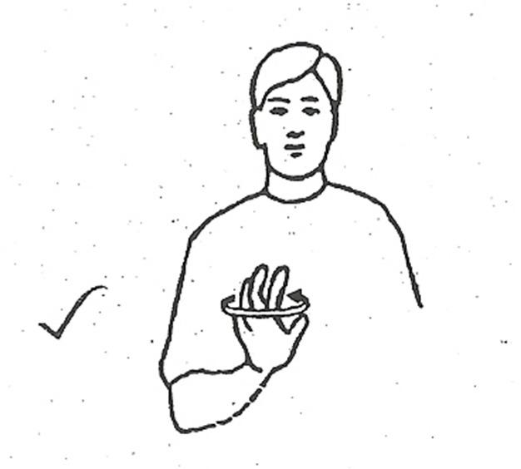

BALL

165

APPENDIX K (Contd…)
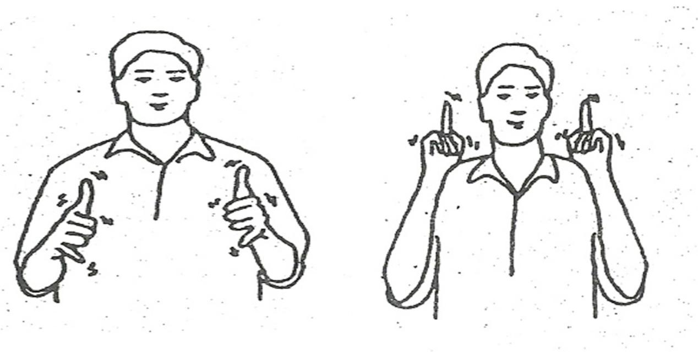

PLAY SIGN - 1 PLAY SIGN - 2
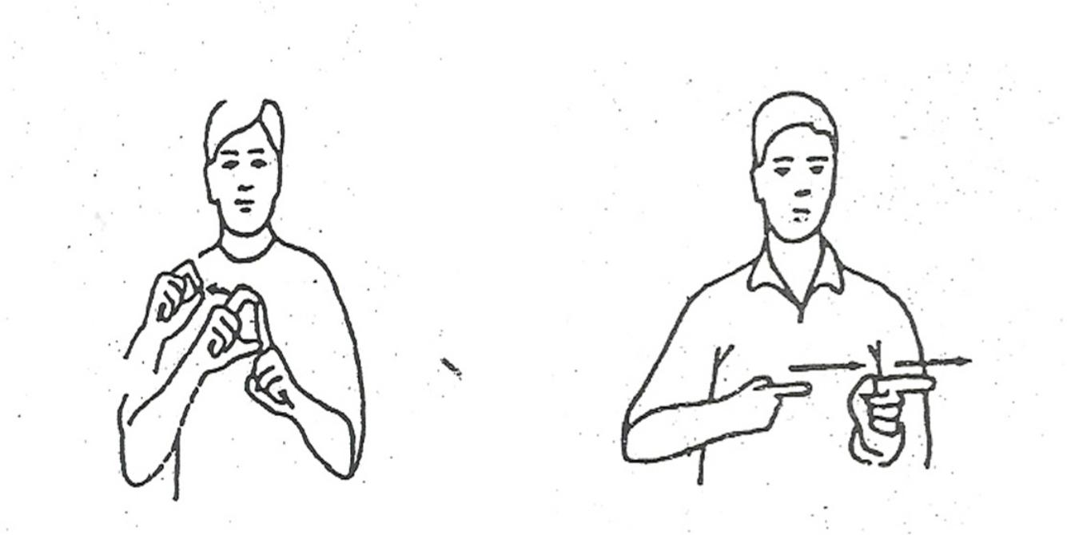

DO FOLLOW

166

APPENDIX K (Contd…)
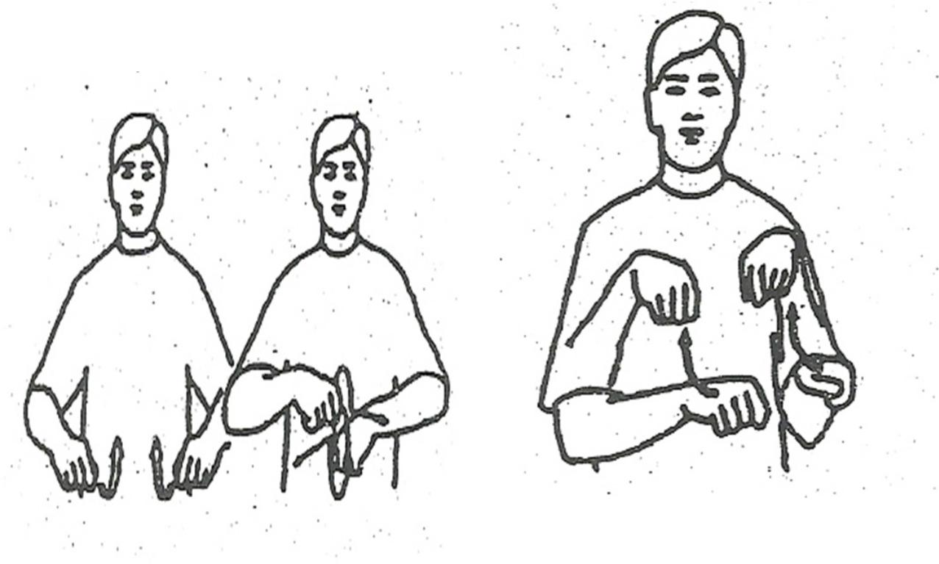

SHOE SOCKS
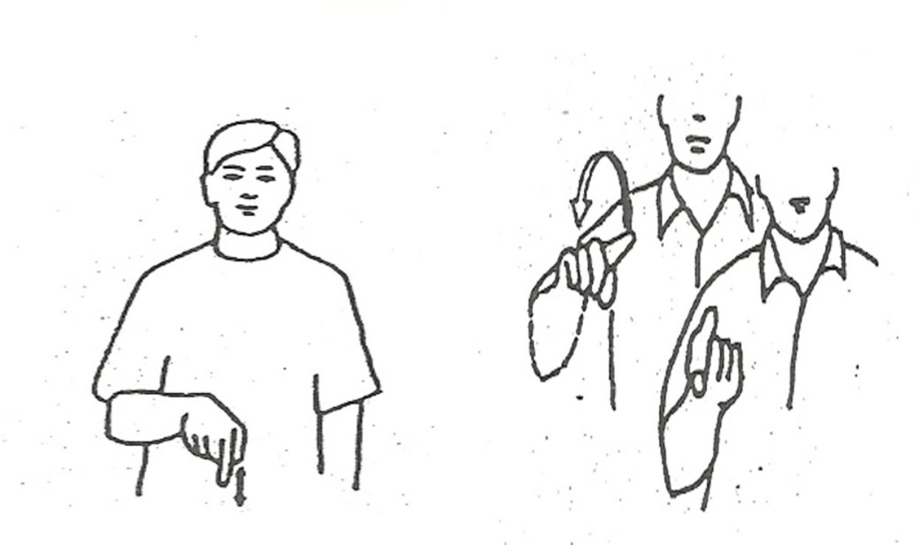

TODAY TOMORROW

167

APPENDIX K (Contd…)
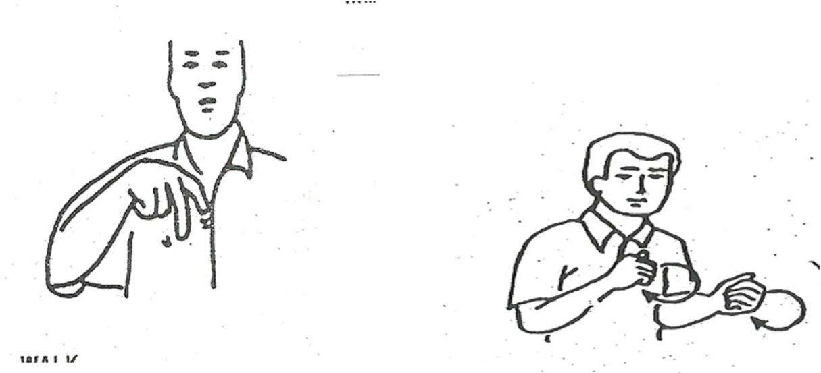

WALK RUN
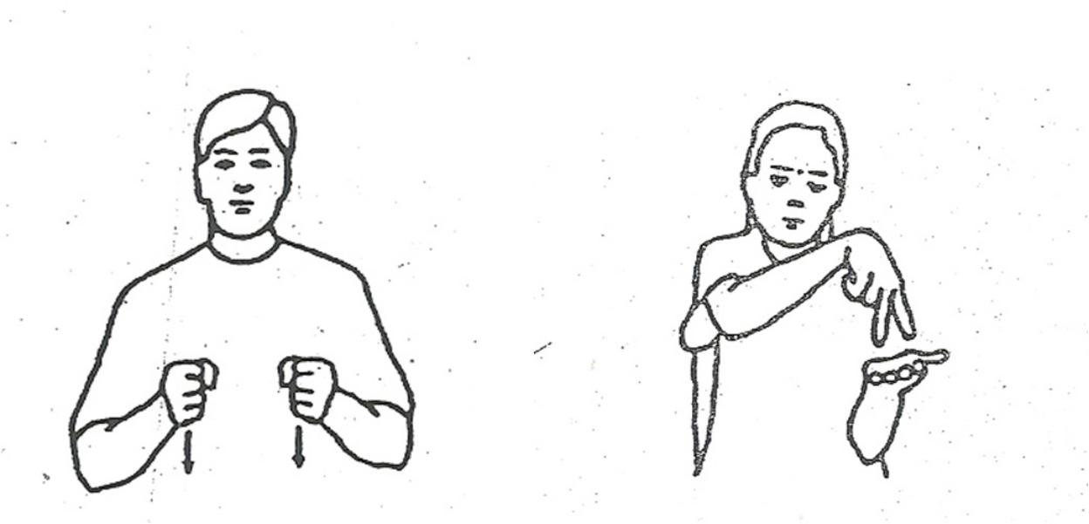

SIT STAND

168

APPENDIX K (Contd…)
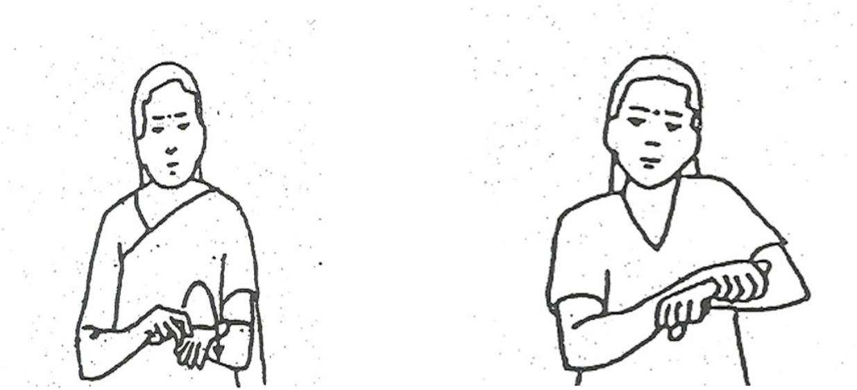

JUMP CATCH
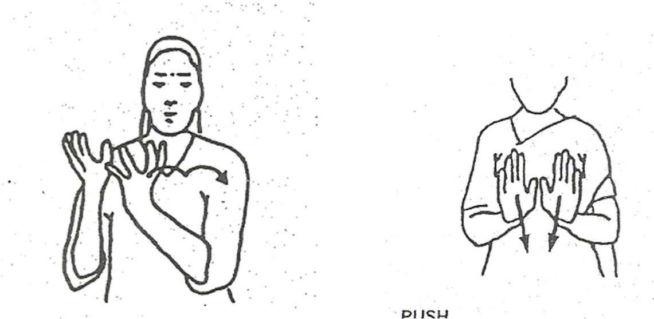

CARRY PUSH

169

APPENDIX K(Contd…)
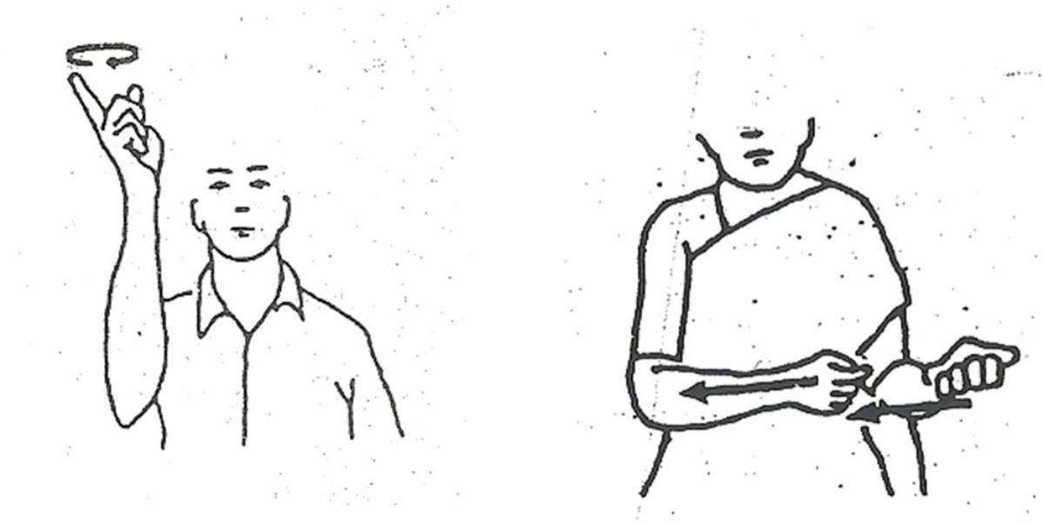

TRAVEL PULL
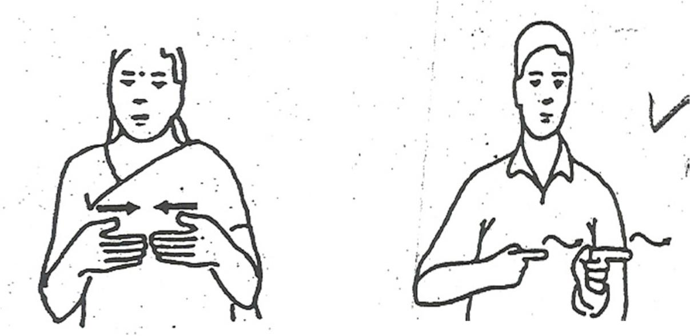

MEET CHASE

170

APPENDIX K (Contd…)
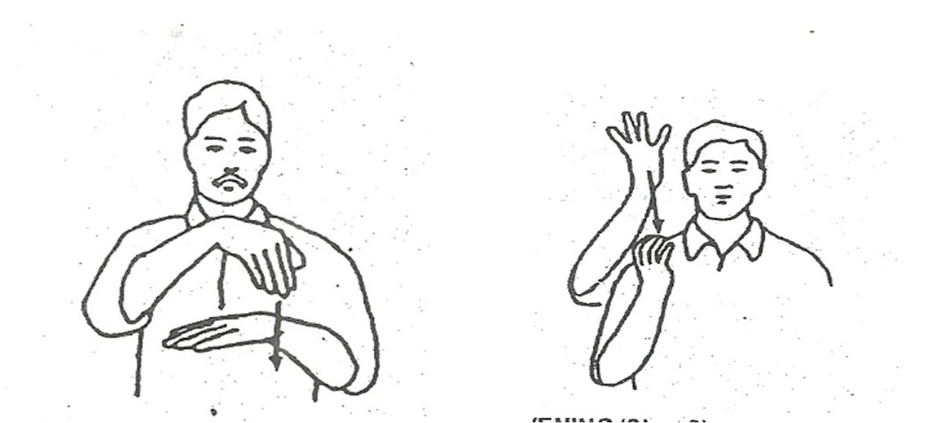

EVENING SIGN 1 EVENING SIGN 2
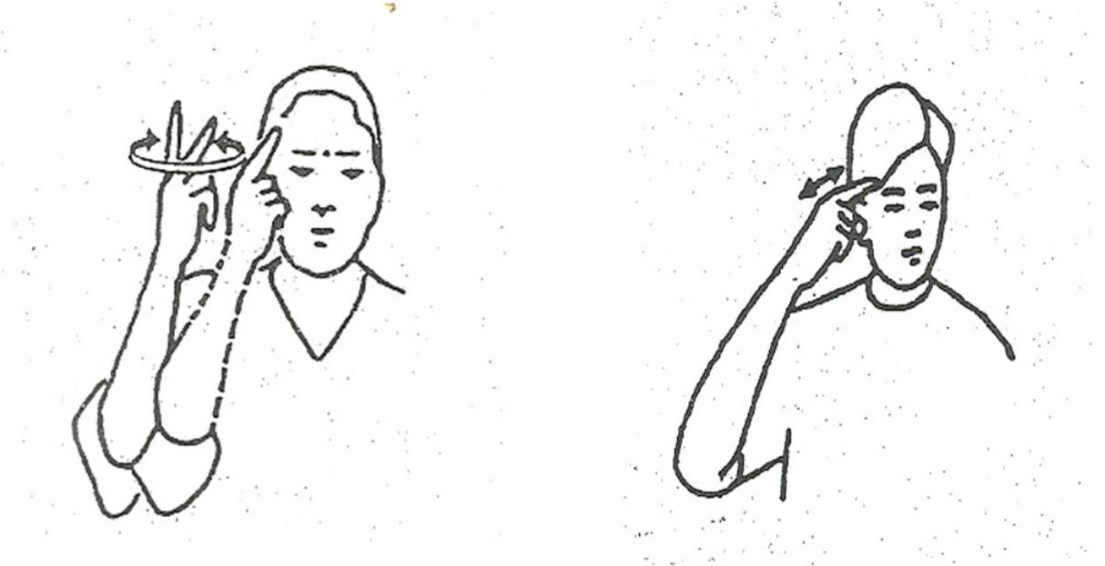

DOUBT THINK

