EFFECT OF DIFFERENT YOGIC PRACTICES ON

PHYSIOLOGICAL, HEMATOLOGICAL AND PSYCHOLOGICAL VARIABLES AMONG ADOLESCENT BOYS

DISSERTATION SUBMITTED TO THE TAMIL NADU PHYSICAL EDUCATION AND SPORTS UNIVERSITY, CHENNAI FOR
THE FULFILLMENT OF THE REQUIREMENTS
FOR THE AWARD OF DEGREE OF

DOCTOR OF PHILOSOPHY

IN

PHYSICAL EDUCATION

Submitted by

N. SAKTHIVEL

Guided by

Dr. A.M.MOORTHY

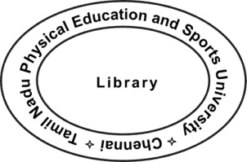

*99002136*

DEPARTMENT OF PHYSICAL EDUCATION

TAMIL NADU PHYSICAL EDUCATION

AND SPORTS UNIVERSITY
CHENNAI – 600 048

INDIA

JUNE - 2014

Dr. A.M. MOORTHY

Principal,

Koviloor Andavar College of Physical Education,

Koviloor, Tamil Nadu.

CERTIFICATE BY THE SUPERVISOR

This is to certify that the dissertation entitled “EFFECT OF DIFFERENT

YOGIC PRACTICES ON PHYSIOLOGICAL, HEMATOLOGICAL AND

PSYCHOLOGICAL VARIABLES AMONG ADOLESCENT BOYS” is a record of research work done by N.SAKTHIVEL a part time scholar of Doctor of Philosophy, in Physical Education, Tamil Nadu Physical Education and Sports University, Chennai during the year 2009 – 2012.

This dissertation is his original work and it has not previously formed the basis for the award to any candidate, for any degree, diploma, associateship or other similar titles. This dissertation represents, entirely an independent work on the part of the candidate but for the general guidance by me.

Station: Koviloor

Date: Supervisor

ii

N.SAKTHIVEL,

Ph.D. Research Scholar (part time),

Department of Physical Education,

Tamil Nadu Physical Education and Sports University,

Chennai – 600 127.

DECLARATION BY THE RESEARCH SCHOLAR

I, N.SAKTHIVEL, part time research scholar of Doctor of Philosophy, in the Department of Physical Education hereby declare that the dissertation entitled “EFFECT OF DIFFERENT YOGIC PRACTICES ON PHYSIOLOGICAL,
HEMATOLOGICAL AND PSYCHOLOGICAL VARIABLES AMONG

ADOLESCENT BOYS” submitted to Tamil Nadu Physical Education and Sports University for the award of Doctor of Philosophy in Physical Education is my original work and it has not previously formed the basis for the award of any degree, diploma associateship, fellowship or any other similar title to any candidate of any University.

Station: Chennai

Date: (N.SAKTHIVEL)

iii

DEDICATED TO MY

Wife

P.RADHIKA

Daughter

S.R.TEJASWINI

iv

ACKNOWLEDGEMENTS

The investigator expresses his profound gratitude to his guide Dr.A.M. MOORTHY, Principal, Koviloor Andavar College of Physical Education, Koviloor, for the valuable and expert guidance and supervision extended throughout this study.

The research scholar is grateful to Professor Dr. Mrs. GRACE HELENA, Vice Chancellor (officiating), Tamil Nadu Physical Education and Sports University, Chennai, for providing necessary encouragement for completing the dissertation.

The researcher extends grateful acknowledgement to Dr. R. ELAGOVAN, Professor and Head, Department of Yoga, Dr. S. THIRUMALAI KUMAR, Associate Professor, Department of Physical Education, Mrs. S. SELVALAKSHMI and Mr. V. DURAISAMI, Assistant Professors, Department of Yoga, Mr. P. KUMARAVELU, Assistant Professor, Department of Physical Education, and other Heads of the Departments and all Faculty members of the Tamil Nadu Physical Education and Sports University for their gracious gestures to take up the study and for their moral support.

The investigator wishes to record his sincere thanks to the Librarian, Tamil Nadu Physical Education and Sports University and the Librarian, Alagappa University, Karaikudi for their help in collecting the materials relevant to this study.

Deep sense gratitude to the parents and teachers of Sreevatsa Viswanathan Vivekananda Vidyalaya Junior colleges, chitlapakkam, chennai, who permitted the scholar to take up the subjects without hesitation and with full commitment.

Deepest appreciation goes to the Lab Technician

Mr. K. THIRUKKALATHY, Megha Clinical Lab, Chromepet, Chennai-44 for his wonderful cooperation in collecting the physiological and heamotological variables.

v

The research scholar records his sincere gratitude to Mr.R.SEETHARAMAN, Asst. General Manager (Cargo), Coimbatore, Mrs.P.V.ANURADHA, M.A., B.Ed., the Principal, Sreevatsa Viswanathan Vivekananda Vidyalaya Junior college, Chitlapakkam, Chennai for encouraging him to take his higher studies and providing all needed facilities to undertake the yoga practices programme all days in the school premisses.

SAKTHIVEL.N

vi

TABLE OF CONTENTS

Page No.

Certificate by the supervisor ii

Declaration by the Research scholar iii

Dedication iv

Acknowledgements v

Table of contents vii

List of tables xiv

List of Illustrations xvii

List of Plates xix

 |  | CHAPTER-I
 |  | INTRODUCTION
1.1 | Yoga- A Practical Discipline of Indian Culture |  | 2
1.2 | History of Yoga |  | 2
1.3 | Contributions of Rishis and Saints to Yoga |  | 3
1.4 | History of Yoga in Indus Vally Civilization |  | 3
1.5 | History of Yoga in The Upanishads |  | 3
1.6 | History of Yoga in The Pathanjali Yoga Sutras |  | 3
1.7 | Pre Classical Yoga |  | 4
1.8 | Classical Yoga |  | 5
1.9 | Post Classical Yoga |  | 5
1.10 | Modern Yoga |  | 5
1.11 | Types of Yoga |  | 6
1.12 | Aim of Yoga |  | 7
1.13 | Need and Importance of Yoga |  | 7
 | 1.13.1 | Importance of Yoga | 7

vii

1.14 | Scope of Yoga Exercise |  | 8
1.15 | Yoga Benefits for All Ages |  | 8
1.16 | Asanas |  | 9
1.17 | Terminology of Asanas |  | 10
1.18 | Common Practice |  | 11
1.19 | Pranayama |  | 11
1.20 | Suryanamaskara |  | 12
1.21 | Benefits of Asanas |  | 12
1.22 | Number of Positions |  | 13
1.23 | The 84 Classical Yoga Asanas |  | 13
1.24 | Physiological Role of Yoga |  | 15
 | 1.24.1 | Physiological Effects of Yoga | 17
 | 1.24.2 | Science of Yoga | 18
 | 1.24.3 | Resting Heart Rate | 18
 | 1.24.4 | Importance of Resting Heart Rate | 19
 | 1.24.5 | Blood Pressure | 19
 | 1.24.6 | Effects of Yoga on Blood Pressure | 20
 | 1.24.7 | Importance of Blood Pressure | 20
1.25.1 | Self Concept |  | 20
1.25.2 | Self Esteem |  | 21
1.25.3 | Anxiety |  | 22
1.26 | Hematological Role of Yoga |  | 22
 | 1.26.1 | Red Blood Cells | 22
 | 1.26.2 | White Blood Cells | 23
 | 1.26.3 | Hemoglobin | 23
1.27 | Objectives of the Study |  | 24
1.28 | Statement of the Problem |  | 24

viii

1.29 | Hypothesis |  | 24
1.30 | Delimitations |  | 25
1.31 | Limitations |  | 26
1.32 | Definition of Terms |  | 26
 | 1.32.1 | Yoga | 26
 | 1.32.2 | Resting Heart Rate | 27
 | 1.32.3 | Systolic Blood Pressure | 27
 | 1.32.4 | Diastolic Blood Pressure | 27
 | 1.32.5 | Red Blood Cells | 27
 | 1.32.6 | Hemoglobin | 28
 | 1.32.7 | White Blood Cells | 28
 | 1.32.8 | Self Concept | 28
 | 1.32.9 | Self Esteem | 28
 | 1.32.10 | Anxiety | 29

 |  | CHAPTER-II
 | REVIEW OF RELATED LITERATURE |  | 30
 |  | CHAPTER-III
 | METHODOLOGY
3.1 | Selection of the Subjects |  | 63
3.2 | Selection of Variables |  | 63
 | 3.2.1 | Dependent Variables | 64
 | 3.2.2 | Independent Variables | 64
3.3 | Experimental Design |  | 66
3.4 | Pilot Study |  | 66
3.5 | Criterion Measures |  | 66
3.6 | Reliability Of Data |  | 67
3.7 | Reliability Of Instruments |  | 67
 |  | ix

3.8 | Tester’s Reliability |  |  | 68
3.9 | Orientation of the subjects |  |  | 68
3.10 | Trianing Program |  |  | 68
3.11 | Swami Sathyananda Saraswathi Yogic |  |  | 71
 | (Bihar School Of Yoga) Practices
 | 3.11.1 |  | Suryanamaskar- Salutation to The Sun | 71
 | 3.11.2 | Bhujangasana (Cobra Pose) |  | 77
 | 3.11.3 |  | Paschimottanasana (Back Stretching Pose) | 78
 | 3.11.4 |  | Ardhamatsyendrasana (Half Spinal Twist) | 79
 | 3.11.5 |  | Sarvangasana (Shoulder Stand Pose) | 80
 | 3.11.6 |  | Halasana (Plough Pose) | 81
 | 3.11.7 |  | Shavasana (Corpse Pose) | 82
 | 3.11.8 |  | Matsyasana (Fish Pose) | 83
 | 3.11.9 |  | Kapalbhati (Frontal Brian Cleansing) | 83
 | 3.11.10 |  | Yoga Nidra | 85
3.12 | Package Ii Yogi Practices –
 | Maharishi Mahesh Yogi’s Practices Training Program |  |  | 86
 | 3.12.1 |  | Vajrasana (Thunderbolt Pose) | 86
 | 3.12.2 |  | Sarvangasana (Shoulder Stand Pose) | 87
 | 3.12.3 |  | Matsyasana (Fish Pose) | 88
 | 3.12.4 |  | PaschiMottanasana (Back Stretching Pose) | 89
 | 3.12.5 |  | Halasana (Plough Pose) | 90
 | 3.12.6 |  | Dhanurasana (Bow Pose) | 91
 | 3.12.7 |  | Mayurasana (Peacock Pose) | 92
 | 3.12.8 |  | Ardha Matsyendrasana (Half Spinal Twist) | 93
 | 3.12.9 |  | Padahastasana (Hand To Foot Pose) | 94
 | 3.12.10 Shavasana (Corpse Pose) |  |  | 94
 | 3.12.11 Sukhapranayama (Easy Pose) |  |  | 95
 | 3.12.12 |  | Transcendental Meditation | 96
 |  |  | x

3.13 Administration of Tests
 | 3.13.1 | Physiological variables | 96
 | 3.13.2 | Hematological variables | 98
 | 3.13.3 | Psychological Variables | 101
 |  | CHAPTER - IV
 |  | ANALYSIS OF DATA AND RESULTS OF STUDY
4.1 | Overview |  | 105
4.2 | Test of Significance |  | 106
4.3 | Level of Significance |  | 106
4.4 | Computation of ‘T’ Test |  | 106
4.5 | Computation of Analysis Of Covariance |  | 110
4.6 | Results on Pulse Rate |  | 111
 | 4.6.1 | Discussion on Pulse Rate | 113
4.7 | Results on Systolic Blood Pressure |  | 115
 | 4.7.1 | Discussion on Systolic Blood Pressure | 117
4.8 | Results on Diastolic Blood Pressure |  | 119
 | 4.8.1 | Discussion on Diastolic Blood Pressure | 121
4.9 | Results on RBC |  | 123
 | 4.9.1 | Discussion on RBC | 125
4.10 | Results on Hemoglobin |  | 127
 | 4.10.1 | Discussion on Hemoglobin | 129
4.11 | Results on WBC |  | 131
 | 4.11.1 | Discussion on WBC | 133
4.12 | Results on Self Concept |  | 135
 | 4.12.1 | Discussion on Self Concept | 137
4.13 | Results on Self Esteem |  | 139
 | 4.13.1 | Discussion on Self Esteem | 141
4.14 | Results on Anxiety |  | 143
 | 4.14.1 | Discussion on Anxiety | 145

xi

CHAPTER V

SUMMARY, CONCLUSIONS AND RECOMMENDATIONS

5.1 | Summary |  | 147
5.2 | Conclusions |  | 149
5.3 | Recommendations for Implication |  | 150
5.4 | Recommendations for further study |  | 151
 |  | BIBLIOGRAPHY
 | Books |  | 152
 | Journals |  | 153
 | Unpublished Theses |  | 157
 | Websites |  | 158
 |  | APPENDICES
Data on Experimental Group-I |  |  | 159
(Swamy Sathyanandha Sarswati Yogic Practices)
Data on Experimental Group-II |  |  | 160
(Maharishi Mahesh Yogic Practices)
Data on Control Group |  |  | 161
Mukta Rani Rastogi’s self concept questionnaire |  |  | 163
Rosenberg’s self esteem scale |  |  | 157
Taylor manifest anxiety scale |  |  | 168
List of subjects
 | i. | Experimental group I | 170
 | ii. | Experimental group II | 170
 | iii. | Control group | 171

xii

ARTICLES

- Influence of Asanas, Pranayama and Meditation on Breath

Holding Time | 172

- Influence of Pranayama Practice on selected physiological

variables among Kabaddi Players | 176
List of plates (photos) | 181

xiii

LIST OF TABLES

Table |  | Page No.
I | Criterion Measures | 66
II | Training Schedule For Package I
 | Swami Sathyananada Saraswathi Yogic Practices | 69
III | Training Schedule For Package Ii
 | Maharishi Mahesh Yogi’s Yoga Practices | 70
IV | Significance Of Mean Gains & Losses Between
 | Pre And Post Test Scores On Selected Variables Of
 | Satyananda Saraswathi Yoga Group | 107

- Significance Of Mean Gains & Losses Between Pre And Post Test Scores On Selected Variables Of

 | Maharishi Mahesh Yoga Group | 108
VI | Significance Of Mean Gains & Losses Between
 | Pre And Post Test Scores On Selected Variables Of
 | Control Group | 109
VII | Computation Of Analysis Of Covariance Of Mean
 | Of Satyananda Saraswathi Yoga, Maharishi Mahesh
 | Yoga And Control Groups On Pulse Rate | 110
VIII | Scheffe’s Test For The Differences Between The
 | Adjusted Post Test Paired Means On Pulse Rate | 112
IX | Computation Of Analysis Of Covariance Of Mean
 | Of Satyananda Saraswathi Yoga, Maharishi Mahesh
 | Yoga And Control Groups On Systolic Blood Pressure | 114

xiv

- The Scheffe’s Test For The Differences Between The Adjusted Post Test Paired Means On Systolic Blood

 | Pressure | 116
XI | Computation Of Analysis Of Covariance Of Mean Of
 | Satyananda Saraswathi Yoga, Maharishi Mahesh
 | Yoga And Control Groups On Diastolic Blood Pressure | 118
XII | Scheffe’s Test For The Differences Between The
 | Adjusted Post Test Paired Means On Diastolic
 | Blood Pressure | 120
XIII | Computation Of Analysis Of Covariance Of Mean Of
 | Satyananda Saraswathi Yoga, Maharishi Mahesh Yoga
 | And Control Groups On Rbc | 122
XIV | The Scheffe’s Test For The Differences Between The
 | Adjusted Post Test Paired Means OnRbc | 124
XV | Computation Of Analysis Of Covariance Of Mean Of
 | Satyananda Saraswathi Yoga, Maharishi Mahesh
 | Yoga And Control Groups On Hemoglobin | 126
XVI | The Scheffe’s Test For The Differences Between The
 | Adjusted Post Test Paired Means on Hemoglobin | 128
XVII | Computation of Analysis of Covariance of Mean of
 | Satyananda Saraswathi Yoga, Maharishi Mahesh
 | Yoga And Control Groups On Wbc | 130
XVIII | The Scheffe’s Test For The Differences Between The
 | Adjusted Post Test Paired Means OnWbc | 132
XIX | Computation Of Analysis Of Covariance Of Mean Of
 | Satyananda Saraswathi Yoga, Maharishi Mahesh | 134
 | Yoga And Control Groups On Self Concept
XX | The Scheffe’s Test For The Differences Between The
 | Adjusted Post Test Paired Means OnSelf Concept | 136

xv

XXI | Computation Of Analysis Of Covariance Of Mean Of
 | Satyananda Saraswathi Yoga, Maharishi Mahesh
 | Yoga And Control Groups On Self Esteem | 138
XXII | Scheffe’s Test For The Differences Between The
 | Adjusted Post Test Paired Means On Self Esteem | 140
XXIII | Computation Of Analysis Of Covariance Of Mean Of
 | Satyananda Saraswathi Yoga, Maharishi Mahesh
 | Yoga And Control Groups On Anxiety | 142
XXIV | Scheffe’s Test For The Difference Between The
 | Adjusted Post Test Paired Means On Anxiety | 144

xvi

LIST OF ILLUSTRATIONS

Figure | Title | Page No.
I | Pre, Post And Adjusted Post Test Differences Of The
 | Satyananda Saraswathi Yoga, Maharishi Mahes Yoga And
 | Control Groups On Pulse Rate | 113
II | Pre Post And Adjusted Post Test Differences Of The
 | Satyananda Saraswathi Yoga, Maharishi Mahesh
 | Yoga And Control Groups On Systolic Blood Pressure | 117
III | Pre Post And Adjusted Post Test Differences Of The,
 | Satyananda Saraswathi Yoga, Maharishi Mahesh Yoga
 | And Control Groups On Diastolic Blood Pressure | 121
IV | Pre Post And Adjusted Post Test Differences Of The,
 | Satyananda Saraswathi Yoga, Maharishi Mahesh
 | Yoga And Control Groups On Rbc | 125
V | Pre Post And Adjusted Post Test Differences Of The,
 | Satyananda Saraswathi Yoga, Maharishi Mahesh Yoga
 | And Control Groups On Hemoglobin | 129
VI | Pre Post And Adjusted Post Test Differences Of The,
 | Satyananda Saraswathi Yoga, Maharishi Mahesh Yoga
 | And Control Groups On Wbc | 113
VII | Pre Post And Adjusted Post Test Differences Of The,
 | Satyananda Saraswathi Yoga, Maharishi Mahesh
 | Yoga And Control Groups On Self Concept | 137

xvii

VIII | Pre Post And Adjusted Post Test Differences Of The,
 | Satyananda Saraswathi Yoga, Maharishi Mahesh Yoga
 | And Control Groups On Self Esteem | 141
IX | Pre Post And Adjusted Post Test Differences Of The,
 | Satyananda Saraswathi Yoga, Maharishi Mahesh Yoga
 | And Control Groups On Anxiety | 145
X | Methodology Chart | 65

xviii

LIST OF PLATES

Photos | Page No.
Suryanamaskar- Salutation to The Sun | 71
Bhujangasana (Cobra Pose) | 77
Paschimottanasana (Back Stretching Pose) | 78
Ardhamatsyendrasana (Half Spinal Twist) | 79
Sarvangasana (Shoulder Stand Pose) | 80
Halasana (Plough Pose) | 81
Shavasana(Corpse Pose) | 82
Matsyasana (Fish Pose) | 83
Kapalbhati (Frontal Brian Cleansing) | 83
Yoga Nidra | 85
Vajrasana (Thunderbolt Pose) | 86
Sarvangasana (Shoulder Stand Pose) | 87
Matsyasana (Fish Pose) | 88
PaschiMottanasana (Back Stretching Pose) | 89
Halasana (Plough Pose) | 90
Dhanurasana (Bow Pose) | 91
Mayurasana (Peacock Pose) | 92
Ardha Matsyendrasana (Half Spinal Twist) | 93
Padahastasana (Hand To Foot Pose) | 94
Shavasana (Corpse Pose) | 94
Sukhapranayama (Easy Pose) | 95
Transcendental Meditation | 96

xix

1

CHAPTER I

INTRODUCTION

Yoga is a way of life. It is predominantly concerned with maintaining a state of equanimity at all costs. All Yoga schools of thought emphasize the importance of the mind remaining calm, because as the saying goes, only when the water is still can you see through it. Yoga Darshan or Yoga Philosophy also happens to be a valid discipline of Indian metaphysics (Brahma Vidhya). It is the result of human wisdom and insight on physiology, psychology, ethics and spirituality collected together and practiced over thousands of years for the well-being of humanity.

The basic idea of yoga is to unite the Atma or individual soul with the Paramatma or the universal soul. According to yoga philosophy, by cleansing one’s mind and controlling one’s thought processes, one can return to that primeval state, when the individual self was nothing but a part of the Divine Self. This is the sense encapsulated in the term `Samadhi’. The aim of the yogi is to be able to perceive the world in its true light and to accept the truth in its entirety.

In Sanskrit, the term ‘yoga’ stands for ‘union’. A yogi’s ultimate aim is to be able to attain this ‘union’ with the Eternal Self with the help of certain mental and physical exercises. It is often said that Hiranyagarbha (The Cosmic Womb) himself had originally advocated the traditional system of yoga, from which all other yoga schools have evolved. But for all extent knowledge of yoga and its practices, such as Yogasanas and pranayama, the entire credit goes to Maharishi Patanjali.

Patanjali systematized the various yogic practices and traditions of his times by encapsulating them in the form of aphorisms in his Yoga Sutra. In this momentous work, he describes the aim of yoga as knowledge of the self and outlines the eight steps or methods of achieving it. These are:

- Yamas or Eternal Vows

- Niyamas or Observances

- Yogasanas or Yoga Postures

2

- Pranayama or Breath Control Exercises

- Pratyahara or withdrawal of the senses from distractions of the outside world

- Dharana or concentration on an object, place or subject

- Dhyana or the continuance of this concentration – meditation and

- Samadhi or the ultimate state of yoga meditation.

1.1 YOGA - A PRACTICAL DISCIPLINE OF INDIAN CULTURE

Yoga is a psychological, physiological and spiritual discipline that has been an integral part of our Indian culture for centuries. Yoga is a complete science of life that originated about thousands of years ago in India and still been practiced in India for centuries.

1.2 HISTORY OF YOGA

Yoga we know today developed by tantric civilization existed in India more than ten thousand years ago. In the archeological excavation made in the Indus Valley Harappa and Mohenjo-Daro, many statues have been found depicting deities resembling Lord Shiva and Parvathi performing various Asanas and practicing meditation. According to the mythical condition, Shiva is said to be the founder of Yoga and Parvathi, his first disciple.

Yoga derived from Sanskrit word ‘yuj’ means to join or yoke or unite. Yoga is a systematic and methodical process to control and develop the mind and body to attain good health, balance of mind and self-realization.

Self-discipline, clean habits, self-control and determination are the important factors to keep in mind before practicing yoga. The proper knowledge of yogic system, Self-discipline, concentration of mind and punctuality in performing yogic exercises are very important to achieve the benefit of yogic practices.

Yoga is an ancient discipline. It is recognized as one of the most important and valuable gifts of Rishi culture as a science and an art of pure life style. Yoga helps the man to evoke hidden potentialities in a systematic and scientific way by which he becomes fuller individual. Physical, mental, intellectual and emotional, moral and

3

spiritual factor develop in a harmonious and integrated fashion to meet all-round challenge at the modern technological era.

1.3 CONTRIBUTIONS OF RISHIS AND SAINTS TO YOGA

Patanjali, the compiler of yoga sutra, was a young adept who had made a masterful contribution to the yoga philosophy. In his 196 sutras of four chapters the entire science of yoga is explained in his eight fold path of yogic practice called “Ashtanga Yoga”

Swami Satyananda Saraswathi of Bihar, disciple of Sivananda said “Yoga is not an ancient myth buried in oblivion. It is the most valuable inheritance of the present. It is the essential need of today and culture of tomorrow”.

The Vadalur Vallalar, Sri Aurobindo and mother of Pondicherry, Vedhanthri Maharishi andBrahamakumari’s organization all of them have given good contributions to the field of yoga.

1.4 HISTORY OF YOGA IN INDUS VALLEY CIVILIZATION

The archeological excavations of ancient civilization shows that even before 3000 BC yoga had evolved. The artifacts and the “Yogi glyptic” are testimony to the fact.

1.5 HISTORY OF YOGA IN THE UPANISHADS

During the period known as pre-classical yoga period, the Brihadaranyaka Upanishad makes the reference of yoga meditation and is clearly reflected in 900 BC to 400 BC. The Mahabharata and the Bhagavad-Gita (oldest Yoga Scripture) show the yoga history in 500 BC and 200 BC respectively. Even in Buddhism, the importance of yoga meditation and various yoga postures have been mentioned.

1.6 HISTORY OF YOGA IN THE PATANJALI YOGA SUTRAS

The main attempt to Patanjali was to define and normalize classical yoga form and is known as Patanjali eight fold path of yoga (Eight Limbs of Classical Yoga). This period is also known as the classical period of yoga.

4

The sage Patanjali reflected on the nature of men and the norms of the society during his time, and he expressed his observations very systematically in the form of aphorisms which deals with the entire span of life, beginning with the code of conduct and ending with the ultimate goal, emancipation and freedom. These aphorisms outline the fundamental tenets of yoga known as the eight limbs or Ashtanga yoga.

The eight steps are Yama, Niyama, Asana, Pranayama, Prathiyahara, Dharana, Dyana and Samadhi. These are sequential stages in an individual’s life journey through yoga. Each step must be understood and followed to attain the ultimate goal of yoga.

1.7 PRE CLASSICAL YOGA

The Pre-Classical Yoga period covers an extensive period of approximately 2,000 years; the creation of the Upanishads marks the beginning of this period, they are a huge work containing over 200 scriptures which describes the idea of karma, the cycle of birth and death, the moral causation from past actions and first mentioned the Koshas (one of five coverings of the soul), these explain three subjects: the ultimate reality (Brahman), the transcendental self (Atman) and the relationship between the two.

Around 500 B.C, the Bhagavad-Gita was created; it is a beautiful story of a conversation between the God-man Krishna and the prince Arjuna. In the Bhagavad-Gita, three aspects must be brought mutually in our existence: Bhakti (devotion), Jnana (knowledge), and Karma (cause and effect). The Gita then tried to unify the Yogic traditions of Bhakti Yoga, Jnana Yoga, and Karma Yoga searching to sacrifice the ego through self-knowledge and it is because of this that it has gained importance.

During this time, Yoga found its way into Buddhism too, the Buddha saw that the suffering is caused by desire, greed, and delusion, its Yoga stresses the importance of Meditation and ethics over Physical Postures. A revered figure named Vyasa, categorized the Vedic hymns into the 4 Vedic texts: Rig-Veda ("Knowledge of Praise"), Yajurveda ("Knowledge of Sacrifice"), Samaveda ("Knowledge of Melodies"), and Atharvaveda ("Knowledge of Atharvan"). Atharvan was a legendary Rishi.

5

1.8 CLASSICAL YOGA

The classical Yoga period is defined by the Yoga Sutra, composed by Patanjali. In Patanjali’s sutras; Yoga is presented in a standardized and approachable way; Patanjali has often been called the founder of Yoga because of this work. Patanjali believed that every individual is composed of Prakrti (matter) and Purusha (spirit) and that the goal of Yoga is to free the spirit from the material world. This is in severe dissimilarity to Pre-classical and Vedic Yoga, which signify the unification of the matter and the spirit.

1.9 POST CLASSICAL YOGA

Yogis of the past had not paid much attention to the physical body as they were focused on meditation and contemplation. A few centuries after Patanjali, Yoga took a turn, the new generation of yoga masters beginning to probe the hidden powers of the human body, developing a system where different exercises, in conjunction with deep breathing and meditation, would help to rejuvenate the physical body, prolong life and achieve enlightenment. The human body was regarded as the temple of the immortal soul.

The Post-Classical Yoga period gave a dramatic increase in Yogic literature and brought big changes to Yoga, with the developing of Hatha Yoga and other branches of Yoga. During this time, Yoga flourished and nowadays is practiced throughout the world. In contrast to classical Yoga, Post-Classical Yoga is focused in the appreciation of the present moment and the affirmation of the unity of everything

1.10 MODERN YOGA

Yoga arrived to the West during the late 1800’s. It can be attributed to many gurus, including Swami Vivekananda, a student of Ramakrishna who was commissioned to attend the 1893 Parliament of Religions in Chicago causing deep impression on the Americans. Other important Yoga gurus include Swami
Paramahamsa Yogananda, Swami Sivananda Radha, Sri Thirumalai Krishnamacharya, Yogi Swami Sivananda, Swami Satchidananda and Maharishi Mahesh Yogi who popularized Transcendental Meditation in the

6

1960’s. Dalai Lama is a great yogi from Tibet; he was awarded the Nobel Prize for peace and has inspired many westerners to learn more about Buddhism and Yoga.

Yogi Swami Sivananda taught the five principles of Yoga which are:

- Proper Relaxation (Savasana)

- Proper Exercise (Asanas)

- Proper Breathing (Pranayama)

- Proper Diet

- Positive Thinking and Meditation (Dhyana)

Yoga now has several schools or styles, all emphasizing the diverse aspects of the practice.

Nowadays, Yoga is the most diversified spiritual practice on the planet; it has gained enormous popularity throughout the last few years, and these days over 30 million people follow the Yoga message of peace.

1.11 TYPES OF YOGA

Various Types of Yoga benefit the human body and mind. While the ultimate goal of yoga is to unify body, mind and soul, there are different ways to achieve this aim. These various ways constitute the different types of yoga.

Yoga is broadly divided into eight types, namely Bhakti Yoga, Hatha Yoga, Jnana Yoga, Karma Yoga, Kundalini Yoga, Mantra Yoga, Bahiranga Yoga and Swara Yoga. Most of these kinds had been practiced in India since ages unknown. Certain factors, like, origin, history, style, technique and significance, differentiate one branch of yoga from the other. Through the development of one`s body, mind and psychic potencies, these ultimately lead to physical strength and further on to spiritual consciousness. Hence the final aim of all kinds of yoga is primarily the same: salvation. Most of the types of yoga also involve the usage of different poses or yoga Asanas, meditation and breathing exercises or Pranayamas.

7

1.12 AIM OF YOGA

In accordance with its nature, atman is completely spiritual; hence spiritual culture is natural to it. However, due to the results of previous actions performed in ignorance of their consequences, the atman remains incarcerated in the physical body and its energy, consciousness becomes shrouded in the darkness of ignorance, life after life. Ignorance causes us to forget our true identity as spiritual beings and hence makes us attached to temporary, non-essential matter. This results in the psyche coming in the grip of an intrusive type of fear that is never far away and always ready to attack. Thus the aim of yoga is to situate the atman in its original, constitutional position, i.e. freedom from false identification with the transitory physical body and mind. When this occurs the mind becomes free from fear, anxiety, suffering and delusion. Just as the fish cannot remain longer than a few minutes outside water, the atman, the spirit soul cannot remain happy in this transient mundane abode, not natural habitat.

1.13 NEED AND IMPORTANCE OF YOGA

The intermediate and advanced students, who insist on continuing their practices, get more and more of the taste of this great 5000+ year old wondrous way of life. Yoga is for the body, mind and spirit. One must learn to use his body, breath and mind to stretch, relax and energize himself.

1.13.1 IMPORTANCE OF YOGA

Yoga Brings down stress and enhances powers of relaxation Boosts physical strength, stamina and flexibility
Bestows greater powers of concentration and self-control Inculcates impulse Control
Helps in rehabilitation of old and new injuries

Intensifies tolerance to pain and enhances mental clarity Boosts functioning of the immune system
Enhances posture and muscle tone Improves blood circulation
Results in healthy, glowing skin

8

Cleanses and improves overall organ functioning

Bestows peace of mind and a more positive outlook to life Infuses a sense of balance and internal harmony

1.14 SCOPE OF YOGA EXERCISE

Near-perfect fitness routine, hatha yoga provides the means for people of any age not only to get and stay in shape but also to develop balance, coordination, and a sense of centeredness. It renews, invigorates, and heals the body - stretching and toning the muscles, joints, and spine and directing blood and oxygen to the internal organs (including the glands and nerves).Yoga is distinctly different from other kinds of exercise. It generates motion without causing strain and imbalances in the body. When practiced correctly, hatha yoga has no such negative effects on either the inner or outer body.

When done with dedication and purpose, hatha yoga can be a quite demanding, yet an immensely rewarding type of exercise. While not inherently aerobic, it involves almost every muscle in the body and challenges the body to work in a different and often more passive way. Since the limbs function as free weights, resistance is created by moving the body's center of gravity. This strengthening gives way to endurance as poses are held for longer periods of time.

Unlike conventional forms of exercise, such as weight training, walking, biking or hiking, hatha yoga stresses quality of movement over quantity. A consistent hatha yoga practice can quiet the mind and refresh the body, bringing health, relaxation, and happiness.

1.15 YOGA BENEFITS FOR ALL AGES

As well as being fun for children, learning yoga develops self-discipline and can enhance their physical and mental health. Asanas are good for developing coordination and help to improve concentration and memory. Regular practice can enable young people to keep their natural flexibility for many years.It can help teenagers to keep their youthful flexibility and give them the inner strength to say no to negative influences.

9

Older people often find that gentle yoga exercises allow them to retain mobility and may relieve problems such as arthritis and poor circulation.During pregnancy, yoga promotes good health in both mother and unborn child. Yoga Asanas lessen the effects of such problems as overweight, backache, and depression. Most women who practice yoga find that it can make labor easier and shorter. Although some Asanas have to be modified during pregnancy, their essence is perfectly suited to this time of expanded self-awareness. Pregnancy is also a very good time for meditation.

Everyone can benefit from following a regular yoga routine, as it counteracts many of the problems suffered in modern life. Asanas release the physical tensions caused by hours of sitting, deep breathing gives vitality by increasing the supply of oxygen to the brain and meditation enhances the powers of concentration. Yoga improves strength and flexibility in the mind as well as the body, and aids relaxation. Yoga can enable one to relax fully, and promotes sound sleep; it also improves digestion and stimulates circulation. It frees the practitioner physically and mentally, often heightening intuition and creativity.

1.16 ASANAS

Asana 'sitting down', 'to sit down' is a body position, typically associated with the practice of Yoga, originally identified as a mastery of sitting still. In the context of Yoga practice, asana refers to two things: the place where a practitioner (or Yogin, in general usage), yogi (male), or Yogini (female) sits and the manner (posture) in which he/she sits. In the Yoga sutras,Patanjali suggests that asana is "to be seated in a position that is firm, but relaxed" for extended, or timeless periods.

As a repertoire of postures were promoted to exercise the body-mind over the centuries to the present day, when yoga is sought as a primarily physical exercise form, modern usage has come to include variations from lying on the back and standing on the head, to a variety of other positions.However, in the Yoga sutras, Patanjali mentions the execution of sitting with a steadfast mind for extended periods as the third of the eight limbs of Classical or Raja yoga, but does not refer standing postures or Kriyas. Yoga practitioners (even those who are adepts at various complex postures) who seek the "simple" practice of chair-less sitting generally find it

10

impossible or surprisingly grueling to sit still for the traditional minimum of one hour (as still practiced in eastern Vipassana), some of them then dedicating their practice to sitting asana and the sensations and mind-states that arise and evaporate in extended sits.

Asana later became a term for various postures useful for restoring and maintaining a practitioner's well-being and improving the body's flexibility and vitality, with the goal of cultivating the ability to remain in seated meditation for extended periods. Asanas are widely known as "Yoga postures" or "Yoga positions". "Asana" quite simply means "a posture". Any way that we may sit, stand or position our hands is an asana. Therefore, many Asanas are possible. However, a particular posture that leads you to a higher possibility is called a Yogasana.

Yoga in the West is commonly practiced as physical exercise or alternative medicine, rather than as the spiritual self-mastery meditation skill.

1.17 TERMINOLOGY OF ASANA

The word Asana in Sanskrit does appear in many contexts denoting a static physical position, although traditional usage is specific to the practice of yoga. Traditional usage defines asana as both singular and plural. In English, plural for asana is defined as Asanas. In addition, English usage within the context of yoga practice sometimes specifies Yogasana or yoga Asana, particularly with regard to the system of the AshtangaVinyasa Yoga. That said,yogasana is also the name of a particular posture that is not specifically associated with the Vinyasa system, and that while "ashtanga" (small 'a') refers to the eight limbs of Yoga delineated below. Ashtanga (capital 'A') refers to the specific system of Yoga developed by Sri Krishnamacharya at the Mysore Palace.

In the Yoga Sutras, Patanjali describes asana as the third of the eight limbs of classical, or Raja Yoga. Asanas are the physical movements of yoga practice and, in combination with pranayama or breathing techniques constitute the style of yoga referred to as Hatha Yoga. In the Yoga Sutra, Patanjali describes asana as a "firm, comfortable posture", referring specifically to the seated posture, most basic of all the

11

asanas. He further suggests that meditation is the path to sam dhi; transpersonal self-realization.

The eight limbs are, in order, the Yamas (restrictions), Niyamas (observances), Asanas (postures), Pranayama (breathe work), Pratyahara (sense of withdrawal or non-attachment), Dharana (concentration), Dhyana (meditation) and Samadhi (realization of the true self or Atman, and unity with Brahman (The Hindu Concept of God)).

1.18 COMMON PRACTICE

In the Yoga Sutras, Patanjali suggests that the only requirement for practicing Asanas is that it be "steady and comfortable”. The body is held poised with the practitioner experiencing no discomfort. When control of the body is mastered, practitioners are believed to free themselves from the duality of heat/cold, hunger/satiety, joy/grief, which is the first step toward the attachment that relieves suffering. This non-dualistic perspective comes from the SankyaSchool of the Himalayan Masters.

Listed below are traditional practices for performing Asanas:

The stomach should be empty.

Force or pressure should not be used, and the body should not tremble.

Lower the head and other parts of the body slowly; in particular, raised heels should be lowered slowly.
The breathing should be controlled. The benefits of Asanas increase if the specific pranayama to the yoga type is performed.

If the body is stressed, perform Corpse Pose or Child Pose.

Such Asanas as Sukhasana or Shavasana help to reduce headaches.

1.19 PRANAYAMA

Pranayama, or breath control, is the Fourth Limb of Ashtanga, as set out by Patanjali in the Yoga Sutra. The practice is an integral part of both Hatha Yoga and AshtangaVinyasa Yoga in the execution of Asanas.

12

Patanjali describes pranayama as the control of the enhanced "life force" that is a result of practicing the various breathing techniques, rather than the exercises themselves. The entirety of breathing practices includes those classified as Pranayama, as well as others called Svarodaya, or the "science of breath". It is a vast practice that goes far beyond the limits of Pranayama as applied to Asana.

1.20 SURYA NAMASKARA

Surya Namaskara or the Salutation of the Sun, which is very commonly practiced in most forms of yoga, originally evolved as a type of worship of Surya, the Vedic solar deity. Surya is the Hindu solar deity by concentrating on the Sun, for vitalization.

The physical aspect of this practice 'links together' twelve Asanas in a dynamically expressed series. A full round of Surya Namaskara is considered to be two sets of the twelve Asanas, with a change in the second set where the opposing leg is moved first. The Asanas included in the sun salutation differ from tradition to tradition.

1.21 BENEFITS OF ASANAS

The physical aspect of what is called yoga in recent years, the Asanas, has been much popularized in the West. Physically, the practice of Asanas is considered to:

Improve Flexibility Improve Strength Improve Balance

Reduce Stress and Anxiety

Reduce symptoms of lower back pain

Be beneficial for asthma and chronic obstructive pulmonary disease (COPD) Increase energy and decrease fatigue
Shorten labor and improve birth outcomes

Improve physical health and quality of life measures in the elderly Improve diabetes management

13

Reduce sleep disturbances Reduce hypertension

Improve blood circulation

Control the complications of diabetes

The emphasis on the physical benefits of yoga, attributed to practice of the Asanas, has de-emphasized the other traditional purposes of yoga which are to facilitate the flow of Prana (vital energy) and to aid in balancing the Koshas (sheaths) of the physical and metaphysical body.

1.22 NUMBER OF POSITIONS

In 1959, Swami Vishnu-Devananda published a compilation of 66 basic postures and 136 variations of those postures. In 1975, Sri Dharma Mitra suggested that "there are an infinite number of Asanas.", when he first began to catalogue the number of Asanas in the Master Yoga Chart of 908 Postures, as an offering of devotion to his guru Swami Kailashananda Maharaj. He eventually compiled a list of 1300 variations, derived from contemporary gurus, yogis, and ancient and contemporary texts. This work is considered one of the primary references for Asanas in the field of yoga today. His work is often mentioned in contemporary references for Iyengar Yoga, Ashtanga Vinyasa Yoga, Sivananda Yoga, and other classical and contemporary texts.

1.23 THE 84 CLASSIC YOGA ASANAS

A group of 84 classic yoga Asanas taught by Lord Shiva is mentioned in several classical texts on yoga. Some of these Asanas are considered highly important in the yogic canon: texts that do mention the 84 frequently single out the first four as necessary or vital to attain yogic perfection. However, a complete list of Shiva's Asanas remains as yet unverified, with only one text attempting a complete corpus.

Commentary on this group of 84 Asanas in the classic yoga texts is as follows:

Patanjali's Yoga Sutra (4-2nd century BC) does not mention a single asana by name, merely specifying the characteristics of a good asana. Later yoga texts however, do mention the 84 Classic Asanas and associate them with Shiva.

14

The GorakshaSamhita (10-11th Century CE), or GorakshaPaddhathi, an early hatha yogic text, describes the origin of the 84 classic Asanas. Observing that there are as many postures as there are beings, and asserting that there are 8,400,000 species in all, the text states that Lord Shiva fashioned an asana for each 100,000, thus giving 84 in all, although it mentions and describes only two in detail: the Siddhasana and the Padmasana.

The Hatha Yoga Pradipika (15th century CE) specifies that of these 84, the first four are important, namely the Siddhasana, Padmasana, Bhadrasana and Simhasana.

The Hatha Ratnavali (17th century CE) is one of the few texts to attempt a listing of all the 84, although 4 out of its list do not have meaningful translations from the Sanskrit, and 21 are merely mentioned without any description. In all, 52 Asanas of the Hatha Ratnavali are confirmed and described by the text itself, or other Asana Corpora.

The GherandaSamhita (late 17th century CE) asserts that Shiva taught 8,400,000 Asanas, out of which 84 are preeminent, and "32 are useful in the world of mortals.

Siddhasana Padmasana Bhadrasana Muktasana Vajrasana Svastikasana, Simhasana Gomukhasana Virasana
Dhanurasana Mritasana Guptasana Matsyasana

Matsyendrasana

15

Gorakshana

Paschimottanasana Utkatasana

Sankatasana Mayurasana Kukkutasana Kurmasana
Uttanakurmakasana Uttanamandukasana Vrikshasana

Mandukasana Garudasana Vrishasana Shalabhasana Makarasana Ushtrasana Bhujangasana

In Shiva Samhita (17th -18th Century CE), the poses Ugrasana and Svastikasana replace the latter two of the Hatha Yoga Pradipika

1.24 PHYSIOLOGICAL ROLE OF YOGA

The central premise of yoga understanding of human physiology concerns the intake of Prana with the breath, as well as the Prana contained in physical food and liquids.

Kent defines Prana as the "motivating force of living matter", it is also referred to as the Life Force, “Chi”, in China or “Ki” in Japan.

In simple terms yoga tradition maintains that the human body consists not only of the physical structure but also the electrical emanations from the whole being, with varying degrees of density, known collectively as the aura, in a ratio of 2/3 physical and 1/3 electrical. The densest radiation of the aura consists of the etheric, which is contained inside the astral body, and extends just a few inches out from the skin, and

16

the finest radiation forms the outer level of the aura, called the causal body. (In some religious disciplines this is also referred to as the nerve body and/or the Akashic record.) The full extension of the aura is usually judged to be approximately 3 ft. but is variable according to process, general health and spiritual enlightenment.

Within the astral body, probably at the etheric level, are the "subtle revolving vortices of energy" (Sturgess) known as the chakras. These are the transformers "which receive, assimilate and distribute Prana" (Sturgess) to the physical body through their connections with the endocrine and nervous systems. Sturgess describes Prana as flowing first to the higher brain centers then filtering down through the six main chakras which are closely connected to the 3 central Nadis, which form part of the so called "subtle" nervous system permeating the physical body and the aura. (These central Nadis, running the length of the spine and the skull probably correspond with the "Governing Vessel", and the ascending dorsal section of the "Great Central Channel (meridian)", from the Chinese Acupuncture tradition(Gach).

Whilst Prana itself is a pure cosmic 'fuel', it is affected by the environment it appears into and as it moves through the chakras it connects with each individual's particular characteristics. The interplay of thoughts, attitudes, feelings, behavior patterns, habits and actions, as well as the social and environmental stresses the individual is subject to, will all have an effect (or warp factor) on the quality and quantity of Prana actually absorbed. So unremitting stress, "artificial values stemming from acquisitiveness and self-interest" alienation from spiritual purpose and the many and varied strains of an unnatural way of 21st century life, will all help to diminish the value of the prana received. The human vehicle then ends up running on low octane or polluted energy causing malfunction and 'dis ease', with resultant physical manifestations in vulnerable areas.

Yoga is sometimes referred to as the science of religion with the view that the human body is a vehicle for the spirit and soul (perhaps best viewed as the passenger and chauffeur!) It offers a number of tools with which to tune and rebalance the 'vehicle', so that it is able to attract the appropriate level and quantity of Prana, and fulfill the human function. Asana and pranayama techniques "cleanse the body of tensions, toxins and impurities and release energy blocks, which impede the

17

harmonious flow of energy in the body." (Sturgess) Meditation techniques have several benefits. For example, not only do they allow a deeper connection to the inner life, which can lead to greater understanding of the actual causes of a person's 'dis ease', they also allow an increase in the connection to, and sharing of, the higher levels of the life force, which are themselves healing and enlightening to the body, mind, soul and spirit.

Yoga, it is believed,, has been evolving and practiced for at least 3 thousand years, and inevitably many schools and disciplines have emerged differing in detail but with the central themes remaining intact. These understandings have arrived during states of deep meditation and resultant 'intuition'. This has come about through connection to what is described as the "vast mind realm" and which in yoga literature is referred to as the "watershed of knowledge" within the ultimate state of meditation, Samadhi. In psychological terminology this might be described as the higher end of the bar of Jung's collective unconscious, or the superconscious. In some ancient writings this can be referred to as the "astral light" of which there are said to be 7 levels, from high to low.

1.24.1 PHYSIOLOGICAL EFFECTS OF YOGA

It is very necessary to keep the body healthy and fit inside out. Yogasanas are done for keeping the internal and external parts of the body healthy. Yoga asanas are carried out to get relief from pain and bring about improvement from various disorders. The yoga postures can also help to bring flexibility to the joints and tendons. It can improve the mental wellbeing of the body. Yoga Asanas are useful in carrying out various functions in the body harmoniously. Achievement of harmony in the body activities can result in development of flexibility. When different asanas are carried out systematically, it can help in massaging the organs and improving its functions thus enhancing the health of the individual.

It can improve the blood circulation in the body and allow unrestricted flow of blood to various parts of the body. Yoga Asanas are also essential for removing the toxins or negative blocks in the body. It can help in toning the muscles and improving the strength of the muscles. Asanas are considered as effective stress busters that can

18

relieve an individual from tension and worry. The slow breathing exercises and meditation carried out can help in relaxation thus improving the quality of life. With yoga asana, ageing is delayed and the person may look young from outside as well from inside.

Yoga Asanas are called as non-violent activity as less amount of energy is expended while doing the yoga poses. Hence, the person does not feel tired. Yoga Asanas are simple and trouble free that can improve the strength and endurance of the body. Certain positions like standing, twisting, bending and balance help in gaining the balance of the mind and the body.

1.24.2 SCIENCE OF YOGA

Yoga is a great science which everyone can practice according to his or her own capacity. Maybe not all, but at least a few techniques can be practiced each day. Yoga techniques along with asana and a few Pranayama are sufficient for most people. It is necessary to practice these preparatory limbs first. While practicing pranayama your mind will be lifted into a new realm of consciousness.

1.24.3 RESTING HEART RATE

Resting heart rate is a person's heart rate when they are at rest, awake but lying down, and not having immediately exerted themselves. The healthy resting heart rate in adults tends to be around 60–80 bpm, with rates below 60 bpm known as bradycardia and rates above 110 bpm known as tachycardia. Note however that conditioned athletes often have resting heart rates below 60 bpm. Tour de France cyclist Lance Armstrong has a resting HR around 32 bpm, and it is not unusual for people doing regular exercise to have resting pulse rates below 50 bpm. Other cyclists like Miguel Indurain and Alberto Contador have reported resting heart rates in the mid 20’s.

Heart rate is measured by finding the pulse of the heart. This pulse rate can be found at any point on the body where the artery's pulsation is transmitted to the surface by pressuring it with the index and middle fingers; often it is compressed against an underlying structure like bone. (A good area is on the neck, under the corner of the jaw) The thumb should not be used for measuring another person's heart

19

rate, as its strong pulse may interfere with the correct perception of the target pulse.(Barry, 1982).

1.24.4 IMPORTANCE OF RESTING HEART RATE

The more you work out the lower your resting pulse is, and the lower your resting pulse is the less hard your heart has to work. The best way to think about is to view your heart as a muscle, and the more you work it the stronger it gets. A stronger heart means more blood with each beat, and the same amount of work can be done with fewer beats.

A higher resting pulse than usual can be a sign of over-training or illness. When you are recovering from a workout, your metabolism and heart are working harder to repair your body and get it back to a homeostasis. Therefore, if in the morning you have a higher resting heart rate than usual, your body could still be in a state of repair and you should adjust your workout regimen accordingly to prevent over-training or injury.

The best thing to do is to work out for at least 1 hour a day, 3 days a week (and preferably more). Aerobic exercise is the very best way to maintain a healthy resting pulse. Some other ways to lower your resting pulse is to make sure you regularly get a full night’s sleep, stay hydrated, quit smoking, meditation and maintain a healthy weight.

1.24.5 BLOOD PRESSURE

Blood pressure (BP), sometimes referred to as arterial blood pressure, is the pressure exerted by circulating blood upon the walls of blood vessels, and is one of the principal vital signs. When used without further specification, "blood pressure" usually refers to the arterial pressure of the systemic circulation. During each heartbeat, blood pressure varies between a maximum (systolic) and a minimum (diastolic) pressure. The blood pressure in the circulation is principally due to the pumping action of the heart. Differences in mean blood pressure are responsible for blood flow from one location to another in the circulation.

20

1.24.6 EFFECTS OF YOGA ON BLOOD PRESSURE

Yoga can be a very effective and non-invasive way of reducing high blood pressure. It is particularly effective in reducing the diastolic number – which is the most important. It is suggested that people with high blood pressure should only practice certain Asanas (postures), whilst acknowledging that there are other Asanas that are not suitable for them. The yogic practices of meditation and pranayama (breathing exercises) are also particularly beneficial for people who suffer from high blood pressure.

Regular practice of yoga increases the Baroreflex sensitivity and decreases the sympathetic tone, thereby restoring blood pressure to normal level in patients of essential hypertension. Meditation by modifying the state of anxiety reduces stress – induced sympathetic over activity thereby decreasing arterial tone and peripheral resistance, and resulting in decreased diastolic blood pressure and heart rate. This may suggest that yoga is more effective in reducing the basal heart rate and blood pressure in morbid conditions like obesity.

1.24.7 IMPORTANCE OF BLOOD PRESSURE

Blood pressure is important because the higher your blood pressure is, the higher your risk of health problems in the future. If your blood pressure is high, it is putting extra strain on your arteries and on your heart. Over time, this strain can cause the arteries to become thicker and less flexible, or to become weaker.

If your arteries become thicker and less flexible, they will become narrower, making them more likely to become clogged up. If an artery becomes completely clogged up (known as a clot), this can lead to a heart attack, a stroke, kidney disease or dementia. More rarely, if an artery has become weakened, the extra strain may eventually lead to the artery bursting. This may also cause a heart attack or stroke.

1.25.1 SELF CONCEPT

Self-concept is our perception or image of our abilities and our uniqueness. At first, one's self-concept is very general and changeable... As we grow older, these self-

21

perceptions become much more organized, detailed and specific.(Pastorino& Doyle-Portillo, 2013)

Research studies have proved that the practice of Yoga brings profound change in an individual. Yoga is a way of life that teaches how best to live for the well-being of the individual and development of a healthy society. Positive changes in the life style of the individual can be brought through practicing it. Yoga develops the physical, mental, intellectual, emotional and spiritual component which helps in building up a sound personality. Self-Concept is the sum total of a person's perception, feelings and beliefs about himself. It is the basis for all motivated behaviors. The present study is an attempt to assess the impact of Yoga on Self-Concept.

1.25.2 SELF ESTEEM

Self-esteem is a term used in psychology to reflect person's overall emotional evaluation of his or her own worth. It is a judgment of oneself as well as an attitude toward the self. Self-esteem encompasses beliefs (for example, "I am competent," "I am worthy") and emotions such as triumph, despair, pride and shame. The self-concept is what we think about the self; self-esteem is the positive or negative evaluations of the self, as in how we feel about it. Self-esteem is also known as the evaluative dimension of the self that includes feelings of worthiness, pride and discouragement. One's self-esteem is also closely associated with self-consciousness (Smith and Mackie,2010)

Self-esteem and stress are deeply connected. When you know how to avoid the signs of chronic stress like rapid heartbeat, cortisol production and high blood pressure, then it can help you to be more confident and develop better self-esteem in other areas as well. Yoga trains you to feel strong mentally and to believe in yourself, so you can leave fear and shyness behind and start succeeding in everyday life. It keeps you healthy, happy and fit. And it physically and mentally re-energizes you, training you to be pro-active.

22

1.25.3 ANXIETY

Anxiety is an unpleasant state of inner turmoil, often accompanied by nervous behavior, such as pacing back and forth and somatic complaints. It is the subjectively unpleasant feelings of dread over something unlikely to happen, such as the feeling of imminent death. Anxiety is not the same as fear, which is felt about something realistically intimidating or dangerous and is an appropriate response to a perceived threat; anxiety is a feeling of fear, worry, and uneasiness, usually generalized and unfocused as an overreaction to a situation that is only subjectively seen as menacing. It is often accompanied by restlessness, fatigue, problems in concentration, and muscular tension. Anxiety is not considered to be a normal reaction to a perceived stressor although many feel it occasionally.

By reducing perceived stress and anxiety, yoga appears to modulate stress response systems. This, in turn, decreases physiological arousal — for example, reducing the heart rate, lowering blood pressure, and easing respiration. There is also evidence that yoga practices help increase heart rate variability, an indicator of the body's ability to respond to stress more flexibly. Practicing yoga can not only be an effective stress reliever, but also a way to ease symptoms of anxiety and depression. By transferring focus and attention to the body and breath, yoga can help to temper anxiety while also releasing physical tension.

1.26 HEMATOLOGICAL ROLE OF YOGA

Hematology, also |  | spelled ‘haematology’ is |  |  | the study | of blood, the blood-
forming | organs, and | blood | diseases. | Hematology |  | includes | the | study
of etiology, diagnosis, treatment, prognosis, |  |  |  | and prevention of blood |  |  | diseases that
affect | the production | of | blood and | its | components, such |  |  | as blood
cells, hemoglobin, blood proteins, and the mechanism of coagulation.

1.26.1 RED BLOOD CELLS

Red blood cells are also known as RBCs, red cells,red blood corpuscles (an archaic term), hematids, erythroid cells or erthyocytes (from Greek erythros for “red” and kytos for “hollow vessel”, with -cyte translated as "cell" in modern

23

usage). Packed red blood cells (pRBC) are red blood cells that have been donated, processed, and stored in a blood bank for blood transfusion.

Yoga has been shown to increase the level of red blood cells in the body. Red blood cells are responsible for carrying oxygen through the blood, and avoid anemia and low energy.

1.26.2 WHITE BLOOD CELLS

White blood cells, or leukocytes (also spelled "leucocytes"), are the cells of the immune system that are involved in defending the body against both infectious disease and foreign materials. Five different and diverse types of leukocytes exist, and several types (including monocytes and neutrophils) are phagocytic. All leukocytes are produced and derived from a multipotent cell in the bone marrow known as a hematopoietic stem cell. They live for about three to four days in the average human body. Leukocytes are found throughout the body, including the blood and lymphatic system.

Bow pose puts pressure on the belly, which makes the digestive system stronger and healthier by sending blood flow to the abdominal organs. Since the digestive system is full of lymphocytes, or small white blood cells that fight invaders, that also means a stronger and healthier individual.

Dynamic Immune Boosting Sequence (Down Dog Vinyasa): This short dynamic sequence, which targets the circulatory system, is an excellent all-around warm-up. It stretches and strengthens most major muscle groups and promotes circulation, helping white blood cells move through the body to fight invaders.

1.26.3 HEMAOGLOBIN

Hemoglobin also spelled haemoglobin and abbreviated Hb or Hgb, is the iron-containing oxygen-transport metalloproteinin the red blood cells of all vertebrates (with the exception of the fish family Channichthyidae as well as the tissues of some invertebrates. Hemoglobin in the blood carries oxygen from the respiratory organs (lungs or gills) to the rest of the body (i.e. the tissues) where it releases the

24

oxygen to burn nutrients to provide energy to power the functions of the organism in the process called metabolism.

Regular practice of different yoga poses increases the RBC production as well as purifies the blood. According to various yoga gurus, anemic patients should start their yoga session with Pranayama followed by Trikonasana. It improves health thereby attaining eternity. Yoga releases the toxins from the body and tries to be in full harmony with nature with the basic 3 aspects of the human elements: the mind, the mental and the spiritual.

1.27 OBJECTIVES OF THE STUDY

- To find out the effect of yogic practices on physiological variables – Resting Heart Rate, Systolic and Diastolic Pressure
- To find out the effect of yogic practices on psychological variables – Self-concept, Self-esteem and Anxiety
- To find out the effect of yogic practices on Hematological variables – RBC, WBC and Hemoglobin.
- To find out the influence of two different schools of yoga practice namely Sathyananda Sarawathi and Maharishi Mahesh among adolescent school boys.

1.28 STATEMENT OF THE PROBLEM

The purpose of the study was to find out the effects of two different schools of yoga practices on selected Physiological, Hematological and Psychological variables among adolescent school boys.

1.29 HYPOTHESES

- It was hypothesized that Sathyananda Saraswathi Bihar School of Yoga Practices and Maharishi Mahesh Yogi’s school of Yoga practices would significantly decrease Resting Heart Rate, Diastolic and Systolic Blood Pressure among adolescent school boys.
- It was hypothesized that Sathyananda Saraswathi Bihar School of Yoga Practices and Maharishi Mahesh Yogi’s school of Yoga practices would

25

significantly increase Red Blood Corpuscles, Haemoglobin Count and White Blood Corpuscles in blood among adolescent school boys.
- It was hypothesized that Sathyananda Saraswathi Bihar School of Yoga Practices and Maharishi Mahesh Yogi’s school of Yoga practices would significantly decrease Anxiety, increase Self Concept and Self Esteem among adolescent school boys.
- It was hypothesized that there would be no significant differences between the effects of Sathyananda Saraswathi Bihar School of Yoga Practices and Maharishi Mahesh Yogi’s school of Yoga practices on the selected Physiological, Psychological and Hematological variables among adolescent school boys.

1.30 DELIMITATIONS

  - The subjects for the study were randomly selected from Sreevatsa Viswanathan Vivekananda Vidyalaya Junior college, chitlapakkam, Chennai.
  - Only 45 boys studying in XI standard were selected as subjects for the study

  - The age of the subjects ranged from 16 to 18 years.

  - Yoga practices prescribed by of Sathyananda Saraswathi Bihar School of Yoga and Maharishi Mahesh Yogi’s school of Yoga only were selected for the study.

  - The Yoga practices were administered to only 15 subjects in each experimental group one hour a day for 6 days for a period of 12 weeks only.
  - The following dependent variables were chosen for the study.

A.PHYSIOLOGICAL VARIABLES

Resting Heart Rate

Diastolic Blood Pressure Systolic Blood Pressure

- HEMATOLOGICAL VARIABLES

Red Blood Cells Hemoglobin

White Blood cells

26

- PSYCOLOGICAL VARIABLES

Self-Concept Self Esteem Anxiety

1.31 LIMITATIONS

- Atmospheric temperature changes and diet were not taken into consideration during the practice sessions.
- The subjects were instructed on the benefits of yoga practices in general and no specific motivational technique was implied to inspire them on any type of yogic package.
- No attempt was made to control the subjects from participating in other extracurricular activities.
- The source of literature was confined to the libraries of Tamil Nadu Physical Education and Sports University, Chennai and Alagappa University, Karaikudi and also the internet.

1.32 DEFINITION OF TERMS

1.32.1 Yoga

Yoga is usually defined as union: union between the limited self and the Divine Self. The aim of Yoga is not really to unite us with anything for we are already united. It is to help us realize our identity with the Divine Self, to make us know and tune into our intrinsic nature. There are many definition of yoga, which apply to all level of existence and awareness. At the physical level, we need to harmonize the functions of different organs, muscles and nerves so that they do not hamper or oppose each other. Disharmony in various body parts and systems brings about inefficiency and lethargy or clumsiness. Moreover, it manifests in diseases in the body
(www.parmarth.com).

The word Yoga is derived from the Sanskrit root “yuj” to bind, join, attach and yoke, to direct and concentrate one’s attention on, to use and apply. It also means union or communion. It is the true union of our will with the will of God. It thus

27

means, says Mahadev Desai in his introduction to the Gita according to Gandhi, the yoking of all the powers of body, mind and soul to God; it means the disciplining of the intellect, the mind, the emotions, the will, which that Yoga presupposes; it means a poise of the soul which enables one to look at life in all its aspects evenly. (Iyengar,

1997)

1.32.2 Resting Heart Rate

The resting heart rate of the body (commonly called RHR) is the number of contractions of the heart that occur in a single minute while the body is at complete rest. This number will vary depending upon the age, gender, and general health of a person. There will also be a large different in the resting heart rate of athletes when compared to non-athletes(www.healthstatus.com)

1.32.3 Systolic Blood Pressure

Systolic Blood Pressure occurs during the systole of the heart. When the left ventricle forces blood into the aorta the pressure rises to the peak (maximum). This is called systolic blood pressure. The range of the pressure is about 100 to 120 mmHg for a normal adult. (Sivaramakrishnan., 2006).

1.32.4 Diastolic Blood Pressure

Diastolic Blood Pressure occurs during the diastole of the heart. The lowest value in pressure is called diastolic blood pressure. Diastolic pressure is about 60 to 80 mmHg for a normal adult. (Sivaramakrishnan., 2006).

1.32.5 Red Blood Cells

Red Blood Cells are small circular, biconcave, disc shaped cells. There are about 5 million red blood cells per cubic millimeter of blood. They have a respiratory pigment called hemoglobin. Red cells transport oxygen. They are synthesized in bone marrow found at the ends of bones. The average life of a red cell is about 120 days.(Sivaramakrishnan., 2006).

28

1.32.6 Hemoglobin

Hemoglobin is a complex protein with more iron. It combines with oxygen to form oxyhemoglobin in the red cells. 15 grams per 100 ml of blood is present in normal blood.(Sivaramakrishnan., 2006).

1.32.7 White Blood cells

White Blood cells are colourless and transparent. They contain a nucleus and are larger than red blood corpuscles. There are about 8000 cells in each cubic millimeter of blood.(Sivaramakrishnan., 2006).

1.32.8 Self-Concept

Self–concept is defined as something of which we are immediately aware. We think of it as the warm, central, private region of our life. As such it plays a crucial part in our consciousness (a concept broader in itself), in our personality (a concept broader than consciousness), and in our organism (a concept broader than personality). Thus it is some kind of core in our being( Allport., 1961).

Self – Concept is a person s total internet view of self in relation to the experience of being and functioning within the environment. It includes value attached to such a view”(Gilliand, 1998).

Self-concept has been variously defined as “The self as known to the self” (Murphy, 1947).

The term self –concept has come into common use, to refer to the second meaning, which refers to the phenomenological approach. Self-concept refers to “The pictures or images a person has himself” (Taneja, 1991).

1.32.9 Self Esteem

Self-esteem is the positive or negative evaluations of the self, as in how we feel about it. Self-esteem is also known as the evaluative dimension of the self that includes feelings of worthiness, prides and discouragement. (Smith and Mackie.,

2007)

29

Self-esteem is a term used in psychology to reflect person’s overall emotional evaluation of his or her own worth. It is a judgment of oneself as an attitude toward the self. Self-esteem encompasses beliefs (for example, “I am competent,” “I am worthy”) and emotions such as triumph, despair, pride and shame.

( http://en.wikipedia.org/wiki/Self-esteem)

1.33.10 Anxiety

Anxiety is a feeling of fear, worry, and uneasiness, usually generalized and unfocused as an overreaction to a situation that is only subjectively seen as menacing

(Henig., 2012).

It is often accompanied by restlessness, fatigue, problems in concentration, and muscular tension. Anxiety is not considered to be a normal reaction to a perceived stressor although many feel it occasionally (Bouras and Holt., 2007).

Anxiety is the state of apprehension, uncertainty, and fear resulting from the anticipation of a realistic or fantasized threatening event or situation, often impairing physical and psychological functioning (http://en.wikipedia.org/wiki/Anxiety)

30

CHAPTER II

REVIEW OF RELATED LITERATURE

A study of relevant literature is an essential step to get a picture of what has been done with regard to the problem under any study. The purpose of the study was to find out the effect of different packages of yogic practices on selected Physiological, Hematological and Psychological variables. The investigator went through several journals, books, magazine, articles and collected necessary relevant materials for this study and presented in this chapter.

Human knowledge has the three phases: Presentation, Transmission and Advancement. This fact is of particular importance in research which operates as a continuous function of ever – closer approximation to the truth.

For any specific research project to occupy a place in the development of a discipline, the researcher must be thoroughly familiar with both previous theory and research. To assure this familiarity, every research project in the behavioral sciences has, as one of its early stage, a review of the theoretical and research literature (Sharma, 1996).

The literature related to any problem helps the scholar to discover what is already known, which would enable the investigator to have a deep insight, clear perspective and a better understanding of the chosen problem and various factors connected with the study. The scholar in fact has recorded more literature presented by specialists in Yoga in books to support the research work undertaken and results of the study.

Blood may be described as a specialized connective tissue in which there is liquid inter cellular substance known as plasma and found elements, the red blood cells, the white blood cells and the platelets suspended in the plasma. Red blood cells contain hemoglobin, which is the molecule that carries oxygen and carbon dioxide through the bloodstream. Yoga can help in increasing blood cell count in two ways. One is by making use of breathing exercises and the other is by doing special asanas.

31

Also because of twists and stretched postures, the functioning of endocrine glands, digestive organs, heart and other organs improves (Jothi, 2014).

Physical exercise and yogic training will influence the general health and fitness. Only few researches were done on the effects of yoga and physical exercise on biochemical variables. Hence the investigator made an attempt to determine effect of yogic practices and physical activity on selected biochemical variables among sedentary men. Three groups (Yoga group, Physical activity group and control group) of fifteen subjects each were selected at random by a lot sampling technique. Yoga group was given selected asana practice, physical activity group were advised to go for walking regularly and control group was given no activities for six weeks. Blood sample were taken before and after the six weeks of training with the help of bio-chemical laboratory experts from the subject’s vein and sent to government hospital at Bangalore to test clinically on Red Blood Cell (RBC) counts, Hemoglobin and White Blood Cell (WBC) counts. The pre test and post test data (report from laboratory) were statistically analyzed by applying ANACOVA and Scheffe’s Post Hoc Test. From the result of this study it was concluded that the selected yogasana practice would influence positively on the selected bio-chemical variables among selected sedentary men. Hence, yogasana should be given due importance in modern life so that human life can become meaningful and help to keep an optimal physical fitness. The researcher reviewed that the available in yogic exercise physiology literatures pertaining to the study from books, journals and research papers. Considering the feasibility of adaptations by subjects of sedentary men between the age group of 22-28 years the mental level of them, availability of time, the environment around the subjects, the effect of yoga training dealing with the changes on Red Blood Cells (RBC), Hemoglobin and White Blood Cells (WBC) in sedentary men were investigated. From this study it was concluded that the selected yogasanas practice would influence positively on the selected bio-chemical variables among selected sedentary men. Hence, yogasanas should be given due importance in modern education so that human life can become meaningful and help to keep an optional physical fitness (Jothi., 2014).

32

The purpose of a study was to see the effect of Ujjayi Pranayama on selected bio- chemical variables of D.A.V. P.G. College, Lucknow (U.P.). The subjects chosen for the study were divided randomly into two equal groups called control and experimental groups consisting of twenty boys in each group. The students of B.A. and B.Sc. who have opted Physical Education as subject were selected for this study and their age ranged from 17 to 23 years. The investigator explained to them the purpose, importance of the experiment and the procedure to be employed to collect their Blood sample, instrument reliability. Further the role of the subjects during the experimentation and the testing procedure was also explained to them in detail. Six weeks of Pranayama trainings were given to the experimental group. The control group was not allowed to participate in any of the training programmes, except in their regular physical education programmes. The experimental group underwent the training programme as per the training schedule prepared by the investigator. The training programme was held five days in a week for 06 weeks; the training was conducted by a yoga trainer and was personally supervised by the investigator. The variables selected for this study were Red Blood Corpuscles (total count), White Blood Corpuscles (total count) and Haemoglobin. Estimation of biochemical variables and the blood samples were analyzed with the help of lab technicians under the supervision of the biochemist and blood samples were analyzed in the research laboratory of biochemistry for the blood test standard equipment’s, reagents and Chemicals were used. Qualitative measurements by qualified personnel with standard equipment’s of the selected variable for each of the subjects were taken at the beginning and at the conclusion of an experimental period of six weeks. The insignificant mean differences between the pre and post test scores in each of the variables among the group were analyzed by the analysis of't' test the level of significance chosen was 0.05. The’t’ test for bio-chemical variables of total Red Blood Corpuscles, White Blood Corpuscles and Hemoglobin percentage indicated that the resultant t- ratio in the case of post- test was statistically insignificant (Gaur.,

2014).

Yoga, the wealth of India, is one of the greatest gifts of India to the world and part of daily routine for the Indians for the years. Today yoga is popular not so much as a system of philosophy as a system of practical discipline the application is yogic

33

techniques is considered beneficial for health and cure of certain disease and for improving general efficiency of individual is different fields, yoga is being utilized from the most fundamentally personal to the social and educational implication of the society as a whole. No matter how times and life styles change the judgment of the ancient sages in matters relating to life and conduct is still relevant. Even though our attitude to the nature of yoga itself may be different from those who were instalment. There was a significant difference in case of self-concept after administrating the different training program namely Asana, Pranayama and combination of Asana Pranayama. Self-concept was significantly improved in Asana Pranayama followed by Pranayama program and Asanas program. The effectiveness of combination of Asana Pranayama program in comparison to other training program may be due to the reason that both Asana Pranayama program increase self-awareness of an individual regarding self and others (Kundu., 2014).

Research shows that yoga helps both the mind and body. It helps manage or control anxiety, arthritis, asthma, back pain, blood pressure, carpal tunnel syndrome, chronic fatigue, depression, diabetes, epilepsy, headaches, heart disease, multiple sclerosis, stress and other conditions and diseases. In addition, yoga improves muscle tone, flexibility, strength, stamina, circulation, posture, concentration and creativity, reduces stress and tension, boosts self-esteem, lowers fat, stimulates the immune system and creates a sense of well-being and calm (Kasala., 2014).

Most yogis learn to check their stressors at the door when they enter a yoga studio. Since stress contributes to blood pressure and heart rate, the more you’re able to de-stress, the better your blood pressure and heart rate will be. No two heart rates are the same, and no two people will see the same results after starting a yoga practice. Your primary care provider can likely help you measure how much yoga has contributed to your lower heart rate after you’ve been practicing for a while. Certain yoga poses can contribute to lowering your heart rate, especially chest-opening poses such as simple twists and Side Plank. In Side Plank, you balance on your side on one hand and one foot while lifting your non-balance arm overhead. This pose can help strengthen your core, but won't cause your heart to race. Similarly, certain resting poses will help bring your heart rate down. Your instructor will likely call for Child's

34

pose following a more aerobic portion of class, since this pose lets you catch your breath and relax. You'll likely end class in Corpse pose, in which you lie on your back and extend your arms and legs on the ground. This pose may be physically easy but can be mentally challenging, since you're meant to empty your head and soak in the work you did during your practice (Iyengar., 2013).

Yoga is qualitatively different from any other mode of physical activity in that it consists of a unique combination of isometric muscular contractions, stretching exercises, relaxation techniques, and breathing exercises. In particular, yoga postures consist of systemic isometric contractions that are known to elicit marked increases in mean blood pressure that are not observed during dynamic exercise. Stretching can also induce increases in blood pressure and sympathetic nerve activity in the muscles. Currently, not much is known about changes in blood pressure and other cardiovascular responses to yoga practice. Systolic, mean, and diastolic blood pressures increased significantly during the yoga practice. The magnitude of these increases in blood pressure was greatest with standing postures. Heart rate and cardiac output increased significantly during yoga practice, especially with standing postures. Overall, no differences existed in cardiovascular responses between the novice and advanced practitioners throughout the yoga testing session; cfPWV velocity was significantly and inversely associated with lumbar flexion but not with sit-and-reach test scores (Miles., 2013).

Yoga is a practice consisting of gentle stretching; breathe control and mind-body intervention. So we aimed at yoga practice on blood pressure and lipid profile. Methods: Carried out at Dept of Cardiology, Owaisi Hospital and research centre. After taking written informed consent, we selected 60 Patients (30 females and 30 males) age 40 years to 60 years who attended our programs with moderate hypertension who is volunteered to participate in the study. They were trained in asanas (postures), Pranayama (breathing exercise) and relaxation techniques for 6 months. Blood pressure, Serum total cholesterol, LDL, VLDL, HDL cholesterol and total triglycerides were measured at the beginning (baseline, day 0) and at the end of the study (after 6 months). The systolic blood pressure came down from 164.0+ 1.9 to 140+1.9 mmHg, Diastolic blood pressure 96+0.8 to 82+0.6 mmHg, pulse rate

35

declined from 85+1.2 to 77 + 0.7 per min, the TC concentration decreased significantly from 200+ 6.5 to 170+ 3.6 mg/dl (p< 0.001) the LDL reduced from 166+ 4.2 to 148+3.7 mg/dl (p<0.001) and the triglycerides showed a significant decrease from 189+10.3 to 166+8.6 mg/dl (p<0.001), while the HDL cholesterol showed a marked increase from 39+1.4 to 46+1.2 mg/dl (p<0.05) (Begum., 2013).

Yoga is an ancient Indian system of exercise and therapy is an art of righteous living or an integrated system for the benefit of the body, mind and inner spirit. Regular practice of Yoga can help to decrease stress and anxiety. Forward bends such as the Paschimottana Asana help to increase blood flow to the brain, reduce stress, have a calming effect on the nervous system, and greatly help in reducing hypertension. The aim of yoga is the attainment of the physical, mental and spiritual health and to control the blood pressure. Yoga training causes decrease in systolic blood pressure (SBP) (average 20%), mean arterial pressure (MAP) (11%), heart rate (HR) (average12.5%) and BMI (8%). SBP, HR and BMI value shows statistically highly significant (p<0.05). Results suggest that there is a significant reduction in blood pressure, heart rate, and BMI in the total cohort with yoga. Yoga control blood pressure of CAD patients (Satyanarayana et al., 2013).

Desirable or normal blood pressure is generally considered to be below 120/80 (one-twenty over eighty). Where 120 represents the systolic measurement and 80 represents the diastolic measurement. However, high blood pressure, also known as the “silent killer”, affects approximately one billion people worldwide, with nearly 1 in three adults in the U.S suffering from the condition. Many patients with mild hypertension would prefer alternative methods of lowering their blood pressure than chronic lifelong treatment with medication. Yoga is becoming increasingly popular and is viewed as a possible alternative. Reason why yoga is able to lower blood pressure so successfully is because of the relaxation and mindfulness associated with it. In fact, researchers from Boston University School of Medicine (BUSM) found that yoga may be superior to other forms of exercise in its positive effect on mood and anxiety. Therefore, blood pressure treatments aimed at preventing complications, such as heart attacks and strokes, work best if the doctor takes into account your body mass index (BMI) as well as other lifestyle factors (Cohen., 2013).

36

For the people who are fighting a high blood pressure problem, yoga asanas or yoga poses and postures can prove a highly effective natural remedy for them. Practicing yoga daily will certainly help to reduce your excessive blood pressure and makes your nervous system stronger than ever. Some yoga asanas greatly helps you in not only reducing the high blood pressure but also aids in removing hypertension. Supine asanas like SuptaBaddhakonasana enormously helps your abdominal area to relax and makes you feel cool and calm. These asanas greatly improves your mental powers and reduces the blood pressure by reducing your mental stress and strain. Yoga asanas are the best natural remedies to reduce the high blood pressure (Mizuno et al., 2013).

In a research study, 58 women and men between the ages for 38 to 62 performed yoga 2-3 times a week through the six-month period. By the end of the study, they found an average drop in blood pressure readings from 133/80 to 130/77. While the drop in blood pressure was slight, it was still larger than a different group of people who didn’t practice yoga, but ate a special diet to help lower blood pressure. Their blood pressure dropped from 134/83 to 132/82. A normal blood pressure is between 100/65 and 120/80. While the top number and bottom number measure different aspects of blood pressure, a reduction in either number is beneficial (Show., 2013).

Increased oxygen in the blood coupled with improved circulation brings more oxygenated blood to the extremities. Studies show asana practice measurably increases levels of hemoglobin-(the carrier of oxygen in the blood) and red blood cells. The exchange of oxygen for carbon dioxide (CO2) happens through a delicate balance of pressure gradients between the blood and alveoli or the blood and cells. When the CO2-rich blood reaches the lungs, the perpetual quest for balance that drives much of the body’s biochemistry demands the transfer of CO2 for oxygen. lf, as during shallow breathing, we lose too much CO2, there is less transfer both at the alveoli and at the cells themselves. The blood will retain what oxygen it has to maintain proper blood pH levels leaving a build-up of metabolic waste at the cells and effectively starving the cells of oxygen (Authors guide, Hippocrates Health Institute., 2013).

37

With each breath, air passes through its conducting zone into the microscopic air sacs in the lunges called alveoli. It is here that external (referring to the lungs) respiration occurs. External respiration is the exchange of oxygen and carbon dioxide between the air and the blood in the lungs. Blood enters the lungs via the pulmonary arteries. It then proceeds through arterioles and into the very tiny alveolar capillaries. Oxygen and carbon dioxide are exchanged between the blood and the air; oxygen is loaded onto the red blood cells while carbon dioxide is unloaded from them into the air. The oxygenated blood then flows out of the alveolar capillaries, through veins and back to the heart via the pulmonary veins. The heart then pumps the blood throughout the systemic arteries to deliver oxygen throughout the body. Pranayama breathing is often performed in yoga and meditation. It means the practice of voluntary breath control and refers to inhalation, retention and exhalation that can be performed quickly or slowly which improves blood circulation and red blood cells (Kravitz., 2013).

YOGA is a curative as well as preventive therapy. This study intended to evaluate the effect of yoga training on various hematological parameters based on the hypothesis that long term regular yoga practice have cardioprotectant and antistress role in young healthy individuals. A prospective study was conducted in 47 normal healthy male participants, aged between 15-35 years. The hematological parameters studied include Hb concentration, RBC count, TLC, PCV, ESR and blood indices which included MCV, MCH and MCHC. The experimental group is considered as control for own before the training. Pre and post yoga training data were analyzed by students paired t test. Post yoga training participants showed, significant increase in MCHC (32.2±1.0 Vs 34.8±1.3, p<0.01), haemoglobin concentration (13.2±2 Vs 14.6±2.1, p<0.05) and neutrophil count. Erythrocyte sedimentation rate (11.4±2.87 Vs 3.87±1.81, p<0.01) and total leucocyte count decreased after yoga. Packed cell volume, red blood cell count and other white blood cells showed changes but within physiological limit. In conclusions, the improvement in hemoglobin concentration and MCHC without increase in number of RBC and haematocrit indicates cardioprotectant and antistress effect of yoga. This statement further supported by decrease total leucocyte count and ESR after yoga. Yoga can be recommended as

38

combined therapy in various clinical conditions, where these parameters altered (Geetanjali., 2013).

The aim of this study was to analyse the effects of the training on the participants´ health and quality of life. 60 healthy nursing students (12 M, 48 F) aged 18.60 ± 0.67 (SD) y were recruited, and 60 min of yoga training was given twice weekly, for 6 months. Selected biochemical and hematological parameters were recorded along with Ferrans and Powers QoL index before and after the training period. QoL was also tested at mid-term. Because we were not able to establish a separate control group, we correlated changes with the subjects´ frequency of attendance. There was a highly significant (p< 0.001) increase in total WBC, RBC and platelet count (Bhavanani AB et al., 2013).

Research studies have proved that the practice of Yoga brings profound change in an individual. Yoga is a way of life & teaches us how best to live for the well-being of the individual and development of a healthy society. Positive changes in the life style of the individual can be brought through practicing it. Yoga develops the physical, mental, intellectual, emotional and spiritual component which helps in building up a sound personality. Self-Concept is the sum total of a person's perception, feelings and beliefs about himself. It is the basis for all motivated behaviors. Dimension wise analysis also revealed that Yoga practitioners differ on all the ten sub-dimensions and overall Self-Concept compared to non-practitioners of Yoga (Salvi., 2013).

Surya Namaskara is a novel and invaluable contribution of Indian culture to mankind. Surya Namaskara practices help the students achieve mental, emotional and physical balance. It improves fitness, promotes relaxation, develops self-concept, self-confidence, and attitude and reduces stress as well as anxiety. Self-concept and attitude are complex component of behavior. Both are improved by Surya Namaskara. Self-concept and attitude of school boys were improved significantly among Surya Namaskara group after three month of practicing Surya Namaskara as a treatment. Self-concept may be explained as person’s perception about himself. It is a central point of phenomenology to one’s personality. It may be described as a looking glass. It is a mental and conceptual understanding and persistent regard that sentient brings

39

hold for their own self existence. Self-concept includes physical, psychological and social attributes, which can influence individual’s attitudes, habits, beliefs and ideas. Significant improvement of self-concept was observed by administering three months treatment of Surya Namaskara among school going boys. Attitude was improved significantly due to three months treatment programme of Surya Namaskara among school going boys (Thakur., 2013).

The resting heart rate measures the number of times the heart beats each minute when one is at rest. Your heart rate increases when one is active, or even when you’re anticipating performing some activity. It also increases when one is in extremely high or low temperatures or altitudes. The resting heart rate is a good indicator of an individual’s overall fitness level. Trained athletes, for example, often have very low resting heart rates, which indicate that their hearts are working efficiently. Check your heart rate when you’ve been resting for at least four hours, you haven’t eaten in the previous two hours, and when you’ve been sitting or lying down for at least 30 minutes. A good time to check your resting heart rate is when you wake up in the morning. Just remain in bed, lying down, and place your index and middle fingers to the side of your upper neck where you can feel the pulse. Count the number of beats in 10 seconds and multiply by six, or go for 20 seconds and multiply by three. Repeat the test on five consecutive mornings and average the results. A normal resting heart rate varies from 50 to 100 beats per minute (Rose., 2012).

One of the most important ways yoga can benefit your cardiovascular health is through heart rate variability (HRV). The term HRV reflects the ability of the heart rate to change beat to beat. If you're healthy and you breathe in deep, your heart rate will speed up; if you exhale deeply, the opposite will occur. These rapid changes occur predominantly due to the influence of the parasympathetic nervous system (PNS). This healthy response is counterbalanced by the sympathetic nervous system (SNS), which releases adrenaline, the premier stress hormone. When the PNS predominates, HRV is high during deep breathing, stress is reduced, and health is promoted. The SNS predominates during stress, and in sufferers of diseases like diabetes mellitus, poor sleep, heart disease, alcoholism, kidney failure and other conditions (Dabhade., 2012).

40

The cardiovascular morbidity is increasing in India in recent years. The present study was done to know the effect of yoga on heart rate and blood pressure in healthy volunteers above the age of 40 years. The cardiovascular status of the subjects was assessed clinically in terms of resting heart rate and blood pressure before the start of yoga practice and again after 6 months of yoga practice. Mean resting heart rate before yoga practice was 77.8 ± 4.8. It reduced significantly to 77.1 ± 5.0 after 2 months of yoga practice. After 4 months, there was further highly significant reduction in resting heart rate to 73.5 ± 5.0. The heart rate reduced further to a highly significant level of 71.3 ± 5.2 after 6 months of yoga practice. After 6 months of yoga practice, in the age group of < 50 years, the resting heart rate reduced from 77.8 ± 5.2 to 70.5 ± 5.5; where as in the age group of > 50 years, heart rate decreased from 77.7

- 4.1 to 72.5 ± 4.5 (Devasena., 2011).

In normal course of blood circulation, the heart received impure blood in its right atrium and sends it to the right ventricle which further sends it to the lungs for purification. The purified blood from the lungs is sent back to the left atrium of the heart which passes it to the left ventricle. Then the blood is distributed to various body organs. Every bit of this blood transport step requires stipulated amount of pressure to carry the blood further. This is called blood pressure. Regular practice of Yoga reduces blood pressure to the tune of 10 to 15 mm / Hg (observed facts, good evidence exists to support this observation). Yoga can reduce weight loss which in turn reduces blood pressure. Regular Yoga performers are less likely to suffer from Hypertension than their age & sex matched counterparts. The night ?dip? of blood pressure a phenomenon seen in normal people and which can be absent in some hypertensive is usually restored as observed. A casual Shavasana and Omkar chanting each can reduce the B.P. by about 10 - 15 mm / Hg even in an untrained person who may not practice Yoga regularly (Chandratreya., 2011).

Yoga increases blood flow and levels of hemoglobin and red blood cells which allows for more oxygen to reach the body cells, enhancing their function. Yoga also thins the blood which can decrease the risk of heart attack and stroke, as they are often caused by blood clots. Twisting poses wring out venous blood from internal organs and allow oxygenated blood to flow in when the twist is released. Inverted

41

poses encourage venous blood flow from the legs and pelvis back to the heart and then pumped through the lungs where it becomes freshly oxygenated. Many studies show yoga lowers the resting heart rate, increases endurance, and can improve the maximum uptake and utilization of oxygen during exercise. Consistently getting the heart rate into aerobic range lowers the risk of heart attack. While not all yoga is aerobic, even yoga exercises that do not increase heart rate into the aerobic range can improve cardiovascular functioning (Woodyard., 2011).

Yoga gets your blood flowing. Relaxation exercises can help your circulation, especially in your hands and feet. Yoga also gets more oxygen to your cells, which function better as a result. Twisting poses wring out venous blood from internal organs and allow oxygenated blood to flow in once the twist is released. Inverted poses, such as headstand, handstand, and shoulder stand, encourage venous blood from the legs and pelvis to flow back to the heart, where it can be pumped to the lungs to be freshly oxygenated. Yoga also boosts levels of hemoglobin and red blood cells, which carry oxygen to the tissues. And it thins the blood by making platelets less sticky and by cutting the level of clot-promoting proteins in the blood. This can lead to a decrease in heart attacks and strokes since blood clots are often the cause of these killers (Dean., 2011).

The purpose of a study was to find out the effect of varied packages of yogic practices on selected motor ability, physiological, hematological and bio-chemical variables among college men students. To facilitate the study, 90 subjects were selected at random from RajapalayamRaju s college, Rajapalayam. Their age was ranged between 18-25 years. They were assigned into three groups Group 1 served as Swami SatyanandaSaraswati Yogic Practices group (EX GP1), Group 2 served as Swami Vishnudevananda Yogic Practices group (EX GP 2) and third one as control group. All the subjects were tested prior to and immediately after the 12 weeks treatment in progression motor ability such as flexibility, muscular strength and cardio vascular endurance and physiological variables such as resting pulse rate, vital capacity, and VO2 Max and hematological variables such as RBC Count, WBC count and platelets count and bio-chemical variables such as blood sugar, high density lipoprotein (HDL) and low density lipoprotein (LDL). The initial and final scores in

42

selected motor ability, physiological, hematological and bio-chemical variables were put in-to statistical treatment using Analysis of Covariance (ANCOVA) to find out the significant mean differences. Scheffe s post hoc test was used to find out the paired mean differences. In all the cases the 0.05 level of confidence was fixed. Newline There was a little improvement difference between the Swami SatyanandaSaraswati and Swami Vishnudevananda yogic practices on the flexibility, resting pulse rate, VO2Max, RBC, WBC, platelets counts and blood sugar but not at the significant level. Based on the mean value was concerned, 12 weeks of Swami SatyanandaSaraswati yogic practice systems improve the flexibility, resting pulse rate, VO2Max, RBC, WBC, platelets counts and blood sugar more than the Swami Vishnudevananda yogic practices (Yoga.P., 2011).

Given the benefits of yoga, it was hypothesized that yoga practice would ameliorate the negative impact of abuse on psychological functioning. The findings suggest that frequent yoga practice might ameliorate the negative impact of abuse history on self-concept and coping skills. In addition, the findings suggested that women who incorporate yoga into other areas of life could get the greatest psychological benefits (Dale., 2011).

Performance psychology is the branch of psychology that studies the factors that allow individuals, communities and societies to flourish. Performance psychology has included the study of the psychological skills and knowledge necessary to facilitate and develop peak performance guidelines into best practice for sports, business, fitness and the performing arts. Self-concept means what you understand about yourself, social character or abilities, physical appearance and body image. The self-concept is composed of relatively permanent self-assessments, such as personality attributes, knowledge of one's skills and abilities, one's occupation and hobbies, and awareness of one's physical attributes. Person's self-concept may change with time, possibly going through turbulent periods of identity crisis and reassessment. Yoga is an important part of physical education and is a way of life, an art of righteous living or an integrated system for the benefit of the body, mind and inner spirit. Yoga is a science that consists of ancient theories, observations and Principles about the body and mind connection which is now being proved by modern

43

medicine. The benefits of yoga are grouped into three categories such as physiological, psychological, biochemical. Yoga can help to solve the problems of any receptive individual, whether those problems are of a physical, physiological and mental. It is concluded that the yogic exercises helped in the development in self-concept, Behavior, Intellectual and school status, Physical appearance and attributes, Popularity, Happiness and satisfaction and decreased Anxiety (Krishnaswamy.,

2011).

The heart rate, also known as pulse rate, is the number of times the heart beats every minute. The normal heart rate for an adult is between 60 and 100 beats a minute, according to the University of Virginia Health System, although athletes can have a rate as low as 40 beats per minute. The heart rate is important because it measures the rhythm of the heart as well as the strength of the blood flow. A high heart rate otherwise known as tachycardia (or more than 100 beats per minute consistently in an adult) can lead to heart disease, stroke, and kidney disease as well as to produce symptoms such as sweating, nausea or vomiting. Common foods, such as raisins and bananas, can lower heart rate, as well as yoga and exercise. Yoga, meditation and other relaxation techniques can lower heart rate, according to Columbia University`s Department of Cardiac Surgery. Any type of stretch or relaxation exercises lower the heart rate (Grimes., 2011).

To achieve the purpose of impact of yogic practices and physical exercises on selected physiological variables, sixty (60) male intercollegiate soccer players from the various colleges in Chennai were selected at random. Their age ranged from 17 to 22 years. The selected subjects were divided into three equal groups of 20 each, namely yogic practice group (Group A), physical exercises group (Group B) and control group (Group C). The experimental groups underwent 12 weeks of training namely; yogic practices and physical exercises respectively, whereas the control group (Group C) maintained their daily routine activities and no special training was given. The subjects of the three groups were tested using standardized tests and procedures on selected physiological variables before and after the training period to find out the training efforts in the following test items: Resting pulse rate through stethoscope, Breath holding time through digital stop watch, Peak flow rate through

44

Wright's peak flow meter. The collected data were analyzed statistically through Analysis of Co-variance (ANACOVA) and Schiff's post hoc test to find out the pre and post training performances, compare the significant difference between the adjusted final means and the better group. The yogic practice group showed significant improvement due to 12 weeks training on resting pulse rate, breath holding time and peak flow rate compared to the physical exercise and control group. In the overall training effects in terms of improved number of Physiological variables and their magnitude of improvement through training, yogic practice group is found to be the better group when compared to the other two groups (Rajakumar., 2010).

Yoga has an immediate quieting effect on the SNS=HPA axis response to stress. While the precise mechanism of action has not been determined, it has been hypothesized that some yoga exercises cause a shift toward parasympathetic nervous system dominance, possibly via direct vagal stimulation. Shapiro et al. noted significant reductions in low-frequency heart rate variability (HRV)—a sign of sympathetic nervous system activation—in depressed patients following an 8-week yoga intervention. Regardless of the pathophysiologic pathway, yoga has been shown to have immediate psychological effects: decreasing anxiety and increasing feelings of emotional, social, and spiritual well-being (Ross and Thomas., 2010).

Using yoga and meditation to treat eating disorders helps in reducing negative body-image thoughts, provides relaxation of the mind and body, creates positive body awareness, and reduces stress. Recent studies have shown that individuals who regularly practice yoga and meditation improve body-image, and lessen their obsessions over their body-image and food. Studies also have shown that yoga and meditation have a positive effect on depression, self-esteem, anxiety, and anger. It has been proven that using yoga and meditation is treating eating disorders can reduce depression, restoring a state of balance and well-being in the individual. Also, there are different yoga practices, which encourage heightened levels of self-esteem, and promote a positive view of the body. These are crucial factors with eating disorders, and it has been shown that the application of yoga and meditation can significantly increase recuperation and healing. Through the elimination of self-judgment, yoga establishes a strong connection between mind and body. This, of course, is the natural

45

state of wellness. By re-establishing this strong connection, mind and body will work in harmony to repair the damage (Phil., 2010).

Developmental uses of yoga are geared toward nurturing inherent capacities and facilitating mastery, e.g., strengthening the physical body, increasing energy and stamina, building coping capacity, and enhancing attention, concentration, and memory.13 Preventative yoga approaches aim to protect and preserve capacity that an individual has already achieved. This may include protecting structural stability or maintaining self-esteem in the face of challenges. One hypothesis why yoga practice may have this differential effect is that increasing self-awareness, especially of limitations, may have the effect of lowering self-esteem and increasing existing anxiety or depression, at least in the short run (Kaley., 2010).

To determine the immediate effects of a combined form of Tai chi/yoga, 38 adults participated in a 20-min Tai chi/yoga class. The session was comprised of standing Tai chi movements, balancing poses and a short Tai chi form and 10 min of standing, sitting and lying down yoga poses. The pre- and post- Tai chi/yoga effects were assessed using the State Anxiety Inventory (STAI), EKG, EEG and math computations Heartrate increased during the session, as would be expected for this moderate-intensity exercise. Changes from pre to post-session assessments suggested increased relaxation including decreased anxiety and a trend for increased EEG theta activity. The increased relaxation may have contributed to the increased speed and accuracy noted on math computations following the Tai chi/yoga class (Field et al., 2010).

The objective of the research was to study the effects of yogic practices and callisthenic exercises on resting pulse rate variables of secondary school boys in Hamirpur district of Uttar Pradesh Total 120 boys subjects (40 yogic practices group, 40 calisthenics exercises group and 40 control group) were put under yogic practices and calisthenics exercises group a pretest was taken for all the 120 subjects. Six weeks training of yogic practices and calisthenics exercises was given to the respective groups. A posttest was taken after six weeks of the training. Analysis of variance was applied to compare the four groups, for their heart rate response pattern, and Scheffe's post hoc test was applied to find out the superiority of the group. The

46

result of the study indicated that Resting pulse rate of yogic practices group was lesser than the other two groups (Kewal., 2009).

The objective of a study was to determine the effect of yoga on weight in youth at risk of developing type 2 diabetes. Secondarily, the impact of participation in yoga on self-concept and psychiatric symptoms was measured. A 12-week prospective pilot Ashtanga yoga program enrolled twenty children and adolescents. Weight was measured before and after the program. All participants completed self-concept, anxiety, and depression inventories at the initiation and completion of the program. Fourteen predominantly Hispanic children, ages 8-15, completed the program. The average weight loss 51 was 2 kg. Weight decreased from 61.2+/-20.2kg to 59.2+/-19.2kg (p=0.01) (Benavides et al., 2009).

Yoga techniques practiced for varying durations have been shown to reduce state anxiety. In this study, there were 300 naïve-to-yoga persons of both sexes who were attending a yoga therapy center in north India for stress relief as day visitors and were not residing at the center. They were assigned to two groups, yoga practice and yoga theory, and their state anxiety was assessed before and after a 2-hr. yoga session. A significant reduction in scores on state anxiety was found in the yoga practice group (14.7% decreases), as well as in the yoga theory group (3.4% decrease). The difference in scores following the sessions was statistically significant. Hence, yoga practices as well as learning about theoretical aspects of yoga appear to reduce state anxiety, with a greater reduction following yoga practice (Telles et al., 2009).

Yoga is mind-body technique which involves relaxation, meditation and a set of physical exercises performed in sync with breathing. Being holistic, it is the best means for achieving physical, mental, social and spiritual well-being of the practitioners. This can be achieved by systematic and disciplined practice of ashtang (eight-limbed) yoga described by sage Patanjali. The first two limbs of ashtang yoga are yam and niyam which are ethical code and personal discipline for the development of our moral, spiritual and social aspects. 3rd and 4th limbs are asan and pranayama which help in our physical development and improvement of physiological functions. 5th and 6th limbs are pratyahar and dharna for controlling our senses and making our mind one-pointed, calm and alert. The final two limbs of

47

dhyan and samadhi result in inner peace, ecstasy, higher level of consciousness and the ultimate union of our individual consciousness with the Universal Consciousness, resulting in God realization. The result is unfoldment of a unique spiritual personality that is a blessing for the whole humanity. Yoga helps in developing our total personality in an integrated and holistic manner (Madanmohan., 2008).

The novelty of a study on Cardiorespiratory and Metabolic Changes during Yoga Sessions to find out the effects of Respiratory Exercises and Meditation Practice was to investigate the changes in cardiorespiratory and metabolic intensity brought about by the practice of pranayama (breathing exercises of yoga) and meditation during the same hatha-yoga session. The technique applied was the one advocated by the hatha-yoga system. Nine yoga instructors-five females and four males, mean age of 44+/-11, 6, were subjected to analysis of the gases expired during three distinct periods of 30 min: rest, respiratory exercises and meditative practice. A metabolic open circuit computerized system was applied (VO2000, Med Graphics-USA). The oxygen uptake (VO2) and the carbon dioxide output (VCO (2)) were statistically different (P <or= 0.05) during meditation and pranayama practices when compared with rest. The heart rate also suffered relevant reductions when results at rest were compared with those during meditation. A smaller proportion of lipids were metabolized during meditation practice compared with rest. The results suggest that the meditation used in this study reduces the metabolic rate whereas the specific pranayama technique in this study increases it when compared with the rest state

(Danucalov., 2008).

The study on the effects of alternate nostril breathing exercise on cardio respiratory functions showed that Pranayama (breathing exercise), one of the yogic techniques can produce different physiological responses in healthy individuals. The responses of Alternate Nostril Breathing (ANB) the Nadisudhi Pranayama on some cardio-respiratory functions were investigated in healthy young adults. The subjects performed ANB exercise (15 minutes every day in the morning) for four weeks. Cardio-respiratory parameters were recorded before and after 4-weeks training period. A significant increment in Peak expiratory flow rate (PEFR L/min) and Pulse pressure (PP) was noted. Although Systolic blood pressure (SBP) was decreased

48

insignificantly, the decreases in pulse rate (PR), respiratory rate (RR] and diastolic blood pressure (DBP) were significant. Results indicate that regular practice of ANB (Nadisudhi) increases parasympathetic activity (Upadhyay et al., 2008).

Anemia is a condition in which the number of red blood cells or the amount of hemoglobin (a protein which facilitates the transport of oxygen from the lungs to the rest of the body) in them is below normal. When a person is anemic, there is a diminished supply of oxygen to the rest of the body as a result of the reduction in the number of red blood cells and the hemoglobin in them. Nearly half the blood flowing in our veins and arteries consists of red blood cells which carry oxygen to the tissues. Approximately one trillion or 100 million new blood cells are formed daily in the bone marrow. The raw materials required in the production of these cells are iron, proteins, and vitamins, especially folic acid and B12. Regular practice of different yoga poses increases the RBC production as well as purifies the blood. According to various yoga gurus anemic patients should start their yoga session with Pranayama followed by Trikonasana. It improves health thereby attaining eternity. Yoga releases the toxins from the body and tries to be in full harmony with nature with the basic 3 aspects of the human elements: the mind, the mental and the spiritual (Authors guide,

Yoga Indian Mirror., 2008).

Deciding which anatomical details of yoga poses to depict is quite a challenge. Unlike weight training and stretching, which focus on specific muscles, yoga focuses on asanas that are whole-body practices; no elements are entirely passive (Kaminoff.,

2007).

To study the effect of six weeks Yogasana training on RBC Count, WBC count, Platelet count, Differential Leucocyte count, Blood Indices and Lipid profile in normal healthy individuals. 34 volunteer subjects [15 males and 19 females] attending Pattanjali Yoga Training Institute at M.E.S High school, Davangere were selected for study. Subjects were in the age group of 20-60 years. Training sessions were held regularly for about 6 weeks. Hematological parameters like Hb %, RBC Count, W.B.C Count, Platelet count, Differential count and blood indices were determined by Improved Version of automated hematology auto-analyzer Swelabalfa- Sweden. For this Hemogram study, 5 ml of blood was collected in EDTA Vial under aseptic

49

precautions. Lipid profile were assessed by Elisa Kitmethods. There was significant increase of Hb%, Mean corpuscular volume (MCV), Mean corpuscular Hemoglobin concentration (MCHC), Mean corpuscular Hemoglobin (MCH). R.B.C Count and Platelet count though increased was not statistically significant. There was decrease in Total Leucocyte count [TLC].Differential Leucocyte count showed decrease in all types of W.B.C except Neutrophils which was statistically increased after training course. Serum triglycerides (ST), Very low density lipoproteins (VLDL), LDL/HDL ratio, TC/HDL and S.C/HDL ratios were significantly decreased in subjects after undergoing yoga training course. High density lipoproteins (HDL) was significantly increased after training course thus depicting the beneficial effect of Yogasana on above parameters for a short duration of six weeks (Chandrashekhar., 2007).

Excessive anxiety is maladaptive. It is often considered to be the major component of unhealthy lifestyle that contributes significantly to the pathogenesis of not only psychiatric but also many other systemic disorders. Among the approaches to reduce the level of anxiety has been the search for healthy lifestyles. The aim of the study was to study the short-term impact of a comprehensive but brief lifestyle intervention, based on yoga, on anxiety levels in normal and diseased subjects. The study was the result of operational research carried out in the Integral Health Clinic (IHC) at the Department of Physiology of All India Institute of Medical Sciences. The subjects had history of hypertension, coronary artery disease, diabetes mellitus, obesity, psychiatric disorders (depression, anxiety, ‘stress’), gastrointestinal problems (duodenal ulcers, irritable bowel disease, Crohn’s disease, chronic constipation) and thyroid disorders(hyperthyroidism and hypothyroidism). The intervention consisted of asanas, pranayama, relaxation techniques, group support, individualized advice, and lectures and films on philosophy of yoga, the place of yoga in daily life, meditation, stress management, nutrition, and knowledge about the illness. The outcome measures were anxiety scores, taken on the first and last day of the course. Anxiety scores, both state and trait anxiety were significantly reduced. Among the diseased subjects significant improvement was seen in the anxiety levels of patients of hypertension, coronary artery disease, obesity, cervical spondylitis and those with psychiatric disorders. The observations suggest that a short educational programme for lifestyle

50

modification and stress management leads to remarkable reduction in the anxiety scores within a period of 10 days (Gupta et al., 2006).

Yoga is a system of physical and mental conditioning that originated in India thousands of years ago. Most Westerners are familiar with the physical exercises of yoga, called asanas, which improve flexibility and strength; the other two main practices of yoga, breathing and meditation, are also important contributors to health and well-being. Among the many health benefits that yoga offers is the lowering of resting heart rate. Resting heart rate is the number of times your heart beats, or contracts, per minute, measured when you are completely at rest. Your resting heart rate indicates your basic fitness level; the fewer times your heart has to beat in a period of time, the healthier it is. A normal resting heart rate is between 60 and 100 beats per minute, according to the Mayo Clinic. A trained athlete might have a resting heart rate closer to 40. To find your resting heart rate, check your pulse: Place two fingers on the side of your neck at the carotid artery or on the inside of your wrist, count the number of beats in 10 seconds, and multiply by 6. The traditional techniques of yoga can reduce stress and help you relax, which helps to lower your resting heart rate. Yoga postures prescribe steady, controlled breathing patterns which help to relax your muscles, including your heart. Yoga breathing exercises focus your mind and teach you how to control your respiration rate. Meditation teaches you how to deeply relax both mind and body to improve concentration and awareness. A study published in 2011 in the “International Journal of Biological and Medical Research” found a significant reduction in resting heart rate after six months of yoga practice in 50 subjects. Blood pressure and weight were also significantly reduced (Rockwood.,

2005).

To execute an investigation, the research scholar employed random sampling method. The study was conducted on a total sample of ninety boys drawn randomly from one hundred and fifty students of Andhra Pradesh Social Welfare Residential School (Boys), Janagoan, Warangal District, A.P., age was ranged from twelve to fifteen years. The pre and post tests design employing analysis of covariance technique was adopted. The purpose of the study was to find out whether Asanas and interval training had any influential effect, individually and collectively on the

51

selected Physiological variables and Bio-chemical variables. Further it was aimed to find out which of the experimental variables were more effective. For this purpose, the research scholar followed the following procedure. The subjects for the study were selected at random and divided into three homogenous groups based on their initial performance. Among the three groups, the control group was strictly under control without undergoing any special activity. The experimental groups were subjected special activity. The experimental groups were subjected to the experimental treatment. EXPERIMENTATION –I The selected ten Asanas training was given in six days a week except Sunday. The duration of the exercises was 20 minutes during the first month 30 minutes during the next month and 40 minutes during the third month in the morning from 6:30 A.M. to 7.10 A.M. EXPERIMENTAL – II The interval training was practiced by the subjects three days per week over a period of three months. Before giving the interval training the subjects were asked to warm up. The duration training schedule was 20 minutes during the first month 30 minutes during the second month and 40 minutes during the third month in the morning from 6:30 am to 7:10 am. :The following criterion measures were chosen for testing the hypothesis.

- Vital capacity was recorded in liters / minute.

- Pulse rate was measured in beats per minute.

- Breath holding time was recorded in seconds.

- Red blood cells, white blood cells and serum cholesterol was measured through blood analysis.

Within the limitations imposed by the experimental conditions, the following conclusions were drawn. Yogic practices and Interval Training had significantly improved the pulse rate, breath holding time, vital capacity and serum cholesterol. When the experimental group-I’s yogic practices were compared with control group, there was significant improvement in pulse rate, vital capacity, breath holding time and serum cholesterol. When the experimental group-II (Interval Training) was compared with control group, there was significant improvement in pulse rate, vital capacity, and breath holding time and serum cholesterol. When the experimental

52

group-I was compared with experimental group-II, experimental group-I had no significant difference in physiological variables where experimental group-II had a significant difference in physiological variables. When the experimental group-I was compared with experimental group-II, experimental group-I had no significant difference in bio-chemical variables whereas experimental group-II had a significant difference in bio-chemical variables except W.B.C and R.B.C (Datla and Karimulla.,

2005).

Yogic breathing is a unique method for balancing the autonomic nervous system and influencing psychological and stress-related disorders. Part I of this series presented a neurophysiologic theory of the effects of Sudarshan Kriya Yoga (SKY). Part II will review clinical studies, our own clinical observations, and guidelines for the safe and effective use of yoga breath techniques in a wide range of clinical conditions.Although more clinical studies are needed to document the benefits of programs that combine pranayama (yogic breathing) asanas (yoga postures), and meditation, there is sufficient evidence to consider Sudarshan Kriya Yoga to be a beneficial, low-risk, low-cost adjunct to the treatment of stress, anxiety, post-traumatic stress disorder (PTSD), depression, stress-related medical illnesses, substance abuse, and rehabilitation of criminal offenders. SKY has been used as a public health intervention to alleviate PTSD in survivors of mass disasters. Yoga techniques enhance well-being, mood, attention, mental focus, and stress tolerance. Proper training by a skilled teacher and a 30-minute practice every day will maximize the benefits. Health care providers play a crucial role in encouraging patients to maintain their yoga practices (Brown and Gerbarg., 2005).

A study on Heart Rate Dynamics during three Forms of Meditation was designed to quantify and compare the instantaneous heart rate dynamics and cardiopulmonary interactions during sequential performance of three meditation protocols with different breathing patterns. Background: We analyzed beat-to-beat heart rate and continuous breathing signals from 10 experienced meditators (4 females; 6 males; mean age 42 years; range 29-55 years) during three traditional interventions: relaxation response, breath of fire, and segmented breathing. Results: Heart rate and respiratory dynamics were generally similar during the relaxation response and segmented breathing. We observed high amplitude, low frequency

53

(approximately 0.05-0.1 Hz) oscillations due to respiratory sinus arrhythmia during both the relaxation response and segmented breathing, along with a significantly (p<0.05) increased coherence between heart rate and breathing during these two maneuvers when compared to baseline. The third technique, breath of fire, was associated with a different pattern of response, marked by a significant increase in mean heart rate with respect to baseline (p<0.01), and a significant decrease in coherence between heart rate and breathing (p<0.05). Conclusions: These findings suggest that different meditative/breathing protocols may evoke common heart rate effects, as well as specific responses. The results support the concept of a "meditation paradox," since a variety of relaxation and meditative techniques may produce active rather than quiescent cardiac dynamics, associated with prominent low frequency heart rate oscillations or increases in mean resting heart rate. These findings also underscore the need to critically assess traditional frequency domain heart rate variability parameters in making inferences about autonomic alterations during meditation with slow breathing (Penk., 2004).

The prevalence of pre hypertension and Stage 1 hypertension continues to increase despite being amenable to no pharmacologic interventions. Iyengar yoga (IY) has been purported to reduce blood pressure (BP) though evidence from randomized trials is lacking. We conducted a randomized controlled trial to assess the effects of 12 weeks of IY verus enhanced usual care (EUC) (based on individual dietary adjustment) on 24-h ambulatory BP in yoga-native adults with untreated pre hypertension or stage 1 hypertension. In total, 26 and 31 subjects in the IY and EUC arms, respectively, completed the study. There were no difference in BP between the groups at 6 and 12 weeks. In the EUC group, 24-h systolic BP (SBP), diastolic BP (DBP) and mean arterial pressure (MAP) significantly decreased by 5, 3 and 3 mmHg, respectively, from baseline at 6 weeks (P<0.05), but were no longer significant at 12 weeks. In the IY group, 24 h SBP was reduced by 6 mmHg at 12 weeks compared to baseline (P=0.05). 24 h DBP (P<0.01) and MAP (P<0.05) decreased significantly each by 5 mmHg. No differences were observed in catecholamine or cortical metabolism to explain the decrease in BP in the IY group at 12 weeks. Twelve weeks of IY produces clinically meaningful improvements in 24 h SBP and DBP. Larger studies are needed to establish the long term efficacy,

54

acceptability, utility and potential mechanisms of IY to control BP (Cohen DL., 2004).

To evaluate effects of Hatha yoga and Omkar meditation on cardiorespiratory performance, psychological profile, and melatonin secretion, thirty healthy men in the age group of 25-35 years volunteered for the study. They were randomly divided in two groups of 15 each. Group 1 subjects served as controls and performed body flexibility exercises for 40 minutes and slow running for 20 minutes during morning hours and played games for 60 minutes during evening hours daily for 3 months. Group 2 subjects practiced selected yogic asanas (postures) for 45 minutes and pranayama for 15 minutes during the morning, whereas during the evening hours these subjects performed preparatory yogic postures for 15 minutes, pranayama for 15 minutes, and meditation for 30 minutes daily, for 3 months. Orthostatic tolerance, heart rate, blood pressure, respiratory rate, dynamic lung function (such as forced vital capacity, forced expiratory volume in 1 second, forced expiratory volume percentage, peak expiratory flow rate, and maximum voluntary ventilation), and psychological profile were measured before and after 3 months of yogic practices. Serial blood samples were drawn at various time intervals to study effects of these yogic practices and Omkar meditation on melatonin levels. Yogic practices for 3 months resulted in an improvement in cardiorespiratory performance and psychological profile. The plasma melatonin also showed an increase after three months of yogic practices. The systolic blood pressure, diastolic blood pressure, mean arterial pressure, and orthostatic tolerance did not show any significant correlation with plasma melatonin. However, the maximum night time melatonin levels in yoga group showed a significant correlation (r = 0.71, p < 0.05) with well-being score (Harinath et al., 2004).

The currents of energy that flow in Spirals and ‘Loops’ in the body are composed of two kinds of energy that we work to keep in dynamic balance. Every hatha yoga pose demands that we actively exercise and consciously bring about a balance between the two: Integrative energy – ‘Muscular Energy’ – a current of energy that firms inward from the periphery toward the core. In its simplest sense, Muscular Energy is that which firms the muscles at work so that they draw close to the bone with a feeling of strength, support and assurance – a very different quality

55

from ‘tightening’ or flexing the muscles for show. Expansive energy–Organic Energy

– a current of energy that expands, flows and radiates outward from the core, bringing about extension with a feeling of lightness, freedom, suppleness and ease. We usually associate ‘stretching’ with the development of Organic Energy, but the qualities associated with the expression of Organic Energy in a yoga pose set it apart from the experience of just a good stretch (Hom., 2002).

A study on Oxygen Consumption and Respiration Following Two Yoga Relaxation Techniques was conducted to evaluate a statement in ancient yoga texts that suggests that a combination of both "calming" and "stimulating" measures may be especially helpful in reaching a state of mental equilibrium. Two yoga practices, one combining "calming and stimulating" measures (cyclic meditation) and the other, a "calming" technique (shavasan), were compared. The oxygen consumption, breath rate, and breath volume of 40 male volunteers (group mean +/- SD, 27.0 +/- 5.7 years) were assessed before and after sessions of cyclic meditation (CM) and before and after sessions of shavasan (SH). The 2 sessions (CM, SH) were 1 day apart. Cyclic meditation includes the practice of yoga postures interspersed with periods of supine relaxation. During SH the subject lies in a supine position throughout the practice. There was a significant decrease in the amount of oxygen consumed and in breath rate and an increase in breath volume after both types of sessions (2-factor ANOVA, paired t test). However, the magnitude of change on all 3 measures was greater after CM: (1) Oxygen consumption decreased 32.1% after CM compared with 10.1% after SH; (2) breath rate decreased 18.0% after CM and 15.2% after SH; and (3) breath volume increased 28.8% after CM and 15.9% after SH. These results support the idea that a combination of yoga postures interspersed with relaxation reduces arousal more than relaxation alone does (Telles., 2000).

Ancient yoga suggests that a combination of both “calming” and “stimulating” measures may be especially helpful in reaching a state of mental equilibrium. Two yoga practices, one combining components are usually recorded, viz. High frequency (0.15-0.50 Hz), which is due to vocal efferent activity and a low frequency component (0.15-0.50 Hz), due to sympathetic activity. The present study was conducted to study the HRV in two yoga practices which have been previously reported to have opposite

56

effects, viz. Sympathetic stimulation (kapalabhati, breathing at high frequency, i.e. 2.0 Hz) and reduced sympathetic activity (nadisuddhi, alternate nostril breathing). Twelve male volunteers (age range, 21 to 33 years) were assessed before and after each practice on separate days. The electrocardiogram (lead J) was digitized on line and off-line analysis was done. The results showed a significant increase in low frequency (LF) power and LF/HF ratio while high frequency (HF) power was significantly lower following kapalabhati. There were no significant changes following nadisuddhi. The results suggest that kapalabhati modifies the autonomic status by increasing sympathetic activity with reduced vocal activity. The study also suggests that HRV is a more useful psycho physiological measure than heart rate alone (Telles et al., 2000).

To achieve the purpose of a study on the effect of pranayama and transcendental meditation on male students of the Nagarjuna University, Andhra Pradesh, seventy five students were randomly selected and their age groups were between 18 and 19. They were equally assigned to three groups of which consisted of pranayama transcendental meditation and pranayama with transcendental meditation respectively. The selected pranayama, transcendental meditation and both were given to the experimental groups for five days for a morning and evening every day for a total period of six weeks pre-tests and post-tests were taken from the subjects. ANCOVA was employed as a statistical technique. It was found out that pranayama does reduce systolic blood pressure, but it has no effect on pulse rate and diastolic blood pressure. It was also revealed that transcendental meditation has positive effect on systolic blood pressure and combined effect of both brought good effect on systolic blood pressure and not effect pulse rate and diastolic blood pressure

(Swaroop., 1997).

In a research study, heart rate, breathing rate, and skin resistance were recorded for 20 community home girls (home group) and for 20 age-matched girls from a regular school (school group). The former group had a significantly higher rate of breathing and a more irregular breath pattern known to correlate with high fear and anxiety, than the school group. Skin resistance was significantly lower in the school group, which may suggest greater arousal, 28 girls of the home group formed 14 pairs, matched for age and duration of stay in the home. Subjects of a pair were

57

randomly assigned to either yoga or games groups. For the former emphasis was on relaxation and awareness, whereas for the latter increasing physical activity was emphasized. At the end of an hour daily for six months both groups showed a significant decrease in the resting heart rate relative to initial values and the yoga group showed a significant decrease in breath rate, which appeared more regular but no significant increase in the skin resistance. These results suggest that a yoga program which includes relaxation, awareness, and graded physical activity is a useful addition to the routine of community home children (Telles et al., 1997).

In a research study it was hypothesized that yoga would improve self-concept and decrease harmful coping techniques. In the experiment, data were gathered using multiple instruments: an abuse history questionnaire, a Yoga Experience Scale, a Profile of Mood States questionnaire, the Self Concept Scale, a COPE Inventory and a demographic and lifestyle questionnaire. Using regression analysis, the researchers found statistical evidence that a Yoga practice is helpful to women who have experienced abuse. Statistics showed that Yoga boosted the woman’s self-concept and improved her coping skills, regardless of whether or not the abuse occurred in child-or adulthood. The results also indicated that when Yoga techniques are incorporated into more areas of life, and used for more than exercise alone, there is even greater benefit (Taylor., 1995).

Synchrogalactic Yoga is a scientific process of self-synchronization that activates our ethnic body according to the super mental codes of cosmic consciousness. Through the practices of Synchrogalactic Yoga, we open our inner awareness to different forms of yoga combined with the synchronic order and how to integrate the yogic way of being into everyday life. All yoga is for the purpose of self-realization. The synchronic codes of time create the context and matrix of meaning to understand our inner explorations and experiences. Through application and meditation of these codes, the body and mind become synchronized with the universal order as coordinated by the 13:20 timing frequency. This system facilitates self-synchronization, where the human mind and soul experience unification at a noospheric, planetary level. This will radically alter our self-perception and perception of the universe (Leviton., 1994).

58

Hatha-Yoga has become increasingly popular in western countries as a method for coping with stress. However, little is known about the physiological and psychological effects of yoga practice. We measured heart rate, blood pressure, the hormones cortisol, prolactin and growth hormone and certain psychological parameters were measured in a yoga practicing group and a control group of young female volunteers reading in a comfortable position during the experimental period. There were no substantial differences between the groups concerning endocrine parameters and blood pressure. The course of heart rate was significantly different; the yoga group had a decrease during the yoga practice. Significant differences between both groups were found in psychological parameters. In the personality inventory the yoga group showed markedly higher scores in life satisfaction and lower scores in excitability, aggressiveness, openness, emotionality and somatic complaints. Significant differences could also be observed concerning coping with stress and the mood at the end of the experiment. The yoga group had significant higher scores in high spirits and extravertedness (Schell., 1994).

For a study on effects of Asanas and physical exercise on selected physiological and bio-chemical variables among school boys, ninety male students were randomly selected from Government Higher Secondary School. The initial score was measured for the selected physiological and bio-chemical variables namely pulse rate, systolic blood pressure, diastolic blood pressure, hemoglobin content and blood sugar level. The treatment was given for a period of 6 weeks for the experimental group. The significance of the difference among two kinds of exercise group and asana group for the pre and posttest mean gain were determined by ‘F’ ratio through analysis of covariance. Asanas had significantly improved the hemoglobin content and reduced the blood sugar pulse rate and blood pressure (Chinnasamy., 1992).

To achieve the purpose of the study on the effect of pranayama aerobic dance and the combination of both on selected physiological and hematological variables, forty men students were selected and classified at random in to four groups. One group acted as control group and other three groups as experimental groups. Six weeks of training should be given for the experimental groups. Pre-test were taken and were analyzed by using ANCOVA technique followed by scheffe’s post hoc test.

59

It was found out that pranayama caused significant increase in red blood corpuscles count and hemoglobin content. It was also that aerobic dance improved the Vo2 max, RBC, hemoglobin content and decreased mean arterial pressure. It was also found at that the combined activity brought more influence on RBC count and hemoglobin content greater than pranayama and aerobic dance groups (Kishore., 1992).

Self-esteem, or how we think of ourselves, is hugely important to our sense of who we are and how we behave. Life regularly presents us with challenges for us to face and how we cope with these situations can be extremely impactful on our Body and Mind. Sometimes life’s difficulties can lead to feelings of being overwhelmed, or not being able to cope and most people are aware of the level of stress that continued exposure to these thoughts and feelings can bring. Increasingly, people are becoming aware of the physical impact of these types of thoughts, on a very simple level in terms of stress stored in the body, but at a deeper level, of the effects on the immune system. Yoga teaches us, through a physical metaphor, to have self- control and to learn to trust in our own ability, which ultimately builds self-esteem. Yoga is based on the principle that Mind and Body are inseparably linked and so whether you access the Mind through the physical training, or the Body through the Spiritual, by studying the Vedas, or through the practice of meditation, then one form of practice will necessarily impact on the other (Carrington., 1980).

The effect of autonomic responses to breath holding and its variations following pranayama were studied on twenty healthy young men. Breath was held at different phases of respiration and parameters recorded were held breath holding time, heart rate systolic and diastolic pressure and galvanic skin resistance (GSR). After taking initial recordings all the subjects practiced Nadi-Shodhana Pranayama for a period of 4 weeks. At the end of 4 weeks same parameters were again recorded and the results compared. Baseline heart rate and blood pressure (systolic and diastolic) showed a tendency to decrease and both these autonomic parameters were significantly decreased at breaking point after pranayamic breathing. Although the GSR was recorted in all subjects the observations made were not conclusive. Thus pranayama breathing exercises appear to alter autonomic responses to breath holding

60

probably by increasing vocal tone and decreasing sympathetic discharges (Bhargava et al., 1988).

Mind can be either the source of bondage or the source of freedom. Mind becomes the gate for this world, the entry; it can also become the exit. Mind leads you to the hell; mind can lead you also to the heaven. So it depends how the mind is used. Right use of mind becomes meditation. Mind is there with everyone. The possibility of darkness and light both are implied in it. Mind itself is neither the enemy nor the friend. You can make it a friend you can make it an enemy. It depends on you – on you who are hidden behind the mind. If you can make the mind your instrument, your slave, the mind becomes the passage through which you can reach the ultimate if you become the slave and the mind is allowed to be the master, the mind which has become master will lead you to ultimate anguish and darkness (Osho., 1986).

In a study on the effects of yoga and the 5 Bx fitness plan on selected physiological parameters, the results indicated an increase in basal metabolic rate, total volume in basal state T-4 thryoxine, hemoglobin, blood cell PWC 130, vital capacity, chest in expansion, breath holding time and flexibility after yoga training. Decreases in heart rate were also observed. When yogic training was discontinued for six weeks following in treatment a significant decline in the values of PWC 130, flexibility and breath holding time were noticed (Dhanraj., 1974).

Self-esteem is feeling good about ourselves. It is understanding that we are worthwhile, regardless of what people say or do to us, regardless of any criticism, complaint or blame that we may face or any judgement people may pass on us. With self-esteem we understand that everything happens for our own good; nothing is negative. No matter how bleak the situation, there is goodness to be found in it. In yoga we call the higher Self, which is our intrinsic nature, the consciousness or pure intelligence. This consciousness expresses itself through the mind and the mind expresses itself through the brain. The brain is in contact with the different systems of the body, and causes them to function or not function according to the mental programming. Unless there is a functional problem the brain is in good working order. However, we only use about 10% of the brain’s potential. The remaining 90% lies dormant, but can start to be awakened through regular practice of yoga and

61

meditation. We all have a perfect Self, the true Self, and we all have the light within us. Both saint and sinner have the same light inside. The problem lies in the faulty programming of the mind (Saraswati., 1974).

The importance of this series of relaxation poses cannot be over-emphasized. They should be performed before and after the asana session and at any time when the body becomes tired. The asanas in this group appear very .easy at first, yet to do them properly is quite difficult as the tension in all the muscles of the body must be consciously released. The muscles often seem to be completely relaxed but, sin fact, tightness still remains. Even during sleep, relaxation is elusive. The asanas give the body the rest it so badly needs. Constant postural abnormalities put excess strain on the muscles of the back and just lying down does not relieve it. These relaxation practices, which are done in the prone position, are very relaxing to the spine and related structures. They are especially recommended for any back/spinal problem. These postures can be adopted during any time of the day for any comfortable duration. They can be combined with relaxing daily activities as well. (Sathyananda,

1969).

Self-esteem and Self-concept plummets cause these children a great deal of emotional pain, especially among females. Also significant is the overall improvements in self-concept seen in six participants. Three patients had improvements in symptoms of depression and anxiety decreased in both participants with elevated anxiety. Not only were children provided a weight loss strategy, but according to one parent, practicing yoga also increased her daughter's self-confidence. Ashtanga yoga may provide positive mental health benefits, self-concept and depression (Thayer., 1967).

Yogi Complete Breathing includes all the good points of High Breathing, Mid Breathing and Low Breathing, with the objectionable features of each eliminated. It brings into play the entire respiratory apparatus, every part of the lungs, every air-cell, and every respiratory muscle. The entire respiratory organism responds to this method of breathing, and the maximum amount of benefit is derived from the minimum expenditure of energy. The chest cavity is increased to its normal limits in all directions and every part of the machinery performs its natural work and functions.

62

One of the most important features of this method of breathing is the fact that the respiratory muscles are fully called into play, whereas in the other forms of breathing only a portion of these muscles are so used. In Complete Breathing, among other muscles, those controlling the ribs are actively used, which increases the space in which the lungs may expand, and also gives the proper support to the organs when needed, Nature availing herself of the perfection of the principle of leverage in this process. Certain muscles hold the lower ribs firmly in position, while other muscles bend them outward (Ramacharaka., 1904).

63

CHAPTER III

METHODOLOGY

Research Methodology involves the systematic procedure by which the research starts from the initial identification of the problem to its final conclusions. The role of methodology is to carry on the research work in a scientific and valid manner.

In this chapter, procedures and methods applied in selection of subjects, selection of variables, experimental design, pilot study, criterion measures, reliability of the data, reliability of instruments, tester’s reliability, orientation of the subjects, training program, training schedule, selection of tests, administration of tests, collection of data and statistical procedure followed in this study have been recorded.

3.1 SELECTION OF THE SUBJECTS

To achieve the purpose of this study, forty five subjects were randomly selected from Sreevatsa Viswanathan Vivekananda Vidyalaya Junior college, Chitlapakkam, Chennai, Tamil Nadu, during the academic year 2012 – 2013. The subjects who were adolescent boys ranged from 15 to 18 years of age. They were randomly divided into three equal groups. Sathyananda Saraswathi Yoga Group (Bihar of School) and Maharishi Mahesh Yogi’s Yoga practices group were considered as two experimental groups and the other group was the control group. All the subjects were adolescent boys only. The nature and importance of the study was explained to the subjects and they expressed their willingness to serve as subjects in the study. A qualified physician examined the subjects medically and declared that they were fit to participate in the yoga practices program.

3.2 SELECTION OF VARIABLES

The research scholar reviewed the literature on yoga in general and research studies in particular on the selected Physiological, Hematological and Psychological variables from books, journals, periodicals, magazines, research papers and internet.

64

Taking into consideration the feasibility criteria, availability of instruments and relevance of the variables of the present study, the following variables were selected as dependent variables.

3.2.1. DEPENDENT VARIABLES

A. PHYSIOLOGICAL VARIABLES

Resting Heart Rate

Diastolic Blood Pressure Systolic Blood Pressure

- HEMATOLOGICAL VARIABLES

Red Blood Cells Hemoglobin
White Blood cells

- PSYCOLOGICAL VARIABLES

Self-Concept Self Esteem Anxiety

3.2.2 INDEPENDENT VARIABLES

Yogic Practice Package I–Sathyananda Saraswathi (Bihar School of Yoga) Yoga Practices.
Yogic Practice Package II –Maharishi Mahesh Yogi’s Yoga Practices. Control Group.

65
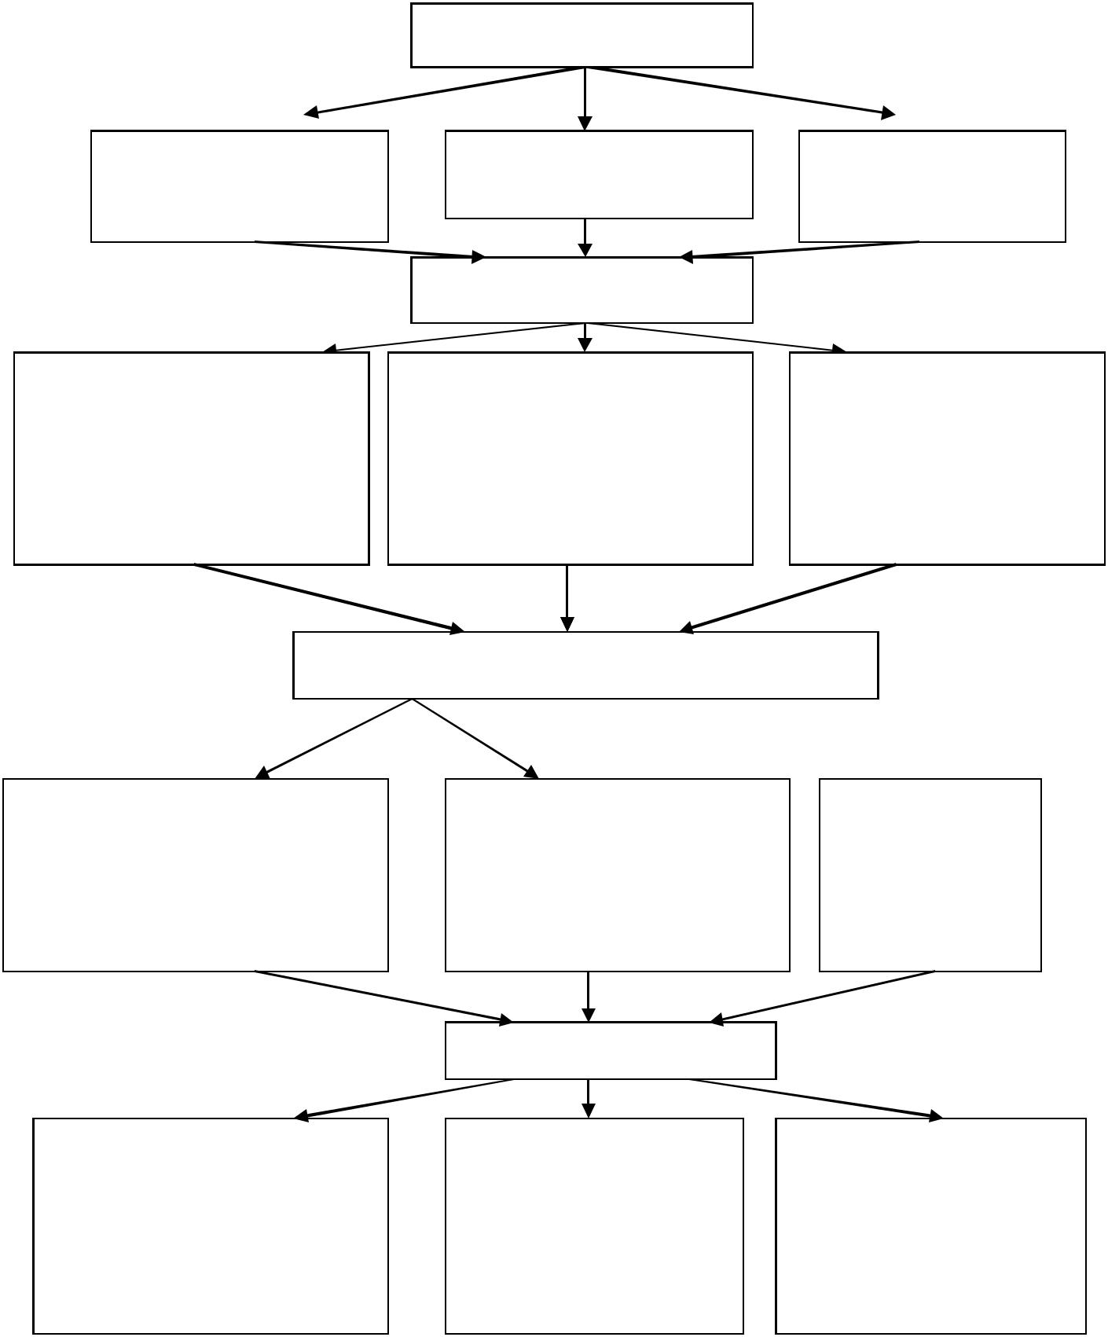

Number of subjects N=45

n =15 |  |  | n =15 |  | n =15
Experimental group-I |  |  | Experimental group-II |  | Control group
n =15 |  |  | n =15 |  | n =15
 |  |  | Pre test
PhysiologicalPhysiologicvariableslvariables |  |  |  |  | Psychological variables
1. Resting heart rate | Haematological variables |  |  |  | 1. Self concept
1. Resting heart rate | 1.Red blood cells |  |  |  | 1. Self concept
2.Diastolic blood pressure
2.Diastolic blood pressure | 2.Haemoglobin |  |  |  | 2. Self esteem

3.Systolic blood pressure |  | 3.White blood cells
 |  | 3. Anxiety
 |  | Experimental Treatment 12 weeks

Swami Satyananda Saraswathi |  | Maharishi Mahesh | Control group
Yogic Practices N=15 |  | Yogic Practices N=15 | N=15
Experimental group-I |  | Experimental group-II

 |  | Post test
Physiological variables |  | Heamatological |  | Psychological variables
1. Resting heart rate |  | variables |  | 1. | Self concept
1. Resting heart rate |  | 1.Red blood cells |  | 1. | Self concept
2.Diastolic blood pressure |  | 1.Red blood cells |  | 2. | Self esteem
2.Diastolic blood pressure |  | 2.Haemoglobin |  | 2. | Self esteem
3.Systolic blood pressure |  | 2.Haemoglobin |  | 3. | Anxiety
3.Systolic blood pressure |  | 3.White blood cells |  | 3. | Anxiety


Stastical Technique - ANCOVA and Scheffe’s Post Hoc Test

Flow Chart Depicting the Methodology Adopted

66

3.3 EXPERIMENTAL DESIGN

The study was formulated as a true random group design consisting of a pretest and posttest. The subjects (N = 45) were randomly assigned to three equal groups of adolescent aged boys of fifteen each. The groups were assigned as experimental group I, II and control group respectively. Pretest was conducted for all the subjects on selected Physiological, Hematological and Psychological variables such as (1) Pulse rate (2) Diastolic Blood pressure (3) Systolic Blood Pressure (4) Hemoglobin (5) Red Blood Cells (6) White Blood Corpuscles (7) Self Concept (8) Self Esteem and (9) Anxiety. The experimental group participated in their respective Sathyananda Saraswathi (Bihar of School) and Maharishi Mahesh Yogi’s Practices for a period of 12 weeks. The posttest was conducted on the above said dependent variables after a period of 12 weeks in the respective treatments. The practice training program was scheduled from 6 am to 7 am and 7 am to 8 am from Monday to Saturday in progression.

3.4 PILOT STUDY

In order to find out the accuracy of measurement of various tests, a pilot study was conducted with a few subjects prior to the study. The pilot study also helped in assessing the basic interest of the subjects to participate in yoga practices besides the suitability of body type to facilitate flexibility.

3.5 CRITERION MEASURES

The following tests were conducted to measure the dependent variables in the

study

67

TABLE - I

 | S. | Variables |  |  | Tools Administered |  |  | Unit of
 | No | Variables |  |  |  |  |  | Measurement
PHYSIOLOGICAL VARIABLES
1 |  | Resting Heart Rate |  |  | Digital | Heart | Rate | Beats per minute
1 |  | Resting Heart Rate |  |  | Monitor |  |  | Beats per minute
2 |  | Diastolic Blood Pressure |  |  | Sphygmomanometer |  |  | mm / Hg
3 |  | Systolic Blood Pressure |  |  | Sphygmomanometer |  |  | mm / Hg
HEMATOLOGICAL VARIABLES
1 |  | Red Blood Cells |  |  | Blood Test (Lab) |  |  | mg / dI
2 |  | White Blood Cells |  |  | Blood Test (Lab) |  |  | mg / dI
3 |  | Hemoglobin |  |  | Blood Test (Lab) |  |  | mg / dI
PSYCOLOGICAL VARIABLES
1 |  | Self-Concept |  |  | Mukta Rani Rastogi Self |  |  | Points
1 |  | Self-Concept |  |  | Concept Scale |  |  | Points
2 |  | Self Esteem |  |  | Rosenberg | Self Esteem |  | Points
2 |  | Self Esteem |  |  | Scale |  |  | Points
3 |  | Anxiety |  |  | Taylor's | Manifest |  | Points
3 |  | Anxiety |  |  | Anxiety Scale |  |  | Points

3.6 RELIABILITY OF DATA

In order to establish the reliability of the data, the investigator established instrument reliability and tester reliability

3.7 RELIABILITY OF INSTRUMENTS

For the practice and the purpose of measurements, mats, measuring yardstick and stop watch used in the study were obtained from standard suppliers which were properly calibrated. Hence they were considered as reliable and accurate. All the instruments were in good condition and workable. Excretion of blood and laboratory tests on Red blood cell, White blood corpuscles and Hemoglobin were done at the laboratory by Bio chemists. They used instruments for this study such as small bottle, needle, disposable syringes, cotton, etc. The experiment was done in a well – established computerized laboratory.

68

3.8 TESTER’S RELIABILITY

The dependent variable for the study like Resting Heart Rate, Blood Pressure, Red Blood Cells, White Blood Cells and Hemoglobin were measured by qualified technicians in the standard laboratory. For assessing the Psychological variables, standardized inventories were responded by the subjects. However, a pilot study was conducted with ten school boys to enable the research scholar understand the usage of questionnaire inventories.

3.9 ORIENTATION OF THE SUBJECTS

Before the collection of data, the subjects were oriented about the purpose of the study. The scholar explained the yogic practice procedures, the training schedule and utility. The procedure of the yogic practices was instructed to the subjects.

3.10 TRIANING PROGRAM

During the program of yogic practices the experimental group I underwent Sathyananda Saraswathi(Bihar School of Yoga) practices program for six days a week from Monday to Saturday 6 am to 7 am and experimental group II underwent Maharishi Mahesh Yogi’s Yoga practices program for six days a week from Monday to Saturday 7 am to 8 am. Experimental treatment was restricted to 12 weeks only. Table II and III show the yogic training schedules.

69

TABLE – II

TRAINING SCHEDULE FOR PACKAGE I

SWAMI SATHYANANADA SARASWATHI YOGIC

(BIHAR SCHOOL OF YOGA) PRACTICES
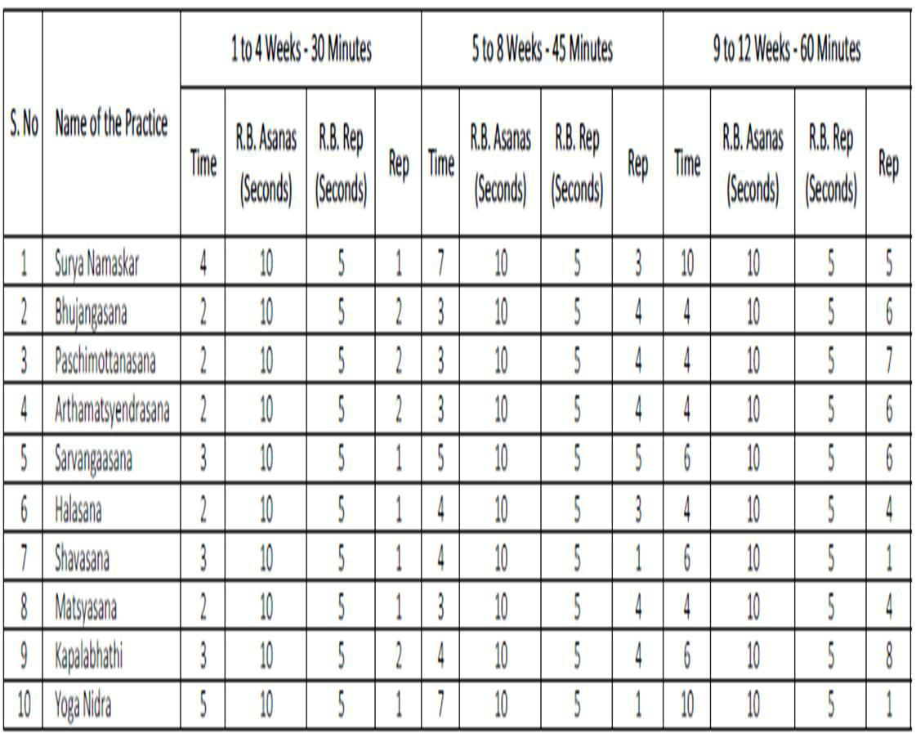

R.B.Asanas – Rest between each Asanas

R.B.Rep – Rest between each Repetition

Rep – Repetition

70

TABLE - III

TRAINING SCHEDULE FOR PACKAGE II

MAHARISHI MAHESH YOGI’S YOGA PRACTICES
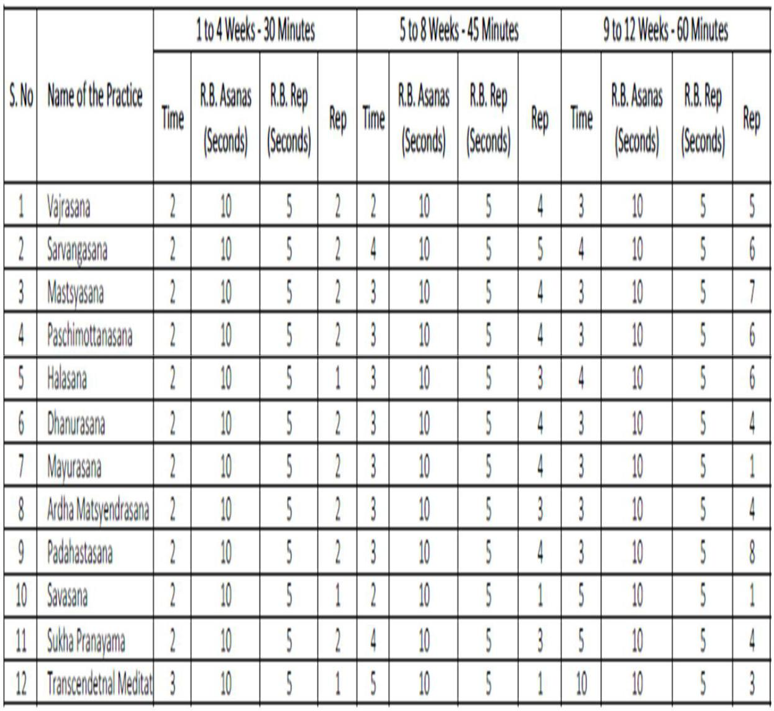

R.B.Asanas – Rest between each Asanas

R.B.Rep – Rest between each Repetition

Rep – Repetition

71

3.11 SWAMI SATHYANANDA SARASWATHI YOGIC (BIHAR SCHOOL OF YOGA) PRACTICES

3.11.1 SURYANAMASKAR – SALUTATION TO THE SUN
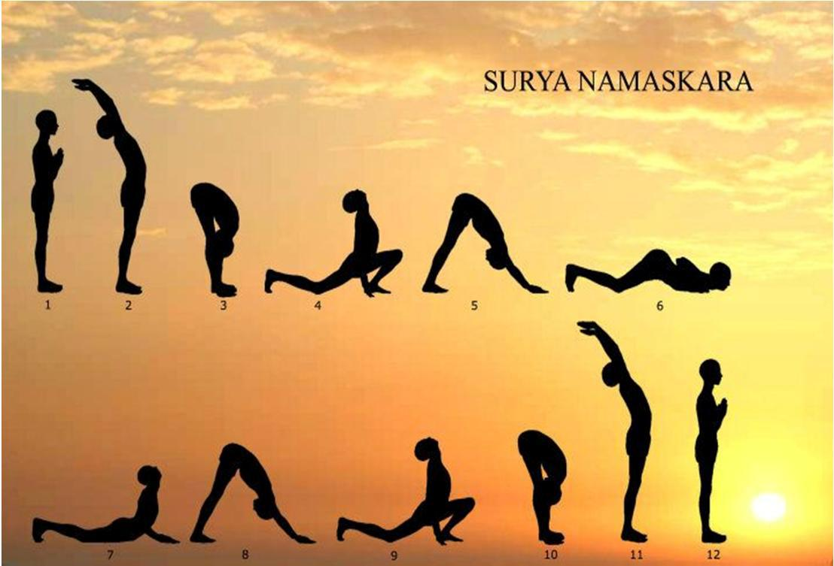

The Sanskrit name’Surya’ refers to the Sun and Namaskara means ‘salutations’. The sun symbolizes spiritual consciousness and in ancient times was worshiped on a daily basis. This dynamic group of asanas is an effective way of loosening up, stretching, massaging and toning all the joints, muscles and internal organs of the body. Suryanamaskara is a complete sadhana in itself for it includes asana, pranayama, mantra and meditation techniques

POSITION 1 – PRANAMASANA (PRAYER POSE)
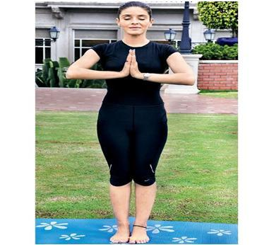

72

Keep the eyes closed.

Remain standing upright with the feet together.

Slowly bend the elbows and place the palms together in front of the chest in Namaskara mudra, mentally offering homage to the sun, the source of all life.
Relax the whole body.

POSITION 2 - HASTA UTTHANASANA (RAISED ARMS POSE)
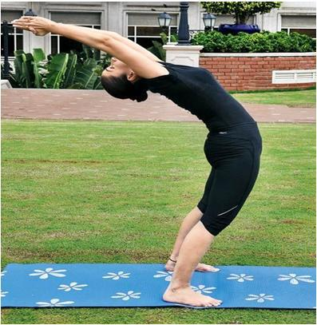

Separate the hands raise and stretch both arms above the head, keeping them shoulder width apart.
Bend the head, arms and upper trunk slightly backward.

POSITION 3 – PADAHASTASANA (HAND TO FOOT POSE)
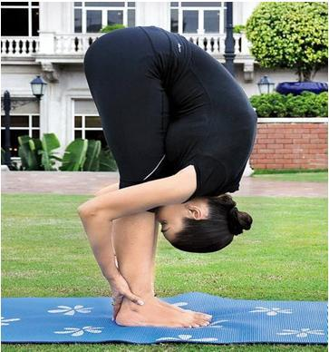

Bend forward from the hips until the fingers or palms of the hands touch the floor on either side of the feet.
Bring the forehead as close to the knees as is comfortable. Do not strain.
Keep the knees straight.

73

POSITION 4 – ASHWA SANCHALANASANA (EQUESTRIAN POSE)
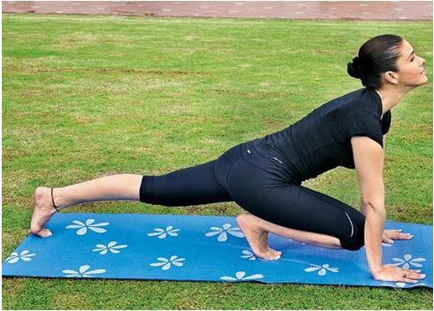

Place the hands on the floor beside the feet.

Stretch the right leg back as far as is comfortable and grasp the floor with the toes.
At the same time, bend the left knee, keeping the left foot on the floor in the same position. Keep the arms straight.
In the final position, the weight of the body should be supported on hands, the left foot, right knee and toes of the right foot. The head should be tilted backward, the back arched and the inner gaze directed upward to the eyebrow center.

POSITION 5 – PARVATASANA (MOUNTAIN POSE)
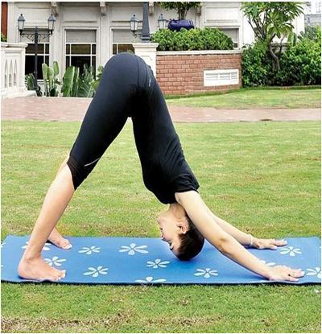

Keep the hands and right foot still, and take the left foot back beside the right foot. Simultaneously, raise the buttocks and lower the head between the arms so that the back and legs form two sides of a triangle.

The legs and arms straighten in the final position and the heels come down towards the floor in the final pose.

74

Bring the head and shoulders towards the knees. Do not strain.

POSITION 6 – ASHTANGA NAMASKARA (SALUTE WITH EIGHT PARTS OR POINTS)
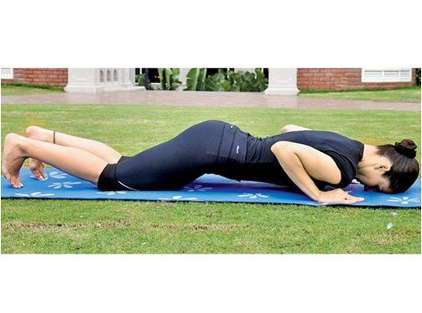

Keep the hands and feet in place.

Lower the knees, chest and chin to the floor; the feet will come up on to the toes.
In the final position only the toes, knees, chest, hands and chin touch the floor. The knees, chest and chin should touch the floor simultaneously.
If this is not possible, first lower the knees, then the chest, and finally the chin. The buttocks, hips and abdomen should be raised.

POSITION 7 – BHUJANGASANA (COBRA POSE)
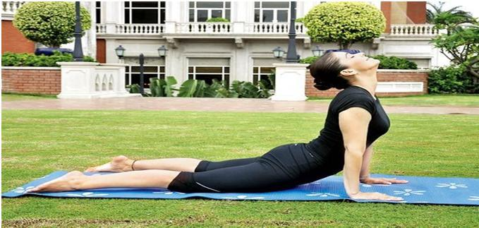

Keep the hands and feet in place.

Slide the chest forward and raise first the head, the shoulders, then, straightening the elbows, arch the back into the cobra pose.
This will lower the buttocks and hips to the floor.

75

Bend the head back and direct the gaze upward to the eyebrow center. The thighs and hips remain on the floor and the arms support the trunk. Unless the spine is very flexible the arms will remain slightly bent.

POSITION 8 – PARVATASANA (MOUNTAIN POSE)
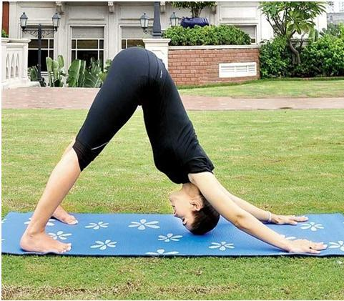

The hands and feet do not move from position 7. From Bhujangasana assume Parvatasana.
Keep the arms and legs straight, grip the floor with the toes and use the strength of the arms to raise the buttocks and lower the heels to the floor.

POSITION 9 – ASHWA SANCHALANASANA (EQUESTRIAN POSE)
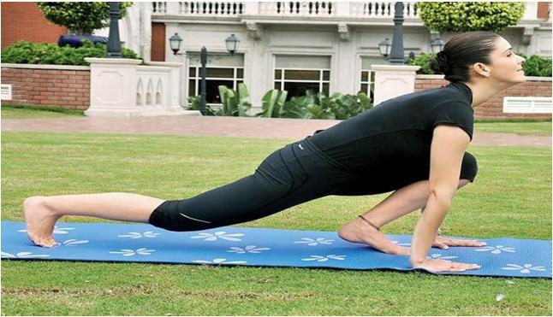

Keep the palms flat on the floor and the right foot in place.

Bend the left leg and bring the left foot forward between the hands.

Simultaneously, lower the right knee so that ittouches the floor and push the pelvis forward.
Tilt the head backward, arch the back and gaze at the eyebrow center.

76

POSITION 10 – PADAHASTASANA (HAND TO FOOT POSE)
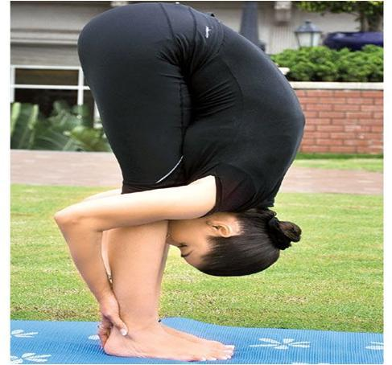

Bring the right foot forward next to the left foot. Straighten both legs.
Bring the forehead as close to the knees as possible without straining.

POSITION 11 – HASTA UTTHANASANA (RAISED ARMS POSE)
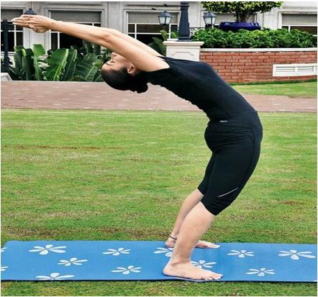

Keep the arms and spine in a straight line.

Raise the torso and stretch the arms above the head. Keep the arms separated, shoulder width apart.

Bend the head, arms and upper trunk backward slightly.

77

POSITION 12 – PRANAMASANA (PRAYER POSE)
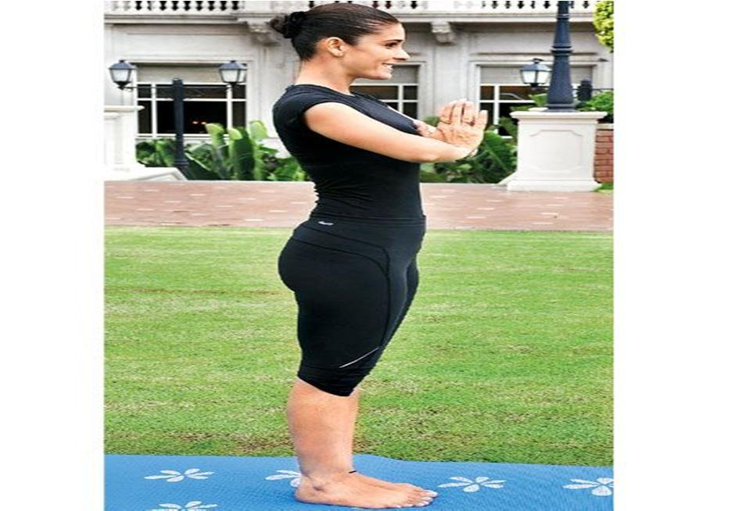

Bring the palms together in front of the chest.

3.11.2 BHUJANGASANA (COBRA POSE)
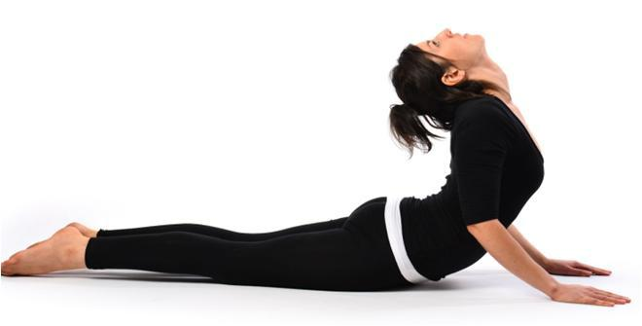

Lie flat on the stomach with the legs straight, feet together and the soles of the feet uppermost.
Place the palms of the hands flat on the floor, below and slightly to the side of the shoulders, with the fingers together and pointing forward.
Position the arms so that the elbows point backward and are close to the sides of the body.
Rest the forehead on the floor and close the eyes. Relax the whole body, especially the lower back. Slowly raise the head.

78

Gently tilt the head backward, so that the chin points forward and the back of the neck is compressed, then raise the neck and then the shoulders. Straighten the elbows, using the back muscles first, and then the arm muscles to raise the trunk further and arch the back.
In the final position, the pubic bone remains in contact with the floor and the navel is raised a maxin1um of 3 cm. If the navel is raised too high, the bend tends to be in the knees and not in the back. The arms may or may not be straight; this will depend on the flexibility of the back. Hold the final position.
To return to the starting position, slowly release the upper back by bending the arms, lower the navel, chest, shoulders and finally the forehead to the floor. Relax the lower back muscles. This is one round.

3.11.3 PASCHIMOTTANASANA (BACK STRETCHING POSE)
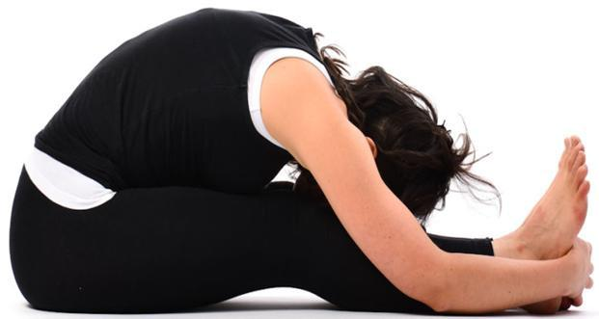

Sit on the floor with the legs outstretched, feet together and hands on the knees.
This is the starting position. Relax the whole body.

Slowly bend forward from the hips, sliding the hands down the legs. Try to grasp the big toes with the fingers and thumbs.
If this is impossible, hold the heels, ankles or any part of the legs that can be reached comfortably. Move slowly without forcing or jerking.
Hold the position for a few seconds. Relax the back and leg muscles, allowing them to gently stretch.
Keeping the legs straight and utilizing the arm muscles, not the back muscles, begin to bend the elbows and gently bring the trunk down towards the legs, maintaining a firm grip on the toes, feet or legs.

79

Try to touch the knees with the forehead. Do not strain. This is the final position.
Hold the position for as long as is comfortable and relax. Slowly return to the starting position. This is one round.

3.11.4 ARDHAMATSYENDRASANA (HALF SPINAL TWIST)
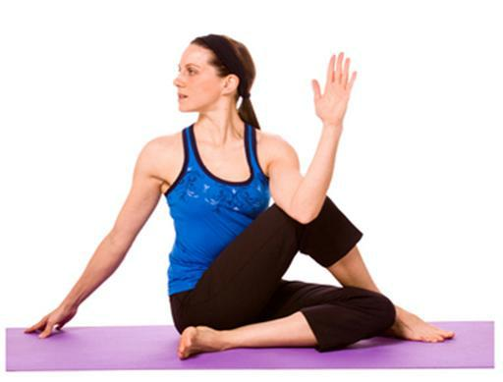

Sit with the legs stretched out in front of the body.

Bend the right leg and place the right foot flat on the floor on the outside of the left knee.
The toes of the right foot should face forward.

Bend the left leg and bring the foot around to the right buttock. The outside edge of the foot should be in contact with the floor.

Pass the left arm through the space between the chest and the right knee, and place it against the outside of the right leg.
Hold the right foot or ankle with the left hand so that the right knee is close to the left armpit.
Sit up as straight as possible.

Raise the right arm in front of the body and gaze at the finger tips.

Slowly twist to the right, simultaneously moving the arm, trunk and head.

Use the left arm as a lever against the right leg to twist the trunk as far as possible without using the back muscles.
Follow the tips of the fingers of the right hand with the gaze and look over the right shoulder.
Do not strain the back.

Bend the right elbow and place the arm around the back of the waist.

80

The back of the right hand should wrap around the left side of the waist.

Alternatively, it can be placed as high as possible between the shoulder blades with the fingers pointing up.
This arm position enforces the straightness of the spine.

Reverse the movements to come out of the posture and repeat on the other side.

3.11.5 SARVANGASANA (SHOULDER STAND POSE)
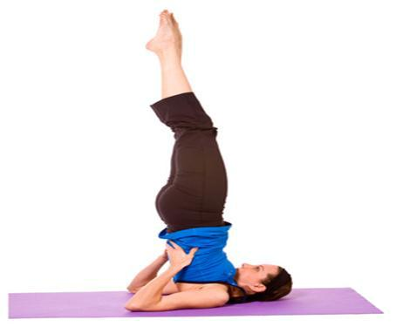

Lie on the back on a folded blanket.

Check that the head and spine are aligned and that the legs are straight with the feet together.
Place the hands beside the body with the palms facing down. Relax the entire body and mind.
Contract the abdominal muscles and, with the support of the arms, slowly raise the legs to the vertical position, keeping them straight.
When the legs are vertical, press the arms and hands down on the floor.

Slowly and smoothly roll the buttocks and spine off the floor, raising the trunk to a vertical position.
Turn the palms of the hands upward, bend the elbows and place the hands behind the ribcage, slightly away from the spine, to support the back. The elbows should be about shoulder width apart.

Gently push the chest forward so that it presses firmly against the chin.

In the final position, the legs are vertical, together and in a straight line with the trunk. The body is supported by the shoulders, nape of the neck and back of the head.

81

The arms provide stability, the chest rests against the chin and the feet are relaxed.
Close the eyes.

Relax the whole body in the final pose for as long as is comfortable.

To return to the starting position, bring the legs forward until the feet are above and behind the back of the head.
Keep the legs straight.

Slowly release the position of the hands and place the arms on the floor beside the body with the palms down.
Gradually lower each vertebra to the floor, followed by the buttocks, so that the legs resume their initial vertical position.
Lower the legs to the floor slowly, keeping the knees straight. Perform this action without using the arms for support.

The whole movement should combine balance with control so that the body contacts the floor slowly and gently.
Relax in shavasana until the respiration and heartbeat return to normal.

3.11.6 HALASANA (PLOUGH POSE)
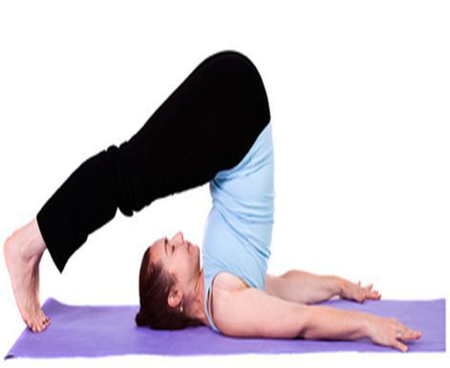

Lie flat on the back with the legs and feet together. Place the arms beside the body with the palms facing down. Relax the whole body.
Raise both legs to the vertical position, keeping them straight and together, using only the abdominal muscles. Press down on the arms and lift the buttocks, rolling the back away from the floor. Lower the legs over the head.

82

Bring the toes towards the floor behind the head without straining, but do not force the toes to touch the floor. Turn the palms up, bend the elbows and place the hands behind the ribcage to support the back, as in sarvangasana.

Relax and hold the final pose for as long as is comfortable.

Return to the starting position by lowering the arms with the palms facing down, then gradually lower each vertebrae of the spine to the floor, followed by the buttocks, so that the legs resume their initial vertical position.

Using the abdominal muscles, lower the legs to the starting position, keeping the knees straight.

3.11.7 SHAVASANA(CORPSE POSE)
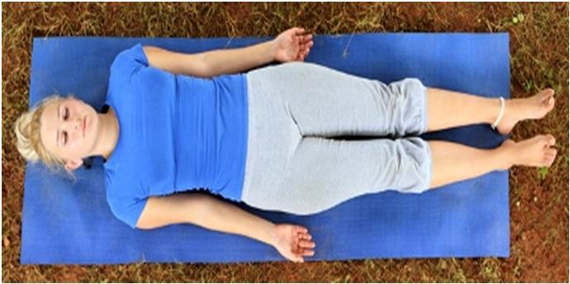

Lie flat on the back with the arms about 15 cm away from the body, palms facing upward.
A thin pillow or folded cloth may be placed behind the head to prevent discomfort.
Let the fingers curl up slightly.

Move the feet slightly apart to a comfortable position and close the eyes. The head and spine should be in a straight line.
Make sure the head does not fall to one side or the other. Relax the whole body and stop all physical movement.

Become aware of the natural breath and allow it to become rhythmic and relaxed.
After some time, again become aware of the body and surroundings, and gently and smoothly release the posture.

83

3.11.8 MATSYASANA (FISH POSE)
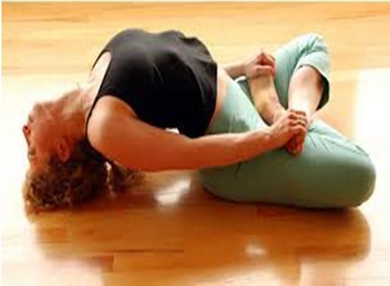

Sit in Padmasana and relax the whole body.

Carefully bend backward, supporting the body with the arms and elbows.

Lift the chest slightly, take the head back and lower the crown of the head to the floor.
Hold the big toes and rest the elbows on the floor.

Adjust the position of the head so that the maximum arch of the back is attained.
Relax the arms and the whole body, allowing the head, buttocks and legs to support the weight of the body.
Close the eyes and breathe slowly and deeply.

Return to the starting position, reversing the order of movements. Repeat the asana, with the legs crossed the other way.
3.11.9 KAPALABHATI (FRONTAL BRAIN CLEANSING)
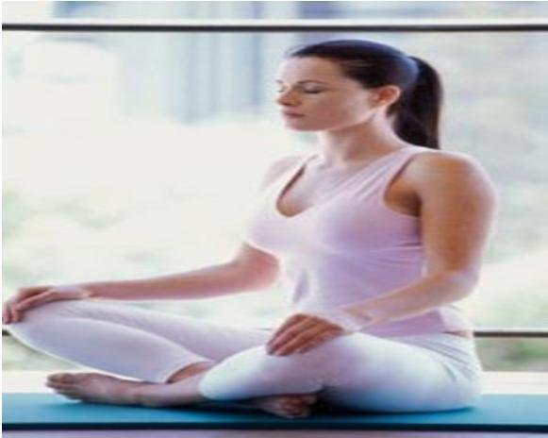

84

Technique 1:VatkramaKapalbhati (Air Cleansing)

This practice is the same as Kapalbhati Pranayama, technique 1.

Technique 2: Vyutkrama Kapalbhati (Sinus Cleansing)

Fill a bowl with pure warm water and add salt to the ratio of one teaspoon per half liter, ensuring the salt is well dissolved.
Stand comfortably and bend over the bowl of water.

Relax the whole body as much as possible in this position.

Scoop the water up in the palm of the hand and sniff it in through the nostrils. Let the water flow down to the mouth and then expel it.
Practice in this way several times.

Dry the nostrils properly as described for jalaneti. This completes the practice.

Technique 3: Sheetkrama Kapalbhati (Mucous Cleansing)

Prepare the water as above.

Stand comfortably and bend over the bowl of water. Take a mouthful of the warm saline water.
Instead of swallowing it, however, push it up and expel it through the nose. Practice in this way several times.
Dry the nostrils as described for jalaneti. This completes the practice.

85

3.11.10 YOGA NIDRA
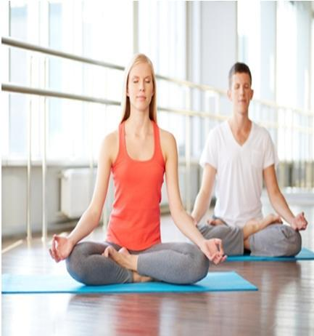

Yoga Nidra (Sanskrit for Yogic Sleep) is a powerful technique from the Tantra Yoga tradition.
It is both a name of a state and of a practice which creates an altered state of consciousness allowing the practitioner to relax and heal their being, expand their faculty of imagination, enter the realm of subconscious & super conscious, effectively manifest seemingly magical changes in their life, certain karmic debris in their life clear (if you believe in Karma) and assist in reaching a state called by some enlightenment.
Yoga Nidra, although Tantric in origin can be classified as a part of the Raja Yoga system’s Eight Limbs of Yoga, the well-known codification system of the Yogic practices by Patanjali (an Indian sage who lived around 200 B.C.).
In fact no less than three of the eight limbs of yoga can be seen in this practice:
Pranayama: Control of breathing through specialized exercises and the subsequent ability to amass, control and direct Prana, the life energy force.
Dharana: Concentration, cultivation and heightening of inner perceptual awareness and
Pratyharya: Control over the sensory mechanisms of the physical body specifically though exercises which deal with willful withdrawal of the senses and influences of the mind. The influences of most interest being those which do not serve us on the path of enlightenment and/or liberation.

86

THE THREE MAIN TRADITIONAL ASPECTS OF THE YOGA NIDRA PRACTICE

A systematic method of inducing complete mental, physical and emotional relaxation while maintaining awareness at deeper levels. A way to manifest any desire (physical, mental or spiritual).A method of altering karma and finding Moksha (Liberation).

3.12 PACKAGE II YOGI PRACTICES – MAHARISHI MAHESH YOGI’S PRACTICES TRAINING PROGRAM

The following are the selected yogi’s practices given to the experimental group II.

3.12.1 VAJRASANA (THUNDERBOLT POSE)
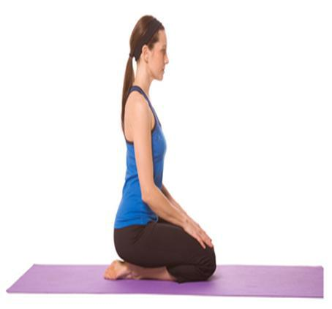

Kneel on the floor with the knees close together. Bring the big toes together and separate the heels.
Lower the buttocks onto the inside surface of the feet with the heels touching the sides of the hips.
Place the hands on the knees, palms down.

The back and head should be straight but not tense. Avoid excessive backward arching of the spine.

Close the eyes, relax the arms and the whole body.

87

Breathe normally and fix the attention on the flow of air passing in and out of the nostrils.

3.12.2 SARVANGASANA (SHOULDER STAND POSE)
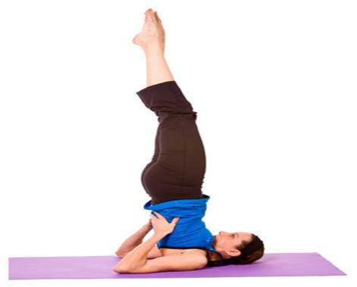

Lie on the back on a folded blanket.

Check that the head and spine are aligned and that the legs are straight with the feet together.
Place the hands beside the body with the palms facing down. Relax the entire body and mind.
Contract the abdominal muscles and, with the support of the arms, slowly raise the legs to the vertical position, keeping them straight.
When the legs are vertical, press the arms and hands down on the floor.

Slowly and smoothly roll the buttocks and spine off the floor, raising the trunk to a vertical position.
Turn the palms of the hands upward, bend the elbows and place the hands behind the ribcage, slightly away from the spine, to support the back.
The elbows should be about shoulder width apart.

Gently push the chest forward so that it presses firmly against the chin.

In the final position, the legs are vertical, together and in a straight line with the trunk. The body is supported by the shoulders, nape of the neck and back of the head.

The arms provide stability, the chest rests against the chin and the feet are relaxed. Close the eyes.
Relax the whole body in the final pose for as long as is comfortable.

88

To return to the starting position, bring the legs forward until the feet are above and behind the back of the head.

Keep the legs straight.

Slowly release the position of the hands and place the arms on the floor beside the body with the palms down.

Gradually lower each vertebra to the floor, followed by the buttocks, so that the legs resume their initial vertical position.

Lower the legs to the floor slowly, keeping the knees straight. Perform this action without using the arms for support.

The whole movement should combine balance with control so that the body contacts the floor slowly and gently.

Relax in Shavasana until the respiration and heart beat return to normal.

3.12.3 MATSYASANA (FISH POSE)
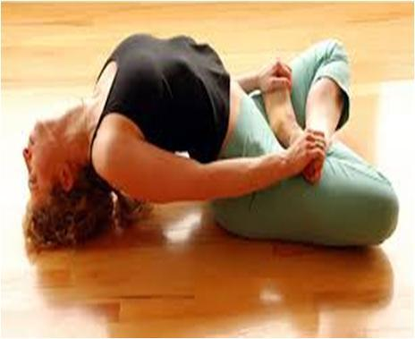

Sit in Padmasana and relax the whole body.

Carefully bend backward, supporting the body with the arms and elbows.

Lift the chest slightly, take the head back and lower the crown of the head to the floor.

Hold the big toes and rest the elbows on the floor.

Adjust the position of the head so that the maximum arch of the back is attained.

Relax the arms and the whole body, allowing the head, buttocks and legs to support the weight of the body.

Close the eyes and breathe slowly and deeply.

Return to the starting position, reversing the order of movements. Repeat the asana, with the legs crossed the other way.

89

3.12.4 PASCHI MOTTANASANA (BACK STRETCHING POSE)
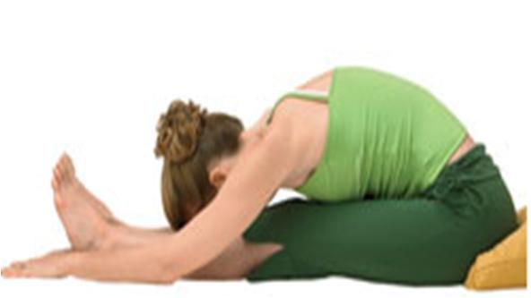

Sit on the floor with the legs outstretched, feet together and hands on the knees.
This is the starting position. Relax the whole body.

Slowly bend forward from the hips, sliding the hands down the legs. Try to grasp the big toes with the fingers and thumbs.
If this is impossible, hold the heels, ankles or any part of the legs that can be reached comfortably.
Move slowly without forcing or jerking. Hold the position for a few seconds.

Relax the back and leg muscles, allowing them to gently stretch.

Keeping the legs straight and utilizing the arm muscles, not the back muscles, begin to bend the elbows and gently bring the trunk down towards the legs, maintaining a firm grip on the toes, feet or legs.
Try to touch the knees with the forehead. Do not strain.

This is the final position. Hold the position for as long as is comfortable and relax.
Slowly return to the starting position. This is one round.

90

3.12.5 HALASANA (PLOUGH POSE)
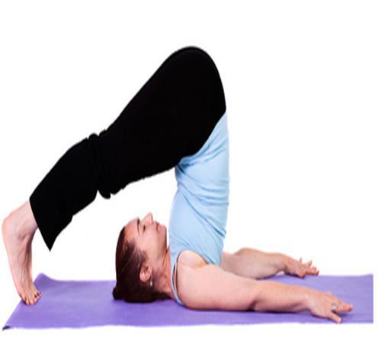

Lie flat on the back with the legs and feet together. Place the arms beside the body with the palms facing down. Relax the whole body.
Raise both legs to the vertical position, keeping them straight and together, using only the abdominal muscles.
Press down on the arms and lift the buttocks, rolling the back away from the floor. Lower the legs over the head. Bring the toes towards the floor behind the head without straining, but do not force the toes to touch the floor.

Turn the palms up, bend the elbows and place the hands behind the ribcage to support the back, as in Sarvangasana. Relax and hold the final pose for as long as is comfortable.

Return to the starting position by lowering the arms with the palms facing down, then gradually lower each vertebrae of the spine to the floor, followed by the buttocks, so that the legs resume their initial vertical position.
Using the abdominal muscles, lower the legs to the starting position, keeping the knees straight.

91

3.12.6 DHANURASANA (BOW POSE)
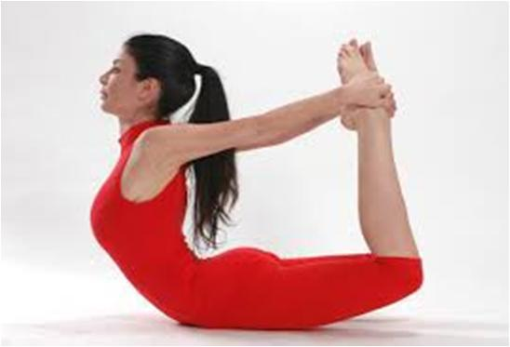

Lie flat on the stomach with the legs and feet together, and the arms and hands beside the body.
Bend the knees and bring the heels close to the buttocks.

Clasp the hands around the ankles. Place the chin on the floor. This is the starting position.
Tense the leg muscles and push the feet away from the body.

Arch the back, lifting the thighs, chest and head together. Keep the arms straight.
In the final position the head is tilted back and the abdomen supports the entire body on the floor.
The only muscular contraction is in the legs; the back and arms remain relaxed.
Hold the final position for as long as is comfortable and then, slowly relaxing the leg muscles lower the legs, chest and head to the starting position.
Release the pose and relax in the prone position until the respiration returns to normal.
This is one round. Practice 3 or up to 5 rounds.

92

3.12.7 MAYURASANA (PEACOCK POSE)
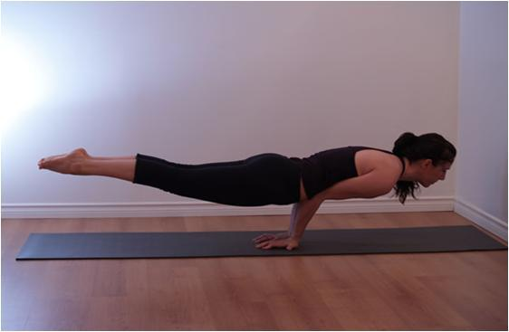

Kneel on the floor. Place the feet together and separate the knees.

Lean forward and place both palms between the knees on the floor with the fingers pointing towards the feet. The hand position will have to be adjusted according to comfort and flexibility.
Bring the elbows and forearms together. Lean further forward and rest the abdomen on the elbows and the chest on the upper arms. Stretch the legs backward so that they are straight and together.

Tense the muscles of the body and slowly elevate the trunk and legs so that they are horizontal to the floor. Hold the head upward. The whole body should now be balanced only on the palms of the hands.

Try to elevate the legs and feet higher, keeping them straight by applying more muscular effort and by adjusting the balance of the body. Do not strain. In the final position, the weight of the body should be supported by the muscles of the abdomen and not the chest.
Maintain the pose for a short period of time, and then slowly return to the base position. This is one round. The asana may be repeated when the breathing rate has returned to normal.

93

3.12.8 ARDHA MATSYENDRASANA (HALF SPINAL TWIST)
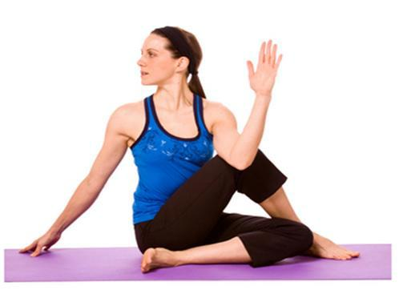

Sit with the legs stretched out in front of the body.

Bend the right leg and place the right foot flat on the floor on the outside of the left knee.
The toes of the right foot should face forward.

Bend the left leg and bring the foot around to the right buttock. The outside edge of the foot should be in contact with the floor.

Pass the left arm through the space between the chest and the right knee, and place it against the outside of the right leg.
Hold the right foot or ankle with the left hand so that the right knee is close to the left armpit.
Sit up as straight as possible.

Raise the right arm in front of the body and gaze at the fingertips.

Slowly twist to the right, simultaneously moving the arm, trunk and head.

Use the left arm as a lever against the right leg to twist the trunk as far as possible without using the back muscles.
Follow the tips of the fingers of the right hand with the gaze and look over the right shoulder.
Do not strain the back.

Bend the right elbow and place the arm around the back of the waist.

The back of the right hand should wrap around the left side of the waist.

Alternatively, it can be placed as high as possible between the shoulder blades with the fingers pointing up.
This arm position enforces the straightness of the spine.

94

Reverse the movements to come out of the posture and repeat on the other side.

3.12.9 PADAHASTASANA (HAND TO FOOT POSE)
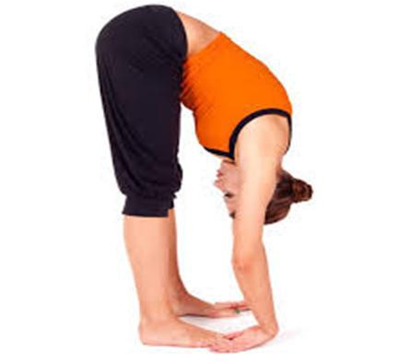

Bend forward from the hips until the fingers or palms of the hands touch the floor on either side of the feet.
Bring the forehead as close to the knees as is comfortable. Do not strain. Keep the knees straight.

3.12.10 SHAVASANA (CORPSE POSE)
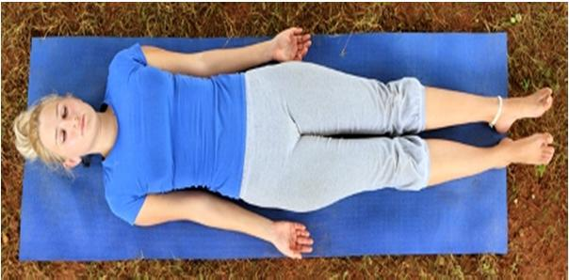

Lie flat on the back with the arms about 15 cm away from the body, palms facing upward.
A thin pillow or folded cloth may be placed behind the head to prevent discomfort.
Let the fingers curl up slightly.

Move the feet slightly apart to a comfortable position and close the eyes. The head and spine should be in a straight line.
Make sure the head does not fall to one side or the other. Relax the whole body and stop all physical movement.

95

Become aware of the natural breath and allow it to become rhythmic and relaxed.
After some time, again become aware of the body and surroundings, and gently and smoothly release the posture.

3.12.11 SUKHAPRANAYAMA(EASY POSE)
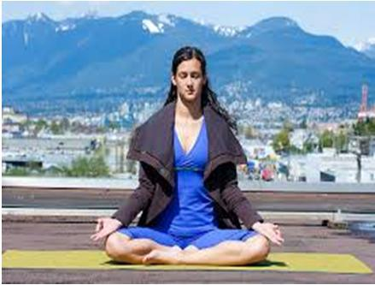

This is called the `Sukha Pranayama'. Sukha means happiness, pranayama means control of Prana. Prana is an esoteric concept of Hinduism, for now we can take it to mean control of breath.

So Sukha Pranayama means the exercise of controlling our breath which gives us happiness. It consists of sitting up straight so that our back is very straight.
Preferably we should sit in the Padmasana posture, a Yoga pose which is actually quite simple and consists more or less of a cross legged sitting position.
We can sit in this way, but it doesn’t matter if we are sitting in a chair in the office or lying down in the bed.
This is not a strenuous exercise and any posture will do, the only essential is that our back should be straight.
This is considered necessary for the flow of `Prana' along our spine. The main point of interest is not the breathing in or out but the gap in between the two breaths.

This period is called `Kumbhaka' and it is very important for Pranayama, in fact this is the most important period in Pranayama. The aim is to prolong this period between the two breaths

96

3.12.12 TRANSCENDENTAL MEDITATION
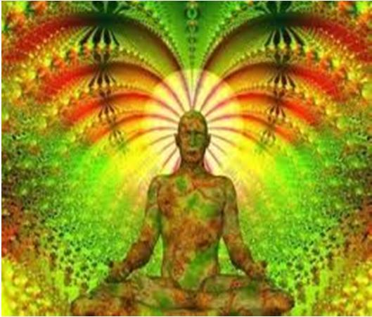

Transcendental Meditation (TM) is a technique for avoiding distracting thoughts and promoting a state of relaxed awareness.
The late Maharishi Mahesh Yogi derived TM from the ancient Vedic tradition of India. He brought the technique to the U.S. in the 1960s.
While meditating, the person practicing TM sits in a comfortable position with eyes closed.
While sitting there, he or she silently repeats a mantra.

A mantra is a meaningless sound from the Vedic tradition that’s been assigned by a certified instructor.

3.13 ADMINISTRATION OF TESTS

3.13.1 Physiological variables

- Resting heart rate

- Diastolic Blood Pressure

- Systolic Blood pressure

Resting Heart Rate

Purpose

To find out the resting heart rate

Instrument

A stop watch

97

Procedure

The most common places to measure heart rate using the palpitation method in the wrist (radical artery). To take the resting heart rate at the wrist, place index and middle fingers together on the opposite wrist, about ½ inch on the inside of the joint, in line with the index finger. Feel for a pulse. When you find a pulse, count the number of beats you feel within a one minute period. We can estimate the rate per minute by counting over 30 seconds and multiplying this figure by 2 and doubling the result.

Blood Pressure

Purpose

To find out the Blood Pressure (Systolic and Diastolic) through theblood pressure monitor

Instrument

Sphygmomanometer Monitor

Procedure

Blood pressure is usually measured by an instrument called sphygmomanometer. It consists of a mercury manometer, cuff and hand pump. The cuff is tied around the upper arm of the individual. Then the hand pump is pressed so that air is inflated in the cuff. When the cuff is fully inflated, air pressure is more than blood pressure. So blood flow is obstructed. Now the hand pump is slowly released till the time the appearance of the first sound is heard (by means of a stethoscope placed at elbow in front or feeling the pressure at the wrist). The mercury reading at the manometer is now noted. This reading is recorded as systolic blood pressure. Now the hand pump is slowly released till the sound becomes louder and louder. Later it stops. When the sound appears, the reading at the manometer is noted. This reading is diastolic pressure. (Sivaramakrishnan., 2006).

98

3.13.2 Hematological variables

- Red Blood Cells

- White Blood Corpuscles

- Hemoglobin

Red Blood Cells

Purpose

To find out the red blood cells in the blood

Instrument

2 Hemacytometers

1 RBC pipet with hose and mouthpiece 1Autolet

2 Lancet Needles (for drawing blood) 2 Platforms (for drawing blood)

Microscope

Procedure

Set up all equipment on your desk so that you are sure to have everything at your fingertips for the procedure

Prepare an autolet with a sterile lance and platform.

- Swab towards the side of the tip of a little-used finger with 70% EtOH. (NOT close to the cuticle!)

99

- Lance by placing the platform of the autolet against the fingertip and pressing the trigger. Alternatively, use a lancet with quick, firm jab to the side of the pad of the finger. Wipe away first blood.

- Using the dilution pipet with RED mixer from hemacytometer kit, draw blood up to the 0.5 mark. This is best done by slightly slanting the pipette down to allow blood to flow in. (Do not allow air to be drawn into the pipet or it will not draw the correct volume of blood. Slight suction should start it. (Make sure the hose is not kinked shut.) Keep the pipette level once you have filled it. Do not allow blood to congeal in pipette! Immediately proceed to the next step:

- Continuing to hold the pipet as horizontal as possible, draw Ringer's solution diluent up to the 101 mark. (Dilution of 1 to 200.)

- Seal the tip with your finger and shake well to mix.

- Empty ~1/2 of pipet into waste container add a small amount of the diluted blood to one chamber of the hemacytometer to just fill the chamber of the hemacytometer. It should flow in to fill. (Do not over fill).

- Let the preparation sit for a minute (for cells to settle).

- Center the grid at 100x, switch to 400x and count and record the RBCs in each of five fields (each with 16 smallest squares) with a clicker (fields: top R & L, bottom R & L, center). Include in the count all cells touching left and bottom sides, ignore cells touching top and right sides. Calculate the RBCs/cmm by adding the cells in the 5 groups and multiplying by 10,000 (i.e., add four zeros). Enter your RBCs/mm in the class data table.

- Wash out the pipette thoroughly with soap and water, rinse well, finish with distilled H₂O rinse, replace in case.

100

White Blood Corpuscles

Purpose

To measure WBC count in the blood

Instrument

2 Hemacytometers 2 Coverslips

one autolet

2 platforms (for drawing blood) 2 lancets (for drawing blood) 1 250 mL beaker for waste fluid 1 bottle WBC diluent (purple) 1 bottle RBC diluent (clear)

2 Kimwipes, soaked in 70% EtOH 2 Paper towels

Procedure

- Swab the tip of a little-used finger with 70% EtOH

- Lance with quick, firm jab to the side of the pad of the finger, wipe away first blood

- Using dilution pipet with the WHITE mixer, draw up to the 0.5 mark. Do not allow blood to congeal in pipette! Proceed immediately to the next step:

- Fill the pipet to the 11 mark with crystal violet diluent

- Shake well to mix with the tip sealed with your finger.

- Empty ~1/2 of pipet into waste container, add a small amount of the diluted blood apply to the second chamber of the hemacytometer. It should flow in to fill the chamber.

- Let the preparation sit for a minute (for cells to settle).

101

- Examine under 100x, count the five fields indicated squares of blue-stained WBCs with a clicker (fields: top L & R, bottom L & R, center). Include in the count all cells touching left and bottom sides, ignore cells touching top and right sides.

Hemoglobin

Purpose

To find out the percentage of hemoglobin concentration in the blood

Instrument

Sterilized syringe with needle Cotton
Spirit stopper

Test tube rubber bung Drabkin’s solution

Photoelectric calorimeter.

Procedure

2 ml of EDTA blood from the subject were taken in a test tube and 5 ml of drabkin’s solution was also added to the test tube, stopper tube by means of a rubber bung and fix the solution through inverting several times.
- Allow it to stand for 10 minutes at room temperature.

- Compare the values with the standard in a photoelectric calorimeter

- Drabkin’s solution was a mixture of 18 ml solution bicarbonate,0.2gm of potassium cyanide and 0.2 g of potassium ferrricyanide and1 litre of distilled water.

3.13.3 Psychological Variables

- Self-Concept (Rastogi 1979)

- Self Esteem (Rosenberg - 1965 )

- Anxiety (Taylor., 1953)

102

Self-Concept

Purpose:

To study the level of self-concept

Technical Tool

Self-Concept Scale developed by Mukta Rani Rastogi was used in the study. This scale consists of ten constructs covering three dimensions of Self-concept i.e., Perceptual, Conceptual and the Attitudinal dimensions. Thus, the ten constructs are - Health, Abilities, Self-Confidence, Self-Acceptance, Worthiness, Present Past Future, and Belief in Convictions, Shame & Guilt, Sociability and Emotional Maturity.

Scoring

The scale consists of 51 statements, divided into ten constructs. The respondent is provided with 5 response alternatives to give their response and therefore a score of 1-5 may be obtained for each item. Positive items are scored 5 to 1 for responses (SA, A, UD, DA,SDA) and negative items are scored 1 to 5 for the same response alternatives. The greater the score, the greater the self-concept of an individual.

Reliability:

Reliability of the scale by split-half method following Spearman Brown prophecy formula was found to be 0.87.

Validity:

Content validity was established on the basis of the ratings by experts.

Self-Exteem

Purpose

To study the level of self-esteem

Technical Tool

Rosenberg Self-esteem Scale

103

Procedure

10 questions dealing general feelings about you are measured using the Rosenberg Self-esteem scale. If you strongly agree, circle SA. If you agree with the statement, circle A. If you disagree, circle D. If you strongly disagree, circle SD.

Scoring

SA=3, A=2, D=1, SD=0. Items with an asterisk are reverse scored, that is, SA=0, A=1, D=2, SD=3. Sum the scores for the 10 items.
The higher the score, the higher the self-esteem.

Anxiety

To study the level of anxiety

Technical Tool

Taylor’s Manifest Anxiety Scale

Procedure

Taylor thought that personality drive level would be reflected in the intensity of “manifested anxiety”, and measured it using true/false responses for the list of questions.

Scoring

True-false responses are used for each item, and the replies indicating anxiety are counted, giving a score from 0 to 50 with the higher the score representing a higher level of anxiety.

Collection of Data

All the tests were administered as pretests for all the subjects 3 days before the commencement of the yogic practices and after the completion of 12 weeks of yoga schedule. Statistical Procedure True Random Group design was employed in this study as experimental design The forty five subjects selected for the study as adolescent boys were assigned at random to one of the three groups as Swami Sathyananda Saraswathy Yogi practices(Experimental group 1) Maharishi Mahesh

104

yogi practices(Experimental group 2) and Control group. The subjects in all the three groups were tested on all the criterion variables prior (pretest) and after 12 weeks of yogic practices(posttest) except that the control group did not participate in any special practice.

The pre and post test data collected from three groups on the selected physiological, hematological and psychological variables were statistically examined for the significant differences, if any, by applying Analysis of Covariance (ANCOVA).No attempt was made to equate the groups in any manner. Hence to make adjustments for differences in the initial means and the test, the adjusted posttest means for significant differences ,the Analysis of Covariance was used.

Whenever an F ratio for adjusted test was found to be significant for adjusted posttest means, Scheffe’s test was followed as a post-hoc test to determine which of the paired mean differences was significant.

105

CHAPTER - IV

ANALYSIS OF DATA AND RESULTS OF STUDY

4.1 OVER VIEW

This chapter deals with the test of significance, level of significance, computation of‘t’ test, computation of ANCOVA, discussion on finding and discussion on hypotheses. The three groups namely Satyananda Saraswathi yoga, Maharishi Mahesh yoga and control groups were analyzed for the differences in their measures of physiological, hematological and psychological variables in relation to pretest, posttest and adjusted post test scores.

The purpose of the study was to find out the effect of different yogic practices on selected physiological, hematological and psychological variables among adolescent boys. To achieve the purpose of the present study, forty five adolescent boys from Sreevatsa Viswanathan Vivekananda Vidyalaya Junior colleges, chitlapakkam, chennai were selected as subjects at random and their ages ranged from 13 to 17 years. The subjects (N=45) were randomly assigned to three equal groups of fifteen students each. The requirement of the experiment procedures, testing as well as different yogic practices schedule were explained to the subjects so as to get full co-operation of the effort required on their part and prior to the administration of the study.

Pretest was conducted for all the subjects on selected physiological, hematological and psychological variables. The initial test scores formed as pretest scores of the subjects. The groups were assigned as Experimental Group I, Experimental Group II and Control Group in an equivalent manner. Experimental Group I was exposed to Satyananda Saraswathi yoga practices, Experimental Group II was exposed to Maharishi Mahesh yoga practices and Control Group was not exposed to any experimental training other than their regular daily activities. The duration of experimental period was 12 weeks. After the experimental treatment, all the forty five subjects were tested on their physiological, hematological and psychological

106

variables. The final test scores formed the post test scores of the subjects. The pretest and post test scores were subjected to statistical analysis using dependent ‘t’ test and Analysis of Covariance (ANCOVA) to find out the significance among the mean differences, if any. Whenever the ‘F’ ratio for adjusted test was found to be significant, scheffe’s post hoc test was used. In all cases 0.05 level of significance was fixed to test hypotheses.

4.2 TEST OF SIGNIFICANCE

This is the crucial portion of the thesis, that of arriving at the conclusion by examining the hypothesis. The procedure of testing the hypothesis in accordance with the results obtained in relation to the level of confidence which was fixed at 0.05 level, was considered necessary for this study. The tests are usually called as the test of significance, since we test whether the difference between the pre-test and post-test scores of the samples are significant or not. In the present study, if the obtained F-ratio was greater than the table F-ratio at 0.05 level, the hypothesis was accepted to the effect that there existed significant difference between the means of groups compared. And if the obtained F-ratio was lesser than the table F-ratio at 0.05 level, then the hypothesis was rejected to the effect that there existed significant difference between the means of groups under study.

4.3 LEVEL OF SIGNIFICANCE

To test the obtained results on all the variables, level of significance 0.05 was chosen and considered as sufficient for the study.

4.4 COMPUTATION OF ‘t’ TEST

The primary objective of the paired ‘t’ ratio was to describe the differences between the pre-test and post-test means of adolescent boys.

Thus the obtained results were interpreted with earlier studies and presented in this chapter well along with graphical presentations.

107

TABLE - IV

SIGNIFICANCE OF MEAN GAINS & LOSSES BETWEEN PRE AND POST TEST SCORES ON SELECTED VARIABLES OF SATYANANDA SARASWATHI YOGA GROUP

 |  |  | Pre-Test | Post- | Mean | Std.
 | S.N | Variables | Pre-Test | Test | differen | Dev | DM | ‘t’ Ratio
 | S.N | Variables | Mean
 |  |  | Mean | Mean | ce | (±)
 | 1 | Pulse Rate | 74.40 | 70.53 | 3.87 | 2.19 | 0.56 | 6.80*
 | 2 | Systolic Blood | 122.20 | 118.46 | 3.73 | 2.63 | 0.67 | 5.49*
 | 2 | Pressure
 | 3 | Diastolic | 81.73 | 78.00 | 3.73 | 1.33 | 0.34 | 10.83*
 | 3 | Blood Pressure
 | 4 | RBC | 4.07 | 4.42 | 0.34 | 0.18 | 0.04 | 7.13*
 | 5 | Hemoglobin | 13.56 | 14.56 | 1.00 | 0.38 | 0.09 | 10.26*
 | 6 | WBC | 5726.66 | 6780.00 | 1053.33 | 666.40 | 172.06 | 6.12*
 | 7 | Self-Concept | 161.66 | 176.00 | 14.33 | 15.35 | 3.96 | 3.61*
 | 8 | Self Esteem | 18.26 | 21.73 | 3.46 | 3.75 | 0.97 | 3.57*
 | 9 | Anxiety | 17.53 | 14.33 | 3.20 | 2.80 | 0.72 | 4.41*

* Significant at 0.05 level

An examination of table-IV indicates that the obtained‘t’ ratios were 6.80, 5.49, 10.83, 7.13, 10.26, 6.12, 3.61, 3.57 and 4.41 for pulse rate, systolic blood pressure, diastolic blood pressure, RBC, hemoglobin, WBC, self-concept, self-esteem and anxiety respectively. The obtained‘t’ ratios on the selected variables were found to be greater than the required table value of 2.14 at 0.05 level of significance for 14 degrees of freedom. So it was found to be significant. The results of this study showed that the differences were statistically significant and explained its effects positively.

108

TABLE – V

SIGNIFICANCE OF MEAN GAINS & LOSSES BETWEEN PRE AND POST TEST SCORES ON SELECTED VARIABLES OF

MAHARISHI MAHESH YOGA GROUP

 |  |  |  | Pre- | Post- | Mean | Std.
 |  | S.N | Variables | Test | Test | Mean | Dev | DM | ‘t’ Ratio
 |  |  |  |  |  | difference | Dev | DM | ‘t’ Ratio
 |  |  |  | Mean | Mean | difference | (±)
 | 1 |  | Pulse Rate | 74.86 | 71.06 | 3.80 | 1.61 | 0.41 | 9.12*
 | 2 |  | Systolic Blood | 122.06 | 118.86 | 3.20 | 1.65 | 0.42 | 4.11*
 |  |  | Pressure
 | 3 |  | Diastolic Blood | 81.86 | 78.66 | 3.20 | 1.08 | 0.27 | 2.60*
 |  |  | Pressure
 | 4 |  | RBC | 4.00 | 4.29 | 0.28 | 0.19 | 0.05 | 5.57*
 | 5 |  | Hemoglobin | 13.62 | 14.46 | 0.84 | 0.46 | 0.11 | 7.05*
 | 6 |  | WBC | 5560.00 | 6580.00 | 1020.00 | 729.18 | 188.27 | 5.41*
 | 7 |  | Self-Concept | 161.13 | 175.13 | 14.00 | 15.46 | 3.99 | 3.50*
 | 8 |  | Self Esteem | 17.26 | 19.86 | 2.60 | 2.92 | 0.75 | 3.44*
 | 9 |  | Anxiety | 18.33 | 15.80 | 2.53 | 1.64 | 0.42 | 5.97*

* Significant at 0.05 level

An examination of table-V indicates that the obtained‘t’ ratios were 9.12, 4.11, 2.60, 5.57, 7.05, 5.41, 3.50, 3.44 and 5.97 for pulse rate, systolic blood pressure, diastolic blood pressure, RBC, hemoglobin, WBC, self-concept, self-esteem and anxiety respectively. The obtained‘t’ ratios on the selected variables were found to be greater than the required table value of 2.14 at 0.05 level of significance for 14 degrees of freedom. So it was found to be significant. The results of this study showed that the differences were statistically significant and explained its effects positively.

109

TABLE – VI

SIGNIFICANCE OF MEAN GAINS & LOSSES BETWEEN PRE AND POST TEST SCORES ON SELECTED VARIABLESOF CONTROL GROUP

 | S. |  | Pre- | Post- | Mean | Std. |  | ‘t’
 | S. | Variables | Test | Test | Mean | Std. | DM | ‘t’
 | No. | Variables | Test | Test | difference | Dev (±) | DM | Ratio
 | No. |  | Mean | Mean | difference | Dev (±) |  | Ratio
 | 1 | Pulse Rate | 74.33 | 74.20 | 0.13 | 0.63 | 0.16 | 0.80
 | 2 | Systolic Blood | 121.66 | 121.33 | 0.33 | 1.04 | 0.27 | 1.23
 | 2 | Pressure
 |  | Diastolic
 | 3 | Blood | 81.00 | 80.80 | 0.20 | 0.77 | 0.20 | 1.00
 |  | Pressure
 | 4 | RBC | 4.07 | 4.08 | 0.01 | 0.05 | 0.01 | 1.09
 | 5 | Hemoglobin | 13.70 | 13.77 | 0.07 | 0.30 | 0.07 | 0.92
 | 6 | WBC | 5786.66 | 5793.33 | 6.66 | 96.11 | 24.81 | 0.26
 | 7 | Self-Concept | 163.33 | 163.53 | 0.20 | 1.61 | 0.41 | 0.48
 | 8 | Self Esteem | 17.73 | 17.93 | 0.20 | 1.52 | 0.39 | 0.50
 | 9 | Anxiety | 18.86 | 18.73 | 0.13 | 2.03 | 0.52 | 0.25

Insignificant at 0.05 level

An examination of table-VI indicates that the obtained‘t’ ratios were 0.80, 1.23, 1.00, 1.09, 0.92, 0.26, 0.48, 0.50 and 0.25 for pulse rate, systolic blood pressure, diastolic blood pressure, RBC, hemoglobin, WBC, self-concept, self-esteem and anxiety respectively. The obtained‘t’ ratios on the selected variables were found to be lesser than the required table value of 2.14 at 0.05 level of significance for 14 degrees of freedom. So it was found to be insignificant.

110

4.5 COMPUTATION OF ANALYSIS OF COVARIANCE

The following tables illustrate the statistical results of the SatyanandaSaraswathi yoga and Maharishi Mahesh yoga groups on selected physiological, hematological and psychological variables among adolescent boys.

TABLE – VII

COMPUTATION OF ANALYSIS OF COVARIANCE OF MEANS OF SATYANANDA SARASWATHI YOGA, MAHARISHI MAHESH YOGA AND CONTROL GROUPS ON PULSE RATE

 |  |  |  |  | SSYG | MMYG | Control | Source of |  |  | Sum of |  |  | df |  |  |  | Means |  |  | F-ratio
 |  |  |  |  | SSYG | MMYG | Group | Variance |  |  | Squares |  |  | df |  |  |  | Squares |  |  | F-ratio
 |  | Pre-Test |  |  |  |  |  | BG |  |  | 2.53 |  |  | 2 |  |  |  | 1.26 |  |  | 0.66
 |  | Pre-Test |  |  | 74.40 | 74.86 | 74.33
 |  | Means |  |  |  |  |  | WG |  |  | 80.66 |  |  | 42 |  |  |  | 1.92
 |  | Post-Test |  |  |  |  |  | BG |  |  | 117.73 |  |  | 2 |  |  |  | 58.86 |  |  | 50.38*
 |  | Post-Test |  |  | 70.53 | 71.06 | 74.20
 |  | Means |  |  |  |  |  | WG |  |  | 49.06 |  |  | 42 |  |  |  | 1.16
 |  | Adjusted |  |  |  |  |  | BG |  |  | 118.92 |  |  | 2 |  |  |  | 59.46 |  |  | 50.95*
 |  | Post-Test |  |  |  |  |  | BG
 |  |  |  |  | 70.55 | 71.02 | 74.22
 |  | Means |  |  |  |  |  | WG |  |  | 47.84 |  |  | 41 |  |  |  | 1.16

B- Between Group Means W- Within Group Means df- Degrees of Freedom

* - Significant

(Table Value for 0.05 Level for df 2 & 42 = 3.22)

(Table Value for 0.05 Level for df 2 & 41 = 3.23)

111

4.6 RESULTS OF PULSE RATE

An examination of table - VII indicated that the pretest means of SatyanandaSaraswathi yoga, Maharishi Mahesh yoga and control groups were 74.40, 74.86 and 74.33 respectively. The obtained F-ratio for the pre-test was 0.66 and the table F-ratio was 3.22. Hence the pre-test mean F-ratio was insignificant at 0.05 level of confidence for the degree of freedom 2 and 42. This proved that there were no significant difference between the experimental and control groups indicating that the process of randomization of the groups was perfect while assigning the subjects to groups.

The post-test means of the SatyanandaSaraswathi yoga, Maharishi Mahesh yoga and control groups were 70.53, 71.06 and 74.20 respectively. The obtained F-ratio for the post-test was 50.38 and the table F-ratio was 3.22. Hence the post-test mean F-ratio was significant at 0.05 level of confidence for the degree of freedom 2 and 42. This proved that the differences between the posttest means of the subjects were significant.

The adjusted post-test means of the SatyanandaSaraswathi yoga, Maharishi Mahesh yoga and control groups were 70.55, 71.02 and 74.22 respectively. The obtained F-ratio for the adjusted post-test means was 50.95 and the table F-ratio was 3.23. Hence, the adjusted post-test mean F-ratio was significant at 0.05 level of confidence for the degree of freedom 2 and 41. This proved that there was a significant difference among the means due to the packages of experimental training on pulse rate.

Since significant differences were recorded, the results were subjected to post hoc analysis using Scheffe’s post hoc test. The results are presented in Table-VIIIX.

112

TABLE – VIII

SCHEFFE’S TEST FOR THE DIFFERENCES BETWEEN THE ADJUSTED POST TEST PAIRED MEANS ON PULSE RATE

 |  | Adjusted Post-test means
 |  |  |  |  |  |  |  | Mean Difference | Required CI
 |  | SSYG |  | MMYG |  | Control |  | Mean Difference | Required CI
 |  | SSYG |  | MMYG |  | Group
 |  | 70.55 |  | 71.02 |  | --- |  | 0.47
 |  | 70.55 |  | --- |  | 74.22 |  | 3.67* | 0.99
 |  | --- |  | 71.02 |  | 74.22 |  | 3.20*

* Significant at 0.05 level of confidence

The multiple comparisons showed in Table VIII proved that there existed significant differences between the adjusted means of SatyanandaSaraswathi yoga with control group (3.67) and Maharishi Mahesh yoga with control group (3.20). There was no significant difference between SatyanandaSaraswathiyoga and Maharishi Mahesh yoga (0.47) at 0.05 level of confidence with the confidence interval value of 0.99.

The pre, post and adjusted means on pulse rate are presented through bar diagram for better understanding of the results of this study in Figure-1.

113

FIGURE - 1

PRE, POST AND ADJUSTED POST TEST DIFFERENCES OF THE SATYANANDA SARASWATHI YOGA, MAHARISHI MAHESH

YOGA AND CONTROL GROUPS ON PULSE RATE
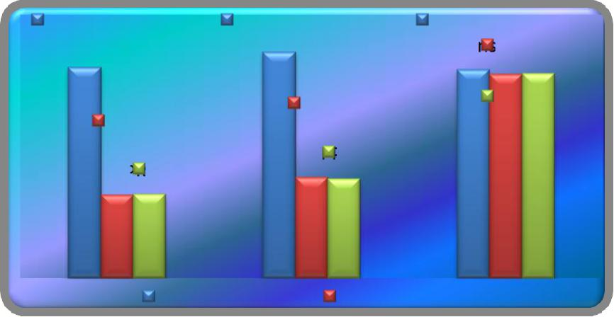

in counts/min

Pre Test |  | Pre Test |  | Pre Test
Means, |  | Means, |  | Means, CG,Post Test
YPRT, 74.4 | YPPT, 74.86 |  |  | 74.33Means, CG,
Post Test |  |  | Post Test | Adjusted74.2
 |  |  | Means, | Means, CG,
Means, |  |  | Means, | 74.22
 |  |  | Adjusted | 74.22
 | Adjusted |  | YPPT, 71.06
YPRT, 70.53 |  |  | Means,
 | Means, |  | YPPT, 71.02
 | YPRT, 70.55
 | Pre Test Means |  | Post Test Means

4.6.1 DISCUSSION ON PULSE RATE

The results presented in table VIII showed that the obtained adjusted means on pulse rate among SatyanandaSaraswathi yoga group was 70.55 followed by Maharishi Mahesh yoga group with mean value of 71.02, and control group with mean value of 74.22. The differences among pre test scores, post test scores and adjusted mean scores of the subjects were statistically treated using ANCOVA and the obtained F values were 0.66, 50.38 and 50.95 respectively. It was found that the obtained F value on pre test scores were not significant and the obtained F values on posttest and adjusted means were significant at 0.05 level of confidence as these were greater than the required table F value of 3.22 and 3.23. The post hoc analysis through Scheffe’s Confidence test proved that due to twelve weeks training SatyanandaSaraswathi yoga and Maharishi Mahesh yoga had decreased pulse rate than the control group and the differences were significant at 0.05 level. Further, the post hoc analysis showed that significant differences existed between the experimental groups, clearly indicating that SatyanandaSaraswathi yoga was better than Maharishi Mahesh yoga in decreasing pulse rate of the adolescent boys. The studies conducted by Kewal Krishnan and Sudhir Kumar Sharma (2009)proved that there was a decrease in pulse rate due to yoga practices.

114

TABLE-IX

COMPUTATION OF ANALYSIS OF COVARIANCE OF MEAN OF SATYANANDA SARASWATHI YOGA, MAHARISHI MAHESH YOGA AND CONTROL GROUPS ON SYSTOLIC BLOOD PRESSURE

 |  |  | SSYG | MMYG | Control |  | Source of
 |  |  | SSYG | MMYG | Group |  | Variance
 |  | Pre-Test |  |  |  |  | BG
 |  | Pre-Test | 122.20 | 122.06 | 121.66
 |  | Means | 122.20 | 122.06 | 121.66
 |  | Means |  |  |  |  | WG
 |  | Post-Test |  |  |  |  | BG
 |  |  | 118.46 | 118.86 | 121.33
 |  | Means |  |  |  |  | WG
 |  | Adjusted |  |  |  |  | BG
 |  | Post-Test | 118.35 | 118.82 | 121.49
 |  | Means |  |  |  |  | WG

Sum of |  | df |  | Means
Squares |  | df |  | Squares
2.31 |  | 2 |  | 1.15
296.66 |  | 42 |  | 7.06
72.31 |  | 2 |  | 36.15
158.80 |  | 42 |  | 3.78
85.45 |  | 2 |  | 42.73
80.51 |  | 41 |  | 1.96

F-ratio

0.16

9.56*

21.76*

B- Between Group Means * - Significant

W- Within Group Means (Table Value for 0.05 Level for df 2 & 42 = 3.22)

df- Degrees of Freedom (Table Value for 0.05 Level for df 2 & 41 = 3.

115

4.7 RESULTS OF SYSTOLIC BLOOD PRESSURE

An examination of table - IX indicated that the pretest means of Satyananda Saraswathi yoga, Maharishi Mahesh yoga and control groups were 122.20, 122.06 and 121.66 respectively. The obtained F-ratio for the pre-test was 0.16 and the table F-ratio was 3.22. Hence the pre-test mean F-ratio was insignificant at 0.05 level of confidence for the degree of freedom 2 and 42. This proved that there were no significant differences between the experimental and control groups indicating that the process of randomization of the groups was perfect while assigning the subjects to groups.

The post-test means of the Satyananda Saraswathi yoga, Maharishi Mahesh yoga and control groups were 118.46, 118.86 and 121.33 respectively. The obtained F-ratio for the post-test was 9.56 and the table F-ratio was 3.22. Hence the post-test mean F-ratio was significant at 0.05 level of confidence for the degree of freedom 2 and 42. This proved that the differences between the posttest means of the subjects were significant.

The adjusted post-test means of the Satyananda Saraswathi yoga, Maharishi Mahesh yoga and control groups were 118.35, 118.82 and 121.49 respectively. The obtained F-ratio for the adjusted post-test means was 21.76 and the table F-ratio was 3.23. Hence the adjusted post-test mean F-ratio was significant at 0.05 level of confidence for the degree of freedom 2 and 41. This proved that there was significant difference among the means due to the packages of both yogic practices on systolic blood pressure.

Since significant differences were recorded, the results were subjected to post hoc analysis using Scheffe’s post hoc test. The results were presented in Table X.

116

TABLE - X

THE SCHEFFE’S TEST FOR THE DIFFERENCES BETWEEN THE ADJUSTED POST TEST PAIRED MEANS ON SYSTOLIC BLOOD PRESSURE

 |  | Adjusted Post-test means |  |  |  | Mean |  | Required CI
 | SSYG |  | MMYG | Control Group |  | Difference
 | 118.35 |  | 118.82 | --- |  | 0.47
 | 118.35 |  | --- | 121.49 |  | 3.14* |  | 1.29
 | --- |  | 118.82 | 121.49 |  | 2.67*

* Significant at 0.05 level of confidence

The multiple comparisons showed in Table X proved that there existed significant differences between the adjusted means of SatyanandaSaraswathi yoga with control group (3.14), Maharishi Mahesh yoga with control group (2.67). There was no significant difference between SatyanandaSaraswathiyoga and Maharishi Mahesh yoga (0.47) at 0.05 level of confidence with the confidence interval value of 1.29.
The pre, post and adjusted means on systolic blood pressure were presented through bar diagram for better understanding of the results of this study in Figure-2.

117

FIGURE - 2

PRE POST AND ADJUSTED POST TEST DIFFERENCES OF THE SATYANANDA SARASWATHI YOGA, MAHARISHI MAHESH

YOGA AND CONTROL GROUPS ON SYSTOLIC

BLOOD PRESSURE
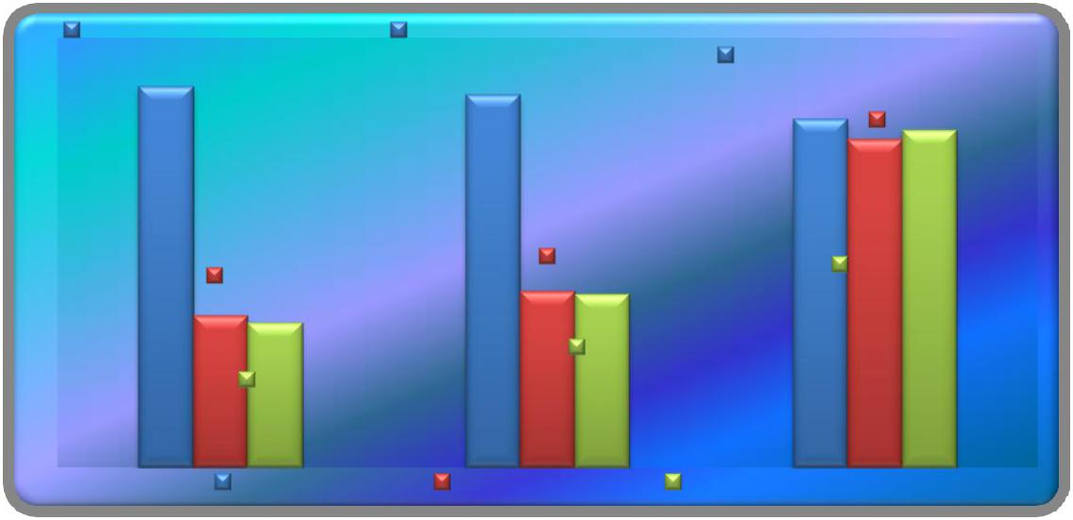

in mmhg

Pre Test Means, | Pre Test Means, |  | Pre Test Means,
YPRT, 122.2 | YPPT, 122.06 |  | Pre Test Means,
YPRT, 122.2 |  |  | CG, 121.66
 |  |  | Post Test
 |  |  | Means, CG,
 |  |  | 121.33
Post Test |  | Post Test | Adjusted Means,
Post Test |  | Means, YPPT, | CG, 121.49
Means, YPRT, |  | Means, YPPT, | CG, 121.49
Means, YPRT, |  | 118.86
118.46 |  | 118.86
118.46 |  | Adjusted Means,
Adjusted Means, |  | YPPT, 118.82
YPRT, 118.35
Pre Test Means | Post Test Means Adjusted Means

4.7.1 DISCUSSION ON SYSTOLIC BLOOD PRESSURE

The results presented in table X showed that the obtained adjusted means on systolic blood pressure among SatyanandaSaraswathi yoga group was 118.35 followed by Maharishi Mahesh yoga group with mean value of 118.82, and control group with mean value of 121.49. The differences among pre test scores, post test scores and adjusted mean scores of the subjects were statistically treated using ANCOVA and the obtained F values were 0.16, 9.56 and 21.76 respectively. It was found that obtained F value on pre test scores were not significant and the obtained F values on posttest and adjusted means were significant at 0.05 level of confidence as these were greater than the required table F value of 3.22 and 3.23. The post hoc analysis through Scheffe’s Confidence test proved that twelve weeks training of Satyananda Saraswathi yoga and Maharishi Mahesh yoga packages had decreased systolic blood pressure than the control group and the differences were significant at 0.05 level. Further, the post hoc analysis showed that there were significant differences between the experimental groups, clearly indicating that Satyananda Saraswathi yoga was better than Maharishi Mahesh yoga in decreasing systolic blood pressure of the adolescent boys. The studies conducted byBegum.,(2013), Sathyanarayana., (2013), and Swaroop., (1997) proved that there was a decrease in systolic blood pressure due to the yoga practices.

118

TABLE – XI

COMPUTATION OF ANALYSIS OF COVARIANCE OF MEAN OF SATYANANDA SARASWATHI YOGA, MAHARISHI MAHESH YOGA AND CONTROL GROUPS ON DIASTOLIC BLOOD PRESSURE

 |  |  | SSYG | MMYG | Control |  | Source of | Sum of | df | Means | F-ratio
 |  |  | SSYG | MMYG | Group |  | Variance | Squares | df | Squares | F-ratio
 |  | Pre-Test |  |  |  |  | BG | 6.53 | 2 | 3.26 | 2.12
 |  | Pre-Test | 81.73 | 81.86 | 81.00 |  |  |  |  |  | 2.12
 |  | Means |  |  |  |  | WG | 64.66 | 42 | 1.54
 |  | Post-Test |  |  |  |  | BG | 64.17 | 2 | 32.08 | 18.78*
 |  | Post-Test | 78.00 | 78.66 | 80.80 |  |  |  |  |  | 18.78*
 |  | Means |  |  |  |  | WG | 71.73 | 42 | 1.70
 |  | Adjusted |  |  |  |  | BG | 84.94 | 2 | 42.47 | 40.78*
 |  | Post-Test | 77.86 | 78.44 | 81.15 |  |  |  |  |  | 40.78*
 |  |  |  |  |  |  | WG | 42.69 | 41 | 1.04
 |  | Means

B- Between Group Means W- Within Group Means df- Degrees of Freedom

* - Significant

(Table Value for 0.05 Level for df 2 & 42 = 3.22)

(Table Value for 0.05 Level for df 2 & 41 = 3.23)

119

4.8 RESULTS OF DIASTOLIC BLOOD PRESSURE

An examination of table - XI indicated that the pretest means of SatyanandaSaraswathi yoga, Maharishi Mahesh yoga and control groups were 81.73, 81.86 and 81.00 respectively. The obtained F-ratio for the pre-test was 2.12 and the table F-ratio was 3.22. Hence the pre-test mean F-ratio was insignificant at 0.05 level of confidence for the degree of freedom 2 and 42. This proved that there were no significant difference between the experimental and control groups indicating that the process of randomization of the groups was perfect while assigning the subjects to groups.
The post-test means of the SatyanandaSaraswathi yoga, Maharishi Mahesh yoga and control groups were 78.00, 78.66 and 80.80 respectively. The obtained F-ratio for the post-test was 18.78 and the table F-ratio was 3.22. Hence the post-test mean F-ratio was significant at 0.05 level of confidence for the degree of freedom 2 and 42. This proved that the differences between the posttest means of the subjects were significant.

The adjusted post-test means of the SatyanandaSaraswathi yoga, Maharishi Mahesh yoga and control groups were 77.86, 78.44 and 81.15 respectively. The obtained F-ratio for the adjusted post-test means was 40.78 and the table F-ratio was 3.23. Hence the adjusted post-test mean F-ratio was significant at 0.05 level of confidence for the degree of freedom 2 and 41. This proved that there was a significant difference among the means due to the experimental trainings on diastolic blood pressure.

Since significant differences were recorded, the results were subjected to post hoc analysis using Scheffe’s post hoc test. The results were presented in Table-XII.

120

TABLE - XII

SCHEFFE’S TEST FOR THE DIFFERENCES BETWEEN THE ADJUSTED POST TEST PAIRED MEANS ON DIASTOLIC BLOOD PRESSURE

 |  | Adjusted Post-test means |  |  | Mean Difference | Required CI
 | SSYG |  | MMYG | Control Group
 | 77.86 |  | 78.44 | --- | 0.58
 | 77.86 |  | --- | 81.15 | 3.29* | 0.94
 | --- |  | 78.44 | 81.15 | 2.71*

* Significant at 0.05 level of confidence

The multiple comparisons showed in Table XII proved that there existed significant differences between the adjusted means of SatyanandaSaraswathi yoga with control group (3.29), Maharishi Mahesh yoga with control group (2.71). There was no significant difference between SatyanandaSaraswathi yoga and Maharishi Mahesh yoga (0.58) at 0.05 level of confidence with the confidence interval value of 0.94.
The pre, post and adjusted means on diastolic blood pressure were presented through bar diagram for better understanding of the results of this study in Figure-3.

121

FIGURE – 3

PRE POST AND ADJUSTED POST TEST DIFFERENCES OF THE

SATYANANDA SARASWATHI YOGA, MAHARISHI MAHESH YOGA AND CONTROL GROUPS ON DIASTOLIC BLOOD PRESSURE
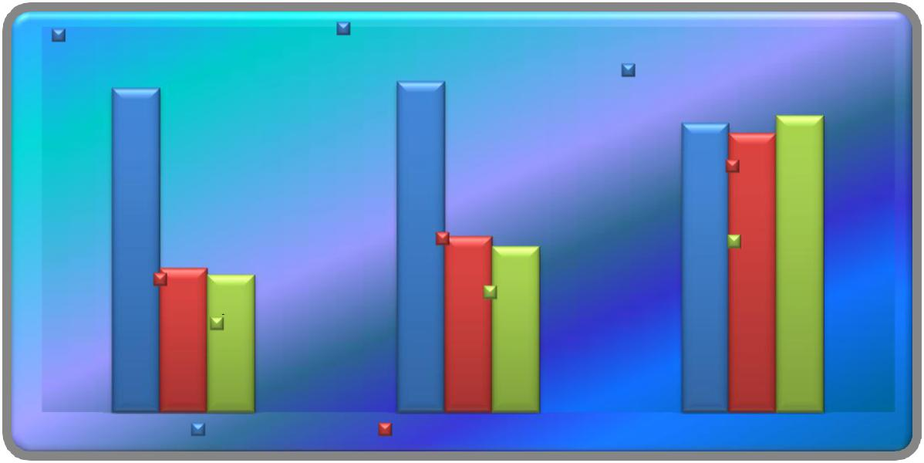

in mmhg

Pre Test Means, | Pre Test Means,
YPRT, 81.73 | YPPT, 81.86 |  | Pre Test Means,
 |  |  | CG, 81
 |  |  | Post Test Means,
 |  |  | CG, 80.8
 |  | Post Test Means, | Adjusted Means,
Post Test Means, |  | YPPT, 78.66 | CG, 81.15
Post Test Means, |  | Adjusted Means,
YPRT, 78
YPRT, 78 |  | YPPT, 78.44
Adjusted Means, |  | YPPT, 78.44
YPRT, 77.86

Pre Test Means Post Test Means Adjusted Means

4.8.1 DISCUSSION ON DIASTOLIC BLOOD PRESSURE

The results presented in table XII showed that the obtained adjusted means on diastolic blood pressure among SatyanandaSaraswathi yoga group was 77.86 followed by Maharishi Mahesh yoga group with mean value of 78.44, and control group with mean value of 81.15. The differences among pre test scores, post test scores and adjusted mean scores of the subjects were statistically treated using ANCOVA and the obtained F values were 2.12, 18.78 and 40.78 respectively. It was found that obtained F value on pre test scores were not significant and the obtained F values on posttest and adjusted means were significant at 0.05 level of confidence as these were greater than the required table F value of 3.22 and 3.23. The post hoc analysis through Scheffe’s Confidence test proved that twelve weeks training of SatyanandaSaraswathi yoga and Maharishi Mahesh yoga had decreased diastolic blood pressure than the control group and the differences were significant at 0.05 level. Further, the post hoc analysis showed that there were significant differencesbetween the experimental groups, clearly indicating that SatyanandaSaraswathi yoga was better than Maharishi Mahesh yoga in decreasing diastolic blood pressure of the adolescent boys. The studies conducted byBegum.,(2013), Sathyanarayana., (2013), and Swaroop., (1997) proved that there was a decrease in diastolic blood pressure due to the yoga practices.

122

TABLE - XIII

COMPUTATION OF ANALYSIS OF COVARIANCE OF MEAN OF SATYANANDA SARASWATHI YOGA, MAHARISHI MAHESH YOGA AND CONTROL GROUPS ON RBC

 |  |  |  |  | Control | Source
 |  | SSYG | MMYG |  | Control | of
 |  | SSYG |  |  | Group | of
 |  |  |  |  | Group | Variance
 | Pre-Test |  |  |  |  | BG
 | Pre-Test | 4.00 | 4.07 |  | 4.05
 | Means | 4.00 | 4.07 |  | 4.05
 | Means |  |  |  |  | WG
 | Post- |  |  |  |  | BG
 | Test | 4.42 | 4.29 |  | 4.08
 | Means |  |  |  |  | WG
 | Adjusted |  |  |  |  | BG
 | Post- | 4.41 | 4.32 |  | 4.07
 | Test | 4.41 | 4.32 |  | 4.07 | WG
 | Means |  |  |  |  | WG

Sum of | df | Means
Squares | df | Squares
0.04 | 2 | 0.02
1.62 | 42 | 0.03
0.87 | 2 | 0.43
1.69 | 42 | 0.04
0.90 | 2 | 0.45
0.92 | 41 | 0.02

F-ratio

0.54

10.90*

20.08*

B- Between Group Means W- Within Group Means df- Degrees of Freedom

* - Significant

(Table Value for 0.05 Level for df 2 & 42 = 3.22)

(Table Value for 0.05 Level for df 2 & 41 = 3.23)

123

4.9 RESULTS OF RBC

An examination of table - XIII indicated that the pretest means of Satyananda Saraswathi yoga, Maharishi Mahesh yoga and control groups were 4.00, 4.07 and 4.05 respectively. The obtained F-ratio for the pre-test was 0.54 and the table F-ratio was 3.22. Hence the pre-test mean F-ratio was insignificant at 0.05 level of confidence for the degree of freedom 2 and 42. This proved that there were no significant difference between the experimental and control groups indicating that the process of randomization of the groups was perfect while assigning the subjects to groups.

The post-test means of the Satyananda Saraswathi yoga, Maharishi Mahesh yoga and control groups were 4.42, 4.29 and 4.08 respectively. The obtained F-ratio for the post-test was 10.90 and the table F-ratio was 3.22. Hence the post-test mean F-ratio was significant at 0.05 level of confidence for the degree of freedom 2 and 42. This proved that the differences between the posttest means of the subjects were significant.

The adjusted post-test means of the Satyananda Saraswathi yoga, Maharishi Mahesh yoga and control groups were 4.41, 4.32 and 4.07 respectively. The obtained F-ratio for the adjusted post-test means was 20.08 and the table F-ratio was 3.23. Hence the adjusted post-test mean F-ratio was significant at 0.05 level of confidence for the degree of freedom 2 and 41. This proved that there was a significant difference among the means due to the experimental trainings on RBC.

Since significant differences were recorded, the results were subjected to post hoc analysis using Scheffe’s post hoc test. The results were presented in Table-XIV.

124

TABLE - XIV

THE SCHEFFE’S TEST FOR THE DIFFERENCES BETWEEN THE ADJUSTED POST TEST PAIRED MEANS ON RBC

 |  | Adjusted Post-test means |  |  |  | Mean Difference |  | Required CI
 | SSYG |  |  | MMYG | Control Group
 | 4.41 |  | 4.32 |  | --- | 0.09
 | 4.41 |  | --- |  | 4.07 | 0.34* |  | 0.13
 | --- |  | 4.32 |  | 4.07 | 0.25*

* Significant at 0.05 level of confidence

The multiple comparisons showed in Table XIV proved that there existed significant differences between the adjusted means of Satyananda Saraswathi yoga with control group (0.34) and Maharishi Mahesh yoga with control group (0.25). There was no significant difference between Satyananda Saraswathiyoga and Maharishi Mahesh yoga (0.09) at 0.05 level of confidence with the confidence interval value of 0.13.
The pre, post and adjusted means on RBC were presented through bar diagram for better understanding of the results of this study in Figure-4.

125

FIGURE - 4

PRE POST AND ADJUSTED POST TEST DIFFERENCES OF THE, SATYANANDA SARASWATHI YOGA, MAHARISHI MAHESH

YOGA AND CONTROL GROUPS ON RBC
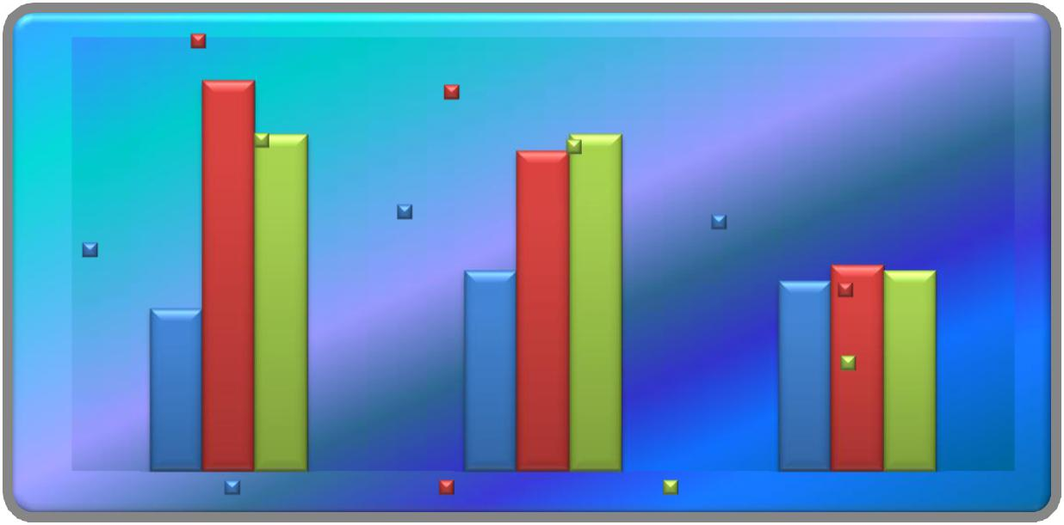

in cells/mcL

Post Test Means,
YPRT, 4.42 |  | Post Test Means,
Adjusted Means, |  | YPPT, 4.29
 |  | Adjusted Means,
YPRT, 4.32 |  | YPPT, 4.32
Pre Test Means, |  |  | Pre Test Means,
Pre Test Means, | YPPT, 4.07 |  | Pre Test Means,
Pre Test Means, |  |  | CG, 4.05
YPRT, 4 |  |  | Post Test Means,
 |  |  | CG, 4.08
 |  |  | Adjusted Means,
 |  |  | CG, 4.07
Pre Test Means |  | Post Test Means | Adjusted Means

4.9.1 DISCUSSION ON RBC

The results presented in table XIV showed that the obtained adjusted means on RBC among Satyananda Saraswathi yoga group was 4.41 followed by Maharishi Mahesh yoga group with mean value of 4.32, and control group with mean value of 4.07. The differences among pre test scores, post test scores and adjusted mean scores of the subjects were statistically treated using ANCOVA and the obtained F values were 0.54, 10.90 and 20.08 respectively. It was found that obtained F value on pre test scores were not significant and the obtained F values on posttest and adjusted means were significant at 0.05 level of confidence as these were greater than the required table F value of 3.22 and 3.23. The post hoc analysis through Scheffe’s Confidence test proved that twelve weeks training of Satyananda Saraswathi yoga and Maharishi Mahesh yoga had increased RBC than the control group and the differences were significant at 0.05 level. Further, the post hoc analysis showed that significant differences existed between the experimental groups, clearly indicating that Satyananda Saraswathi yoga was better than Maharishi Mahesh yoga in increasing RBC of the adolescent boys. The studies conducted by Jothi.,(2014), and Kravitz., (2013)proved that there was an increase in Red Blood Cells due to yogic practices.

126

TABLE - XV

COMPUTATION OF ANALYSIS OF COVARIANCE OF MEAN OF SATYANANDA SARASWATHI YOGA, MAHARISHI MAHESH YOGA AND CONTROL GROUPS ON HEMOGLOBIN

Control

SSYG MMYG
Group

Pre-Test
13.56 13.62 13.70
Means

Post-

Test 14.56 14.46 13.77

Means

Adjusted

Post-
14.58 14.46 13.75
Test

Means

Source

of
Variance

BG

WG

BG

WG

BG

WG

Sum of | df | Means
Squares | df | Squares
0.14 | 2 | 0.07
6.52 | 42 | 0.15
5.61 | 2 | 2.80
3.55 | 42 | 0.08
5.99 | 2 | 2.99
3.00 | 41 | 0.07

F-ratio

0.47

33.20*

40.86*

B- Between Group Means W- Within Group Means df- Degrees of Freedom

* - Significant

(Table Value for 0.05 Level for df 2 & 42 = 3.22)

(Table Value for 0.05 Level for df 2 & 41 = 3.23)

127

4.10 RESULTS OF HEMOGLOBIN

An examination of table - XV indicated that the pretest means of Satyananda Saraswathi yoga, Maharishi Mahesh yoga and control groups were 13.56, 13.62 and 13.70 respectively. The obtained F-ratio for the pre-test was 0.47 and the table F-ratio was 3.22. Hence the pre-test mean F-ratio was insignificant at 0.05 level of confidence for the degree of freedom 2 and 42. This proved that there were no significant differences between the experimental and control groups indicating that the process of randomization of the groups was perfect while assigning the subjects to groups.

The post-test means of the Satyananda Saraswathi yoga, Maharishi Mahesh yoga and control groups were 14.56, 14.46 and 13.77 respectively. The obtained F-ratio for the post-test was 33.20 and the table F-ratio was 3.22. Hence the post-test mean F-ratio was significant at 0.05 level of confidence for the degree of freedom 2 and 42. This proved that the differences between the posttest means of the subjects were significant.

The adjusted post-test means of the Satyananda Saraswathi yoga, Maharishi Mahesh yoga and control groups were 14.58, 14.46 and 13.75 respectively. The obtained F-ratio for the adjusted post-test means was 40.86 and the table F-ratio was 3.23. Hence the adjusted post-test mean F-ratio was significant at 0.05 level of confidence for the degree of freedom 2 and 41. This proved that there was a significant difference among the means due to the packages of both yogic practices on hemoglobin.

Since significant differences were recorded, the results were subjected to post hoc analysis using Scheffe’s post hoc test. The results were presented in Table – XVI.

128

TABLE – XVI

THE SCHEFFE’S TEST FOR THE DIFFERENCES BETWEEN THE ADJUSTED POST TEST PAIRED MEANS ON HEMOGLOBIN

 |  | Adjusted Post-test means |  |  | Mean Difference | Required CI
 | SSYG |  | MMYG | Control Group
 | 14.58 |  | 14.46 | --- | 0.12
 | 14.58 |  | --- | 13.75 | 0.83* | 0.24
 | --- |  | 14.46 | 13.75 | 0.71*

* Significant at 0.05 level of confidence

The multiple comparisons showed in Table XVI proved that there existed significant differences between the adjusted means of Satyananda Saraswathi yoga with control group (0.83), Maharishi Mahesh yoga with control group (0.71). There was no significant difference between Satyananda Saraswathi yoga and Maharishi Mahesh yoga (0.12) at 0.05 level of confidence with the confidence interval value of 0.24.

The pre, post and adjusted means on hemoglobin were presented through bar diagram for better understanding of the results of this study in Figure-5.

129

FIGURE – 5

PRE POST AND ADJUSTED POST TEST DIFFERENCES OF THE, SATYANANDA SARASWATHI YOGA, MAHARISHI MAHESH YOGA AND CONTROL GROUPS ON HEMOGLOBIN
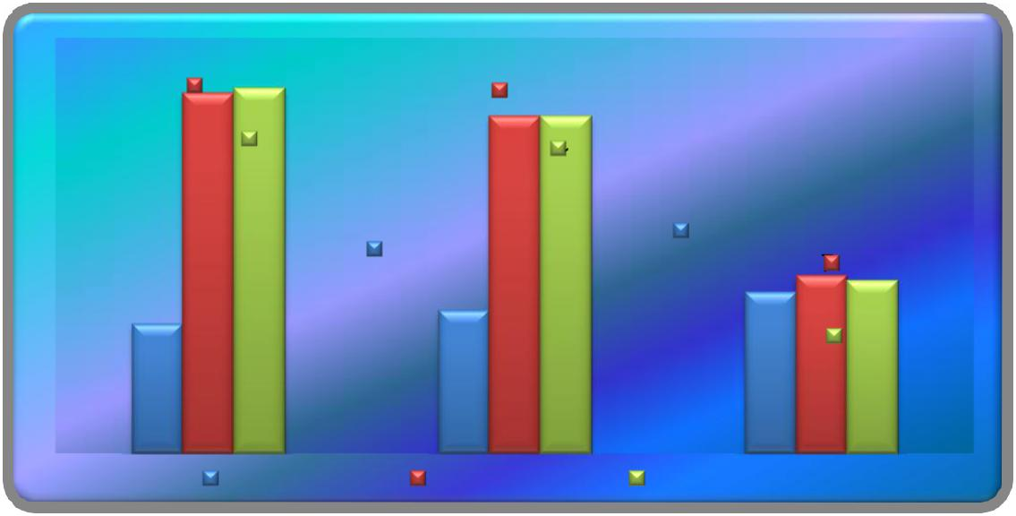

in gm/dL

Post Test |  | Post Test
Means, YPRT, |  | Means, YPPT,
Adjusted |  | Adjusted
14.56
14.56 |  | 14.46
Means, YPRT, |  | Means, YPPT,
14.58
14.58 |  | 14.46 | Pre Test Means,
Pre Test Means, | Pre Test Means, |  | CG, 13.7 Post Test
Pre Test Means, |  | YPPT, 13.62 | CG, 13.7 Post Test
YPRT, 13.56 |  | YPPT, 13.62 | Means, CG,
 |  |  | 13.77
 |  |  | Adjusted
 |  |  | Means, CG,
 |  |  | 13.75
Pre Test Means |  | Post Test Means Adjusted Means

4.10.1 DISCUSSION ON HEMOGLOBIN

The results presented in table XVI showed that the obtained adjusted means on hemoglobin among Satyananda Saraswathi yoga group was 14.58 followed by Maharishi Mahesh yoga group with mean value of 14.46, and control group with mean value of 13.75. The differences among pre test scores, post test scores and adjusted mean scores of the subjects were statistically treated using ANCOVA and the obtained F values were 0.47, 33.20 and 40.86 respectively. It was found that obtained F value on pre test scores were not significant and the obtained F values on posttest and adjusted means were significant at 0.05 level of confidence as these were greater than the required table F value of 3.22 and 3.23. The post hoc analysis through Scheffe’s Confidence test proved that twelve weeks training of Satyananda Saraswathi yoga and Maharishi Mahesh yoga had increased hemoglobin than the control group and the differences were significant at 0.05 level. Further, the post hoc analysis showed that significant differences existed between the experimental groups, clearly indicating that Satyananda Saraswathi yoga was significantly better than Maharishi Mahesh yoga in increasing hemoglobin of the adolescent boys. The studies conducted by Dean.,(2011), Chinnasamy., (1992) and Geetanjali., (2013)proved that there was an increase in hemoglobin through yoga practices.

130

TABLE – XVII

COMPUTATION OF ANALYSIS OF COVARIANCE OF MEAN OF SATYANANDA SARASWATHI YOGA, MAHARISHI MAHESH YOGA AND CONTROL GROUPS ON WBC

 |  |  | SSYG | MMYG | Control | Source
 |  |  | SSYG | MMYG | Control | of
 |  |  | SSYG | MMYG | Group | of
 |  |  |  |  | Group | Variance
 |  | Pre-Test |  |  |  | BG
 |  | Pre-Test | 5726.66 | 5560.00 | 5786.66
 |  | Means | 5726.66 | 5560.00 | 5786.66
 |  | Means |  |  |  | WG
 |  | Post- |  |  |  | BG
 |  | Test | 6780.00 | 6580.00 | 5793.33
 |  | Means |  |  |  | WG
 |  | Adjusted |  |  |  | BG
 |  | Post- |  |  |  | BG
 |  | Post- | 6768.50 | 6622.39 | 5762.43
 |  | Test | 6768.50 | 6622.39 | 5762.43 | WG
 |  | Means |  |  |  | WG

Sum of |  | df |  | Means
Squares |  | df |  | Squares
413777.77 |  | 2 |  | 206888.88
15662666.66 |  | 42 |  | 372920.63
8161777.77 |  | 2 |  | 4080888.88
8257333.33 |  | 42 |  | 196603.17
8782335.15 |  | 2 |  | 4391167.57
6619626.99 |  | 41 |  | 161454.31

F-ratio

0.55

20.75*

27.19*

B- Between Group Means * - Significant

W- Within Group Means (Table Value for 0.05 Level for df 2 & 42 = 3.22)

df- Degrees of Freedom (Table Value for 0.05 Level for df 2 & 41 = 3.23)

131

4.11 RESULTS OF WBC

An examination of table - XVII indicated that the pretest means of Satyananda Saraswathi yoga, Maharishi Mahesh yoga and control groups were 5726.66, 5560.00 and 5786.66 respectively. The obtained F-ratio for the pre-test was 0.55 and the table F-ratio was 3.22. Hence the pre-test mean F-ratio was insignificant at 0.05 level of confidence for the degree of freedom 2 and 42. This proved that there were no significant difference between the experimental and control groups indicating that the process of randomization of the groups was perfect while assigning the subjects to groups.

The post-test means of the Satyananda Saraswathi yoga, Maharishi Mahesh yoga and control groups were 6780.00, 6580.00 and 5793.33 respectively. The obtained F-ratio for the post-test was 20.75 and the table F-ratio was 3.22. Hence the post-test mean F-ratio was significant at 0.05 level of confidence for the degree of freedom 2 and 42. This proved that the differences between the posttest means of the subjects were significant.

The adjusted post-test means of the Satyananda Saraswathi yoga, Maharishi Mahesh yoga and control groups were 6768.50, 6622.39 and 5762.43 respectively. The obtained F-ratio for the adjusted post-test means was 27.19 and the table F-ratio was 3.23. Hence the adjusted post-test mean F-ratio was significant at 0.05 level of confidence for the degree of freedom 2 and 41. This proved that there was a significant difference among the means due to the experimental trainings on WBC.

Since significant differences were recorded, the results were subjected to post hoc analysis using Scheffe’s post hoc test. The results were presented in Table-XVIII.

132

TABLE - XVIII

THE SCHEFFE’S TEST FOR THE DIFFERENCES BETWEEN THE ADJUSTED POST TEST PAIRED MEANS ON WBC

 |  | Adjusted Post-test means |  |  |  |  |  | Mean Difference |  | Required CI
 |  | SSYG |  | MMYG |  | Control Group
 |  | 6768.50 |  | 6622.39 |  | --- |  | 146.11
 |  | 6768.50 |  | --- |  | 5762.43 |  | 1006.07* |  | 372.91
 |  | --- |  | 6622.39 |  | 5762.43 |  | 860.00*

* Significant at 0.05 level of confidence

The multiple comparisons showed in Table XVIII proved that there existed significant differences between the adjusted means of Satyananda Saraswathi yoga with control group (1006.07), Maharishi Mahesh yoga with control group (860.00). There was no significant difference between Satyananda Saraswathi yoga and Maharishi Mahesh yoga (146.11) at 0.05 level of confidence with the confidence interval value of 372.91.

The pre, post and adjusted means on WBC were presented through bar diagram for better understanding of the results of this study in Figure-6.

133

FIGURE - 6

PRE POST AND ADJUSTED POST TEST DIFFERENCES OF THE, SATYANANDA SARASWATHI YOGA, MAHARISHI MAHESH YOGA AND CONTROL GROUPS ON WBC
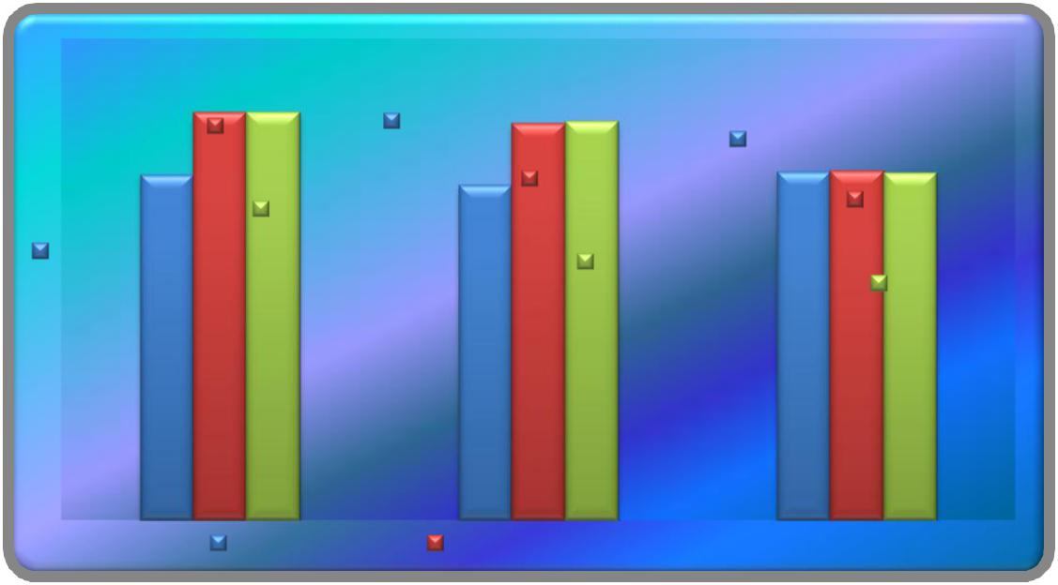

in cells/mcL

 | _{Post Test} Pre Test Means, |  | Pre Test Means,
Means, YPRT, |  | YPPT, 5560
 |  | YPPT, 5560 |  | CG, 5786.7
 | 6780 | Post Test |  | CG, 5786.7
 | 6780 | Means, YPPT, |  | Post Test
 | Adjusted | Means, YPPT, |  | Means, CG,
Pre Test Means, | Means, YPRT, | 6580 |  | Means, CG,
Pre Test Means, | Means, YPRT, | 6580 |  | 5793.3
YPRT, 5726.7 | 6768.5 | Adjusted |  | 5793.3
YPRT, 5726.7 | 6768.5 | Means, YPPT, |  | Adjusted

6622.4 | Means, CG,
6622.4 | 5762.4

Pre Test Means Post Test Means Adjusted Means

4.11.1 DISCUSSION ON WBC

The results presented in table XVIII showed that the obtained adjusted means on WBC among Satyananda Saraswathi yoga group was 6768.50 followed by Maharishi Mahesh yoga group with mean value of 6622.39, and control group with mean value of 5762.43. The differences among pretest scores, post test scores and adjusted mean scores of the subjects were statistically treated using ANCOVA and the obtained F values were 0.55, 20.75 and 27.19 respectively. It was found that obtained F value on pre test scores were not significant and the obtained F values on posttest and adjusted means were significant at 0.05 level of confidence as these were greater than the required table F value of 3.22 and 3.23. The post hoc analysis through Scheffe’s Confidence test proved that twelve weeks training of Satyananda Saraswathi yoga and Maharishi Mahesh yoga had increased WBC than the control group and the differences were significant at 0.05 level. Further, the post hoc analysis showed that significant differences existed between the experimental groups, clearly indicating that Satyananda Saraswathi yoga was better than Maharishi Mahesh yoga in increasing WBC of the adolescent boys. The studies conducted by Yoga.,(2011),

134

Chandrashekar., (2007) and Datla and Karimulla., (2005)proved that there was an increase in White Blood Cells through yoga practices.

TABLE – XIX

COMPUTATION OF ANALYSIS OF COVARIANCE OF MEAN OF SATYANANDA SARASWATHI YOGA, MAHARISHI MAHESH YOGA AND CONTROL GROUPS ON SELF CONCEPT

 |  | SSYG |  |  | Control | Source |  | Sum of |  |  |  | Means
 |  | SSYG | MMYG |  | Control | of |  | Sum of |  | df |  | Means |  | F-ratio
 |  | SSYG |  |  | Group | of |  | Squares |  | df |  | Squares |  | F-ratio
 |  |  |  |  | Group | Variance |  | Squares |  |  |  | Squares
 | Pre-Test |  |  |  |  | BG |  | 39.51 |  | 2 |  | 19.75 |  | 0.18
 | Pre-Test | 161.66 | 161.13 |  | 163.33
 | Means | 161.66 | 161.13 |  | 163.33
 | Means |  |  |  |  | WG |  | 4536.40 |  | 42 |  | 108.01
 | Post- |  |  |  |  | BG |  | 1453.64 |  | 2 |  | 726.82 |  | 4.00*
 | Test | 176.00 | 175.13 |  | 163.53
 | Means |  |  |  |  | WG |  | 7617.46 |  | 42 |  | 181.36
 | Adjusted |  |  |  |  | BG |  | 1730.14 |  | 2 |  | 865.07 |  | 5.94*
 | Post- |  |  |  |  | BG |  |  |  |  |  |  |  | 5.94*
 | Post- | 176.22 | 175.68 |  | 162.75
 | Test | 176.22 | 175.68 |  | 162.75 | WG |  | 5970.86 |  | 41 |  | 145.63
 | Means |  |  |  |  | WG |  | 5970.86 |  | 41 |  | 145.63

B- Between Group Means * - Significant W- Within Group Means (Table Value for 0.05 Level for df 2 & 42 = 3.22) df-
Degrees of Freedom (Table Value for 0.05 Level for df 2 & 41 = 3.23)

135

4.12 RESULTS OF SELF CONCEPT

An examination of table - XIX indicated that the pretest means of Satyananda Saraswathi yoga, Maharishi Mahesh yoga and control groups were 161.66, 161.13 and 163.33 respectively. The obtained F-ratio for the pre-test was 0.18 and the table F-ratio was 3.22. Hence the pre-test mean F-ratio was insignificant at 0.05 level of confidence for the degree of freedom 2 and 42. This proved that there were no significant difference between the experimental and control groups indicating that the process of randomization of the groups was perfect while assigning the subjects to groups.

The post-test means of the Satyananda Saraswathi yoga, Maharishi Mahesh yoga and control groups were 176.00, 175.13 and 163.53 respectively. The obtained F-ratio for the post-test was 4.00 and the table F-ratio was 3.22. Hence post-test mean F-ratio was significant at 0.05 level of confidence for the degree of freedom 2 and 42. This proved that the differences between the posttest means of the subjects were significant.

The adjusted post-test means of the Satyananda Saraswathi yoga, Maharishi Mahesh yoga and control groups were 176.22, 175.68 and 162.75 respectively. The obtained F-ratio for the adjusted post-test means was 5.94 and the table F-ratio was 3.23. Hence the adjusted post-test mean F-ratio was significant at 0.05 level of confidence for the degree of freedom 2 and 41. This proved that there was a significant difference among the means due to the packages of both the yogic practices on self-concept.

Since significant differences were recorded, the results were subjected to post hoc analysis using Scheffe’s post hoc test. The results are presented in Table-XX.

136

TABLE - XX

THE SCHEFFE’S TEST FOR THE DIFFERENCES BETWEEN THE ADJUSTED POST TEST PAIRED MEANS ON SELF CONCEPT

 |  | Adjusted Post-test means |  |  | Mean Difference | Required CI
 | SSYG |  | MMYG | Control Group
 | 176.22 |  | 175.68 | --- | 0.54
 | 176.22 |  | --- | 162.75 | 13.47* | 11.19
 | --- |  | 175.68 | 162.75 | 12.93*

* Significant at 0.05 level of confidence

The multiple comparisons showed in Table XX proved that there existed significant differences between the adjusted means of Satyananda Saraswathi yoga with control group (13.47), Maharishi Mahesh yoga with control group (12.93). There was no significant difference between Satyananda Saraswathi yoga and Maharishi Mahesh yoga (0.54) at 0.05 level of confidence with the confidence interval value of 11.19.

The pre, post and adjusted means on self-concept were presented through bar diagram for better understanding of the results of this study in Figure-7.

137

FIGURE - 7

PRE POST AND ADJUSTED POST TEST DIFFERENCES OF THE, SATYANANDA SARASWATHI YOGA, MAHARISHI MAHESH

YOGA AND CONTROL GROUPS ON SELF CONCEPT
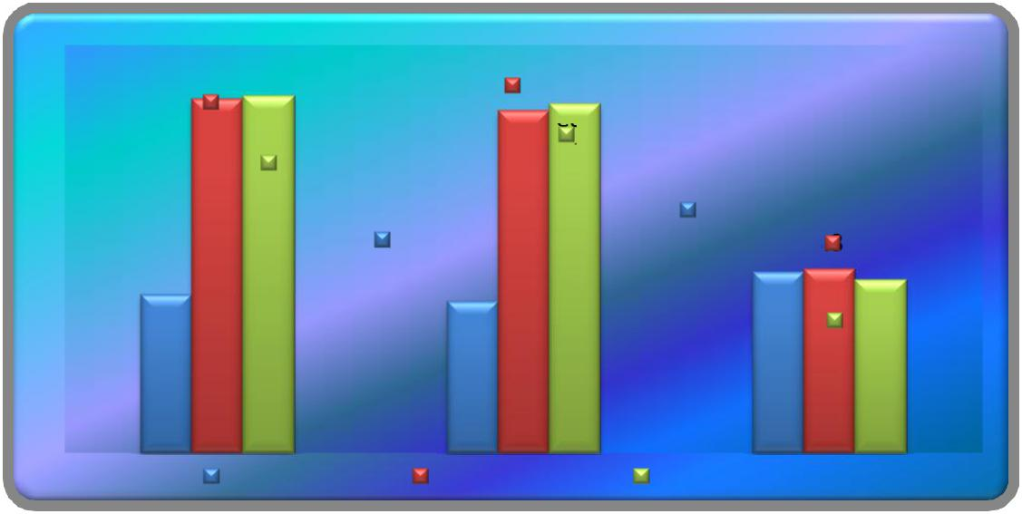

in points

Post Test |  | Post Test
 |  | Means, YPPT,
Means, YPRT,
 |  | Adjusted
 | Adjusted | 175.13
 | 176 | Means, YPPT,
 | Means, YPRT, |  | ^{175.68} Pre Test Means,
Pre Test Means, | ^{176.22}Pre Test Means, |  | CG, 163.33 Post Test
YPRT, 161.66 |  | YPPT, 161.13 | Means, CG,
 |  |  | 163.53
 |  |  | Adjusted
 |  |  | Means, CG,
 |  |  | 162.75
Pre Test Means |  | Post Test Means | Adjusted Means

4.12.1 DISCUSSION ON SELF CONCEPT

The results presented in table XX showed that the obtained adjusted means on self-concept among Satyananda Saraswathi yoga group was 176.22 followed by Maharishi Mahesh yoga group with mean value of 175.68, and control group with mean value of 162.75. The differences among pretest scores, post test scores and adjusted mean scores of the subjects were statistically treated using ANCOVA and the obtained F values were 0.18, 4.00 and 5.94 respectively. It was found that obtained F value on pre test scores were not significant and the obtained F values on posttest and adjusted means were significant at 0.05 level of confidence as these were greater than the required table F value of 3.22 and 3.23. The post hoc analysis through Scheffe’s Confidence test proved that twelve weeks training of Satyananda Saraswathi yoga and Maharishi Mahesh yoga had improved self-concept than the control group and the differences were significant at 0.05 level. Further, the post hoc analysis showed that there was significant differences between the experimental groups, clearly indicating that Satyananda Saraswathiyoga was better than Maharishi Mahesh yoga in improving self-concept of the adolescent boys. The studies conducted by Salvi., (2013), Dale., (2011), Taylor., (1995) and Kundu., (2014)proved that there was an increase in self-concept through yoga practices.

138

TABLE - XXI

COMPUTATION OF ANALYSIS OF COVARIANCE OF MEAN OF SATYANANDA SARASWATHI YOGA, MAHARISHI MAHESH YOGA AND CONTROL GROUPS ON SELF ESTEEM

Control
SSYG MMYG
Group

Pre-Test
18.26 17.26 17.73
Means

Post-

Test 21.73 19.86 17.93

Means

Adjusted

Post-
21.41 20.17 17.94
Test

Means

Source

of

Variance

BG

WG

BG

WG

BG

WG

Sum of | df | Means
Squares | df | Squares
7.51 | 2 | 3.75
416.80 | 42 | 9.92
108.31 | 2 | 54.15
457.60 | 42 | 10.89
92.21 | 2 | 46.10
292.48 | 41 | 7.13

F-

ratio

0.37

4.97*

6.46*

B- Between Group Means W- Within Group Means df- Degrees of Freedom

* - Significant

(Table Value for 0.05 Level for df 2 & 42 = 3.22)

(Table Value for 0.05 Level for df 2 & 41 = 3.23)

139

4.13 RESULTS OF SELF ESTEEM

An examination of table - XXI indicated that the pretest means of Satyananda Saraswathi yoga, Maharishi Mahesh yoga and control groups were 18.26, 17.26 and 17.73 respectively. The obtained F-ratio for the pre-test was 0.37 and the table F-ratio was 3.22. Hence the pre-test mean F-ratio was insignificant at 0.05 level of confidence for the degree of freedom 2 and 42. This proved that there were no significant difference between the experimental and control groups indicating that the process of randomization of the groups was perfect while assigning the subjects to groups.

The post-test means of the Satyananda Saraswathi yoga, Maharishi Mahesh yoga and control groups were 21.73, 19.86 and 17.93 respectively. The obtained F-ratio for the post-test was 4.97 and the table F-ratio was 3.22. Hence the post-test mean F-ratio was significant at 0.05 level of confidence for the degree of freedom 2 and 42. This proved that the differences between the posttest means of the subjects were significant.

The adjusted post-test means of the Satyananda Saraswathi yoga, Maharishi Mahesh yoga and control groups were 21.41, 20.17 and 17.94 respectively. The obtained F-ratio for the adjusted post-test means was 6.46 and the table F-ratio was 3.23. Hence the adjusted post-test mean F-ratio was significant at 0.05 level of confidence for the degree of freedom 2 and 41. This proved that there was a significant difference among the means due to the packages of both yogic practices on self-esteem.

Since significant differences were recorded, the results were subjected to post hoc analysis using Scheffe’s post hoc test. The results were presented in Table-XXII.

140

TABLE - XXII

SCHEFFE’S TEST FOR THE DIFFERENCES BETWEEN THE ADJUSTED POST TEST PAIRED MEANS ON SELF ESTEEM

 |  | Adjusted Post-test means |  |  | Mean Difference | Required CI
 | SSYG |  | MMYG | Control Group
 | 21.41 |  | 20.17 | --- | 1.24
 | 21.41 |  | --- | 17.94 | 3.47* | 2.47
 | --- |  | 20.17 | 17.94 | 2.23*

* Significant at 0.05 level of confidence

The multiple comparisons showed in Table XXII proved that there existed significant differences between the adjusted means of Satyananda Saraswathi yoga with control group (3.47), Maharishi Mahesh yoga with control group (2.23). There was no significant difference between Satyananda Saraswathi yoga and Maharishi Mahesh yoga (1.24) at 0.05 level of confidence with the confidence interval value 2.47.

The pre, post and adjusted means on self-esteem were presented through bar diagram for better understanding of the results of this study in Figure-8.

141

FIGURE – 8

PRE POST AND ADJUSTED POST TEST DIFFERENCES OF THE, SATYANANDA SARASWATHI YOGA, MAHARISHI MAHESH YOGA AND CONTROL GROUPS ON SELF ESTEEM
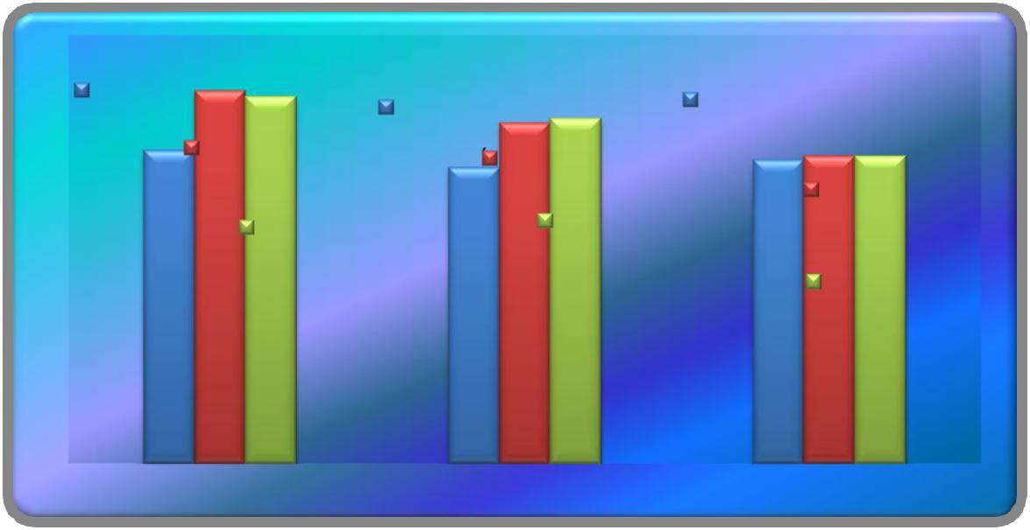

in points

Pre Test Means, | Pre Test Means, |  | Pre Test Means,
YPRT, 18.26
YPRT, 18.26 | YPPT, 17.26 |  |  | CG, 17.73
Post Test Means, |  |  |  | CG, 17.73
Post Test Means, |  | Post Test Means,
YPRT, 21.73 |  | Post Test Means, |  | Post Test Means,
YPRT, 21.73 |  | YPPT, 19.86 |  | Post Test Means,
Adjusted Means, |  | Adjusted Means, |  | CG, 17.93
YPRT, 21.41 |  | YPPT, 20.17 |  | Adjusted Means,
 |  |  |  | CG, 17.94

Pre Test Means Post Test Means Adjusted Means

4.13.1 DISCUSSION ON SELF ESTEEM

The results presented in table XXII showed that the obtained adjusted means on self-esteem among SatyanandaSaraswathi yoga group was 21.41 followed by Maharishi Mahesh yoga group with mean value of 20.17, and control group with mean value of 17.94. The differences among pretest scores, post test scores and adjusted mean scores of the subjects were statistically treated using ANCOVA and the obtained F values were 0.37, 4.97 and 6.46 respectively. It was found that obtained F value on pre test scores were not significant and the obtained F values on posttest and adjusted means were significant at 0.05 level of confidence as these were greater than the required table F value of 3.22 and 3.23. The post hoc analysis through Scheffe’s Confidence test proved that twelve weeks training of SatyanandaSaraswathi yoga and Maharishi Mahesh yoga had improved self-esteem than the control group and the differences were significant at 0.05 level. Further, the post hoc analysis showed that there was significant differences between the experimental groups, clearly indicating that SatyanandaSaraswathiyoga was better than Maharishi Mahesh yoga by increasing self-esteem of the adolescent boys. The studies conducted by Thayer., (1967),

142

Kasala., (2014) and Saraswathi., (1974) proved that there was an improvement in self-esteem through yoga practices.

TABLE – XXIII

COMPUTATION OF ANALYSIS OF COVARIANCE OF MEAN OF SATYANANDA SARASWATHI YOGA, MAHARISHI MAHESH YOGA AND CONTROL GROUPS ON ANXIETY

 |  |  |  |  | Control | Source
 |  | SSYG | MMYG |  | Control | of
 |  | SSYG |  |  | Group | of
 |  |  |  |  | Group | Variance
 | Pre-Test |  |  |  |  | BG
 | Pre-Test | 17.53 | 18.33 |  | 18.86
 | Means | 17.53 | 18.33 |  | 18.86
 | Means |  |  |  |  | WG
 | Post- |  |  |  |  | BG
 | Test | 14.33 | 15.80 |  | 18.73
 | Means |  |  |  |  | WG
 | Adjusted |  |  |  |  | BG
 | Post- | 14.83 | 15.73 |  | 18.29
 | Test | 14.83 | 15.73 |  | 18.29 | WG
 | Means |  |  |  |  | WG

Sum of | df | Means
Squares | df | Squares
13.51 | 2 | 6.75
738.80 | 42 | 17.59
150.57 | 2 | 75.28
518.66 | 42 | 12.34
94.70 | 2 | 47.35
144.45 | 41 | 3.52

F-ratio

0.38

6.09*

13.43*

B- Between Group Means W- Within Group Means df- Degrees of Freedom

* - Significant

(Table Value for 0.05 Level for df 2 & 42 = 3.22)

(Table Value for 0.05 Level for df 2 & 41 = 3.23)

143

4.14 RESULTS OF ANXIETY

An examination of table - XXIII indicated that the pretest means of Satyananda Saraswathi yoga, Maharishi Mahesh yoga and control groups were 17.53, 18.33 and 18.86 respectively. The obtained F-ratio for the pre-test was 0.38 and the table F-ratio was 3.22. Hence the pre-test mean F-ratio was insignificant at 0.05 level of confidence for the degree of freedom 2 and 42. This proved that there were no significant difference between the experimental and control groups indicating that the process of randomization of the groups was perfect while assigning the subjects to groups.

The post-test means of the Satyananda Saraswathi yoga, Maharishi Mahesh yoga and control groups were 14.33, 15.80 and 16.28 respectively. The obtained F-ratio for the post-test was 6.09 and the table F-ratio was 3.22. Hence the post-test mean F-ratio was significant at 0.05 level of confidence for the degree of freedom 2 and 42. This proved that the differences between the posttest means of the subjects were significant.

The adjusted post-test means of the Satyananda Saraswathi yoga, Maharishi Mahesh yoga and control groups were 14.83, 15.73 and 18.29 respectively. The obtained F-ratio for the adjusted post-test means was 13.43 and the table F-ratio was 3.23. Hence the adjusted post-test mean F-ratio was significant at 0.05 level of confidence for the degree of freedom 2 and 41. This proved that there was significant difference among the means due to the packages of both the yogic practices on anxiety.

Since significant differences were recorded, the results were subjected to post hoc analysis using Scheffe’s post hoc test. The results are presented in Table-XXIV.

144

TABLE – XXIV

SCHEFFE’S TEST FOR THE DIFFERENCE BETWEEN THE ADJUSTED POST TEST PAIRED MEANS ON ANXIETY

 |  | Adjusted Post-test means |  |  | Mean Difference | Required CI
 | SSYG |  | MMYG | Control Group
 | 14.83 |  | 15.73 | --- | 0.90
 | 14.83 |  | --- | 18.29 | 3.46* | 1.74
 | --- |  | 15.73 | 18.29 | 2.56*

* Significant at 0.05 level of confidence

The multiple comparisons showed in Table XXIV proved that there existed significant differences between the adjusted means of Satyananda Saraswathi yoga with control group (3.46), Maharishi Mahesh yoga with control group (2.56). There was no significant difference between Satyananda Saraswathi yoga and Maharishi Mahesh yoga (0.90) at 0.05 level of confidence with the confidence interval value of 1.74.

The pre, post and adjusted means on anxiety were presented through bar diagram for better understanding of the results of this study in Figure-9.

145

FIGURE – 9

PRE POST AND ADJUSTED POST TEST DIFFERENCES OF THE, SATYANANDA SARASWATHI YOGA, MAHARISHI MAHESH YOGA AND CONTROL GROUPS ON ANXIETY
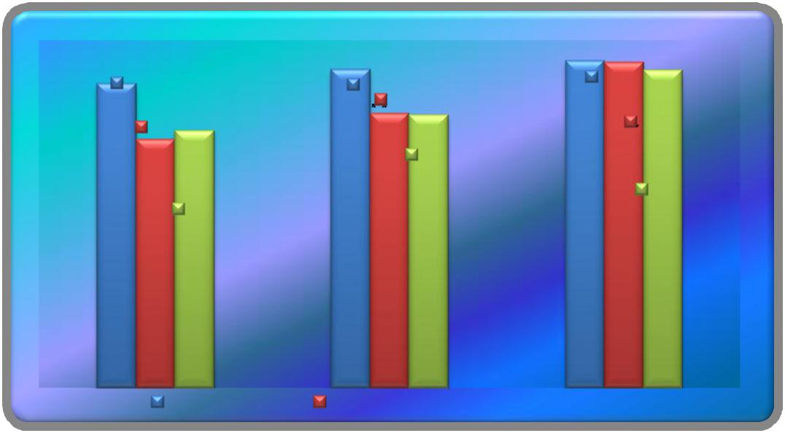

in points

Pre Test | Pre Test | Pre Test
Means, YPRT, | Post Test | Means, CG,
Means, YPRT, | Means, YPPT, | Means, CG,
Post Test | Means, YPPT, | Post Test
17.53 | 18.33 | 18.86
Means, YPRT, | 15Adjusted.8 | Means, CG,
14.33 | Means, YPPT, | 18.73
Adjusted | 15.73 | Adjusted
Adjusted | 15.73 | Means, CG,
Means, YPRT, |  | Means, CG,
Means, YPRT, |  | 18.29
14.83 |  | 18.29

Pre Test Means Post Test Means Adjusted Means

4.14.1 DISCUSSION ON ANXIETY

The results presented in table XXIV showed that the obtained adjusted means on anxiety among Satyananda Saraswathi yoga group was 14.83 followed by Maharishi Mahesh yoga group with mean value of 15.73, and control group with mean value of 18.29. The differences among pretest scores, post test scores and adjusted mean scores of the subjects were statistically treated using ANCOVA and the obtained F values were 0.38, 6.09 and 13.43 respectively. It was found that obtained F value on pretest scores were not significant and the obtained F values on posttest and adjusted means were significant at 0.05 level of confidence as these were greater than the required table F value of 3.22 and 3.23. The post hoc analysis through Scheffe’s Confidence test proved that twelve weeks training of Satyananda Saraswathi yoga and Maharishi Mahesh yoga had decreased anxiety than the control group and the differences were significant at 0.05 level. Further, the post hoc analysis showed that there were significant differences between the experimental groups, clearly indicating that Satyananda Saraswathi yoga was significantly better than Maharishi Mahesh yoga in decreasing anxiety of the adolescent boys. The studies conducted by), Ross and Thomas., (2010), Thakur., (2013Gupta., (2006) and Telles., (2009)proved that there was a decrease in anxiety due to yogic practices.

146

DISCUSSION ON HYPOTHESES

On the basis of the results of the study, the following discussions on the hypotheses formulated in the study were recorded

- As the findings of the study showed that both the yogic practices packages such as Swami Sathyananda Saraswathi Yogic practices and Maharishi Mahesh Yoga Practices influence changes in the selected Physiological, Hematological and Psychological variables such as decrease in Pulse Rate, Diastolic and Systolic Blood Pressure, the 1st hypotheses formulated in the study was accepted at 0.05 level of confidence.

- The results of the study indicated that Swami Sathyananda Saraswathi Yogic practices and Maharishi Mahesh Yoga Practices had increased Red Blood Cells, Hemoglobin count and White Blood Corpuscles in Blood among adolescent boys significantly. Hence, the formulated hypotheses II was accepted at 0.05 level of confidence.

- It had also been recorded from the findings that Yoga practices from Swami Sathyananda Saraswathi Yogic practices and Maharishi Mahesh Yoga Practices had significantly decreased Anxiety and increased Self-concept and Self-esteem. Hence, the third hypotheses formulated in the study were also accepted at 0.05 level of confidence.

- The fourth Hypotheses as null hypothesis that there would no significant differences between the effects of Swami Sathyananda Saraswathi Yogic practices and Maharishi Mahesh Yogic Practices was rejected at 0.05 level of confidence as Swami Sathyananda Saraswathi Yogic practices had significantly decreased Resting Pulse Rate, Diastolic and Systolic Blood Pressure, increased Red Blood Cells, Hemoglobin and White Blood Corpuscles and decreased Anxiety and increased Self-concept and Self-esteem better than Maharishi Mahesh Yoga Practices.

147

CHAPTER V

SUMMARY, CONCLUSIONS AND RECOMMENDATIONS

5.1 SUMMARY

Yoga is a way of life. It is predominantly concerned with maintaining a state of equanimity at all costs. All Yoga schools of thought emphasize the importance of the mind remaining calm, because as the saying goes, only when the water is still can you see through it. Yoga Darshan or Yoga Philosophy also happens to be a valid discipline of Indian metaphysics (Brahma Vidhya). It is the result of human wisdom and insight on physiology, psychology, ethics and spirituality collected together and practiced over thousands of years for the well-being of humanity.

The basic idea of yoga is to unite the Atma or individual soul with the Paramatma or the universal soul. According to yoga philosophy, by cleansing one’s mind and controlling one’s thought processes, one can return to that primeval state, when the individual self was nothing but a part of the Divine Self. This is the sense encapsulated in the term Samadhi. The aim of the yogi is to be able to perceive the world in its true light and to accept the truth in its entirety.

In Sanskrit, the term ‘yoga’ stands for ‘union’. A yogi’s ultimate aim is to be able to attain this ‘union’ with the Eternal Self with the help of certain mental and physical exercises. It is often said that Hiranyagarbha (The Cosmic Womb) himself had originally advocated the traditional system of yoga, from which all other yoga schools have evolved. But for all extent knowledge of yoga and its practices, such as Yogasanas and pranayama, the entire credit goes to Maharishi Patanjali.

Research Methodology involves the systematic procedure by which the research starts from the initial identification of the problem to its final conclusions. The role of methodology is to carry on the research work in a scientific and valid manner.

148

Procedures and methods applied in selection of subjects, selection of variables, experimental design, pilot study, criterion measures, reliability of the data, reliability of instruments, tester’s reliability, orientation of the subjects, training program, training schedule, selection of tests, administration of tests, collection of data and statistical procedure followed in this study have been recorded.

To achieve the purpose of this study, forty five subjects were randomly selected from Sreevatsa Viswanathaan Vivekananda Vidyalaya Junior College, Chennai, Tamil Nadu, during the academic year 2011 – 2012. The subjects who were adolescent boys ranged from 15 to 18 years of age. They were randomly divided into three equal groups. Sathyananda Saraswathy Yoga Group (Bihar of School) and Maharishi Mahesh Yogi’s Yoga practices group were considered as two experimental groups and the other group was the control group. All the subjects were adolescent boys only. The nature and importance of the study was explained to the subjects and they expressed their willingness to serve as subjects in the study. A qualified physician examined the subjects medically and declared that they were fit to participate in the yoga practices program.

The research scholar reviewed the literature on yoga in general and research studies in particular on the selected Physiological, Hematological and Psychological variables from books, journals, periodicals, magazines, research papers and internet.

The study was formulated as a true random group design consisting of a pretest and posttest, the subjects (N = 45) were randomly assigned to three equal groups of adolescent aged boys of fifteen each. The groups were assigned as experimental group I, II and control group respectively. Pretest was conducted for all the subjects on selected Psychological, Hematological and Physiological variables such as (1) Pulse rate (2) Diastolic Blood pressure (3) Systolic Blood Pressure (4) Hemoglobin (5) Red Blood Cells (6) White Blood Corpuscles (7) Self Concept (8) Self Esteem and (9) Anxiety. The experimental group participated in their respective Sathyananda Saraswathi (Bihar of School) and Maharishi Mahesh Yogi’s Practices for a period of 12 weeks. The posttest was conducted on the above said dependent variables after a period of 12 weeks in the respective treatments. The practice training

149

program was scheduled from 6 am to 7 am and 7 am to 8 am from Monday to Saturday in progression.

Before the collection of data, the subjects were oriented about the purpose of the study. The scholar explained the yogic practice procedures, the training schedule and utility. The procedure of the yogic practices was instructed to the subjects.

During the program of yogic practices the experimental group I underwent Sathyananda Saraswathi (Bihar School of Yoga) practices program for six days a week from Monday to Saturday 6 am to 7 am and experimental group II underwent Maharishi Mahesh Yogi’s Yoga practices program for six days a week from Monday to Saturday 7 am to 8 am. Experimental treatment was restricted to 12 weeks only. Table II and III show the yogic training schedules.

5.2 CONCLUSIONS

On the basis of the results obtained and by analyzing the data collected on the dependent variables for the study, the following conclusions were drawn

- There were significant differences between experimental group I (Swami Satyanandha Saraswathy yogic practices) and control group showing that Swami Satyanandha Saraswathy yogic practices had decreased resting heart rate, systolic and diastolic blood pressure, increased red blood cells, hemoglobin and white blood cells, increased self-concept and self-esteem and decreased anxiety.

- There were significant differences between experimental group II (Maharishi Mahesh yogic practices) and control group showing that Maharishi Mahesh yogic practices had decreased Resting heart rate, systolic and diastolic blood pressure, increased red blood cells, hemoglobin and white blood cells, increased self-concept and self-esteem and decreased anxiety.

- Swami Satyanandha Saraswathy yogic practices had shown greater changes in the dependent variable, such as a decrease in resting heart rate, systolic and diastolic blood pressure, increased in red blood cells, hemoglobin and white blood cells, increase in self-concept and self-esteem and decrease in anxiety than through the practices of Maharishi Mahesh yogi’s package.

150

- It has been observed that both the yogic packges have included sarvangasana, pachimottasana, matyasana, halasana and ardhamatyendrasana.

Though both the yogi practices had significantly increased the dependent variables in the study, the differences with greater and positive effects as felt by the researcher were attributed to the inclusion of suryanamaskar and yoga nidhra in Satyanandha Saraswathy Yogic Practice. It has been clearly stated by Swami SatyanandaSaraswathithat suryanamaskar stimulates and balances all the systems of the body including the circulatory, respiratory and digestive systems. Its influence on the endocrine glands helps to balance the transistor period between childhood and adolescence in growing children. Synchronizing the breath with the physical movements of suryanamaskar ensures that the practitioner, at least for a few minutes daily, breathes as deeply and rhythmically as possible, increasing mental clarity by bringing fresh, oxygenated blood to the brain. (Sathyananda, 1999)

5.3 RECOMMENDATIONS

The following recommendations are laid down by the investigator based on the results of this study.

Recommendations for Implication

- As both the packages of yogic practices had recorded positive influences on the selected physiological, hematological and psychological variables, any one yogic practice package shall be recommended for inclusion in instruction through physical education curriculum for male adolescents.
- Based on the limitations of gender with needed modifications and time durations, any one of the packages may be introduced for female adolescents.

- Yoga as theory and practice may be introduced in the curriculum in schools and colleges citing the influential research references as the findings recorded in this study.

151

5.4 RECOMMENDATIONS FOR FURTHER STUDY

- A similar study may be undertaken on female students and on different age groups of both sexes.
- Studies to find out the influences of yogi practices on the fitness and game specific performance variables may be conducted.
- Studies to construct game specific yogic practices which may help to enhance physical, physiological, hematological, and psychological and skill related variables may be conducted.

- A similar study may be conducted with yogic practices prescribed by other authors and systems in yoga.

152

BIBLIOGRAPHY

BOOKS

Bouras, N.; Holt, G. Psychiatric and Behavioral Disorders in Intellectual and Developmental Disabilities (2nd ed.). Cambridge University Press. 2007.

Clarke, Harrison, H, and David.H, Clarke, Advanced Statistics with Application to Physical Education, New Jersey: Englewood Cliffs, Prentice Hall, Inc.1972

Cohen, Louis, Lawrence Manion, and Keith Morrison. Research methods in education. Routledge, 2013.

Fox, Edward L., et al., The Physiological Basis of Physical Education and Athletics, (3ED), New York: W.M.C. Brown Publishers.

Grimes, Karlyn. The Everything Anti-Inflammation Diet Book.Krause

Publications, 2011.

Horn, Bruce Van. Yoga for Men: A Workout for the Body, Mind, and Spirit.

Andrews McMeel Publishing, 2002.

Iyengar B.K.S., Light on Yoga (5th Ed), London: Grorge Allen and Unwin Publishers Ltd 1986.

Leviton, Richard. The imagination of Pentecost: Rudolf Steiner and contemporary spirituality. SteinerBooks, 1994.

Ramacharaka, Yogi. Hatha Yoga : Yogi Philosophy of Physical Well-being, Yogi Publication Society, 1904.

Saraswathi Swami Satyananda., Asana Pranayama Mudra Bandha Bihar, India:

Yoga Publications Trust, 2008.

Satyananda. Meditations from the Tantras, with Live Class Transcriptions. Bihar School of Yoga, 1974.

Shaver Larry G. Essentials of Exercise Physiology, Delhi: Surjith Publishers, p.271.

153

Sivaramakrishnan S., Anatomy and Physiology for Physical Education, New Delhi:

Friends Publication 2006. ISBN:81-7216-192-1

Yogi Maharishi Mahesh,Science of Being and Art of Living: Transcendental Meditation 2009.

JOURNALS

Bavanani et al., “Hematological, Biochemical and Psychological Effects of A Yoga Training Programme in Nursing students” International Research Journal of

Paramedical and Applied Sciences (IRJPAS) 2013: 2(6):17-13

Balaji, P. A., Smitha R. Varne, and Syed Sadat Ali. "Physiological effects of yogic practices and transcendental meditation in health and disease." North American journal of medical sciences 4.10 (2012): 442.

Begum, Noorjahan. "To Evaluate The Effect Of Yoga On Moderate Degree Hypertension And Lipid Profile." National Journal of Integrated Research in Medicine 4.3 (2013).

Benavides, Sandra, and Joshua Caballero. "Ashtanga yoga for children and adolescents for weight management and psychological well being: an uncontrolled open pilot study." Complementary therapies in clinical practice15.2 (2009): 110-114.

Bhargava.R, MG Gogate and JF. Mascarenhas, “Autonomic responses to breath holding and Variations following pranayama” Indian J. Physiol. Pharmacol, 1988, Oct-Dec; 32(4):257-64.

Brown and Gerbarg “ Sudharshan Kriya Yogic Breathing in tne Treatment of stress, Anxiety and Depression” The Journal of Alternative and Complimentary Medicine, August 2005, 11(4): 711-171

Carrington, Patricia, et al. "The use of meditation-relaxation techniques for the management of stress in a working population." Journal of Occupational and Environmental Medicine 22.4 (1980): 221-231.

154

Catalfo, Phil. "Is Yoga a Religion?." Yoga Journal: Yoga News and Trends(2001).

Chandrashekar “Effect of Six weeks Yogesana Training on Hemotological Parameters and Lipid Profile” National Journal of Basic Medical Sciences, 119 Volume III, Issue-2, 2007

Chandratreya, Sujit. "Yoga: An evidence-based therapy." Journal of mid-life

health 2.1 (2011): 3.

Dabhade, Abhijeet Madhukar, et al. "Effect of pranayama (breathing exercise) on arrhythmias in the human heart." Explore: The Journal of Science and Healing 8.1:12-15(2012)

Dale, Lourdes P., et al. "Yoga practice may buffer the deleterious effects of abuse on women's self-concept and dysfunctional coping." Journal of Aggression, Maltreatment & Trauma 20.1 (2011): 90-102.

Datla and Karimulla “ Effect of Yogic Practices and Interval Training on Selected Physiological and Biochemical Variables among High School Boys” Asian

Journal of Physical Education and Computer Science in Sports, Volume 5:1 pp 83-85 ISSN 0975-7732, (2005)

Devasena, Indla, and Pandurang Narhare. "International Journal of Biological & Medical Research." Int J Biol Med Res 2.3 (2011): 750-753.

Field et al., “Taichi/Yoga Effects on Anxiety, Heart rate, EEG and Math Computations” Complementary Therpies in Clinical Practice,16:4 (November 2010) pp235-238.

Gaur Mahendra Pratab “The Effect of Ujjayi Pranayama on Selected Biochemical Variables” Lucknow: DAVPG College Journal of Physical Education 1:9 (Mar 2014)

Gupta et al., “Effect of Yoga Based Lifestyle Intervention on State and Trait Anxiety” Indian Journal of Physical Pharamacol, 50(1): 41-47 (2006)

155

Gitanjali Purohit et al., “Cardio protectant and Anti stress Effect of Yoga Training and its Correlation with Hemotological Parameters: A Perspective Study of Young Healthy Individuals” Scholars Journal of Applied Medical Sciences (SJAMS) Sch.J.App.Med.Sci,1:16 (2013)

Hagins Marshall et al., A Randomized Controlled Trial Comparing the Effects of Yoga With an Active Control on Ambulatory Blood Pressure in Individuals With Prehypertension and Stage 1 Hypertension, The Journal of Clinical Hypertension. Dec 2013: n/a-n/a

Harinath et al., “Effect of Hatha Yoga and Omkar Meditation in Cardiorespiratory Performance, Psychological Profile and Melatonin Secretion” The Journal of Alternative Complementary Medicine 10(2): 261-268, (July 2004)

Henig, Robin Marantz "Anxiety". The New York Times Magazine. (August 20, 2012). Jothi. K. “Effect of Yogic Practices and Physical Activity on Selected
Biochemical Variables among Sedentary Men” International Interdisciplinary Research Journal, ISSN 2249- 9598, Vol-IV, (Jan 2014)

Kaley-Isley, Lisa C., et al. "Yoga as a complementary therapy for children and adolescents: a guide for clinicians." Psychiatry (Edgmont) 7.8 (2010): 20.

Kasala, Eshvendar Reddy, et al. "Effect of meditation on neurophysiological changes in stress mediated depression." Complementary therapies in clinical practice 20.1: 74-80, (2014)

Kundu, Uday Bhanu, and Tarak Nath Pramanik. "Effect of Asanas and Pranayama on Self Concept of School Going Children." Group 11.2.73: 30. (2014)

Krishnaswamy, PC, P. Manjappa, and R. Suresh. "The Effect of Yogic Exercises on Self Concept an Experimental Study."(2011)

Miles, Steven C., et al. "Arterial blood pressure and cardiovascular responses to yoga practice." Alternative Therapies in Health & Medicine 19.1 (2013).

156

Mizuno, Julio, and Henrique Luiz Monteiro. "An assessment of a sequence of yoga exercises to patients with arterial hypertension." Journal of bodywork and movement therapies 17.1 (2013): 35-41.

Murugesan.R, N. Govindarajulu and TK.Bera, ‘Effect of selected yogic practices on the Management of hypertension”, Indian J. Physiol Pharmacol,44(2): 207-10(2000 Apr)

Rockwood, Kenneth, et al. "A global clinical measure of fitness and frailty in elderly people." Canadian Medical Association Journal 173.5: 489-495. (2005)

Ross, Alyson, and Sue Thomas. "The health benefits of yoga and exercise: a review of comparison studies." The journal of alternative and complementary medicine 16.1 (2010): 3-12.

Salvi, Bhaskar D. "Effect of Yoga on Depression, Self Concept And Mental Health of Normal Health Students." Asian Journal of Multidimensional Research2.1: 71-75. (2013)

Satyanarayana M., Rajeswari K.R., Rani N.J., Krishna C.S., Rao P.V. Effect of santhi kriya on certain psychophysiological parameters: a preliminary study. Indian J Physiol Pharmacol. 36:88–92, (1992)

Schell FJ, Allolio B, Schonecke OWDepartment of Internal Medicine, University of Würzburg, Germany.International Journal of Psychosomatics : Official Publication of the International Psychosomatics Institute[1994, 41(1-4):46-52]

Smith, E. R.; Mackie, D. M. (2007). Social Psychology (Third ed.). Hove:

Psychology Press. ISBN 978-1-84169-408-5.

Taylor, Douglas N. "Effects of a behavioral stress-management program on anxiety, mood, self-esteem, and T-cell count in HIV-positive men."Psychological Reports 76.2 :451-457. (1995)

Taylor, Janet A. "A personality scale of manifest anxiety." The Journal of Abnormal and Social Psychology 48.2: 285.(1953)

157

Telles.S, et al., “Comparison of changes in autonomic and respiratory parameters of girls after yoga and games at a community home” Percept Mot. Skills, 84(1): 251-7. (1997 Feb).

Telles.S, SK Reddy and HR. Nagendra, “Oxygen consumption and respiration following two yoga relaxation techniques”. Appl. Psychophysiol. Biofeedback, 25(4):221-7 (2000)

Thakur, Kuntal. "Effects of Surya Namaskara on Selected Psychological Parameters of School Boys." International Journal of Health Sciences and Research (IJHSR) 3.4 (2013): 65-69.

Thayer, Robert E. "MEASUREMENT OF ACTIVATION THROUGH SELF-REPORT Monograph Supplement 1-V20." Psychological reports 20.2: 663-678. (1967)

Upadhyay Dhungel K,Malhotra

breathing exercise on

J10(1):25-7. 2008 Mar.

V,Sarkar D,Prajapati R. “Effect of alternate nostril cardio respiratory functions”. Nepal Med Coll

UNPUBLISHED THESES

Kishore “Effect of Pranayama, on Selected Physiological and Hematological Variables” Unpublished Master of Philosophy Dissertation, Alagappa University 1992, p.p 75-77.

Swaroop “Effect of pranayama and Meditation on Pulse Rate and Blood Pressure of Male students of Nagarjuna University”Unpublished Master of Philosophy Dissertation, Alagappa University 1997, p.p 71-73.

SEMINAR PAPER

Verso, ML "The Evolution of Blood Counting Techniques".Read at a meeting of the Section of the History of Medicine, First Australian Medical Congress. (May 1962) Retrieved 9 September 2013.

158

WEBSITES

http://en.wikipedia.org/wiki/Self-esteem

http://en.wikipedia.org/wiki/Anxiety

http://en.wikipedia.org/wiki/Hemocytometer

www.HumanKinetics.com

www.wwnorton.com/college/psych/psychsci/media/rosenberg.htm

www.biharyyoga.net

www.rikhiapeeth.net

www.brihaspati.net

www.irjpas.com

www.PubMed.com

www.ebscohost.com

cohendl@mail.med.upenn.edu. 2004.

159
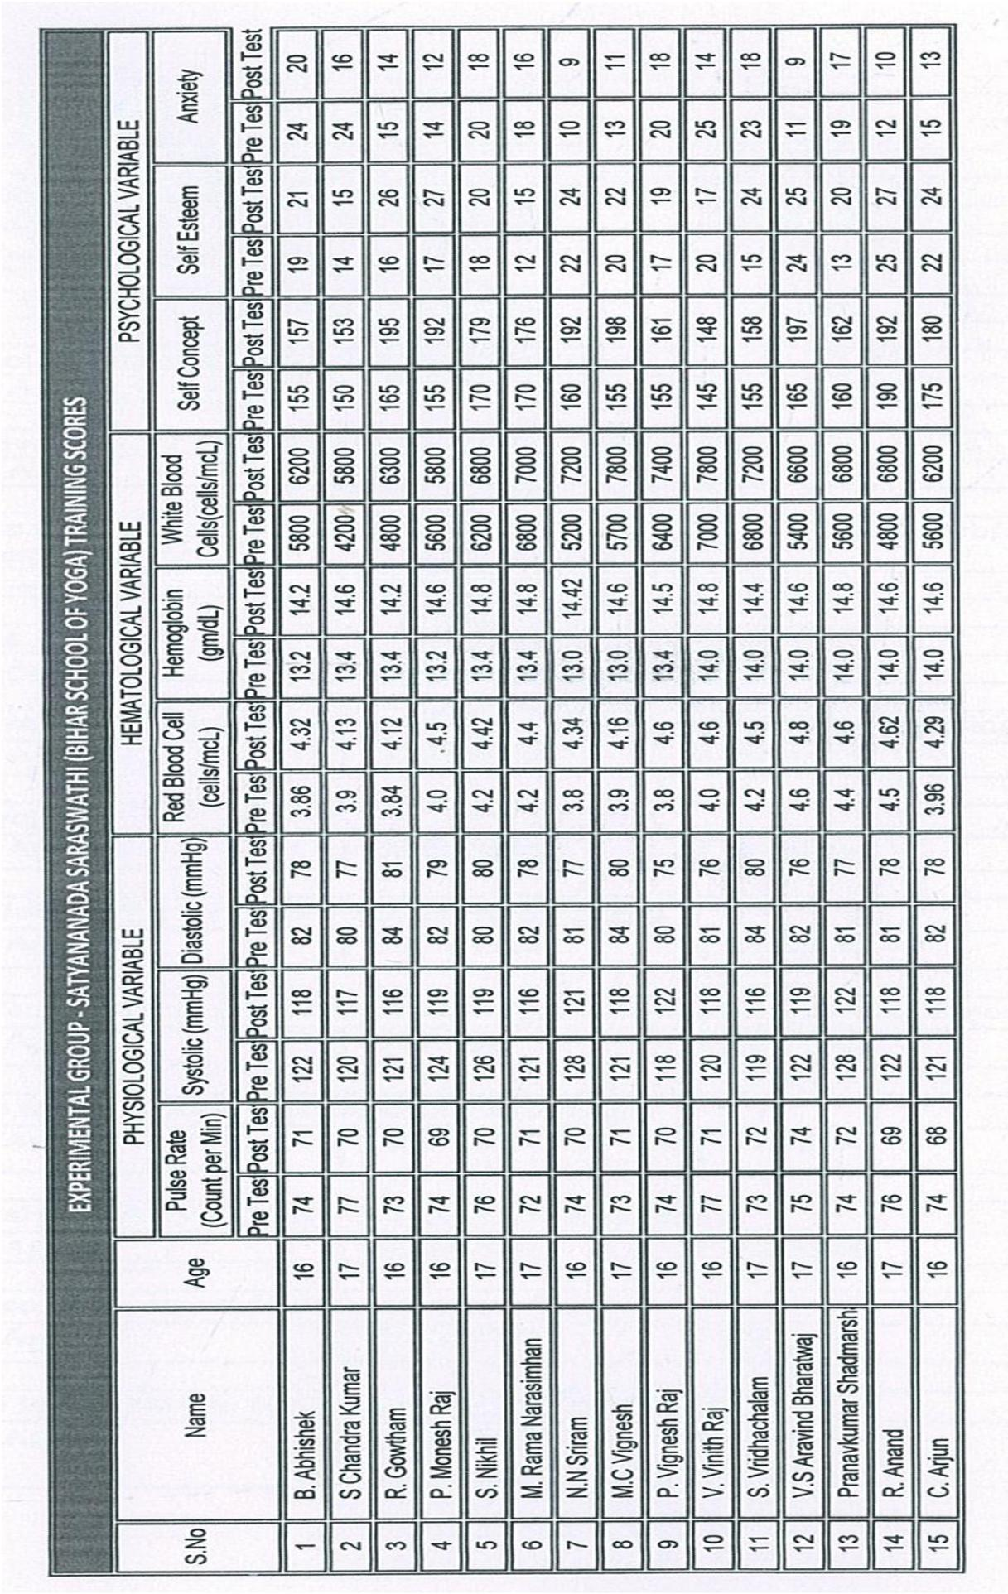

160
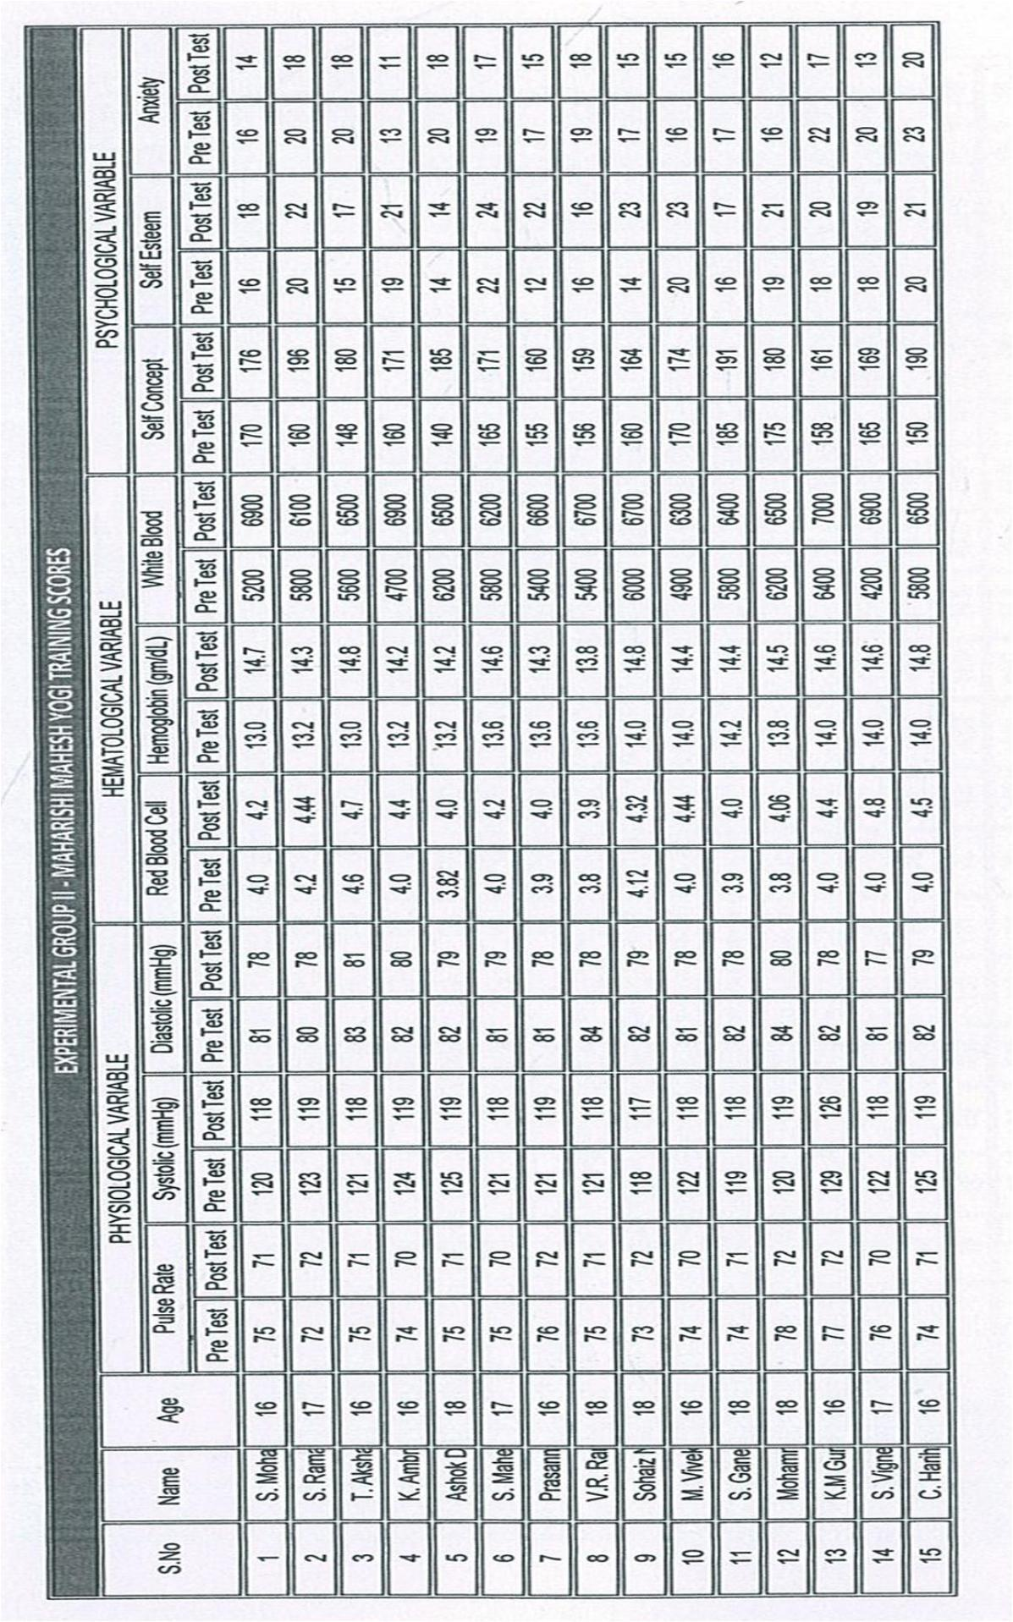

161
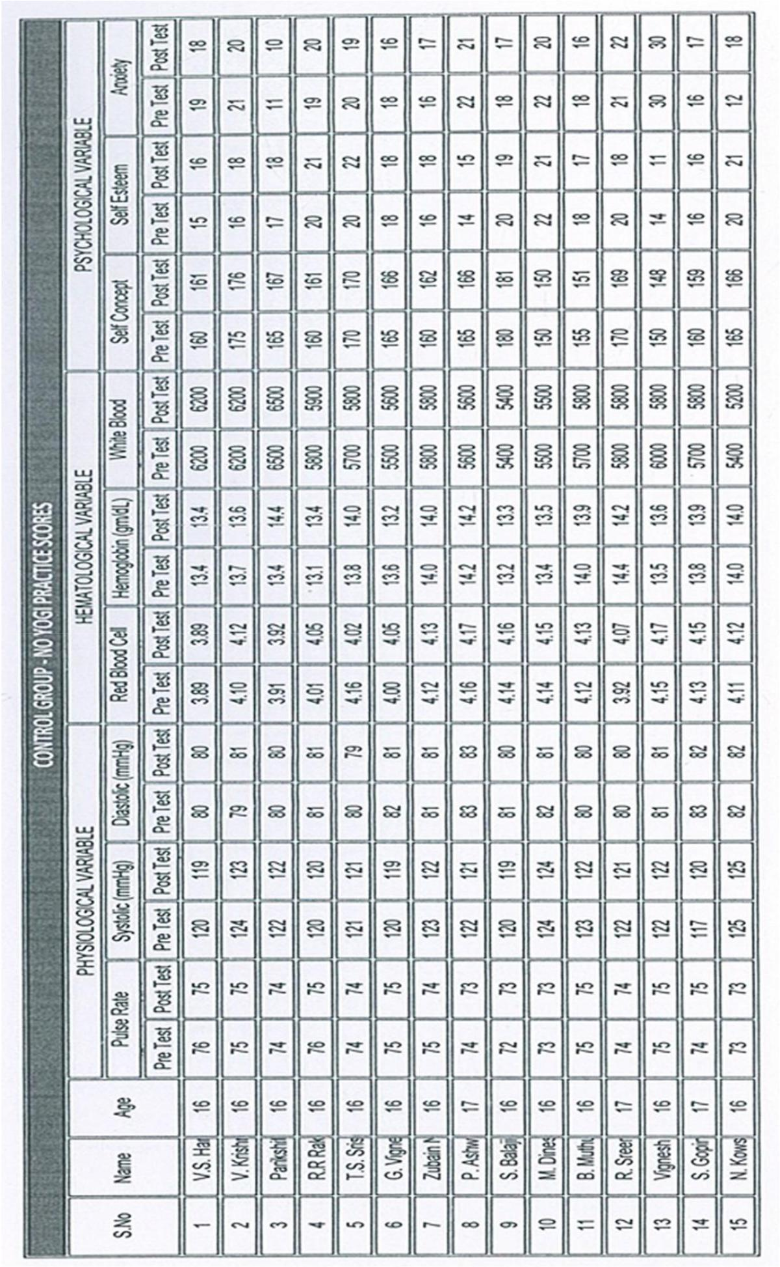

162
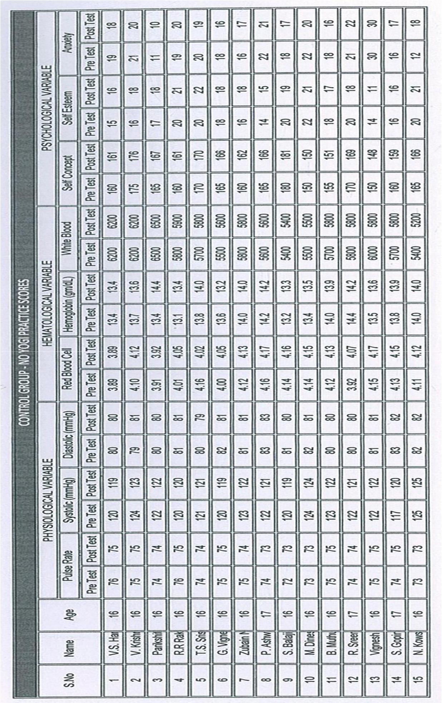

163
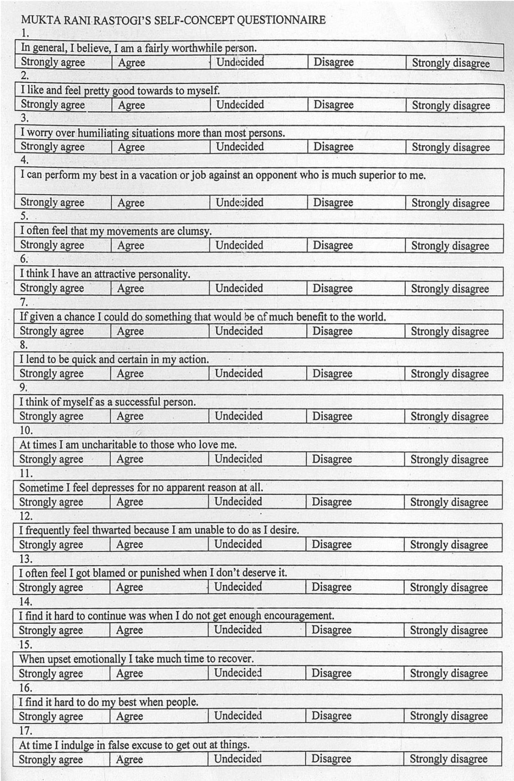

164
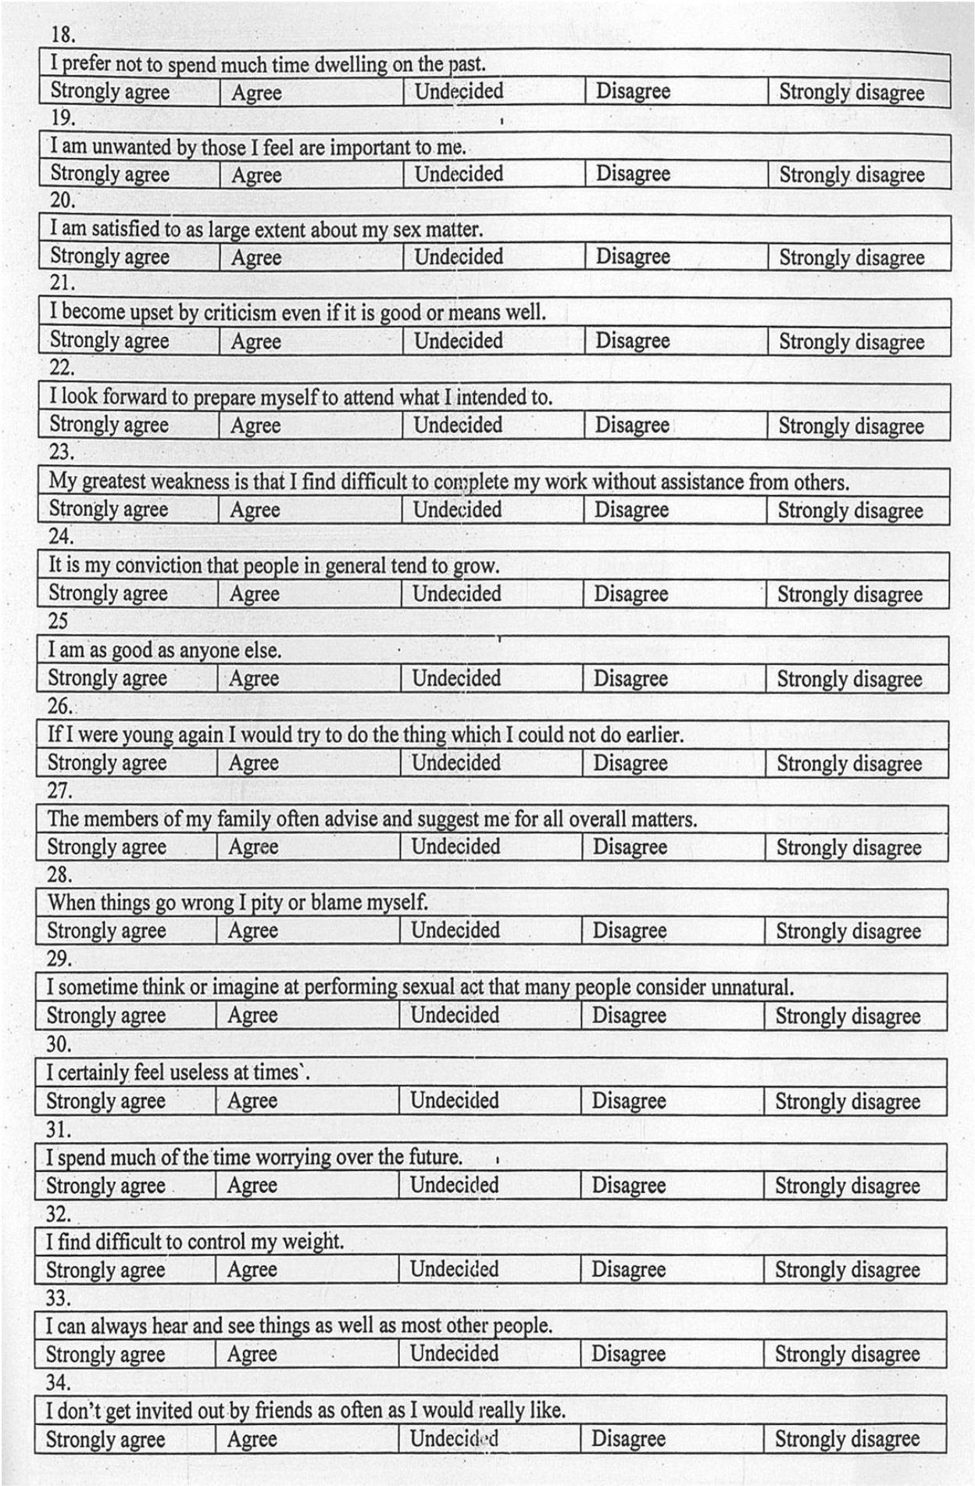

165
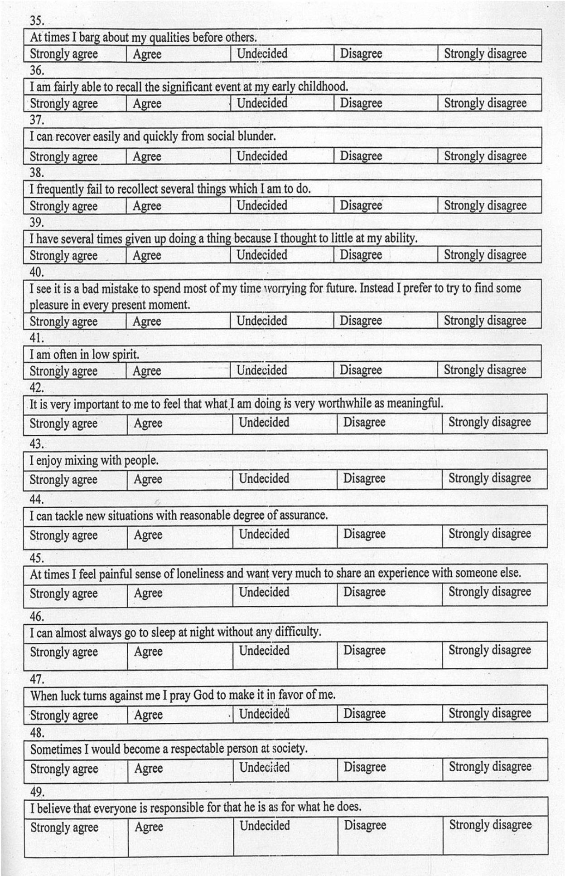

166
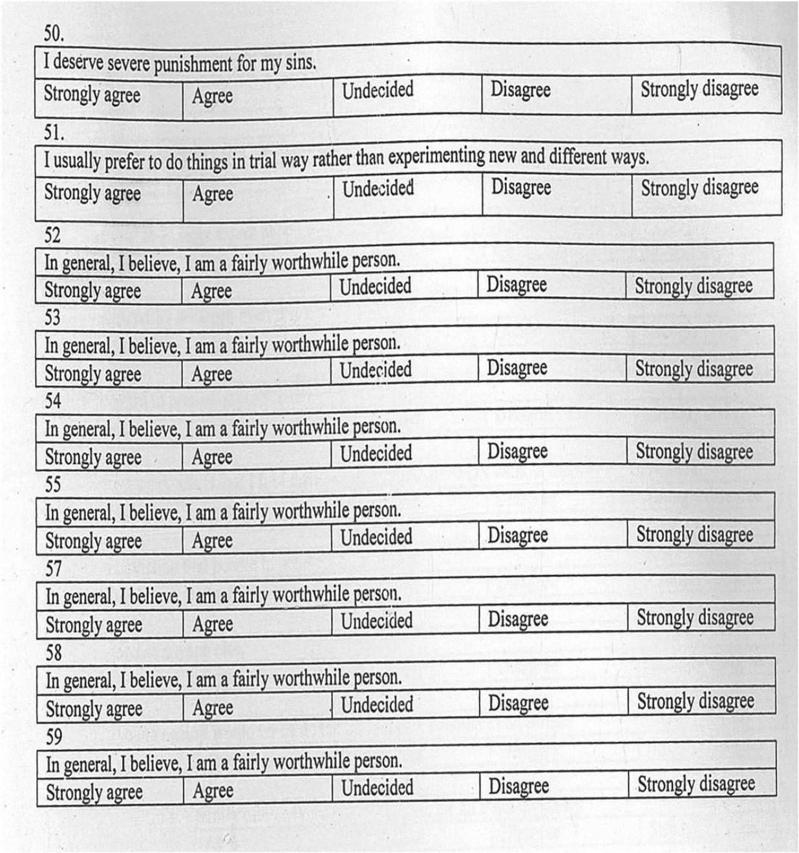

167

Appendix -V

Rosenberg's Self-Esteem Scale

STATEMENT

- I feel that I am a person of worth, at least on an equal plane with others.

- I feel that I have a number of good qualities..

- All in all, I am inclined to feel that I am a failure.

- I am able to do things as well as most other people.
- I feel I do not have much to be proud of.

- I take a positive attitude toward myself.

- On the whole, I am satisfied with myself.

- I wish I could have more respect for myself.

- I certainly feel useless at times.

- At times I think I am no good at all.

Strongly |  |  |  | Agree | Disagree |  |  |  | Strongly
Agree |  |  |  |  |  |  |  |  | Disagree


Scores are calculated as follows:

For items 1, 2, 4, 6, and 7:

Strongly agree = 3 Agree = 2 Disagree = 1 Strongly disagree = 0

168

For items 3, 5, 8, 9, and 10 (which are reversed in valence):

Strongly agree = 0 Agree = 1 Disagree = 2 Strongly disagree = 3

The scale ranges from 0-30. Scores between 15 and 25 are within normal range;

scores below 15 suggest low self-esteem.

Appendix-VI

Taylor Manifest Anxiety Scale

The statements below inquire about your behaviour and emotions. Consider each statement carefully. Then indicate whether the statements are generally true or false for you.


True False

1. I do not tire quickly

2. I believe I am no more nervous than others

3. I have very few headaches

4. I work under a great deal of tension

5. I frequently notice my hand shakes when I try do something

6. I blush no more often than others

7. I have diarrhea one a month or more

8. I worry quite a bit over possible misfortunes

9. I practically never blush

10. I am often afraid that I am going to blush

11. My hands and feet are usually warm enough

12. I sweat very easily even on cool days

13. Sometimes when embarrassed, I break out in a sweat

14. I hardly ever notice my heart pounding, and I am seldom short of breath

15. I feel hungry almost all of the time

16. I am very seldom troubled by constipation

17. I have a great deal of stomach trouble

169


True False

18. I have had periods in which I lost sleep over worry

19. I am easily embarrassed

20. I am more sensitive than most other people

21. I frequently find myself worrying about something

22. I wish I could be as happy as others seem to be

23. I am usually calm and not easily upset

24. I feel anxiety about something or someone almost all of the time

25. I am happy most of the time

26. It makes me nervous to have to wait

27. Sometimes I become so excited I find it hard to get to sleep

28. I have sometimes felt that difficulties piling up so high I couldn't get over them

29. I admit I have felt worried beyond reason over small things

30. I have very few fears compared to my friends

31. I certainly feel useless at times

32. I find it hard to keep my mind on a task or job

33. I am usually self-conscious

34. I am inclined to take things hard

35. At times I think I am no good at all

36. I am certainly lacking in self-confidence

37. I sometimes feel that I am about to go to pieces

38. I am entirely self-confident

170

Appendix-VII

EXPERIMENTAL GROUP-I

SAMY SATHYANANDHA SURYANAMASKAR

S.NO |  | NAME |  | AGE
1 | Abhishek.B |  |  | 16
2 | Chandra kumar.S |  |  | 17
3 | Gowtham.R |  |  | 16
4 | Monesh raj.P |  |  | 16
5 | Nikil. S |  |  | 17
6 | Rama narasimhan.M |  |  | 17
7 | Sriram.N |  |  | 16
8 | Vignesh. M |  |  | 17
9 | Vignesh raj. P |  |  | 16
10 | Vinith raj. V |  |  | 16
11 | Vridhchalam. S |  |  | 17
12 | Aravind bharatwaj. V |  |  | 17
13 | Pranavkumar |  |  | 16
14 | Anand. R |  |  | 17
15 | Arjun. C |  |  | 16

EXPERIMENTAL GROUP-II

MAHARISHI MAHESH

S.NO | NAME | AGE
1 | Mohan. S | 16
2 | Ramanathan. S | 17
3 | Akshy. T | 16
4 | Ambrish. K | 16
5 | Ashok danil rajkumar | 18
6 | Maheswaren. S | 17
7 | Prasanna venkatesh | 16
8 | Rangarajan. V.R | 18
9 | Sohaiz nawaz khan | 18
10 | Vivek. M | 16
11 | Ganesh aravindh. S | 18
12 | Mohammed hameedhul | 18
13 | Guruprasad.K.M | 16
14 | Vignesh. S | 17
15 | Hariharan. C | 16

171

CONTROL GROUP

S.NO | NAME | AGE
1 | Krishnan. V | 17
2 | Parikhith. V | 16
3 | Raakesh. R.R | 16
4 | Srisylan. T.S | 16
5 | Zubain nawaz khan | 17
6 | Ashwin. P | 17
7 | Balaji | 16
8 | Dinesh | 18
9 | Muthukumar | 17
10 | Sreeram | 16
11 | Vignesh balakrishnan | 17
12 | Gopinath. S | 16
13 | Vignesh.G | 16
14 | Kowshicsriram. N | 17
15 | Harisankar. V.S | 17

172

Appendix-VIII

INFLUENCE OF ASANAS, PRANAYAMA AND MEDITATION ON BREATH HOLDING TIME

ABSTRACT

The purpose of the present study was to find out the influence of asanaS, pranayama and meditation practice on Breath Holding Time. To achieve purpose of the study, the forty students were randomly selected as subjects. The age of the subjects ranged from 15 to 17 years. The selected subjects were divided in to four equal groups of ten subjects from each. Group I underwent asana practices, Group II underwent pranayama practice, and Group III underwent meditation practice for five days per week for eight weeks of training period and Group IV acted as control that did not participate in any special training programme apart from their regular activities. The data was collected prior to and after the training programme of eight weeks. Breath Holding Time was chosen as a criterion variable. The analysis of covariance (ANCOVA) was used to analyze the data. The results of the study showed that the Breath Holding Time was significantly improved due to the Asana, pranayama and meditation practice.

Key words: Asana, Pranayama, Meditation, Breath Holding Time.

INTRODUCTION

The study of yoga is fascinating to those with a philosophical mind and is the silencing of the minds activities, which lead to complete realization of the intrinsic nature of the Supreme Being. It is a practical holistic philosophy designed to bring about profound state as well is an integral subject, which takes in to consideration man as a whole (Iyengar 1966). The aim of yoga is to devise ways and means of helping the better emotional and intellectual concentration. Asana is the main yogic too for balancing the physical body. It consists of various static postures and physical movements performed to release tension, improve flexibility, maximize the flow of energy and remove fixation (sivananda swamy 1934). The objective of asana is to create a free flow of energy in order to help to direct our attention within. In this study

173

an attempt was made to find out the effects of asana, pranayama and meditation practice on breath holding time.

METHODOLOGY

The selected subjects were divided in to four equal groups of ten subjects each. Group I underwent asana practices, Group II underwent pranayama practice group, Group III underwent meditation practice for five days per week for eight weeks of training period and Group IV acted as control that did not participate in any special training programme apart from their regular activities. Subjects were required to attend yoga classes apiece week five days for a total of eight weeks. Each yoga session consisted of 10 minutes of pranayamas (breath-control exercises), 15 minutes of supine relaxation in savasana (corpse pose). The subjects were evaluated before and after the training program. Breath holding time was measured by manual breath holding method the unit of measurement was in numbers. The findings and discussion influence of asana, pranayama and meditation practice on breath holding time was analyzed separately and presented below. The analysis of covariance on breath holding time of the pre and post test scores of experimental group I, II, III and control group have been analyzed and presented in Table-A.

TABLE-A

ANALYSIS OF COVARIENCE OF PRE-TEST POST TEST AND ADJUSTED POST TEST ON BREATH HOLDING TIME OF THREE EXPERIMENTAL GROUPS AND CONTROL GROUP (scores in seconds)
 |  | Exp. | Exp. | Exp. | Control |  |  |  | Mean | OF Value
 |  | Exp. | Group | Group | Control |  |  |  | Mean | OF Value
Test |  | Group I | Group | Group | group | SV | SS | df | square | OF Value
 |  | Group I | II | III
Pre | test
mean |  | 53.00 | 52.80 | 52.50 | 52.90 | B | 1.40 | 3 | 0.47 | 0.12
SD |  | 1.92 | 1.96 | 1.82 | 1.99 | W | 145.00 | 36 | 4.03
Post | test | 54.10 | 62.50 | 58.10 | 52.60 | B | 591.07 | 3 | 197.02 | 70.44*
mean
SD |  | 1.78 | 1.59 | 1.39 | 1.64 | W | 100.70 | 36 | 2.80
Adjusted |  | 53.97 | 62.50 | 58.30 | 52.53 | B | 608.36 | 3 | 202.79 | 198.94*
post-test |  |  |  |  |  | W | 35.68 | 36 | 1.02
mean

*significant at 0.05 level of confidence.

174

Table-A shows the analyzed data on breath holding time. The pre-test means of breath holding time were 53.00 for Experimental Group I, 52.80 for Experimental Group II, 52.50 for Experimental Group III and 52.90 for Control group. The obtained “F” ratio of 0.12 was lesser than the table F-ratio 4.12. Hence the pre-test was not significant at 0.05 level of confidence for the degrees of freedom 3 and 36. The post-test means of breath holding time were 54.10 for Experimental Group I, 62.50 for Experimental Group II, 58.10 for Experimental Group III and 52.60 for Control group. . The obtained “F” ratio of 70.44 was higher than the table F-ratio 4.12. Hence the post-test was significant at 0.05 level of confidence for the degrees of freedom 3 and 36. The adjusted post-test means of breath holding time were 53.97 for Experimental Group I, 62.50 for Experimental Group II, 58.30 for Experimental Group III and 52.53 for Control group. . The obtained “F” ratio of 198.94 was higher than the table F-ratio 4.12. Hence the post-test was significant at 0.05 level of confidence for the degrees of freedom 3 and 35. Since, four groups were compared, whenever the obtained “F” ratio for adjusted post test was found to be significant, the Scheffe’s test to find out the paired mean differences and it was presented in Table-B

TABLE-B

SCHEFFE’S POST HOC TEST MEAN DIFFERENCE ON BREATH

HOLDING TIME AMONG THE GROUPS (Scores in seconds)

Exp.Group | Exp.Group | Exp.Group | Control | Mean | Confidence
 |  |  |  |  | Interval
I | II | III | Group | Difference | Interval
 |  |  |  |  | Value
53.97 | 62.50 | - | - | 8.53* | 1.30
53.97 | - | 58.30 | - | 4.33* | 1.30
53.97 | - | - | 52.53 | 1.43* | 1.30
- | 62.50 | 58.30 | - | 4.20* | 1.30
- | 62.50 | - | 52.53 | 9.97* | 1.30
- | - | 58.30 | 52.53 | 5.77* | 1.30

*significant at 0.05 level of confidence.

Table-B shows the Scheffe’s post-hoc test results. The ordered adjusted final mean difference for breath holding time of Experimental group I, II, III and control

175

group were tested for significance at 0.05 level of confidence against confidential interval value. The mean difference between Experimental group I and Experimental group II, Experimental group I and Experimental group III, Experimental group I and control group, Experimental group II and Experimental group III, Experimental group
- and control group, Experimental group III and control group were 8.53, 4.33, 1.43, 4.20, 9.97 and 5.77 respectively and it was seen to be greater than the confidential interval value of 1.30. Hence all the comparisons were significant.

CONCLUSIONS

It was concluded that

- The practice of asana for 8 weeks had improved breathing holding slightly.

- Meditation practice for 8 weeks had improved breathing holding better than the practice of asana.
- The practice of pranayama had a great influence on improving breath holding time than the other two.
- It is evident that practice of asana, pranayama and meditation improve breath holding time.

REFERENCES

- Shaver, Larry G (1982) Essentials of Exercise Physiology, Delhi surject publication, pp.6-10.
- Pratima M. Bhutkar 1, Milind V. Bhutkar 1, Govind B. Taware2, Vinayak Doijad2 and B.R. Doddamani1 (2008) Effect of suryanamaskar practice on cardio-respiratory fitness parameters. A1 Ame en Journal of med sci 1(2): 126-129.
- Cooper, Kenneth (1931) H., M.D., Aerobics, Evans, New York.

- Mahesh yogi, maharishis (1963), The science of being and the art of living, SRM puplication.
- Sivananda swamy (1934) yoga, Asanas, Madras.

- Taimini, I, K (1967), the science of yoga, The Theosophical publishing house, wheaton, illions.

176

INFLUENCE OF PRANAYAMA PRACTICE ON SELECTED PHYSIOLOGICAL VARIABLES AMONG KABADDI PLAYERS

ABSTRACT

For the purpose of the study 30 kabbadi players were selected from Govt Arts College, Nandanam, Chennai, were selected as subjects. The players who participated Intra mural competition were selected as subjects. The study was limited for selected physiological variables that are breath holding time, pulse rate, systolic and diastolic blood pressure. The experimental group was given pranayama practice for a period of 6 weeks. The data were collected on the selected physiological variables before training as well as immediately after 6 weeks training. The significance of the difference among the means of experimental group was found out. Pre test and post test were conduced and the data were analyzed through‘t’ test. The result of the study showed significant differences on selected physiological variables such as maximum breath holding time, pulse rate and diastolic blood pressure due to the influence of pranayama practice. But there was no significant difference on systolic blood pressure due to the influence of pranayama practice.

INTRODUCTION

Pranayama is a scientific mental and physical exercise. In this exercise, the diaphragm and the abdominal muscles get good exercise by controlled movement and relaxation respectively. The heart, lungs and digestive organs like stomach, liver, and nervous and endocrine system. The spinal card spine nerves get the massage and the rejuvenating exercise. It helps to normalize the circulation of blood. The process of pranayama involves purka (whaling) kumbhaka (retention) and rechaka (exhaling). One who practice pranayama regularly and punctually enjoy, vitally, glowing face, sparking eyes, sharp memory and concentration of mind. Regular and systematic practice of pranayama removes many of the chronic diseases and brings purity of the mind. Pranayama develops the working and capacity of the lungs, the heart, the lever and other important internal organs, purifies blood and increases its supply and circulation to the different parts of the body. All the tissues and nerves get proper

177

supply of blood and oxygen and this ensures proper supply of nerve energy for the different function of the body.

METHODOLOGY

For the purpose of the study 30 kabbadi players were selected from Govt Arts College, Nandanam, Chennai. The players who participated in the Intra mural competition were selected as subjects for the study. The experimental group underwent pranayama practice, (pranayama below and nostril method) weekly 3 days (Monday, Wednesday and Friday) at early morning from 6 to 6.45 am for 6 weeks. The study was delimited to selected physiological variables that are breath holding time, pulse rate, systolic and diastolic blood pressure. Breath holding time was measured by counting the number of seconds between the holding of breath by closing the nostril with the thumb and fingers and the final releaser of breath. Systolic and diastolic blood pressure was measured by spigmomonometer. Pre test and post test data were analyzed through‘t’ test.

RESULTS AND DISCUSSION

The following tables illustrate the statistical results of the effect of pranayama on selected physiological variables among kabbadi players. To find out the difference between mean of the initial and final data under the study, t ratio was used.

TABLE-I

MEAN, STANDARD DEVIATION, STANDARD ERROR AND T-RATIO OF THE PRE AND POST TEST ON BREATH HOLDING TIME

Variables | Test | Mean | S.D | S.E | ‘t’-ratio
Breath | Pre-test | 37.50 | 9.04 | 2.61
Holding |  |  |  |  | 1.97
Time | Post test | 46.42 | 12.53 | 3.70
Significant at 0.05 level, degrees of freedom n-1=11 is 1.79

Table –I shows the analyzed data on breath holding time. The pre test mean of the group was 37.50. The post test mean of the group was 46.42. The obtained ‘t’ ratio

178

1.97 was significant at 0.05 level (1.97). The obtained ‘t’ value (1.97) was higher than the table value (1.97) which was significant.

DISCUSSION ON FINDINGS

The results indicated that the experimental group significantly improved breath holding time, due to the influence of pranayama practice.

TABLE-II

MEAN, STANDARD DEVIATION, STANDARD ERROR AND T-RATIO OF THE PRE AND POST TEST ON PULSE RATE

Variables | Test | Mean | S.D | S.E | ‘t’-ratio
 | Pre-test | 79.66 | 7.60 | 2.19
Pulse rate |  |  |  |  | 2.97
 | Post test | 70.33 | 7.86 | 2.27
Significant at 0.05 level, degrees of freedom n-1=11 is 1.79

Table – II shows the analyzed data on pulse rate. The pre test mean of the group was 79.66. The post test mean of the group was 70.33. The obtained ‘t’ ratio 2.97 which was significant at 0.05 level (1.97). The obtained’ ratio value (2.97) is higher than the table value (1.97). This was significant.

Discussion on Findings

The results indicated that the experimental group significantly improved in pulse rate, due to the influence of pranayama practice.

TABLE-III

MEAN, STANDARD DEVIATION, STANDARD ERROR AND T-RATIO OF THE PRE AND POST TEST ON SYSTOLIC BLOOD PRESSURE

Variables | Test | Mean | S.D | S.E | ‘t’-ratio
Systolic | Pre-test | 131.00 | 5.60 | 1.61
Blood |  |  |  |  | 1.06
pressure | Post test | 128.08 | 7.71 | 2.22

Significant at 0.05 level, degrees of freedom n-1=11 is 1.79

179

Table – III shows the analyzed data on systolic blood pressure. The pre test mean of the group was 131. The post test mean of the group was 128.08. The obtained ‘t’ ratio 1.06 was significant at 0.05 level (1.97). The obtained ‘t’ ratio value (1.06) is less than the table value (1.97) which was significant.

DISCUSSION ON FINDINGS

The results indicated that the experimental group did not significantly improve in systolic blood pressure, due to the influence of pranayama practice.

TABLE-IV

MEAN, STANDARD DEVIATION, STANDARD ERROR AND T-RATIO OF THE PRE AND POST TEST ON DIASTOLIC BLOOD PRESSURE

Variables | Test | Mean | S.D | S.E | ‘t’-ratio
Diastolic | Pre-test | 65.50 | 65.50 | 6.11
Blood |  |  |  |  | 2.31
pressure | Post test | 71.16 | 5.91 | 1.70
Significant at 0.05 level, degrees of freedom n-1=11 is 1.79

Table – IV shows the analyzed data on pulse rate. The pre test mean of the group was 66.5. The post test mean of the group was 71.16. The obtained ‘t’ ratio 2.31 was significant at 0.05 level (1.79). The obtained ‘t’ ratio value (2.31) is higher than the table value (1.79) which was significant.

DISCUSSION ON FINDINGS

The results indicated that the experimental group significantly improved in diastolic blood pressure, due to the influence of pranayama practice.

CONCLUSIONS

From the results of the study the following conclusions were drawn

- There were significant differences on selected physiological variables such as maximum breath holding time, pulse rate and diastolic blood pressure due to the influence of pranayama practice.

180

- There was significant change on systolic pressure due to the influence of pranayama practice.

REFERENCE

- Kaul H.K. (1991) Pranayama for health. Subject publication Delhi. P. 17

- Kuvalayanada (1983) pranayama kaivalayadhama lovavala. India.

- Nimbalkar, sadashiv, p. (1992) yoga for health and peace, yoga vidya niktan, Bombay.
- Lohan usha, Dolly, Rajesh (2001) the effect of asana and pranayama on physical and physiological components of boys between 12-16 years. Journals of sports and sports science, 25:1.

- Ghosh, S.K. (2003) “Effect of physical exercise, yogic practice and their combined training on selected physiological variables among high school boys” yoga mimamsa vol. XXXV, P.15.

181

Photos of subjects with Research Scholar during Yogic Practices
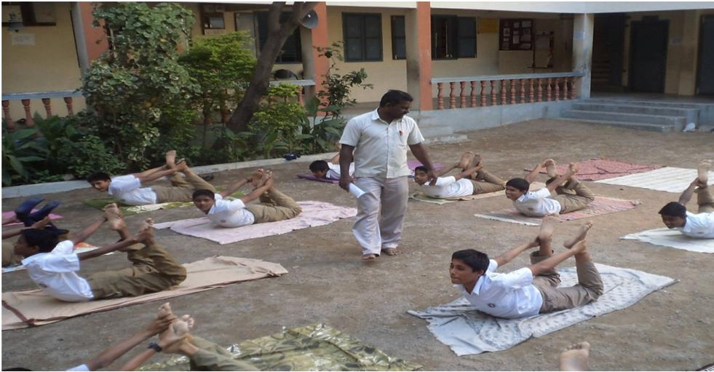
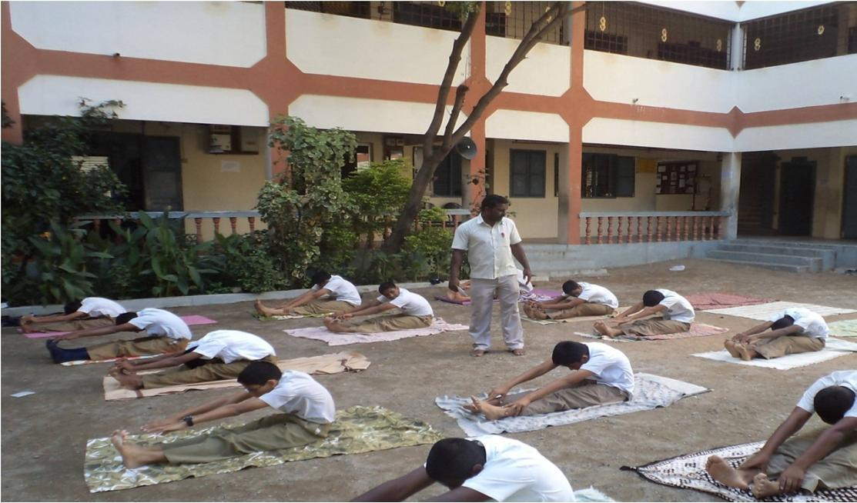

182
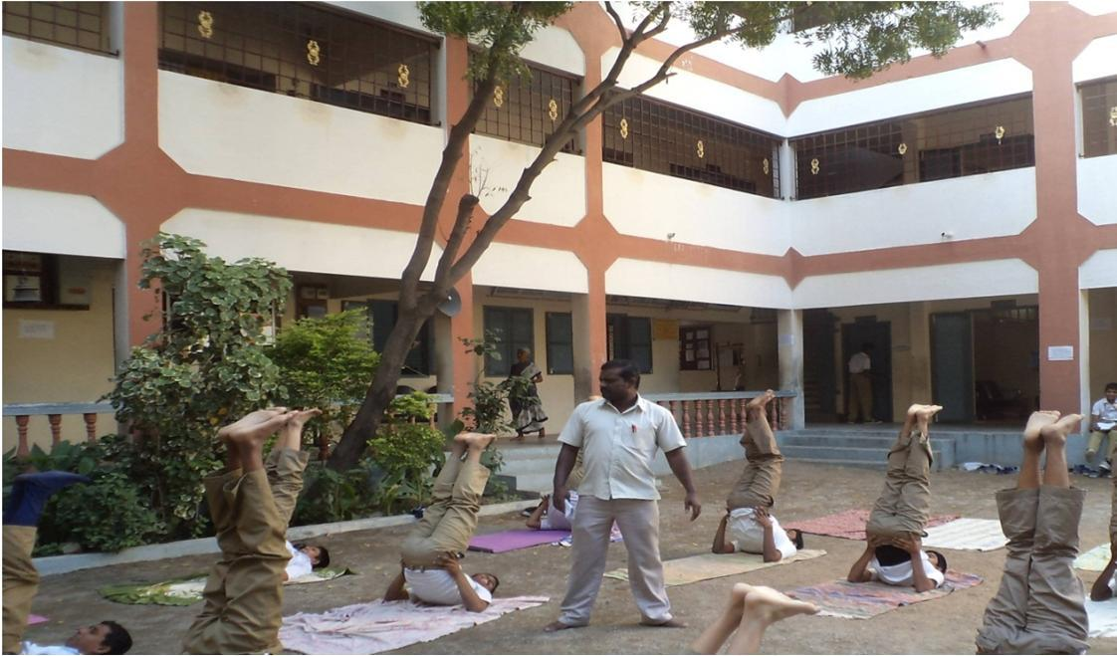
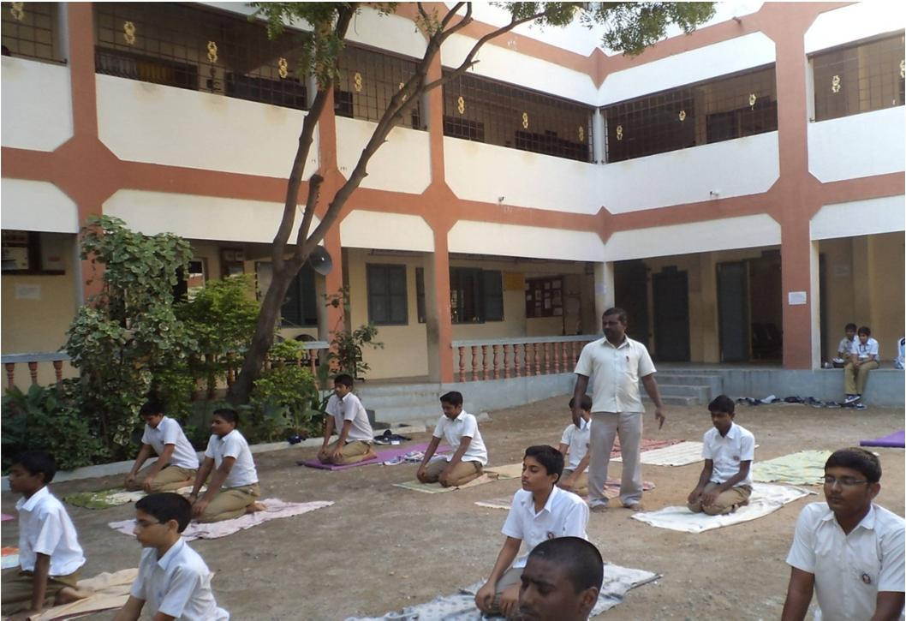

183
