CHAPTER III

METHODOLOGY

Research methodology involves the systematic procedure by which researcher starts from the initial identification of the problem to its final conclusion. The role of the methodology is to carry on the research work in a scientific and valid manner. The purpose of the study is to find out whether there would be any significant influence of Asanas and pranayama on selected physical, psychological, physiological and hematological parameters among degree college students.

This chapter provides an overview of the method used in the study for the selection of subjects, selection of variables, experimental design, pilot study, orientation of the subjects, criterion measures, reliability of data, reliability of instruments, testers competency, subjects reliability, training programme, training schedule, training procedure, test administration, collection of data and statistical technique which has been explained in detailed.

3.1 SELECTION OF SUBJECTS
For the present investigation sixty degree college students were selected randomly from S.S.R Government college of Physical Education, Gopannapalem, Andhra Pradesh, and their age ranged between 19-25 years. The Selected degree college students subjects were assigned to experimental group I, experimental group II, experimental group III and control group IV each group consists of 15 subjects. Experimental group I underwent Asanas, experimental group II underwent pranayama, experimental group III Combined practices (Asanas and Pranayama) for twelve weeks and control group no training was provided during the period of study.

3.2 SELECTION OF VARIABLES
The investigator reviewed the available scientific literature pertaining to the study from books, journals, periodicals, magazines, research papers and available sources from Tamilnadu physical education and Sports University, Tirupathi University, Achraya Nagarguna University, Guntur and also with help of professional experts in yoga, the following physical psychological physiological and hematological parameters were selected.

3.2.1 SELECTION OF DEPENDENT VARIABLES

PHYSICAL VARIABLES
1. Agility
2. Flexibility
3. Cardiovascular endurance

Psychological Variables
1. Anxiety
2. Aggression
3. Stress

Physiological variables
1. Pulse Rate
2. Mean Arterial Blood Pressure
3. Vital Capacity

Hematological Variables
1. Hemoglobin
2. Red Blood cell
3. White Blood cell.

    - SELECTION OF INDEPENDENT VARIABLES
1. Experimental group I - Asanas.
2. Experimental group II - Pranayama
3. Experimental group III - Combined Practices (Asanas and Pranayama)
4. Control group - No training.

3.3 EXPERIMENTAL DESIGN
The study was formulated as a random group design, consisting of pre and post test. Sixty degree college students were randomly selected and divided into four equal groups. The groups were assigned as experimental group I (Asanas), experimental group II (Pranayama), experimental group III combined practices (Asanas and Pranayama) and control group (no training). The pre test was conducted on all the subjects on selected physical, psychological, physiological and hematological parameters such as agility, flexibility, cardiovascular endurance, anxiety, aggression, stress, pulse rate, mean arterial blood pressure, vital capacity, Hemoglobin, Red Blood Cell and White Blood Cell. The experimental group participated in their respective Asanas, Pranayama and combined practices (Asanas and Pranayama) for a period of 12 weeks. The post test was calculated on all the selected variables after 12 weeks of the training period.

3.4 PILOT STUDY
A pilot study was conducted to assess and finalize the training programme to ensure the intensity and duration of the training programme within the limits of the subject’s capacity to produce their desired effect. For this purpose, 5 subjects were selected and given Asanas, Pranayama and combined (Asanas and Pranayama) practices (5 in each group) respectively to determine the intensity and duration of a training session. The calculated intra-class correlation of the pilot shows that there was significant improvement in physical, psychological, physiological and hematological parameters. Based on the response of the subjects in the pilot study and during the training, the investigator adopted the suitable training schedule for the study. The number of repetitions assigned to each subject was tested and it was found that were within the reach of the individual’s capacity.

3.5 ORIENTATION OF THE SUBJECTS
Prior to the test the investigator explained to the subjects about the purpose of the Asanas, Pranayama and combined (Asanas and Pranayama) practices. The investigator also explained briefly in depth about the effects and benefits of the training to the subjects. Commonly used Asanas, pranayama and combined (Asanas and Pranayama) practices are selected after consulting an expert in pranayama and explained about Asanas for the co-operation of the subjects. The method and the value of each loosening exercises, Asanas, relaxation and pranayama were explained and performed first by the investigator. The investigator got full co-operation and motivated them to involve completely and execute the training to their extreme level for the maximum output from the subjects.

3.6 RELIABILITY OF DATA
The reliability of data was ensured by establishing the instrument reliability, tester reliability, test competency and subject’s reliability.

3.7 RELIABILITY OF INSTRUMENT
All the equipments which were used in the study had been obtained from standard firms which catered to need of various research laboratory in India and abroad. All instruments were available in Ramnaidu Diagnostic Center, Andhra Pradesh, and their calibrations were accepted as enough for the purpose of the study.

3.8 CRITERION MEASURES

By glancing the literature and in consultation with professionals and experts the following criterion measures were selected for measuring the variables in this study is presented in the Table I.
TABLE I
CRITERIAN MEASURES AND TEST INSTRUMENTS USED
S.No | VARIABLES | CRITERIAN MEASURES | Unit of Measurement
1 | Agility | shuttle run | Seconds
2 | Flexibility | Sit and reach test | Centimeters
3 | Cardiovascular endurance | 12 minutes run/walk, cooper test | In meters
4 | Anxiety | Taylor (1953) Questionnaire | Marks
5 | Aggression | Arnold, Questionnaire | Marks
6 | Stress | Dr.Latha Satish (1997) Questionnaire | Marks
7 | Pulse Rate | Polar Heart rate Monitor | Number of Beats per minute
8 | Mean Arterial Blood pressure | Stethoscope and spymomanomometer | mmHg
9 | Vital Capacity | Spiro meter | Milliliter
10 | Hemoglobin | Blood samples | g/dl
11 | Red Blood Cell | Blood samples | mmol/
12 | White Blood Cell | Blood samples | thousands/ mm³

3.9 TESTERS COMPETENCY
The intra class correlation coefficient obtained for test-retest data are presented in Table II.
TABLE II
INTRA CLASS CORRELATION COEFFICIENT OF TEST– RETEST SCORES
Sl.No | VARIABLES | COEFFICIENT OF CORRELATION
1. | Agility | 98*
2. | Flexibility | 98*
3. | Cardiovascular endurance | 99*
4. | Pulse Rate | 98*
5. | Mean Arterial Blood pressure | 97*
6. | Vital Capacity | 96*
7. | Hemoglobin | 97*
8. | Red Blood Cell | 95*
9. | White Blood Cell | 94*
*Significant at 0.05 level
As for psychological variables Anxiety, Aggression and Stress, the authors of the questionnaire have determined reliability and the same was adapted for this study and considered as reliable. Reliability was established by the test-retest processes. Fifteen degree college students were tested on selected variables. The repeated measurement of individuals on the same test is done to determine reliability.

3.10 SUBJECTS RELIABILITY
The intra class correlation value of the above test and retest also indicated subject reliability as the same subjects were used under similar conditions by the same tester. The co-efficient of reliability was significant at 0.05 level, for the above test under investigation.

3.11 TRAINING PROGRAMME

The subjects were selected at random and were divided into four groups and the experimental group I underwent Asanas from 6.00 am to 7.00 am and experimental group II underwent pranayama from 7.00 am to 8.00 am for the duration of sixty minutes from Monday to Saturday (6 days/week) and combined practices (Asanas and pranayama) for 12 weeks, whereas the control group no training. The Asanas, pranayama and combined (Asanas and pranayama) for the selected experimental groups are presented in the following order.
    - Experimental Group I – Asanas (Loosening exercises, Asanas and relaxation).
    - Experimental Group II – Pranayama (Loosening exercises, pranayama and relaxation).
    - Experimental Group III – Combined practices (Asanas and pranayama).
    - Control Group - No training

3.12 TRAINING SCHEDULE FOR EXPERIMENTAL GROUP I – ASANAS
TRAINING
Experimental group I underwent Asanas for 40 to 60 minutes were given to the subjects during the experimental period. The Asanas program was scheduled for one session in the morning between 7.00 am to 8.00 am for 6 days (Monday to Saturday) a week and the same were continued for 12 weeks.

TABLE III

EXPERIMENTAL GROUP – I (ASANAS) FOR ONE TO FOUR WEEKS
S.NO | NAME OF PRACTICES | REPETITION | DURATION
1 | Prayer | 1 | 2 min
2 | Pawanamuktasana Series | 1 | 10 min
3 | Tadasana | 2 | 2 min
4 | Vrikshasana | 2 | 2 min
5 | Trikonasana | 2 | 2 min
6 | Ardha Padmasana | 2 | 2 min
7 | Padmasana | 2 | 2 min
8 | Vajrasana | 2 | 2 min
9 | Bhujangasana | 2 | 2 min
10 | Viparitakarani | 2 | 2 min
11 | Relaxation | 1 | 10 min
12 | Prayer | 1 | 2 min

TABLE IV

EXPERIMENTAL GROUP – I ASANAS FOR FIVE TO EIGHT WEEKS
S.NO | NAME OF PRACTICES | TIMES | DURATION
1 | Prayer | 1 | 2 min
2 | Loosening Exercises  (Sithilikarana Vyayama) | 1 | 10 min
3 | First two weeks Practices | 1 | 5 min
4 | Padahasthasana | 2 | 2 min
5 | Ardhakatichakrasana | 2 | 2 min
6 | Ardhachakrasana | 2 | 2 min
7 | Shalabasana | 2 | 2 min
8 | Sarvangasana | 2 | 2 min
9 | Vakrasana | 2 | 2 min
10 | Matsyasana | 2 | 2 min
11 | Yogamudra | 2 | 2 min
12 | Relaxation | 1 | 10 min
13 | Prayer | 1 | 2 min

TABLE V

EXPERIMENTAL GROUP – I ASANAS FOR NINE TO TWELVE WEEKS
S.NO | NAME OF PRACTICES | TIMES | DURATION
1 | Prayer | 1 | 2 min
2 | Loosening Exercises  (Pawanamuktasana series) | 1 | 10 min
3 | Last eight weeks Practices | 1 | 10 min
4 | Parivrittitrikonasana | 2 | 2 min
5 | Vrikshasana | 2 | 2 min
6 | Paschimothasana | 2 | 2 min
7 | Halasana | 2 | 2 min
8 | Dhanurasana | 2 | 2 min
9 | Ardha matyendrasana | 2 | 2 min
10 | Shasanakasana | 2 | 2 min
11 | Ushtrasana | 2 | 2 min
12 | Relaxation | 1 | 10 min
13 | Prayer | 1 | 2 min

3.13 TRAINING SCHEDULE FOR EXPERIMENTAL GROUP II – PRANAYAMA
PRACTICES
Experimental group II underwent pranayama for 40 to 60 minutes were given to the subjects during the experimental period. The pranayama program was scheduled for one session in the morning between 6.00 am to 7.00 am for 6 days (Monday to Saturday) a week and the same were continued for 12 weeks.

TABLE VI

EXPERIMENTAL GROUP – II PRANAYAMA FOR ONE TO FOUR WEEKS
S.NO | NAME OF PRACTICES | REPETITION | DURATION
1 | Prayer | 2 | 2 min
2 | Loosening Exercises  (Pavana Muktha Asanas ) | 1 | 10 min
3 | Sectional Breathing | 1 | 4 min
4 | Anuloma Viloma | 2 | 4 min
5 | Suryabhedana | 2 | 2 min
6 | Chandrabhedana | 2 | 2 min
7 | Kapalabhati | 2 | 4 min
8 | Relaxation | 1 | 10 min
9 | Prayer | 1 | 2 min

TABLE VII

EXPERIMENTAL GROUP – II PRANAYAMA FOR FIVE TO EIGHT WEEKS
S.NO | NAME OF PRACTICES | TIMES | DURATION
1 | Prayer | 1 | 2 min
2 | Loosening Exercises  (Pavana Muktha Asanas) | 1 | 10 min
3 | Recap of First four weeks Practices | 1 | 5 min
4 | Bhramari | 3 | 6 min
5 | Sitkari | 3 | 4 min
6 | Nadi Shudhi | 3 | 6 min
7 | Relaxation | 1 | 10 min
8 | Prayer | 1 | 2 min

TABLE VIII

EXPERIMENTAL GROUP – II PRANAYAMA FOR NINE TO TWELVE WEEKS
S.NO | NAME OF PRACTICES | TIMES | DURATION
1 | Prayer | 1 | 2 min
2 | Loosening Exercises  (Pavana Muktha Asanas) | 1 | 10 min
3 | Recap of last eight weeks Practices | 1 | 6 min
4 | Kapalabhati | 3 | 6min
5 | Bhastrika | 3 | 6min
6 | Bhramari | 3 | 6min
7 | Ujjaii | 3 | 6min
8 | Nadi Shudhi | 3 | 6min
9 | Relaxation | 1 | 10 min
10 | Prayer | 1 | 2 min

3.14 TRAINING SCHEDULE FOR EXPERIMENTAL GROUP III – COMBINED
PRACTICES (ASANAS AND PRANAYAMA)
Experimental group III underwent combined (Asanas and pranayama) for 60 minutes were given to the subjects during the experimental period. The pranayama program was scheduled for one session in the morning between 6.30 am to 7.30 am for 6 days (Monday to Saturday) a week and the same were continued for 12 weeks.
TABLE IX

EXPERIMENTAL GROUP –III (COMBINED GROUP) FOR ONE TO FOUR WEEKS
S.NO | NAME OF PRACTICES | REPETITION | DURATION
1 | Prayer | 1 | 2 min
2 | Pawanamuktasana Series | 1 | 10 min
3 | Tadasana | 2 | 2 min
4 | Trikonasana | 2 | 2 min
5 | Padmasana | 2 | 2 min
6 | Vajrasana | 2 | 2 min
7 | Bhujangasana | 2 | 2 min
8 | Viparitakarani | 2 | 2 min
9 | Savasana | 1 | 3 min
10 | Sectional Breathing | 2 | 2 min
11 | Anulom vilom | 2 | 2 min
12 | Relaxation | 1 | 10 min
13 | Prayer | 1 | 2 min

TABLE X
EXPERIMENTAL GROUP – III (COMBINED GROUP) FIVE TO EIGHT WEEKS
S.NO | NAME OF PRACTICES | TIMES | DURATION
1 | Prayer | 1 | 2 min
2 | Loosening Exercises  (Sithilikarana Vyayama) | 1 | 10 min
3 | First two weeks Practices | 1 | 5 min
4 | Padahasthasana | 2 | 2 min
5 | Ardhakatichakrasana | 2 | 2 min
6 | Shalabasana | 2 | 2 min
7 | Sarvangasana | 2 | 2 min
8 | Matsyasana | 2 | 2 min
10 | Yogamudra | 2 | 2 min
11 | Savasana | 2 | 3 min
12 | Kapalabhati | 2 | 2 min
13 | Bhastrika | 2 | 2 min
14 | Bhramari | 2 | 2 min
15 | Relaxation | 1 | 10 min
16 | Prayer | 1 | 2 min

TABLE XI
EXPERIMENTAL GROUP – III (COMBINED GROUP) FOR NINE TO TWELVE WEEKS
S.NO | NAME OF PRACTICES | TIMES | DURATION
1 | Prayer | 1 | 2 min
2 | Loosening Exercises  (Pawanamuktasana series) | 1 | 10 min
3 | Last eight weeks Practices | 1 | 10 min
4 | Parivrittitrikonasana | 2 | 2 min
5 | Vrikshasana | 2 | 2 min
6 | Paschimothasana | 2 | 2 min
7 | Halasana | 2 | 2 min
8 | Dhanurasana | 2 | 2 min
9 | Ardha Matysendrasana | 2 | 2 min
10 | Shasanakasana | 2 | 2 min
11 | Ushtrasana | 2 | 2 min
12 | Savasana | 2 | 2 min
13 | Bhastrika | 2 | 2 min
14 | Sitali | 2 | 2 min
15 | Ujjai | 2 | 2 min
16 | NadiShodhana | 2 | 2 min
17 | Relaxation | 1 | 10 min
18 | Prayer | 1 | 2 min

3.15 YOGA PRACTICES AND PROCEDURES
3.15.1 TRAINING PROCEDURES OF ASANAS PRACTICE

YOGA PRAYER
SHANTHI MANTHRA (At the time of starting)
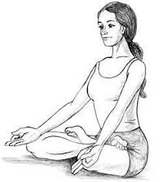

Figure - 1
Om......................Om....................Om.................
Sahana Vavathu, Sahanou Bhunaktu
Sahaveeryam-Karvavahai
Tejaswinaa Vadhitamastu, Ma...Vidvishavahai
Om.... Shanthi......... Shanthi.......... Shanthi hi......
LOOSENING EXERCISES –SITHILKARANA VYAYAMA
NECK MOVEMENTS – KANTHASANCHALANA
Figure - 2

Step 1 Sit in the Vajrasana Position;
Step 2 Keep your neck straight, then slowly but without jerk.
Step 3 Start rotating neck clockwise from left shoulder to backwards then to the right shoulder and to front.
Step 4 Repeat this in anticlockwise direction starting from right shoulder

SHOULDER MOVEMENTS -SKANDHASANCHALANA
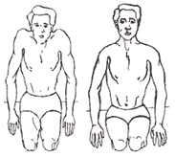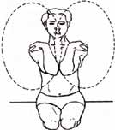
Figure – 3

Step 1 Sit in the Vajrasana Position,
Step 2 Keep the body straight, with arms by side.
Step 3 Then slowly but without jerk lift both shoulders upwards as much as possible near to ears,
Step 4 Back to normal position.
Step 5 Fold the hands and place left fist on left shoulder and right fist on right shoulder, bring both elbows together near chest, then slowly but without jerk.

HAND MOVEMENTS -HASTASANCHALANA
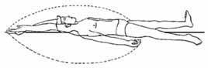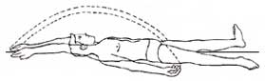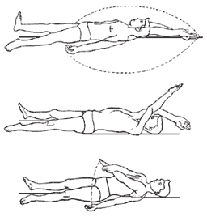
Figure - 4

Step 1 Relax in Shavasana position,
Step 2 Keep the hands 6 inches away from the body,
Step 3 Legs separated with 12 inch distance between them,
Step 3 Lift the hands 1 to 1.5 inch above ground and slowly rotate them towards head without bending elbows,
Step 5 Keep the hands parallel to the ground till both the palms meet, place left palm on right palm and stretch hands upwards andlegs downwards for 5 to 10 seconds, then slowly but without jerk rotate both the hands back to the normal position via the same path.

LEG MOVEMENTS - PADASANCHALAN
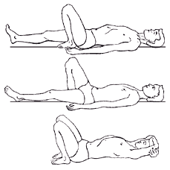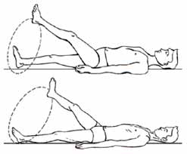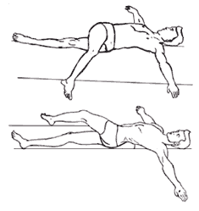
Figure - 5

Step 1 Relax in Supine position,
Step 2 Keep your hands around head rotating them sideways,
Step 3 Then lift your left leg and bring it near to the hip,
Step 4 Repeat this procedure for the right leg.
Step 5 Then slowly bring both the hands back to the normal
position.
KNEE: MOVEMENT - JANUSANCHALAN
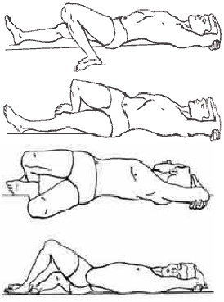
Figure - 6

Step 1 Relax in Supine position,
Step 2 Move the hands around head
Step 3 Then bend left leg in knee and rest foot near to hips,
Step 4 Then turn the knee to the right side as far as possible.
Step 5 Repeat this procedure for the right leg.
Step 6 Then slowly bring both the hands back to the normal position.
PAVANA MUKTHASANA

Figure - 7
STEPS
  - Sit erect, hands back, leg outstretched.
  - Bend toes forward.
  - Bend toes back
  - Bend the feet forward
  - Bend the feet back
  - Keep the leg on right thigh: with hands, turn left foot front and back: repeat with the leg
  - Turn the legs gently to the right and left.
  - Alternately, draw the right and left legs up to the chest.
  - Lift outstretched legs one at a time, and place the feet gently on the ground.
  - Spread legs wide, touch big toe of right foot with left hand: repeat on other side.
  - Stretch the hands in front of the, Fingers close together with palms facing outward.
  - Open and close the fingers tightly.
  - Arms out in front, form a wide circle with the arms, stretching them back and forth.
  - Arms still outstretched, close the fingers into a fist and make a circle at the wrists.
  - Make a fist with the fingers, fold the arms at the elbow, and draw the hands up to shoulders.
  - Close fists, bend elbows, raise arms; revolve arms to back of body.
  - Close fists, bend arms at elbows, place on shoulders, and recline the body back.
  - End forward with outstretched hands.
  - Twist the body to the right and left side.
  - Turn the neck to the right, and then to the left.
  - Turn the neck to the left, and then to the left.
  - Bend the head back, and inhale.
  - Bend the head forward, and exhale.
  - Fold right leg behind, as the bend to the left; raise arms, exhale, and reach for the floor.
  - Fold the left leg as the stretch the right; raise the arms, exhale, and the chest down on the floor.

3.15.2 ASANAS
SITTING ASANAS
ARDHA PADMASANA – HALF LOTUS POSTURE
Figure - 8
Step 1 From staff pose – dandasana, bend the right knee and bring the right ankle to the left hip crease with the sole of the right foot facing upwards.
Step 2 Settle the foot into the hip crease.
Step 3 Bend the left knee and cross the left ankle under the right hip knee in a comfortable, cross-legged position.

PADMASANA –LOTUS POSTURE
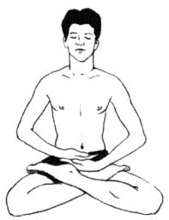
Figure - 9

Step 1 Sit on the floor with the legs stretched out straight in front.
Step 2 Bend the right knee and grasp the right foot with both hands and place it on top of the left thigh bringing the heel as close to the navel as possible.
Step 3 Bend the left knee and grasp the left foot with both hands and place it on top of the right thigh bringing the heel as close to the navel as possible.
Step 4 Both knees should be on the ground and the soles of the feet are pointed upward. The spine is held straight but not rigid.

VAJRASANA -THUNDERBOLT POSTURE
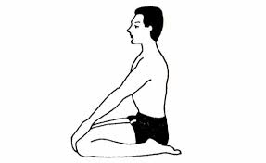
Figure - 10
Step 1 Sit back on the heels, keeping them apart and well tucked in under the buttocks.
Step 2 Keep the head, shoulders and buttocks in a straight line.
Step 3 Place the palms on the respective thighs.
Step 4 Breathe normally.
Step 5 It may be practiced for maximum feasible duration, especially after meals for 5- minutes at least.

PASCHIMOTHANASANA - BACK-STRETCHING POSTURE
Figure - 11
Step 1 Sit in dandasana with legs stretched and heels together. Back, neck and head should be held straight. Bring both the hands with the palms down, parallel to the legs.
Step 2 Inhale and proceed towards the toes and try to touch them.
Step 3 Exhale and slowly bring your head down in between the hands; stretch out the hands, toes and head.
Step 4 Inhale and return to the first position.

VAKRASANA -SITTING SIDEWARD TWIST POSTURE

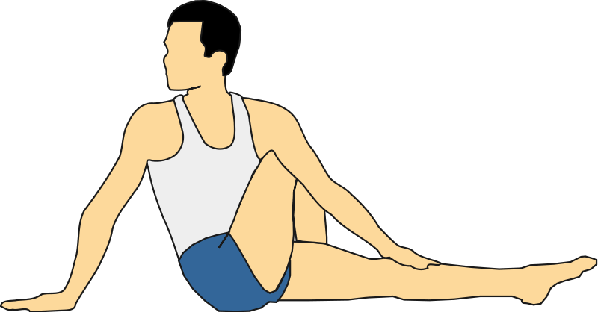
Figure - 12
Step 1 Sit in danadasana.
Step 2 Bend the left leg in the knee and place it near the thigh of left leg.
Step 3 Place the right hand beyond the folded knee of the left leg and in front of the left hand. Keep the palms of both the hands in opposite direction. There should be a distance of one foot between the two hands.
Step 4 Press the standing left knee with the right hand and shoulders, and twist the neck to the left. Turn the sight also in the same direction and continue normal breathing.
SHASHANKASANA -HARE POSTURE
Figure - 13
Step 1 Sit in Vajrasana.
Step 2 Inhale and raise the hands slowly above your shoulder.
Step 3 Exhale and slowly bend forward and try to place the head on the floor and resting the hands from elbow onwards on the floor.
Step 4 Stay for 20 to 30 breath counts and then come back to original position slowly with exhalation.
MATSYASANA -FISH POSTURE
Figure - 14

Step1 Lie on back in Padma Asana: Plant hands under lower back, raise the chest and bend the head.
Step 2 Hold big toes with hands and breathe deeply. Stay in this position for5-15 counts and come to normal position.

USHTRASANA -CAMEL POSTURE
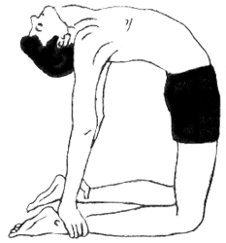
Figure - 15

Step 1 Sit with knees bend.
Step 2 Hold the ankles with hands.
Step 3 Raise the buttocks from the seated position and bend head back.
Step 4 Inhale deeply 4 or 5 times and hold for 5 seconds.

TADASANA - MOUNTAIN POSTURE
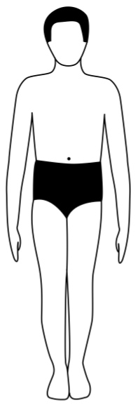
Figure - 16
Step 1 Stand with both feet touching from the heel to the big toe, keeping the back straight and the arms pressed slightly against the sides with palms facing inward.
Step 2 Slightly tighten or flex the muscles in the knees, thighs, stomach and buttocks maintaining a firm posture. Balance you weight evenly on both feet.
Step 3 Inhale through the nostrils and lift the buttocks off the legs arching the back and thrusting the abdomen forward and tilt the head as far back as possible.

VRIKSHASANA - TREE POSTURE
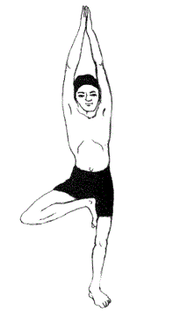
Figure - 17

Step 1 Stand with the feet together and the arms by your sides (see the tad-asana
Step 2 Bend the right leg at the knee, raise the right thigh and bring the sole of the right foot as high up the inside of the left thigh as possible.
Step 3 Balancing on the left foot, raise both arms over the head keeping the elbows unbent and joining the palms together. Hold the posture while breathing gently through the nostrils for about 10 complete breaths.
Step 4 Lower the arms and right leg and return to the tad-asana, standing position with feet together and arms at the sides. Pause for a few moments and repeat on the opposite leg.

PADAHASTHASANA -HAND- TO-FOOT POSTURE
Figure - 18
Step 1 Stand erect. Keep the arms by the sides. Keep the heels close together. Keep some gap between the feet.
Step 2 Raise both the arms. Slowly bend forward at the waist. Keep the knees stiff and firm. The legs should not bend at the knees.
Step 3 Keep the palms under the feet.
Step 4 Slowly exhale - while bending low and contract the stomach. Put forehead between the knees. Hold this position for two to ten seconds.

ARDHAKATICHAKRASANA -LATERAL ARC POSTURE
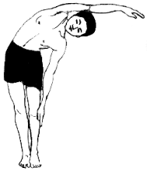
Figure - 19
- Stand erect with feet close together, hands along the thighs, fingers stretched out.
- While inhaling, slowly raise the right arm sideways up above the head until the arm touches the ear, palm facing left.
- Bend slowly on the left-side; slide the left palm down as far as possible along the left leg. Exhale as you bend. Raised hand should not bend at the elbow. Knee straight. Breathe normally. Maintain for about a minute.
- Return to position 2 inhaling completely. Bring the hand down to 1st position.
- Repeat on the left side, by bending towards the right.

UTKATASANA - THE HALF-SQUAT POSE
NAME- "Ut" means 'raised' and "kata' means "hips" in Sanskrit. This posture is known as "Utkatasana" because while practicing it, the heels and hips are raised.
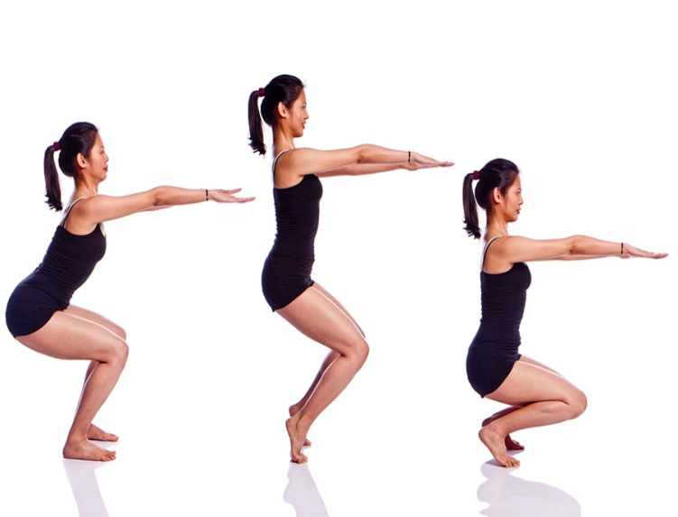
Figure - 20
Method of Practice:
1. Stand erect, keeping the feet apart at a slight angle to each other.
2. Stretch out the arms in front of the chest at shoulder level with palms turned down.
3. Inhaling raise the body slowly until stand on tiptoe.
4. Keep the balance.
5. Keeping the trunk and head erect, lower the body very slowly while exhaling till the back of the thighs press against the respective calves.
6. Exhaling, raise the right shoulder and bend the trunk and head together along with the raised right arm sideways to the left till the right arm is parallel to the floor.
7. Squat on the heels, without lowering the latter to the ground.
8. Squat erects on the toes and keeps balance.
9. Spread the knees apart and keep them parallel to the floor.
10. Rest the palms on the respective knees and find the balance.
11. Bring the knees closer and stretch out the arms straight again in front of the chest.
12. Inhaling, rise up slowly on tiptoe, keeping the trunk and head straight, until standing on tiptoe.
13. Exhale.
14. Return to the starting position with the foot flat on the floor.

Benefits:
- This asana provides good exercise to the lower portion of the body, particularly the muscles of the hips, thighs, calves, ankles and feet.
- The tendons at the back of the legs are stretched.
- It also strengthens the toes and the muscles which support the arches of the feet.
- It loosens stiff knees and hip-joints and enhances their mobility.

ARDHA CHAKRASANA- HALF WEEL POSTURE
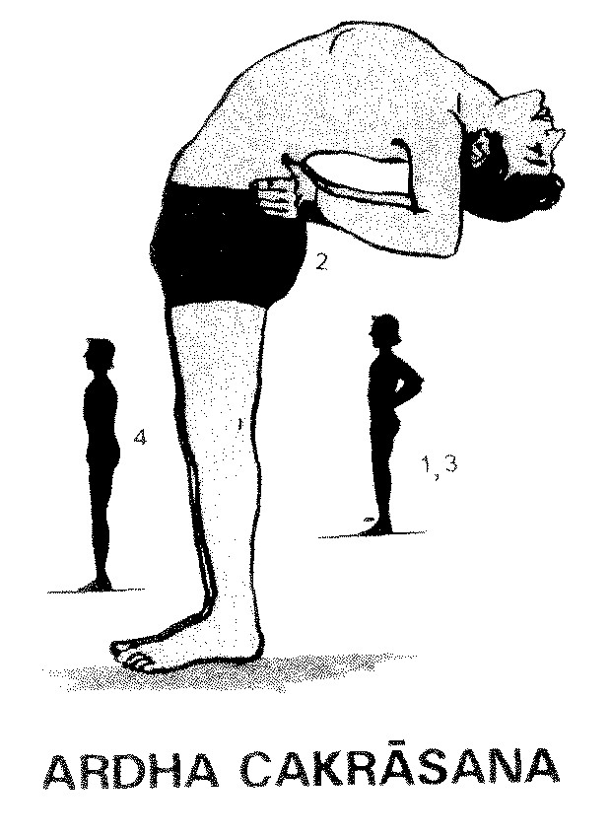
Figure - 21
Step 1 Stand Tad asana.
Step 2 Place your hands on your waist, Inhale and bend back, fixing your eyes on an object behind, like a picture on the wall.
Step 3 Stay for as long as you can, exhale and bend forward.

PARIVRITTI TRIKONASANA - THE TRIANGLE POSE
NAME- "Tri" means 'three', 'Kona' means 'angle', and 'Trikona' means 'triangle' in Sanskrit The straight legs with the floor between the feet resemble the three sides of a triangle in this asana. Hence the name.
Complimentary: Self
Type: Standing
Category: Cultural
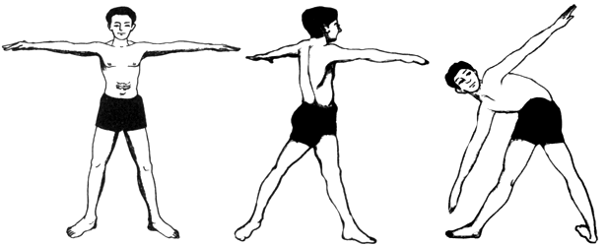
Figure - 22

Method of Practice:
- Stand erect. Keep the feet sufficiently apart.
- Inhaling, raise and stretch out the arms sideways to shoulder level and parallel to the floor with palms facing downward.
- Exhale slowly and breathe normally a few times.
- Take a deep breath.
- Exhaling slowly, rotate the trunk and head together from the waistline all the way around to the left without moving the feet or changing the position of the arms, and complete the exhalation. Hold this position for a few seconds while holding out the breath.
- Hold this position for a few seconds while holding out the breath.
- Take a deep breath again.
- Exhaling slowly, extend the right arm downward towards the left big toe without bending the knees. While the right arm is moving downward, bend down the head and trunk slowly to the left from the waist.
- Rest the fingertips of the right hand on the left big toe.
- Raise and stretch the left arm straight up and bring it in line with the lowered right arm, keeping the left palm turned inwards.
- Holding out the breath, turn the head to the left and look up quickly at the fingertips of the left hand.
- Still holding out the breath, again turn the head downwards and look down quickly on the left big toe and look up at the fingertips of the raised hand a second time.
- Maintain this position as long as you can comfortably hold out the breath.
- Inhaling, release the right hand, twist the trunk and head back and rise up slowly to the erect standing position, lowering the left arm to the shoulder level and rotating the right arm sideways up to shoulder level in a wide circle.
- Exhale slowly and take a few normal breaths.
- Repeat the whole exercise, twisting the trunk and head to the right.
PRONE POSTURE

BHUJANGASANA - COBRA POSTURE

Figure - 23
Step 1 Lie on the stomach with the head turned to one side and the arms alongside the body with palms facing upward.
Step 2 Turn the head and place the chin on the floor. Inhale then exhale slowly through the nostrils and swing the arms around until the hands are placed just below the chin with the palms down and the finger tips of each hand almost touching and the elbows on the floor.
Step 3 Inhale slowly through the nostrils, press down on the hands and lift the torso from the waist up off the floor, arching the spine backwards and straightening the arms. Keep the hips on the floor.
Step 4 Tilt the head as far back as possible and hold the posture for the duration of the inhaled breath.
Step 5 Exhale and reverse the process to return to position 1.
SHALABHASANA -LOCUST POSTURE
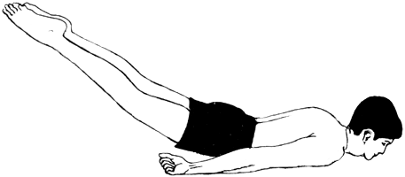
Figure - 24

Step 1 Lie on the floor with the abdomen touching the mat.
Step 2 Rest the chin on the floor with arms at the sides. The heels and toes must be held together.
Step 3 Inhale and lift both the legs above the floor. While lifting the legs, pressure must be applied on the fists.
Step 4 Maintain this position for a few seconds and come back to the original position.
Step 5 Relax and feel the stretch on the muscle of the back.

HALASANA - THE PLOUGH POSE

NAME- "Hala" means "Plough" in Sanskrit. This posture is called 'Halasana' because in the final position the body resembles the Indian plough.
Complimentary: Matsyasana, Ustrasana, Supta vajrasana
Type: supine
Category: Cultural
Figure - 25

Method of Practice:
- Assume the Ardha Halasana posture without much support from the hands.
- Exhaling slowly, press the palms on the floor and raise the posterior, hips and lower back off the floor and, simultaneously, lower and move the legs right over the head without bending the knees until the toes touch the ground at the nearest point beyond the head.
- Inhale and breathe freely.
- Slide away the toes together straight along the floor, curving the spine to the maximum extent.
- Stabilize theself in this position and complete the exhalation.
- Take a deep breath.
- Exhaling slowly, straighten the legs and slide away the toes together straight along the ground and away from the head till the lower parts of the thighs are brought opposite the forehead.
- Inhale and breathe normally.
- Press the chest against the chin and form a firm chin-lock.
- Lift the arms and move them slowly until they rest on the floor on either side of the head.
- Form a finger-lock and keep the clasped hands encircling the top of the head.
- Take a deep breath.
- Exhaling, slide the toes forward as far away from the head as possible.
- Keep the legs straight and together.
- Keep the knees stiff and the toes pressing the ground.
- Hold this position as long as comfortable, breathing freely.
- Restore the arms to their original position on the respective sides.
- Inhaling, bring back the legs together to the perpendicular position without bending the knees.
- Exhaling, bring down the legs until the heels rest on the floor.
- Breathe normally and relax completely in Savasana.
SUPINE POSTURE
VIPARITHAKARANI - HALF SHOULDER STAND POSTURE
Figure - 26
Step 1 Lie on back and relax the whole body.
Step 2 Fold the legs over the stomach and lift it high up.
Step 3 with help of hands; Support the buttocks and the chest as lift them.
Step 4 then rest the elbows on the floor and strengthen the legs.
Step 5 Focus the eyes on the big toes and hold

SARVANGASANA - THE ALL-PARTS POSE

NAME- "Sarva" means "all" and "Anga" means "part" in Sanskrit. Almost all parts of the body are involved and derive benefit from this asana and hence the name.
Complimentary: Matsyasana, Ustrasana, Supta vajrasana
Type: supine
Category: Cultural
Figure - 27

Method of Practice:
- Lie on the back with arms on the sides and palms turned down.
- Keep the legs together, the heels and big toes together.
- Breathe normally and relax the whole body.
- Pressing the palms and elbows down and keeping the knees straight.
- Inhale and while inhaling, raise the legs together till they are perpendicular to the floor.
- Exhale and while exhaling, increase the pressure of the palms and elbows against the floor and raise the hips and lower back off the floor and move the legs towards the head.
- Place the palms beneath the hips and prop up the trunk and legs.
- Sliding the palms higher on the trunk, keep on pushing the hips and the small of the back higher and raise the whole trunk off the floor till it is vertical. While doing this, bring the legs also back to the vertical position.
- Place the palms at the back of the ribs and support the raised trunk and legs with the palms, forearms and elbows.
- Sliding the palms higher and higher again, raise the hips and legs further till the trunk and legs are in a straight line.
- Push the chest forward towards the chin and form a chin-lock.
- Fix the gaze on the big toes and keep the balance.
- Breathe deeply and rhythmically and maintain this posture for about three minutes.
- Return slowly to the starting position in the reverse order.
- Take a few deep breaths and then breathe normally.
- Relax the body completely in Savasana.

DHANURASANA - THE BOW POSE

NAME- "Dhanus" means "bow" in Sanskrit. In the final position of this asana, the body takes the shape of a bow, drawn tight to shoot an arrow. The stretched arms and lower legs resemble the taut bowstring, while the trunk and thighs resemble the wooden part of the bow.
Complimentary:
Type:Prone
Category: Cultural

Figure -28

Method of Practice:
- Lie with abdomen, chest and chin resting on the ground.
- Stretch the arms on the sides. Keep the feet a little apart.
- Bend the legs backwards and grasp the corresponding ankles firmly.
- Hold the arms stiff and straight. Keep the knees sufficiently apart.
- Raise the chin and bend the head and neck backward without raising the chest.
- Inhaling, pull the legs slowly upward towards the ceiling (not the head).
- While pulling hard against the ankles, raise the knees, thighs, hips, the lower region of the navel, chest, shoulders, chin, neck and head upward all together until the body is balanced on the navel region which alone should touch the floor.
- Arch the back as much as possible with the arms and legs tugging at each other.
- Slowly bring the big toes, the inner edges of the feet and the knees closer and join them together.
- Keep the head up and backward as far as you can and look up.
- Hold the breath and maintain the posture until any strain.
- Exhaling, return slowly to the starting position in the reverse order.

SHAVASANA -CORPSE POSTURE
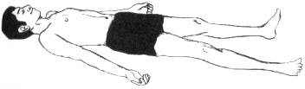
Figure - 29

Sep 1 Lie on the back with the feet comfortably apart.
Step 2 The spinal column is straight but not rigid and the arms rest
Step 3 The head is in line with the spine eyes and mouth is closed gently.
Step 4 Relax body completely.

3.16 PRANAYAMA
SECTIONAL BREATHING

Figure - 30

- Inhale by first expanding the abdomen and then the chest in one slow, smooth motion until the maximum possible amount of air has been drawn into the lungs.
- Then exhale and allow the air to passively escape from the lungs.
- This should be accompanied by a feeling of letting go and relaxation.
- Inhalation is active, exhalation is passive.
The whole movement should be smooth (no jerks) from the abdomen to the chest, like a wave.

ANULOMA VILOMA
SURYA ANULOMA VILOMA - RIGHT NOSTRIL

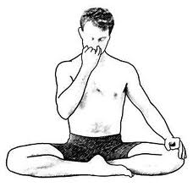
Figure - 31
Step 1 Sit erect in Padmasana and Adopt Nasika mudra
Step 2 Close the left nostril with fingers
Step 3 Inhalation and exhalation through right nostril.

CHANDRA ANULOMA VILOMA-LEFT NOSTRIL YOGA BREATHING

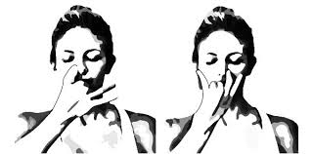
Figure - 32

Step 1 Sit erect in Padmasana and Adopt Nasika mudra
Step 2 Close the right nostril with fingers
Step 3 Inhalation and exhalation through left nostril.

BRAHMARI -BUMBLE BEE BREATHING

Figure - 33
Step 1 Sit comfortably in any meditative posture.
Step 2 Inhale slowly and deeply through the nose. Let the inhalation caress the throat area.
Step 3 Then gently plug the ears with the respective index fingers and closed eyes.
Step 4 Exhale slowly producing a long and continuous humming sound.
Step 5 Enjoy the sound and vibrations produced during these breathing techniques.

KAPALABHATI - STIMULATING THE BRAIN CELLS
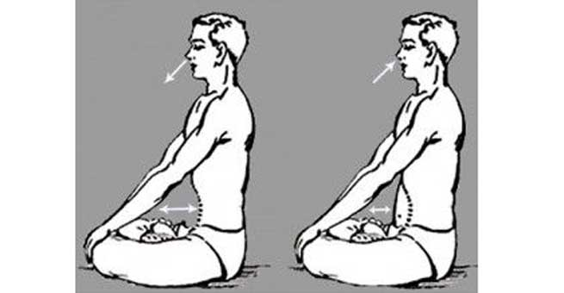
Figure - 34
Step 1 Sit in comfortable crossed leg position with back straight .Face to be relaxed.
Step 2 exhale forcibly using abdominal muscles.
Step 3 Inhale deeply through nostril, expanding abdomen and exhale with the forceful contraction of abdominal muscles. (Pull the abdomen in by quickly contracting the abdominal muscles and exhale through the nose). The air is pushed out of lungs by contraction of the diaphragm.
Step 4 After exhalation again inhalation but inhalation should not involve any effort. To inhale just relax and the lungs will automatically expand and filled with air.

BHASTRIKA PRANAYAMA
‘Bhastrika’ literally means ‘bellows.’ It is performed by instant and quick expirations of breath.
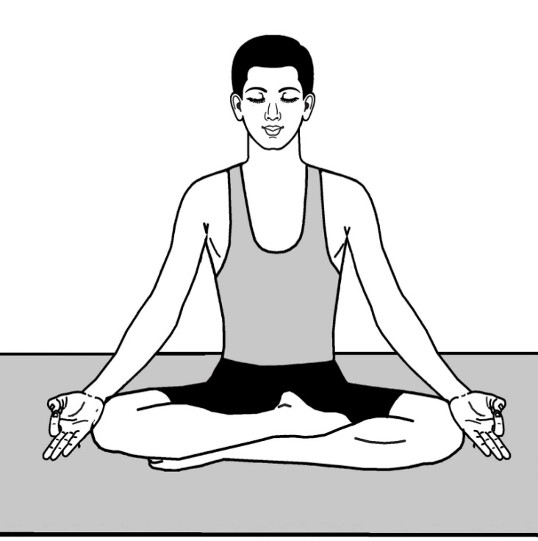
Figure - 35

- Be seated in comfortable posture. Padmasana (crossed leg) and Vajrasana are the ideal yoga postures to practice pranayama. Place the hands on the knees. Feel relaxed. Focus on breathing pattern and be relaxed.
- Breathe in by inhaling forcefully through both the nostrils. Make sure that the lungs are full with air. Once you inhale fully, exhale with great force making hissing sound.
- In Bhastrika pranayama one needs to apply force while breathing in and breathing out. One can determine how much speed to apply while inhaling and exhaling keeping in mind, heath and endurance power.
- When breathe in while performing Bhastrika pranayama, the abdominal should not blow up. Instead your chest area should blow up. Repeat the procedure for 5 to 10 times.
The Successfully completed Bhastrika pranayama One should perform Bhastrika pranayama for 5 minutes every day. Those who have high blood pressure or heart disease should not practice Bhastrika pranayama.

UJJAYI
- Sit erect in any comfortable posture. Keep spine erect.
- Inhale, slowly drawing air by both the nostrils in such a way that while inhaling the touch of air is experienced in the throat and some sound is produced.
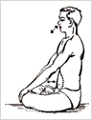
Figure - 36
- During inhalation do not allow abdomen to bulge out, let the chest expand.
- After completing inhalation slowly exhale. During exhalation chest should go inside and abdomen should remain steady.
- While doing Ujjiayi air should touch the throat.
- Do not let abdomen to bulge out.
- After practicing it for few days, knowing your limitations, keep the ratio between inhalation and exhalation 1 : 2.
- In easy Ujjiayi Pranayama, inhalation and exhalation can be practised by both the nostrils.
SHEETKARI PRANAYAMA
Figure - 37
- Sit in a comfortable meditative postures like padmasana,siddhasana or vajrasana.
- Keep the spine erect and eyes gently closed.
- Fold the tongue and extend it out.
- Inhale deeply through the folded tongue.
- After the inhalation gently draw the tongue in, close the mouth and exhale slowly through the nostrils.
- Feel the coolness and relaxation.

SHEETALI
- Begineers can start with deep breathing practice in sitting position (Padmasana - Lotus, Swastikasana- Auspicious, Vajrasana - Thunderbolt, Any Cross legged position in which the body can be relaxed and spine is erect.)
- Then start inhaling through mouth by rolling the tongue, make sure that the air passing in is cooled via tongue.
- Initially 4 seconds inhale through mouth while rolling the tongue and exhale for 6 seconds through both nostrils, this can be practiced for about 5 minutes.
Figure - 38
- With practice one can increase the counts to 4:8, or 5:10 or 6:12 seconds
- One should have Low Blood pressure then this pranayama can bring it further down. So must be careful.
- It may feel little cold or tingling sensation in the throat due to cold air but this is normal.
- Under No circumstances the proportion of the breathing should be forced.
- If feel dizzy then please stop the practice and continue normal brathing.

NADISHUDHI -ALTERNATE NOSTRIL BREATHING
Figure - 39
Step 1 Sit comfortably in any meditative posture. Be calm and close the
eyes.
Step 2 Close the right nostril with the right thumb.
Step 3 Now inhale slowly through the left nostril and fill the lungs.
Step 4 After complete inhalation, press the left nostril with the ring finger of the right hand and close the left nostril. Open the right nostril, exhale slowly.
Step 5 After complete exhalation, again inhale through the right nostril and fill the lungs.
Step 6 Close the right nostril by pressing it with the right thumb.
Step 7 After opening the left nostril, breathe out slowly.
Step 8 This process is one round of Nadi Shudhi Pranayama.
MANTRA (After Practices)
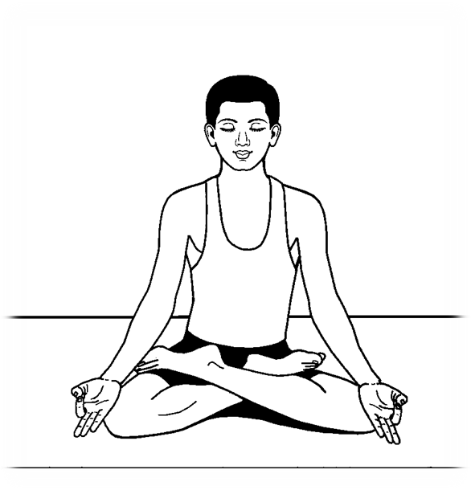
Figure - 40
Oom......... Asathoma Sadgamaya
Tamasoma Jyothirgamaya
Mrutyorma Amrutangamaya
Om.... Shanthi......... Shanthi.......... Shanthi hi......
Whereas the control group followed the normal daily routine without any training programme.

3.17 TEST ADMINISTRATION
3.17.1 PHYSICAL VARIABLES

3.17.1.1 AGILITY
Objective
The purpose of this test was to measure agility.
Facilities and Equipments
Floor, stop watch, whistle, score sheet, measuring tape, chunnam powder, two wooden blocks (2”x2”x4”), score card and pencil.
Administration
Two parallel lines were drawn on the floor 10 meters apart. The blocks were placed behind one of the lines. The subjects were instructed to start from behind the other line. To start the shuttle run a whistle was blown and the subject ran to the blocks up one block, run back to the starting lines and placed the block on the ground beyond the line. Then the subject ran back picked up the other block and run across the starting line as fast as possible. The stop watch was started as the whistle blew and stopped when the subject crossed the starting line.
Scoring
The trials were administered with a rest period of five minutes in between the best of the two times were recorded as the scores in seconds.

3.17.1.2 FLEXIBILITY
Purpose
To measure the flexibility
Equipment required:
Sit and reach box (or alternatively a ruler can be used, and a step or box)
Procedure:
This test involves sitting on the floor with legs stretched out straight ahead. Shoes should be removed. The soles of the feet are placed flat against the box. Both knees should be locked and pressed flat to the floor - the tester may assist by holding them down. With the palms facing downwards, and the hands on top of each other or side by side, the subject reaches forward along the measuring line as far as possible. Ensure that the hands remain at the same level, not one reaching further forward than the other. After some practice reaches, the subject reaches out and holds that position for at one-two seconds while the distance is recorded. Make sure there are no jerky movements. See also video demonstrations of the Sit and Reach Test.
Scoring
The score is recorded to the nearest centimeter or half inch as the distance reached by the hand. Some test versions use the level of the feet as the zero mark, while others have the zero mark 9 inches before the feet. There is also the modified sit and reach test which moves the zero mark depending on the arm and leg length of the subject. The table below gives you a general guide for expected scores (in cm and inches) for adults using zero at the level of the feet.
3.17.1.3 CARDIOVASCULAR ENDURANCE (12 MIN RUN/WALK TEST)
Purpose
To measure cardio vascular endurance
Equipment
A 400m track with division into eight quarters by placing makers. Stopwatches whistle and distance markers all needed for group testing.
Procedure
The runners started behind a line and upon the starting signal; run/walk as many laps as possible around the course within the 12 minutes. The spotters maintain a count of each lap, and when the signal to stop is given, they immediately run to the spots at which their runners were at the instant the whistles or command to stop was given.
Scoring
The number of laps covered by the subject plus the number of 50 metre zone passed on the last lap within, 12 minutes were measured, counted to record the distance in meters.

3.17.2 PSYCHOLOGICAL VARIABLES

3.17.2.1 ANXIETY
Anxiety was measured through the anxiety questionnaire. The anxiety questionnaire was designed to measure the degree of anxiety experience prior to the competition.
It was developed by Spielberger. Spielbergers Trait Anxiety questionnaire was given to all subjects. Twenty items were adopted from Spielbergers Trait Anxiety questionnaire for this investigation. The complete questionnaire is scores as follows:
S.No | Response | Score of Positive statements | Score of Negative statements
1 | Not at all | 1 | 4
2 | Some what | 2 | 3
3 | Moderately so | 3 | 2
4 | Very much | 4 | 1

Positive Statements | 1,2,5,8,10,11,15,16,19,20
Negative Statements | 3,4,6,7,9,12,13,14,17,18

3.17.2.2 AGGRESSION

Purpose : To measure the level of aggression of an individual
Equipments : Aggression questionnaire.(Designed By Arnold and Mark ,
professors from the University of Texas at Austin)
Procedure : Recorded in a sitting relaxation position
Scoring : If the control index was decided by giving a weightage of
1, 2,3,4,5 marks against low, normal, average, high, very
high level of aggression the index ranges from 0 to 145

3.17.2.3 STRESS

The standard psychological tool device by Everly and Gitdano’s was used to quantify psychological stress. This test consists of 14 statements. Each statement consists of 4 responses: Almost always true, usually true, Seldom true, Never true.
All the statements are positive in nature. The respondents made a tick mark ( √ ) on any one of the responses that fit to them best.
The scale was revalidated by the researcher by administrating it on 20 students and reliability was computed by test and retest method and reliability obtained was 82. Hence the inventory in it original forms was made use of in this investigation. A copy of questionnaire is given in appendix – I.
Scoring
The inventory was scored with the help of a scoring key and which is given below. The scoring obtained for each statement was added and it was treated .as individual score. The total score constitutes the psychological stress score. The range psychological stress score of the subject is given in appendix.
Scoring Key
Sl.No | Response | Score
1 | Almost Always True | 3
2 | Usually True | 2
3 | Seldom true | 1
4 | Never True | 0

3.17.3 PHYSIOLOGICAL VARIABLES

3.17.3.1 PULSE RATE
Objective
To measure the pulse rate of each subject per minute
Equipments
Digital Heart Rate Measuring Machine, Model No. EW 243, manufactured by National Company, Japan.
Administration
The pulse rate of all the subjects was recorded in a sitting position, in the evening between 4 and 5 p.m. Before taking pulse rate the subjects were asked to relax for about 30 minutes.
Then the subjects were instructed to sit in a back supported chair and maintain in a slight incline position and placed his left hand on the table. Next the researcher was collected Heart Rate or pulse rate by using Digital Heart Rate measuring machine which was placed in the chest level on a table. In this way the researcher was measured the heart rate of the subject (Kamrul, 2007).
Scoring
The number of pulse beats per minute was recorded as the scores.

3.17.3.2 MEAN ARTERIAL BLOOD PRESSURE
Objective
The purpose of the test was to measure the systolic and diastolic blood pressure.
Equipment
A dial type of sphygmomanometer and stethoscope a chart and a table were used for recording the blood pressure.
Administration
The blood pressure for all the subjects was checked in the morning. The subjects were given adequate time to relax in a chair in a comfortable position so that the normal pressure was restored. While taxing the blood pressure the subjects right arm was completely made bare to make certain that the clothes did not compress the blood vessels. The instrument was kept at the level of the heart on the table. The blood pressure measurement was taken with the subject in a sitting position the fore arm being kept straight in relaxed positions on the table. The pressure cuff was wrapped around the arm evenly the lower edge being placed approximately one inch above the anticubical space. Care was taken that the stethoscope was not in contact with the cuff. The cuff was inflated until the artery was fully pressed, so that no heart beat could be learned.
When the heart beat was not audible air was released by opening the air value of the rubber tube and the systolic stroke the heart sent to spurt into artery and at the peak of the systolic stroke the first heart beat become audiable at which instant the read in millimeter of measuring (mmhg) was recorded with the gradual release of air, the heart beat become muffled and then disappeared. This indicated blood pressure at the diastolic stage and the reading was noted in mm Hg. Like the same blood pressure was recorded after the walking exercise was over.
Mean arterial pressure
Mean arterial pressure also measured by using the formula.
P mean = Diastolic pressure + 1/3 pulse pressure.
Pulse pressure is the difference between systolic pressure and diastolic pressure (Mathew, 1988).

3.17.3.3 VITAL CAPACITY

Purpose:
To uses the vital capacity
Equipment:
Dry Spiro meter, Chair, and nose clips
Procedure
Vital capacity of the subject was determined by the Spiro meter in sitting position. The subject was allowed to inspire the maximum amount of air voluntarily and then he was asked to blow into the dry Spiro meter to the maximum extent. While taking the test the nose of the subject was clipped using a nose clip.
Scoring:
The Vital capacity of the subject was obtained from the movement of circular volume indicator which was set at ‘0’ before the vital capacity measure was taken. The result was recorded in milliliter.

3.17.4 HEMATOLOGICAL VARIABLES

3.17.4.1 HEMOGLOBIN
Purpose
To find out the percentage of hemoglobin concentration in the blood. To assess the hemoglobin concentration was estimated by Cyanmethaemoglobin method.
Equipment
Cyanmethaemoglobin method consists of a graduated tube, three sets of test tubes, potassium cyanide and potassium ferricyanide.
Procedure
Hemoglobin concentration was estimated using colorimetric procedure by Cyanmethaemoglobin method (Mukherjee, 1997). An aliquot of well mixed whole blood was taken and reacted with a solution of potassium cyanide and potassium ferricyanide. The chemical reaction yields a product of stable color, the cyanmethaemoglobin. The intensity of the color is proportional to the haemoglobin concentration at 540 nm.
The following reagents were used for the assay:
(a) Reagent 1: Drabkin’s Reagent (50 mg Potassium cyanide, 200 mg Potassium ferricianide and 1000 ml Distilled water).
(b) Reagent 2: Cyanmathaeoglobin standard. All reagents were supplied by Merck Ltd., India.
A three sets of test tubes were taken and marked as Blank, Test and Standard. In the Blank 5.0 ml of Reagent 1 was taken. The tube marked as Test contained 5.0 ml of Reagent 1, then 20 μl of an aliquot of well-mixed EDTA-anticoagulated blood specimen was added, mixed well and stand for 10 minutes. Another tube marked as Standard contained 5.0 ml of Cyanmathaeoglobin standard. Blank solution was used for setting the spectrophotometer. Absorbance (Abs.) of the Test and Standard was performed using pectrophotometer at 540 nm.
Hemoglobin concentration was expressed as g/dl. Normal : 12.00 to 16.00 gms

3.17.4.2 RED BLOOD CELL TEST

Purpose
To count the red blood corpuscles cell
Equipment
Heamocytometer
Procedure
Capillary blood was collected up to the mark 0.5 in the RBC pipette and diluted.
Red blood cell corpuscles
Their number was estimated with an improved neubauer Heamocytometer as explained by Dacie and Lewis (1964).
Materials
A red blood corpuscle pipette, diluted fluids, improved new bears counting and microscope was used.
Procedure
A 1:200 dilution of blood was done by washing 20ml of blood taken in to the micropipette into 4ml of diluting fluid, contained in a glass 75x12 mm tube. After sealing the tube tightly fitting rubber cork the diluted blood was mixed by hand for at least-two minutes by titling the tub through an angle of about 120 combined with rotation, thus allowing the air bubble to mix the suspension, the improved Neubears counting chamber, with its cover glass already in position, was filled without delay. This was simply accomplished with the aid of a Rasteur Pipetle. The champers was left undisturbed for two minutes for the cells to settle. The cells were counted, using 4mm dry objective and x10 eyepieces. The cell counting was done from the four corners and one central smaller sequence of the red blood corpuscles counting area. So eighty smallest squares of 1/400 square millimeter area each were counted. The total number of red blood cell was expressed as N x10¹² / liter of blood.

3.17.4.3 WHITE BLOOD CELL TEST
Their number was estimated with an improved Neubeaurs haemocytometer as explained by Dacie and Lewis (1964).
Materials
A white blood corpuscle pipe toe, diluting fluid, improved Neubeaurs counting clamber and microscope were used.
Procedure
A1 in 20 dilution of blood was made of adding 20 m1 of blood in to 0.38 milliliter of diluting fluid in a 75x10mm glass tube. After tightly corking the tube, the suspension was mixed by rotating the tube for at least one minute. The improved neubeaurs counting chamber with its cover glass already in position was filled by means of a past our pipette. The red cells were analyzed by the diluting fluid but the leucocytes remained in fact, their nuclei staining deep violet blank. The cells were counted with 16 mm objective and x10 eyepieces. The counting was done from all the smaller squares of the four corner white blood corpuscles counting areas. Thus the total area counted was 4 square millimeter.

3.18 COLLECTION OF DATA

To achieve the purpose of the study four groups consisting of 15 subjects each were selected at random, the first second and third experimental groups were treated with Asanas, pranayama, and combined (Asanas and pranayama) for about twelve weeks (5 days/week). After the training period all subjects were tested on selected criterion variables at different levels as pre and post training. The pre and post test data on the selected criterion variables were collected by administering the test as per the standardized procedures before and after the twelve weeks of the training programme. Similarly the blood sample was collected from individuals

3.19 STATISTICAL TECHNIQUE
The data obtained were analyzed by Analysis of Covariance (ANCOVA) to assess the significant difference among the groups between the pre test and post test on physical, psychological physiological and hematological variables to find out the influence of Asanas and pranayama on selected physical psychological physiological and hematological parameters among degree college students. The normality of the data collected was tested through F test (ANCOVA). The adjusted post test mean differences among the experimental groups were tested and if the adjusted post test result was significant the Scheffe’s post hoc test was used to determine the significance of the paired means differences (Thirumalaisamy, 1995). The investigator has analyzed scientific results obtained by application of various methodologies discussed above and the results are analyzed and presented in form of detailed discussion graphs and various tables in the next chapter.

